KOPS

KOPS stands for Kubernetes operations.  
  
Kops will not just help you to create, delete and manage your Kubernetes cluster, It also provision the necessary cloud infrastructure automatically.  
  
Supports multiple OS. You can either provision directly or generate terraform manifest

Self-healing. Everything is created within ASG  
  
Install Kubectl

Check the Kubectl version



Install KOPS

Install AWS CLI

Create a IAM Account for KOPS which will be used to setup K8s cluster using KOPS

Create IAM user group

Attach the policies to the KOPS group

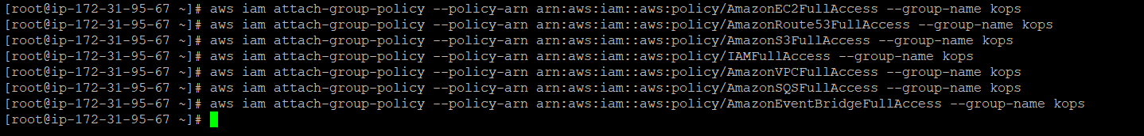

Add user KOPS and assign the user to KOPS group

Create IAM access key for user KOPS

Use the KOPS user to provision k8s cluster.

Create an S3 bucket to store the Kubernetes cluster state

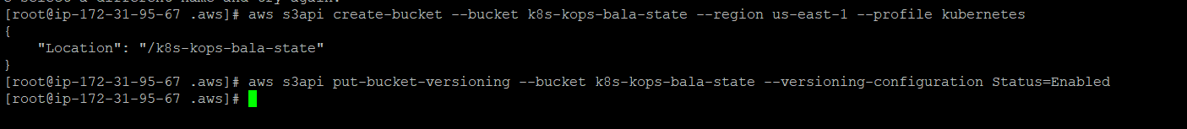

For a gossip-based cluster, make sure the name ends with k8s.local. For example:

kops create cluster k8s-cluster.k8s.local --node-count=2 --zones="us-east-1a,us-east-1b" --node-size=t2.medium --master-size=t2.medium --networking=calico --topology=private --bastion=true --state=s3://k8s-kops-bala-state --yes

Create K8s cluster using KOPS

Check the resources created automatically for you in AWS

Check the status using kubectl

Validate the cluster

Get the cluster name

