Kubeadm

Create 1 master and 2 worker nodes using Kubeadm  
  
Ensure network connectivity between master and worker nodes

Disable Swap in all 3 machines

Let IP tables see bridge traffic

To install containers in pods, Kubernetes need container runtime like Docker, Continerd.

Install docker on RHEL8

Add the official repo to install docker



Install docker

Start docker and check status

Control docker to use systemd for management of container cgroups

Disable selinux

Add the repositories for K8s

Install Kubernetes

Run only on master, Initialize the kubeadm

Join the worker nodes

Deploy pod network for the pods to communicate with each other

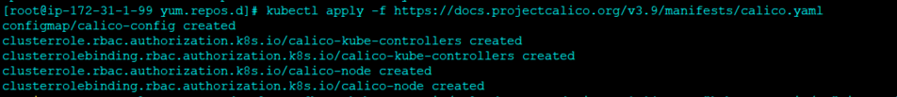

Validate  
  
