Minikube

Minikube lets you to provision a single node k8s cluster on your virtual machine locally.

You need hypervisor like VirtualBox or libvirt to install minikube.

For EC2 Instances we do not have access to the BIOS to enable hypervisor, since AWS EC2 instance itself is a Virtual Machine. Thus, we are using the --vm-driver=none tag. No need to install a Hypervisor (VirtualBox or KVM)

Check virtualization is supported, it has to return some values.

Install Kubectl

Using --vm-driver=none requires docker

Install Minikube

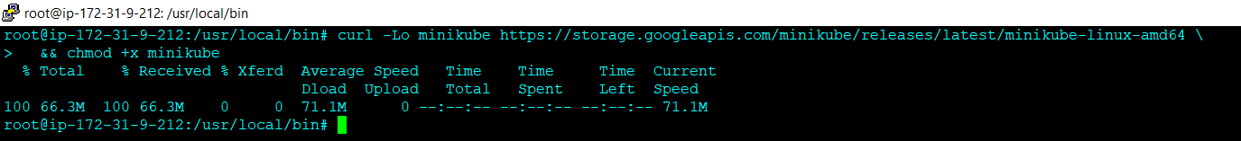

Start minikube

Check the status

Create a container

Expose the container

Enable dashboard

Stop the Kubernetes cluster

Delete the K8s cluster

