NFS provisioning

Enable nfs-server

Check the status

Create Directories

Export the FS



Login to worked node and see you are able to ping nfs-server

Mount the NFS into Worked node

Check the mount in Worked node

Create a PV

Check the status of PV

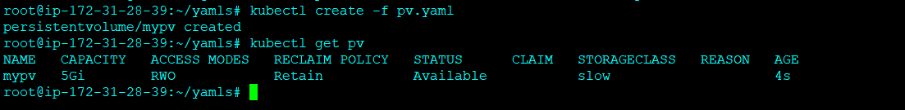

Create a PVC

StorageClassName should be same for both PV and PVC

Check the status, PVC should be bound to pv

Create a POD claiming the PVC

Name of the volume and Name of the volume mount must be same

Check the status of the pod

Login to the Worker node/Docker container and see NFS is mounted to the volume

Create a index.html file

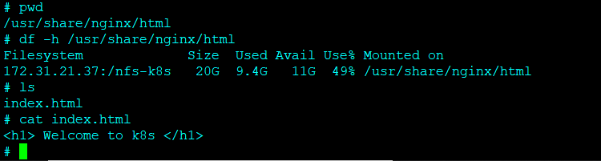

Create a service and access the pod

