

FLOWCRM – PROJECT REPORT
BY
BALAMURUGAN B

Placement Empowerment Program - Full Stack MERN

DECLARATION

I, Balamurugan B, hereby declare that the Project Report entitled “FLOWCRM – AI-Based Customer Relationship Management System”, carried out by me under the guidance of Dr. Divya J, M. Tech, Ph.D-Full Stack PEP Incharge, is submitted as part of the requirements for the award of Professional Elective Project (PEP) marks in Semester VI of the Bachelor of Engineering in Computer Science and Engineering.

Date: 22 Apr 2026
Place: Chennai

1.ABSTRACT

FlowCRM is an AI-powered Customer Relationship Management (CRM) system designed to improve the efficiency of business operations related to lead handling, task organization, and sales pipeline tracking. In many traditional CRM systems, users are required to manually interpret large volumes of data, which can lead to inefficiencies and missed opportunities. FlowCRM addresses this limitation by integrating artificial intelligence to automatically analyze data and generate meaningful, actionable insights.
The system provides a centralized platform where users can manage leads, monitor their progression through different pipeline stages, and assign or track tasks associated with each lead. A key feature of the system is its AI-driven insights module, which evaluates patterns in lead activity and task completion to suggest follow-ups, highlight high-priority opportunities, and identify potential risks in the sales process.
Developed using modern web technologies such as React.js for the frontend, Node.js and Express.js for the backend, and MongoDB for data storage, the application follows a modular and scalable architecture. The user interface is designed to be intuitive and responsive, ensuring ease of use across different devices. Additionally, integration with generative AI enables dynamic analysis of business data, transforming the CRM from a passive data storage system into an active decision-support tool.
Overall, FlowCRM demonstrates how intelligent automation and structured data management can be combined to enhance productivity, improve decision-making, and support business growth in a competitive environment.

2.LIST OF CONTENTS
Chapter no. | Title
1 | Abstract
2 | List of Contents
3 | Analysis  - Introduction  - Functional requirements  - Non-Functional requirements
4 | Methodology and Implementation  - Design approach  - Key concepts used  - Development phases  - Tools and technologies used  - Folder structure
5 | Execution and Output  - Steps to run the project  - Output description

5. Execution and Output
- Steps to run the project
- Output description
6. Future Enhacements
7. Conclusion

3.ANALYSIS

3.1 Introduction
Customer Relationship Management systems are essential for managing business interactions, tracking leads, and improving customer engagement. However, many existing systems lack intelligent assistance and require users to manually interpret data.
FlowCRM addresses this gap by:
- Providing a centralized system for managing leads and tasks
- Offering visual pipeline tracking
- Using AI to generate actionable insights
- Reducing manual effort and improving productivity
3.2 Functional Requirements
The system must:
- Enable users to create, update, and delete leads
- Track lead status across different pipeline stages
- Allow task creation, assignment, and tracking
- Display a dashboard with insights and summaries
- Generate AI-based insights based on leads and tasks
3.3 Non-Functional Requirements
- Performance: Fast loading and response time
- Scalability: Ability to handle increasing data and users
- Usability: Clean and intuitive UI for easy navigation
- Security: Secure authentication and data handling 4
4.METHODOLOGY AND IMPLEMENTATION

4.1 Design Approach
The system follows a modular full-stack architecture:
- Frontend handles UI and user interaction
- Backend manages business logic and APIs
- Database stores persistent data
- AI module processes data and generates insights
4.2 Key Concepts Used
- CRUD Operations (Create, Read, Update, Delete)
- RESTful API design
- State management in frontend
- Component-based UI architecture
- Asynchronous data handling (API calls)
- AI prompt-based insight generation
- SDG 8– Decent Work and Economic Growth (Enhances business productivity and efficiency)
4.3 Development Phases
Planning → Design → Development → Testing → Deployment

4.4 Tools and Technologies Used
Frontend:
- React.js (Vite)
- Tailwind CSS
Backend:
- Node.js
- Express.js
Database:
- MongoDB (Atlas)
AI Integration:
- Groq API
Other Tools:
- Postman (API testing)
- Git (version control)
4.5 Folder Structure
Frontend:
src
├── components/
├── pages/
├── services/
├── assets/
└── App.jsx

Backend:
server/
├── controllers/
├── routes/
├── models/
├── config/
└── server.js
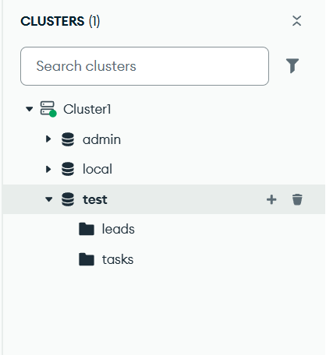
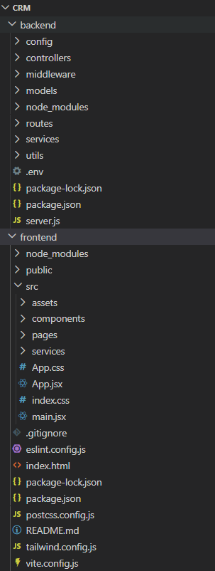

Figure: Folder Structure and Database overview

5.EXECUTION AND OUTPUT

5.1 Steps to Run the Project
Backend Setup:
Navigate to backend folder
Run: `npm install`
Start server: `npm start`

Frontend Setup:
Navigate to frontend folder
Run: `npm install`
Start app: `npm run dev`

5.2 Output Description
The system provides:
Dashboard:
- Displays AI insights, pipeline status, and tasks
Leads Page:
- Manage and track all leads
Tasks Page:
- View and update assigned tasks
AI Insights Panel:
Suggests actions like:
- Follow-up reminders
- High-priority leads
- Risk alerts
The UI is clean, responsive, and structured for efficient navigation.
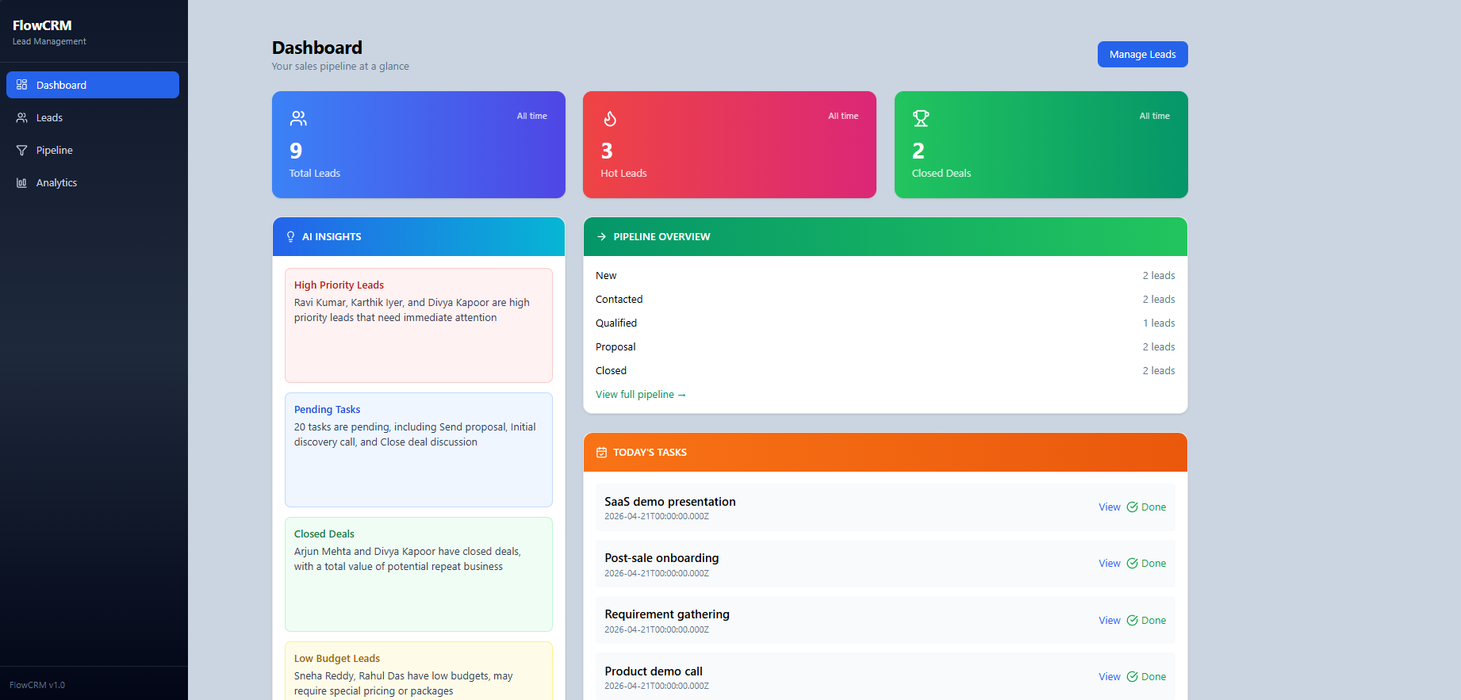
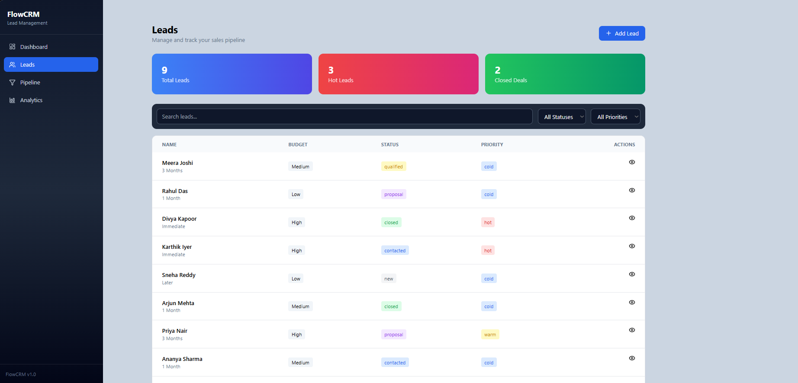

Figure: Output from Live server
6.FUTURE ENHANCEMENTS
The FlowCRM system can be further improved by incorporating the following features:
- Integration with email and messaging platforms for automated communication
- Implementation of real-time notifications and reminders
- Advanced analytics and predictive forecasting
- Integration with third-party tools such as payment systems and marketing platforms

7.CONCLUSION
The development of FlowCRM highlights the effective integration of full-stack web technologies with artificial intelligence to create a modern and intelligent business management system. The project successfully achieves its primary objective of simplifying customer relationship management by providing a unified platform for handling leads, tracking tasks, and visualizing sales pipelines. A key strength of the system is its AI-driven insights capability, which enables users to make informed decisions, prioritize important leads, and reduce workflow delays, thereby improving overall efficiency and conversion potential. From a technical perspective, the project demonstrates the practical application of concepts such as RESTful API design, component-based frontend development, database management, and asynchronous communication. The modular architecture ensures scalability and ease of maintenance. While the system is functional and effective, it can be further enhanced with features such as real-time notifications, advanced analytics, third-party integrations, and role-based access control. Overall, FlowCRM serves as a strong example of how artificial intelligence can transform traditional CRM systems into smarter and more efficient solutions.

