Assign a public IP to the application gateway.

Add path-based routing

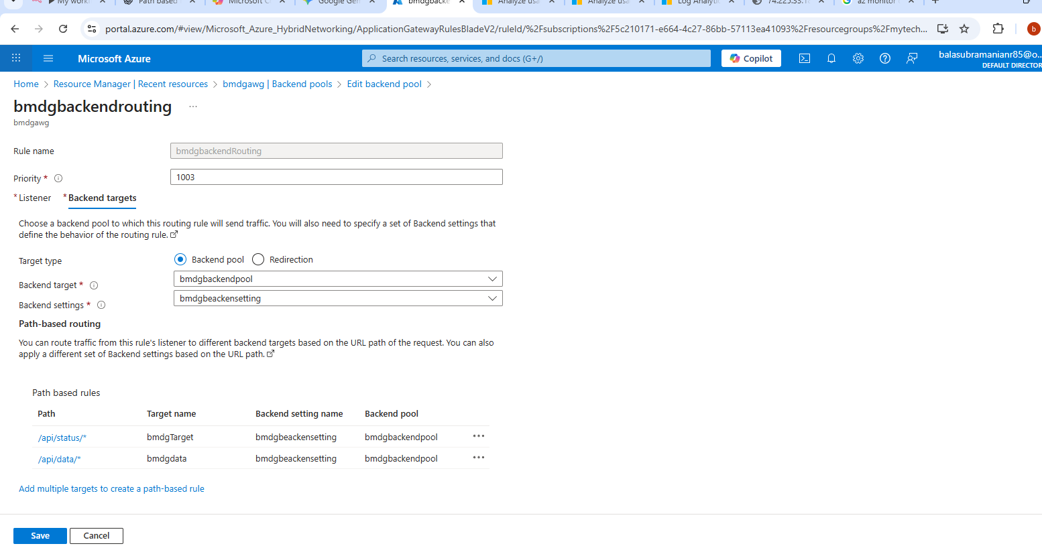

- Validate the curl for the validation API using the Application Gateway public IP.
- Add a WAF rule and switch from Standard to WAF V2.
- Create a Log Analytics workspace.
- In Application Gateway, configure diagnostic settings.
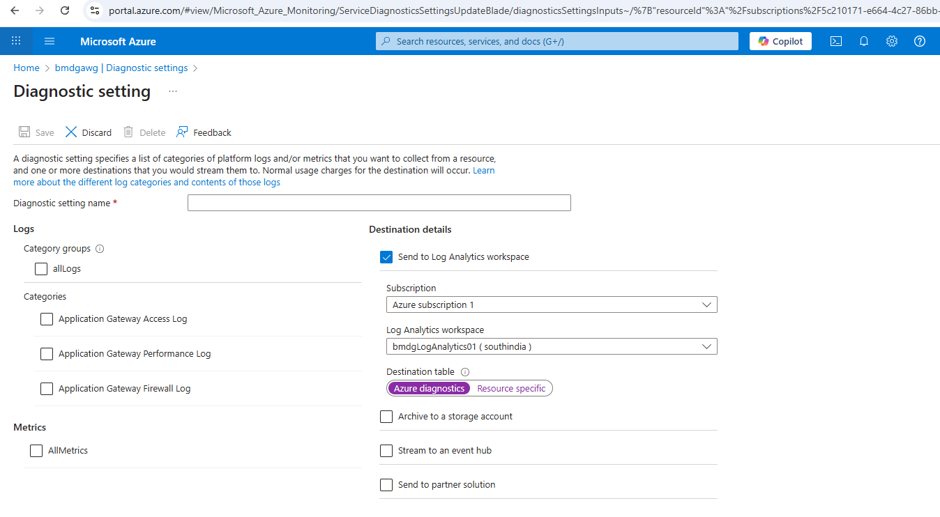

Run the following rule in Log Analytics to verify that logs are being sent to the workspace.

AzureDiagnostics
| where Category == "ApplicationGatewayFirewallLog"
| sort by TimeGenerated desc
| take 20

AzureDiagnostics
| where Category == "ApplicationGatewayAccessLog"
| sort by TimeGenerated desc
| take 20
If still logs are not flowing please run the below command .

az monitor diagnostic-settings create --name bmdgDiagnosticRule --resource "/subscriptions//<<subscriptionID>>//resourceGroups//<<resourceName>>//providers/Microsoft.Network/applicationGateways/<<gatewayname>>" --workspace "/subscriptions/<<subscriptionID>>///resourceGroups/<<resourceName>>/providers/Microsoft.OperationalInsights/workspaces/<<Log Analytics workspace Name>>" --logs "[{\"category\":\"ApplicationGatewayFirewallLog\",\"enabled\":true},{\"category\":\"ApplicationGatewayAccessLog\",\"enabled\":true}]" --metrics "[{\"category\":\"AllMetrics\",\"enabled\":true}]"

