Day 1 Css Report:

TOPICS COVERED:

. Android introduction

. Android Studio installation

. ANDROID INTRODUCTION:

.In Android Introduction have learned about android operating system for smartphones and tablet computers.

.Developed by Open Handest Alliance led by google built on linux foundation.

. Anroid is often symbolized by the green robot to the right.

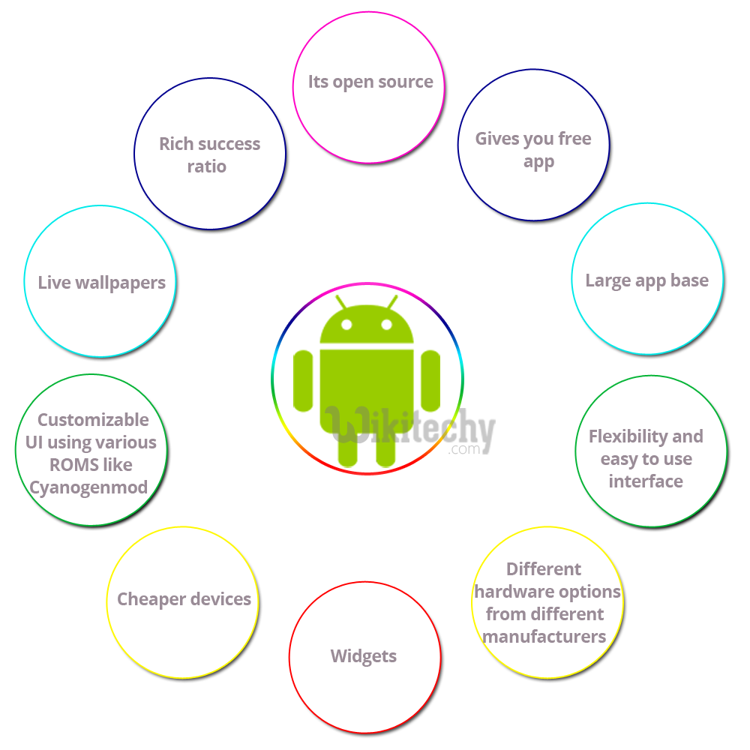

. Version of android /history of android.

. **Android** is a powerful Operating System supporting many applications in **Smart Phones.**

. These applications make life more comfortable and advanced for the users.

. Hardware’s that support Android are mainly based on **ARM architecture** platform.

. Some of the current features and specifications of android are:

. Android is architected in the form of a software stack comprising applications, an operating system, run-time environment, middleware, services and libraries.

. Each layer of the stack, and the corresponding elements within each layer, are tightly integrated and carefully tuned to provide the optimal application development and execution environment for mobile devices.

.Android is architected in the form of a software stack comprising applications, an operating system, run-time environment, middleware, services and libraries.

* Each layer of the stack, and the corresponding elements within each layer, are tightly integrated and carefully tuned to provide the optimal application development and execution environment for mobile devices.

. Android libiraries .

. Android Studio installation:

There are two ways to install android studio

By ADT Bundle

By Setup Eclipse Manually

URL for the download is <https://developer.android.com/studio/index.html>

Now double click on the exe file, it will be installed.