Assignement-13.2

val rdd1 = sc.parallelize(List((1, 2), (3, 4), (3, 6)))

pairrdd.collect

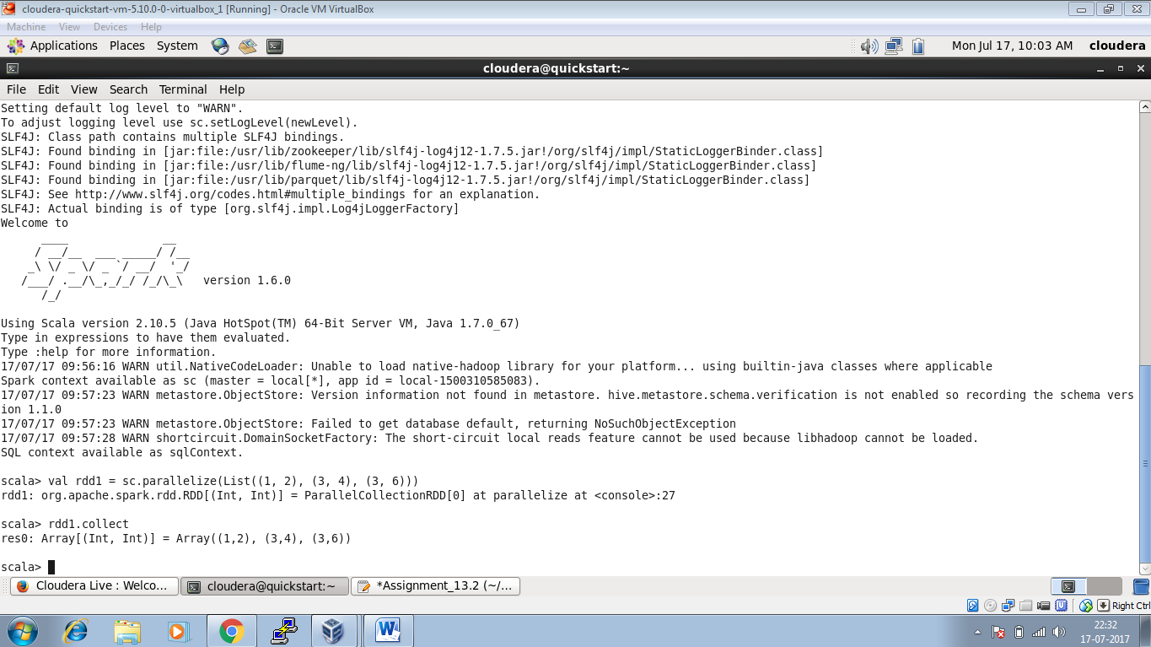

Task2:

val x=sc.parallelize (Seq ("a", "b", "c", "d", "e"))

val y=x.zipWithIndex

y.collect ()

or

val rdd1=sc.parallelize (Seq ("a", "b", "c", "d", "e")).zipWithIndex.collect

