Assignment 8.1

WordCount program using pig local mode

1. Loading the data set

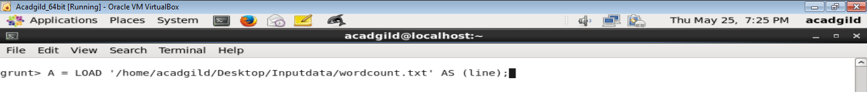

View the loaded data set using dump command

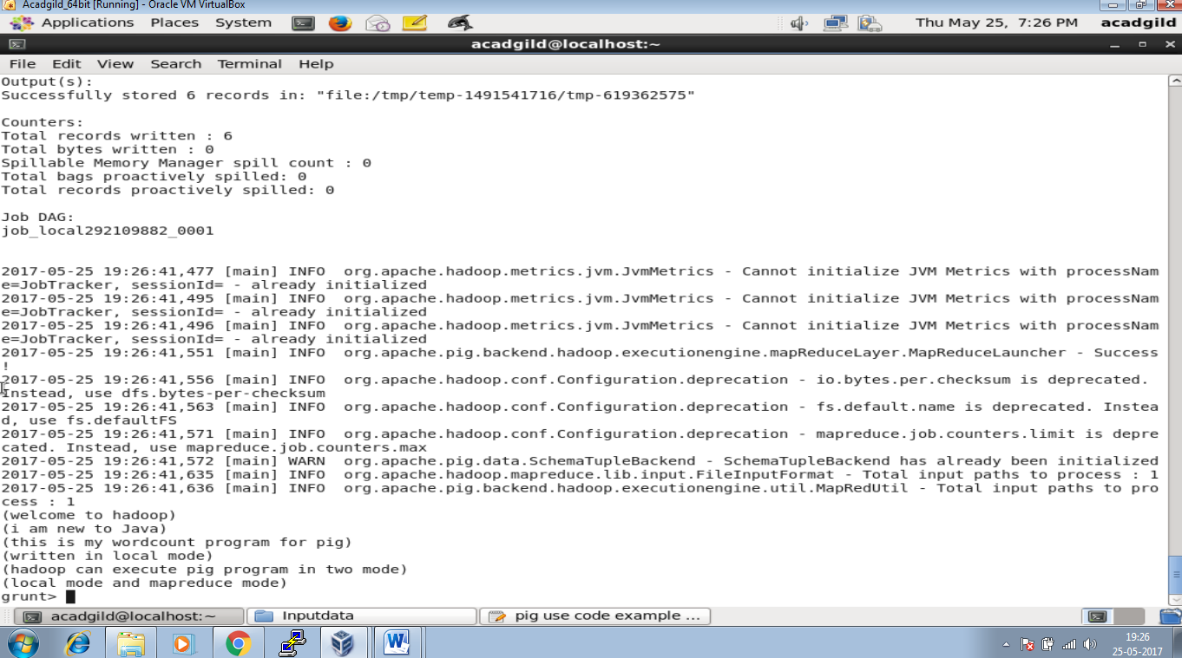

Splitting each word into line

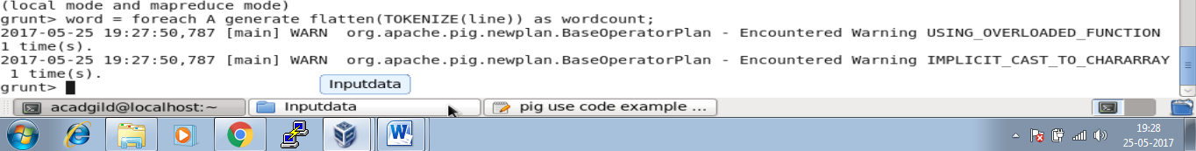

Dumping the Splitted line

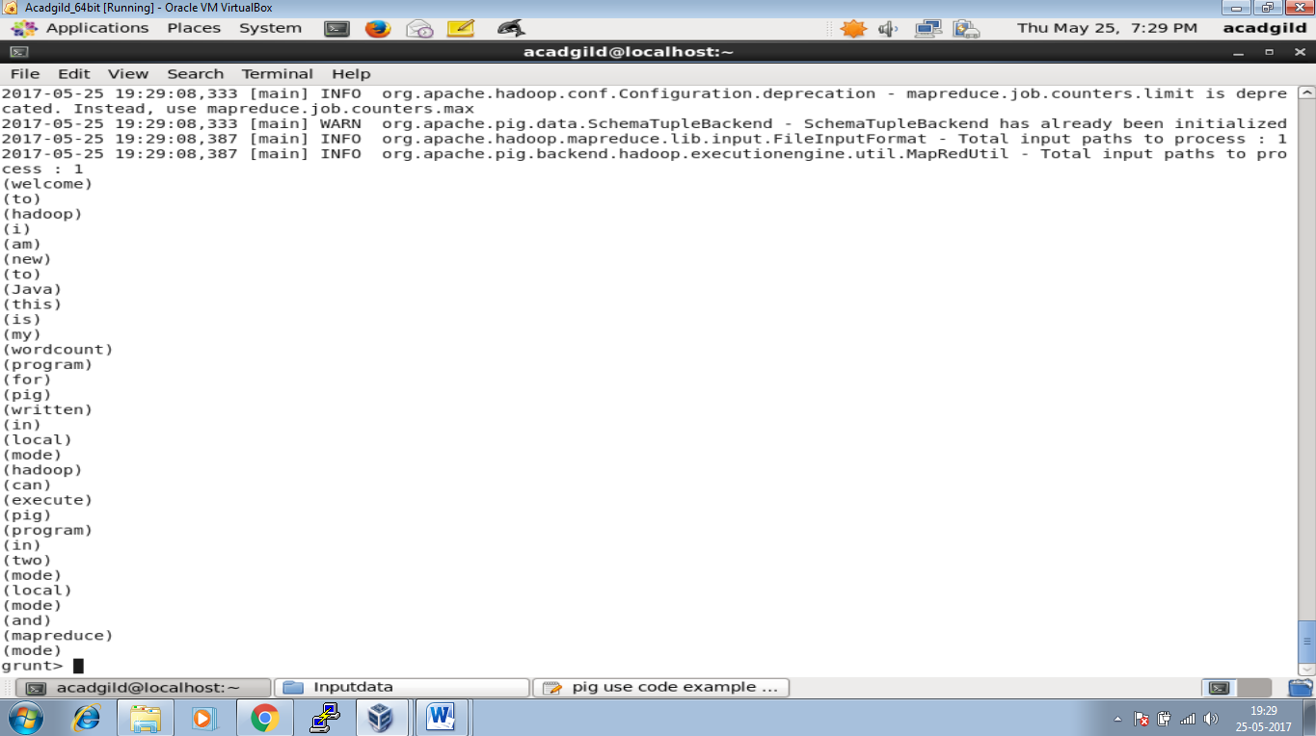

Grouping the word together

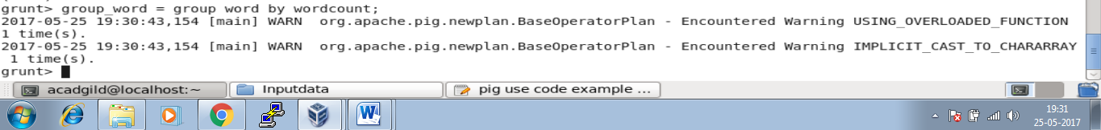

Dumping the grouped word



Output for dump group_word

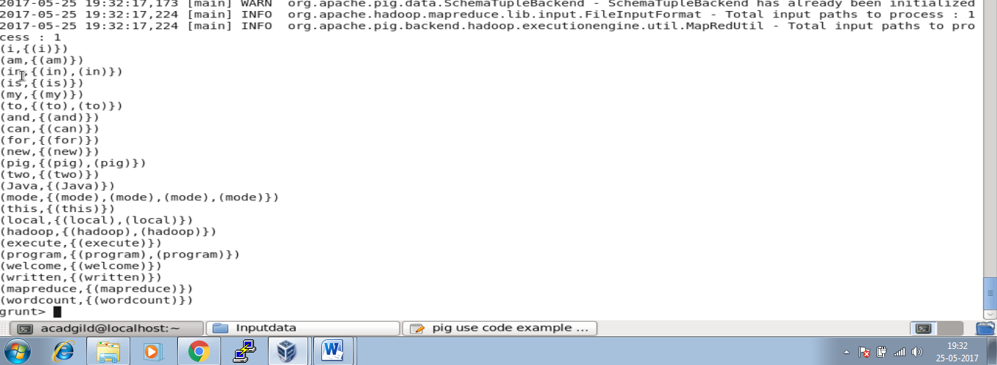

Command to Count the occurrence in the file.



Output of Occ

