**NOBLE COLLEGE OF ARTS AND SCIENCE FOR WOMEN**

**PALAVANATHAM**

**UNLOCKING INSIGHTS INTO THEGLOBAL AIR TRANSPORTATION NETWORK WITH TABLEAU**

**1.INTRODUCTION**

Air transport is the activity that allows the transfer of people, merchandise and mail in aircraft. Therefore, we are talking about the type of transport that travels by air and is present in airports. Air cargo transport is the most recent means of freight transport and has caused a great advance for the logistics sector. A type of transport that year after year sees its turnover grow.

**1.1 PURPOSE:**

Air transport allows people from different countries to cross international boundaries and travel other countries for personal, business, medical, and tourism purposes. Nowadays, it has become one of the most popular means of transporting goods for commercial purposes.

**2. PROBLEM DEFINITION & DESIGN THINKING**

2.1 Empathy Map

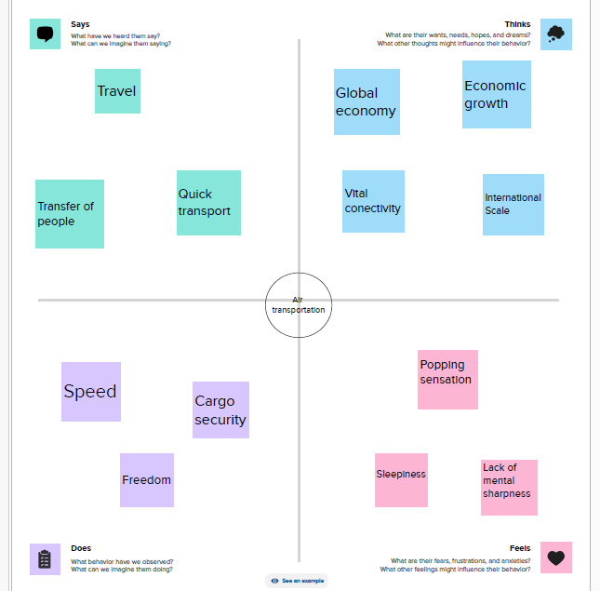

**2.2 Ideation & Brainstroming map**

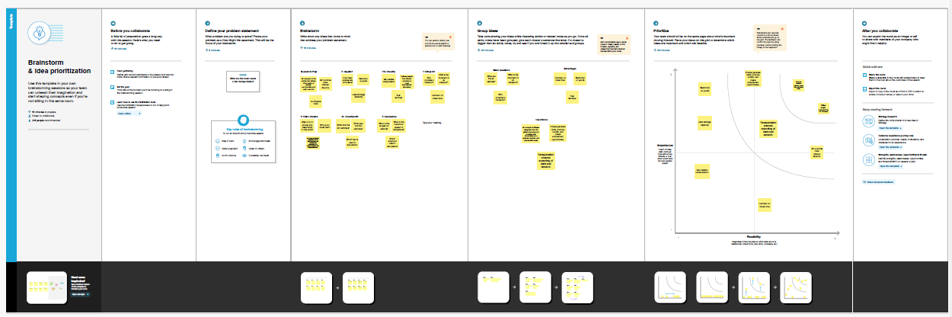

**DASHBOARD 1:**

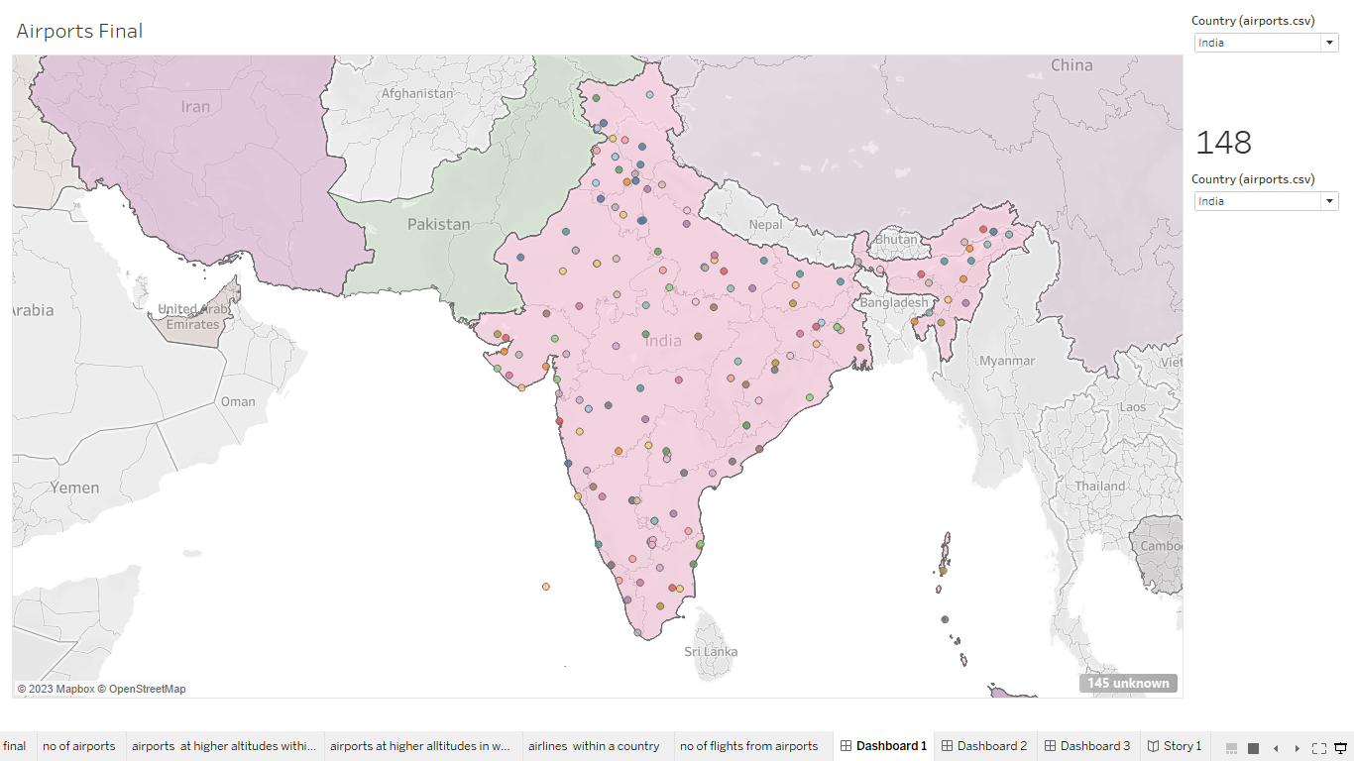

**DASHBOARD 2:**

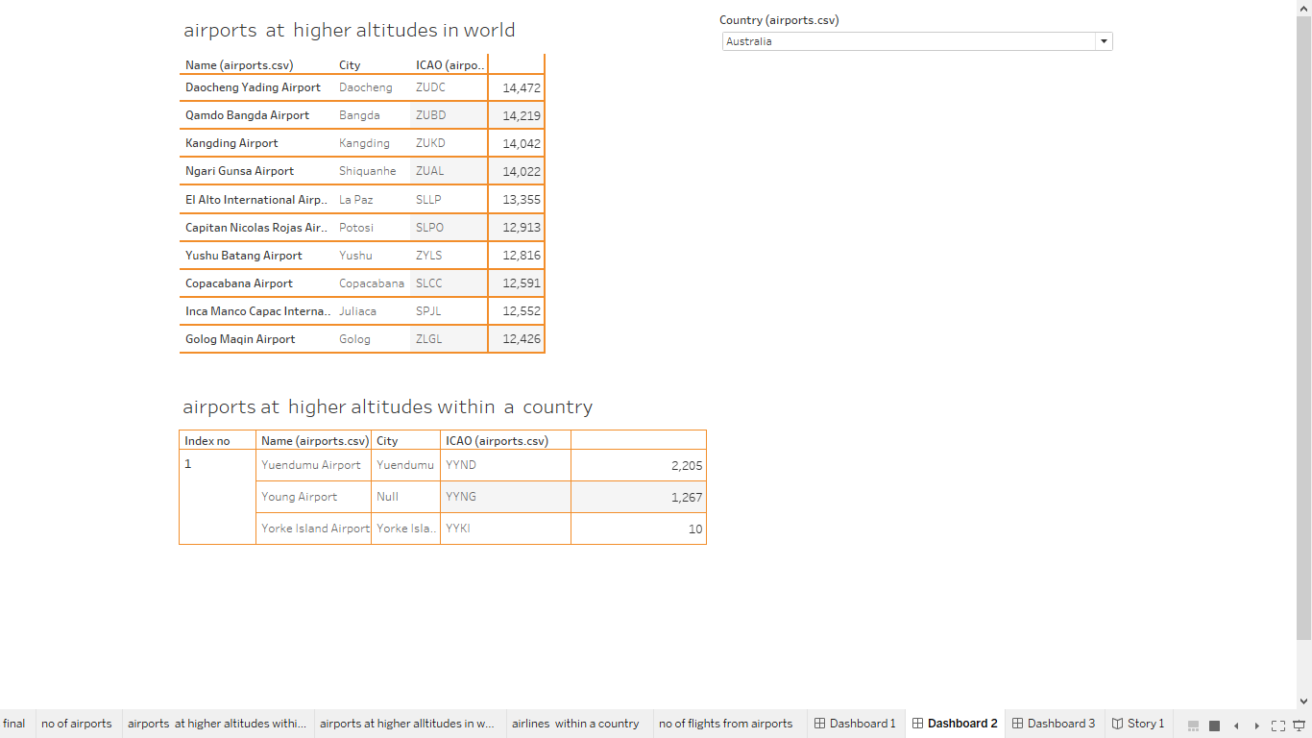

**DASHBOARD 3:**

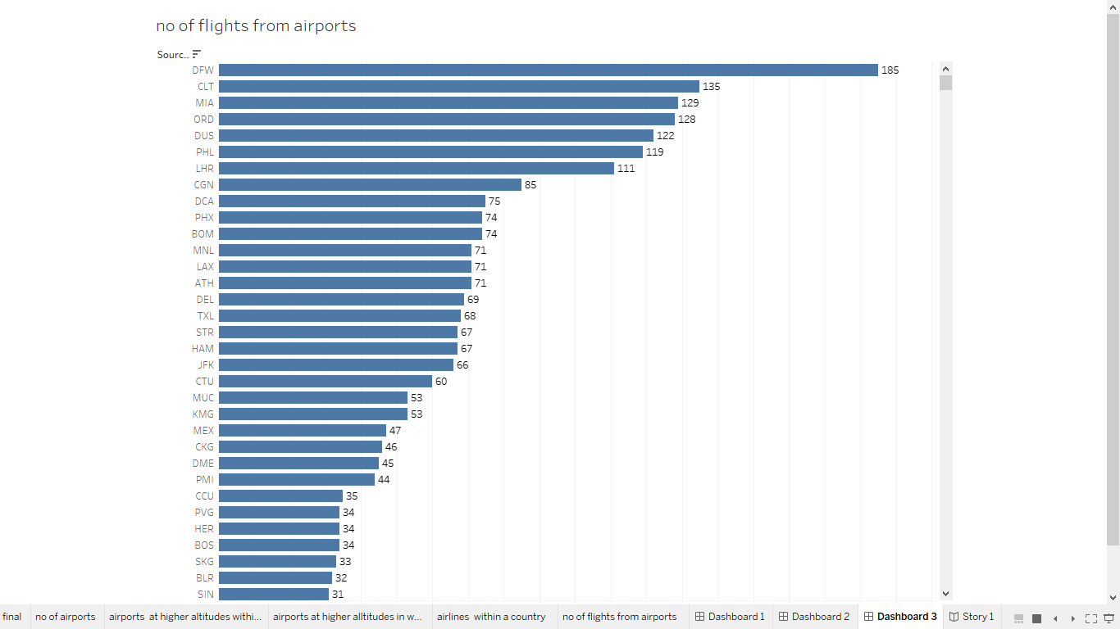

**RESULT:**

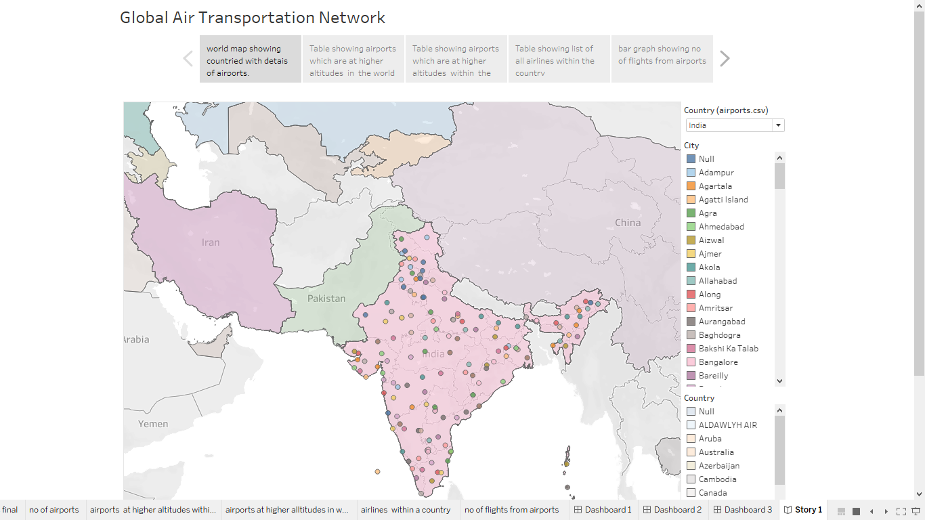

**4. ADVANTAGES & DISADVANTAGES**

**Advantages:**

**Air is the type of freight capable of traveling long distances in short periods of time. This makes this model an optimum choice if the client has an urgent need to ship a product or if their freight demands**[**special standards of protection**](https://www.curefirst.in/the-pharmaceutical-transportation/)**or acclimation. It is the quickest transport mode and is therefore ideal for long-distance transport of goods. It takes less time.**

**Air transportation offers convenient, reliable and fast services of transport. It is considered the cheapest way to ship peregrinated goods. It offers a standard, convenient, reliable and fast service.**

**In regions that are not readily accessible to other modes of transport, air transport is considered to be the only means of transport. Open to all regions, irrespective of land interference. A vast network of airlines covering nearly the whole globe is available for many airlines. This ensures that the package can be sent almost anywhere.**

**Disadvantages:**

**Air travel is considered to be the most expensive means of transportation. The cost of maintaining aircraft is higher and the costs for the building of aerodromes and anions are much higher. That’s why air travel is so expensive that it gets beyond ordinary people’s grasp.**

**There is a whole variety of materials not suitable for such products, from explosives, gases, batteries, fired solids and liquids, which cannot be shipped by air to name but a few.**

**The aircraft have no room and therefore are not ideal for carriage of voluminous and cheaper materials. As is seen for rails, the load volume cannot be raised.**

**5. APPLICATIONS**

**GIT HUB AND TABLEAU** are used to apply the solution.

**6. CONCLUSION**

**Air transportation offers convenient, reliable and fast services of transport. It is considered the cheapest way to ship peregrinated goods. It offers a standard, convenient, reliable and fast service.**

**7. FUTURE SCOPE**

**Air is the type of freight capable of traveling long distances in short periods of time. This makes this model an optimum choice if the client has an urgent need to ship a product or if their freight demands**[**special standards of protection**](https://www.curefirst.in/the-pharmaceutical-transportation/)**or acclimation. It is the quickest transport mode and is therefore ideal for long-distance transport of goods.**