Let's learn about list comprehensions! You are given three integers ***X***,***Y*** and ***Z*** representing the dimensions of a cuboid along with an integer ***N***. You have to print a list of all possible coordinates given by ***(i,j,k)*** on a 3D grid where the sum of ***i+j+k*** is not equal to N. Here, ***0<=i<=X; 0<=j<=Y; 0<=k<=Z***

**Input Format :**

Four integers **X,Y,Z** and ***N*** each on four separate lines, respectively.

**Constraints :**

Print the list in lexicographic increasing order.

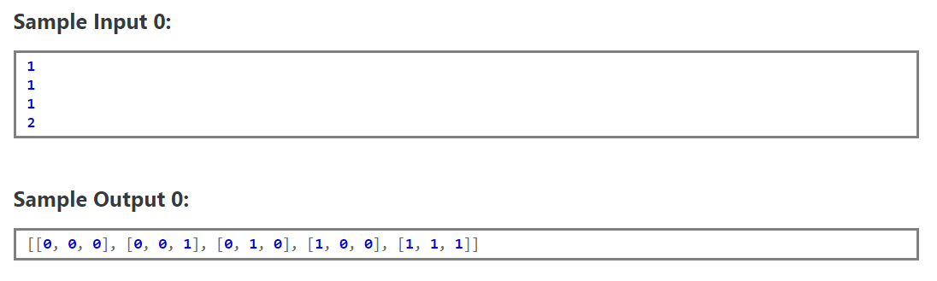

**Explanation 0 :**

***Concept***  
You have already used lists in previous hacks. List comprehensions are an elegant way to build a list without having to use different for loops to append values one by one. This example might help.  
**Example :** You are given two integers x and y . You need to find out the ordered pairs ( i , j ) , such that ( i + j ) is not equal to n and print them in lexicographic order.( 0 <= i <= x ) and ( 0 <= j <= y) This is the code if ***we dont use list comprehensions in Python.***

python x = int ( raw_input()) y = int ( raw_input()) n = int ( raw_input()) ar = [] p = 0 for i in range ( x + 1 ) : for j in range( y + 1): if i+j != n: ar.append([]) ar[p] = [ i , j ] p+=1 print arr  
Other smaller codes may also exist, but using list comprehensions is always a good option. ***Code using list comprehensions:***  
  
python x = int ( raw_input()) y = int ( raw_input()) n = int ( raw_input()) print [ [ i, j] for i in range( x + 1) for j in range( y + 1) if ( ( i + j ) != n )]