



AI-Powered & FAQ Chatbot
Student Name: BALAMURUGAN MS
Student Name: SIVAKUMAR K Student Name: DHASARATHASAKKA RA VARTHI P
Student Name: SUNDARESWARAN P
Student Name: MANOJKUMAR A
& Roll No: 20234108
& Roll No: 20234143 & Roll No: 20234110
& Roll No: 20233350
& Roll No: 20232131
Student Name:MUTHAMIZHEZHIYAN M & Roll No: 20241263

Team Name : Prime Vision
Name: M.S.BALAMURUGAN

Challenge
- Students repeatedly ask the same academic and campus-related questions.
- Manual communication from staff causes delays.
- Students have diﬃculty ﬁnding correct and updated information quickly.
- No centralized automated answering system for common student questions.
- Increased workload for oﬃce staff and faculty due to repetitive queries.

Signiﬁcance
- he chatbot provides instant responses 24×7, helping students save time.
- Reduces manual dependency on staff, improving eﬃciency.
- Supports smoother communication during exams, events & announcements.
- Beneﬁcial for colleges with large student counts.
- Helps digital transformation of educational institutions.

Target User
- College students (UG / PG)
- College administration staff
- Department coordinators
- First-year students who need frequent guidance

Use case
- A student logs into the website and asks questions like:
- “What is the fees due date?”
- “Where is the exam timetable?”
- “When is the symposium?”
- Chatbot answers instantly based on college data from database.
- Admin can log in and add new FAQs like timetables, circulars, results etc.

Existing Solutions

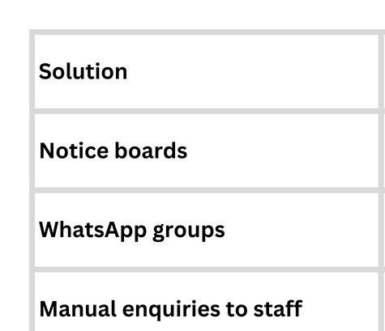

Solution Concept
  - A web-based chatbot system starting as a GK Chatbot using API.
  - A button switches to College Chatbot Mode.
  - User Login → Use College FAQ chatbot.
  - Admin Login → Add / Edit / Delete college information.
  - Simple text-only interface (No voice, No multi-language).

Thank You

