STABLE-ROUTENET
v4 — Architecture, Failure Analysis & Chronological Research Design
Research Architecture, Failure Analysis, and Experimental Design
Comprehensive design document derived from the v3.1 notebook, the completed 5-epoch experiment, the DFDCP screening result, and a targeted review of recent sparse-MoE and deepfake domain-generalization research. Content is organized chronologically, walking the architecture from its first concept through the v3.1 implementation to the v4 proposal.
STATUS
Stable-RouteNet v4 is a proposed architecture. None of the v4 changes in this document should be presented as experimentally validated until the controlled v4 ablations (Section: v4 Ablation Plan) are run.
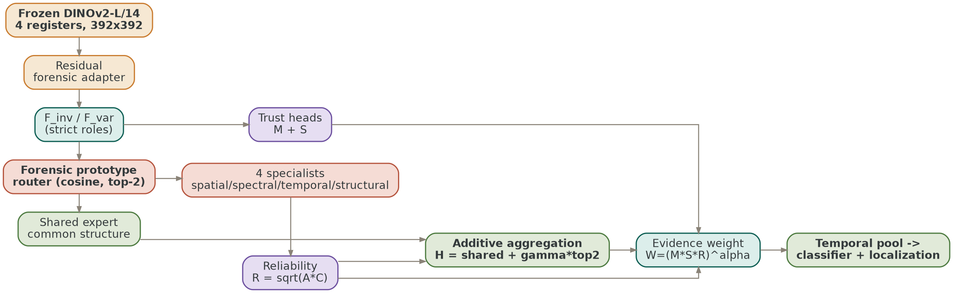
Preview — the v4 proposed architecture (detailed in Stage 6)

Contents
Executive Summary
How This Document Is Organized
Stage 1 — Initial Stable-RouteNet Concept CONCEPTUAL
Stage 2 — v2 Research-Corrected Design IMPLEMENTATION BRANCH
Stage 3 — v2.3 Six-Configuration Reliability Discovery EXPERIMENTALLY SCREENED
Stage 4 — v3.1 Canonical Implemented Architecture EXPERIMENTALLY RUN
Stage 5 — v3.1 Post-Hoc Diagnosis FINDING
Stage 6 — Stable-RouteNet v4 Proposed Architecture PROPOSED
References and Research Anchors
Appendix A — v3.1 Source Data and Output Contract
Appendix B — v3.1 Computational Findings
Appendix C — Source Traceability for This Chronology

Executive Summary
Stable-RouteNet was designed around a simple research principle: evidence that remains stable under nuisance interventions is more likely to transfer across manipulation methods and datasets than evidence tied to a particular training distribution. v3.1 operationalized this through frozen DINOv2 features, a residual forensic adapter, invariant/variant feature decomposition, manipulation evidence M, stability S, expert agreement A, intervention consistency C, reliability R = sqrt(A·C), and geometric evidence weighting W = (M·S·R)^α.
The completed v3.1 run demonstrates that the implementation can execute the complete pipeline, learn a strong source-domain classifier, and produce a valid DFDCP evaluation. However, the experiment also exposes a major research/engineering mismatch: the 5-epoch run ends at step 250, while several sparse-MoE and evidence-weighting mechanisms are scheduled to activate only at steps 450, 600, and 750. The final DFDCP evaluation uses step = 10⁹, enabling sparse routing and evidence-weighting behavior that the training run never optimized.
The consequence is a large source-to-target gap: validation AUROC reaches 0.9720, while DFDCP AUROC is only 0.5904. At the same time, routing entropy collapses from 1.294 to 0.193 by epoch 5, with Expert 2 receiving only 3.4% of dispatches. The correct response is not to abandon MoE — it is to redesign the training/evaluation contract and incorporate lessons from Switch Transformers, ST-MoE, GMoE, Expert Choice routing, shared-expert designs, and recent deepfake domain-generalization work.
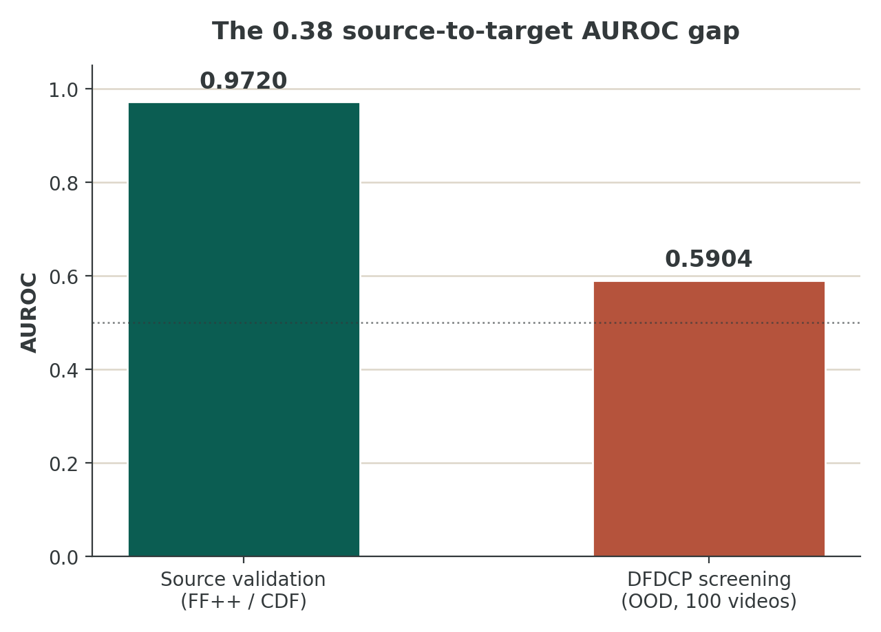
Figure — the source-to-target AUROC gap that motivates the v4 redesign

How This Document Is Organized
The material is presented as a chronological research record — six stages, from the original concept through to the v4 proposal — rather than as a flat feature list. Each stage below is expanded into its own section with its own diagram, tables, and findings.
Stage | Design / Phase | Status | Core Change
1 | Initial Stable-RouteNet concept | Conceptual | Stable forensic evidence + intervention-stability + evidence-conditioned sparse MoE
2 | v2 research-corrected design | Implementation branch | Fix evidence bypass, mask loophole, stability saturation, free-R issue, expert/router problems, stronger preflight
3 | v2.3 six-configuration reliability discovery | Experimentally screened | A–F controlled variants: product, geometric, calibrated-R, orthogonality, router decisiveness, full combination
4 | v3.1 canonical implemented architecture | Experimentally run | DINOv2-with-registers + F_inv/F_var + M/S + global-context token router + top-2 + deterministic R + geometric W
5 | v3.1 post-hoc diagnosis | Finding | Training/evaluation graph mismatch; MoE losses/gates activate too late for a 250-step run; OOD weakness
6 | v4 redesigned architecture | Proposed | Shared expert + specialist experts + prototype routing + Switch balance + z-loss + selective invariance + exact train/test graph match
Status convention: “Conceptual” = a research proposal in project notes. “Experimentally screened / run” = a concrete notebook branch was executed or evaluated. “Proposed” = not yet experimentally validated.

STAGE  1 | Initial Stable-RouteNet Concept  The original research idea, before any controlled screening

The earliest architecture centered on a frozen DINOv2 foundation, a forensic adapter, an invariant/variable split, token-level evidence variables, a hierarchical router, sparse experts, and final evidence aggregation. This established the project's central idea: stable evidence should be more transferable than unstable shortcut evidence.
Figure 1.1 — Initial concept: stable forensic evidence routing
RESEARCH IDEA
Stable forensic evidence should survive nuisance changes and receive consistent expert support. Status at this stage: conceptual design, not yet a controlled architecture.

STAGE  2 | v2 Research-Corrected Design  Tightening the original concept with explicit fixes

The v2 design tightened the original concept by introducing relative stability targets, removing the free learned reliability head, shrinking expert capacity, making routing controls explicit, and strengthening the preflight/evaluation contract. The v2 notebooks describe these as corrections to evidence bypass, mask collapse, absolute-stability saturation, reliability calibration, expert collapse, router design, capacity, and loss scaling.
Figure 2.1 — v2 research-corrected architecture
MAJOR CONCEPTUAL CORRECTIONS
Relative stability instead of absolute; no free reliability head; lighter expert capacity; explicit routing controls; stronger preflight and evaluation isolation.

STAGE  3 | v2.3 Six-Configuration Reliability Discovery  The first controlled comparison of evidence-weighting and expert-structure choices

The common v2.3 base was held fixed while six targeted formulations were screened: A product trust; B geometric trust; C calibrated R + geometric; D strong all-expert orthogonality; E orthogonality + router decisiveness; F calibrated R + geometric + orthogonality + decisiveness. This was the first systematic comparison designed to isolate the contribution of the evidence-weighting and expert-structure choices.
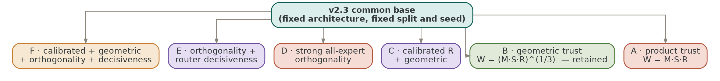
Figure 3.1 — v2.3 six-configuration controlled reliability discovery

Screening Decision Trail
Variant | Architecture Change | DFDCP AUROC | Decision / Lesson
A_product | W = M·S·R | 0.6364 | Control; hard suppression was too aggressive
B_geometric | W = (M·S·R)^(1/3) | 0.7028 | Best documented external screening result; retained
C_reliable | Calibrated R + geometric W | — | Screened; reliability calibration did not establish better correctness prediction
D_orth | Strong all-expert correction orthogonality | 0.6472 | External generalization harmed; strong orthogonality removed/redesigned
E_orth_route | Orthogonality + router decisiveness | — | Screened as a combined stress test
F_full | Calibrated R + geometric + orthogonality + decisiveness | — | Screened as full combination; not adopted as-is
Evidence note: the project records document the six-configuration screening harness and the specific reported A/B/D outcomes above; blank result cells are intentionally not filled with inferred values. The screening used the same deterministic source split and seed family.

STAGE  4 | v3.1 Canonical Implemented Architecture  What was actually built, trained for 5 epochs, and screened on DFDCP

The canonical v3.1 implementation used DINOv2-L/14 with four registers, a 384-dimensional residual adapter, F_inv/F_var, M and S heads, global-context-conditioned token routing, four experts with top-2 dispatch, deterministic A/C-derived reliability, and geometric evidence weighting. The implementation was executed in the 5-epoch confirmation run.
Figure 4.1 — v3.1 implemented architecture

Snapshot: Current v3.1 State
Item | Current v3.1 State
Canonical model | Stable-RouteNet v3.1
Backbone | facebook/dinov2-with-registers-large; frozen
Input | 392 × 392; patch size 14; 28 × 28 patch grid
Temporal clip | 8 frames per sample
Experts | 4; top-2 token routing
Trainable parameters | 4.685M; total ≌309.1M including frozen DINO
Training | 5 epochs; 250 global optimization steps
Data | 300 train videos: 150 FF++ + 150 CDF; 50 validation videos: 25 + 25
OOD screening | 100 DFDCP videos: 50 real + 50 method_A fake
Seed | 0
Final checkpoint | epoch 5 / global step 250
The notebook successfully downloaded and loaded the exact DINOv2-with-registers-large checkpoint and verified the expected 1024 hidden dimension, 4 register tokens, and 14-pixel patch size. The preflight suite covered DINO geometry, paired data shape, finite outputs, top-2 router validity, sparse/dense equivalence, objective finiteness, gradient finiteness, frozen-backbone isolation, checkpoint round-trip, and tiny DFDCP inference.

4.1 Backbone and Feature Formation
The frozen DINOv2-L/14-with-registers backbone emits 789 tokens at 392 × 392 input resolution: 1 CLS token, 4 learned register tokens, and 784 spatial patch tokens. Stable-RouteNet discards the prefix tokens for spatial forensic processing and operates on the 28 × 28 patch grid.
A residual ForensicAdapter projects the 1024-dimensional DINO features to a 384-dimensional working space. The adapter uses layer normalization, a linear projection, two Transformer encoder layers, and an output normalization. Two projections then construct F_inv and F_var, intended to separate transferable/invariant forensic evidence from nuisance-sensitive variation.

4.2 Evidence Heads
M is produced by a small MLP over F_inv and represents manipulation evidence. S is another learned scalar in the range 0.10–1.00, trained from an intervention-derived stability target. These evidence quantities are intended to gate the contribution of features to the final classifier.

4.3 v3.1 Routing
A global router first consumes mean-pooled F_inv and generates a 384-dimensional context vector. That context is repeated over every token and concatenated with the token representation, M, and S. A second token router produces four expert logits. Top-2 experts are selected per token and their outputs are renormalized before sparse aggregation.
KEY DESIGN DECISION
The v3.1 “global + token” design is better described as global-context-conditioned token routing than a true hierarchical MoE. The global router does not select an expert or a subset of experts — it supplies context to the token router.

4.4 Reliability and Evidence Weighting
For each token, two selected experts produce correction vectors Δ₁ and Δ₂. Expert agreement is A = (1 + cos(Δ₁, Δ₂)) / 2. Intervention consistency is computed as an exponential penalty on the normalized displacement between original and intervened invariant features. Reliability is R = sqrt(A·C). Final evidence weighting is W = (M·S·R)^α with α constrained to [0.2, 0.8] and initialized at 1/3.

4.5 Experimental Results
Epoch | Train Loss | Val AUROC | AP | ACC | F1 | Entropy
1 | 1.2723 | 0.6696 | 0.6758 | 0.620 | 0.578 | 1.2939
2 | 1.1741 | 0.7380 | 0.7438 | 0.540 | 0.179 | 1.2977
3 | 1.0949 | 0.8064 | 0.7856 | 0.600 | 0.375 | 1.2522
4 | 0.9086 | 0.9628 | 0.9731 | 0.880 | 0.864 | 0.6748
5 | 0.6314 | 0.9720 | 0.9750 | 0.890 | 0.895 | 0.1934
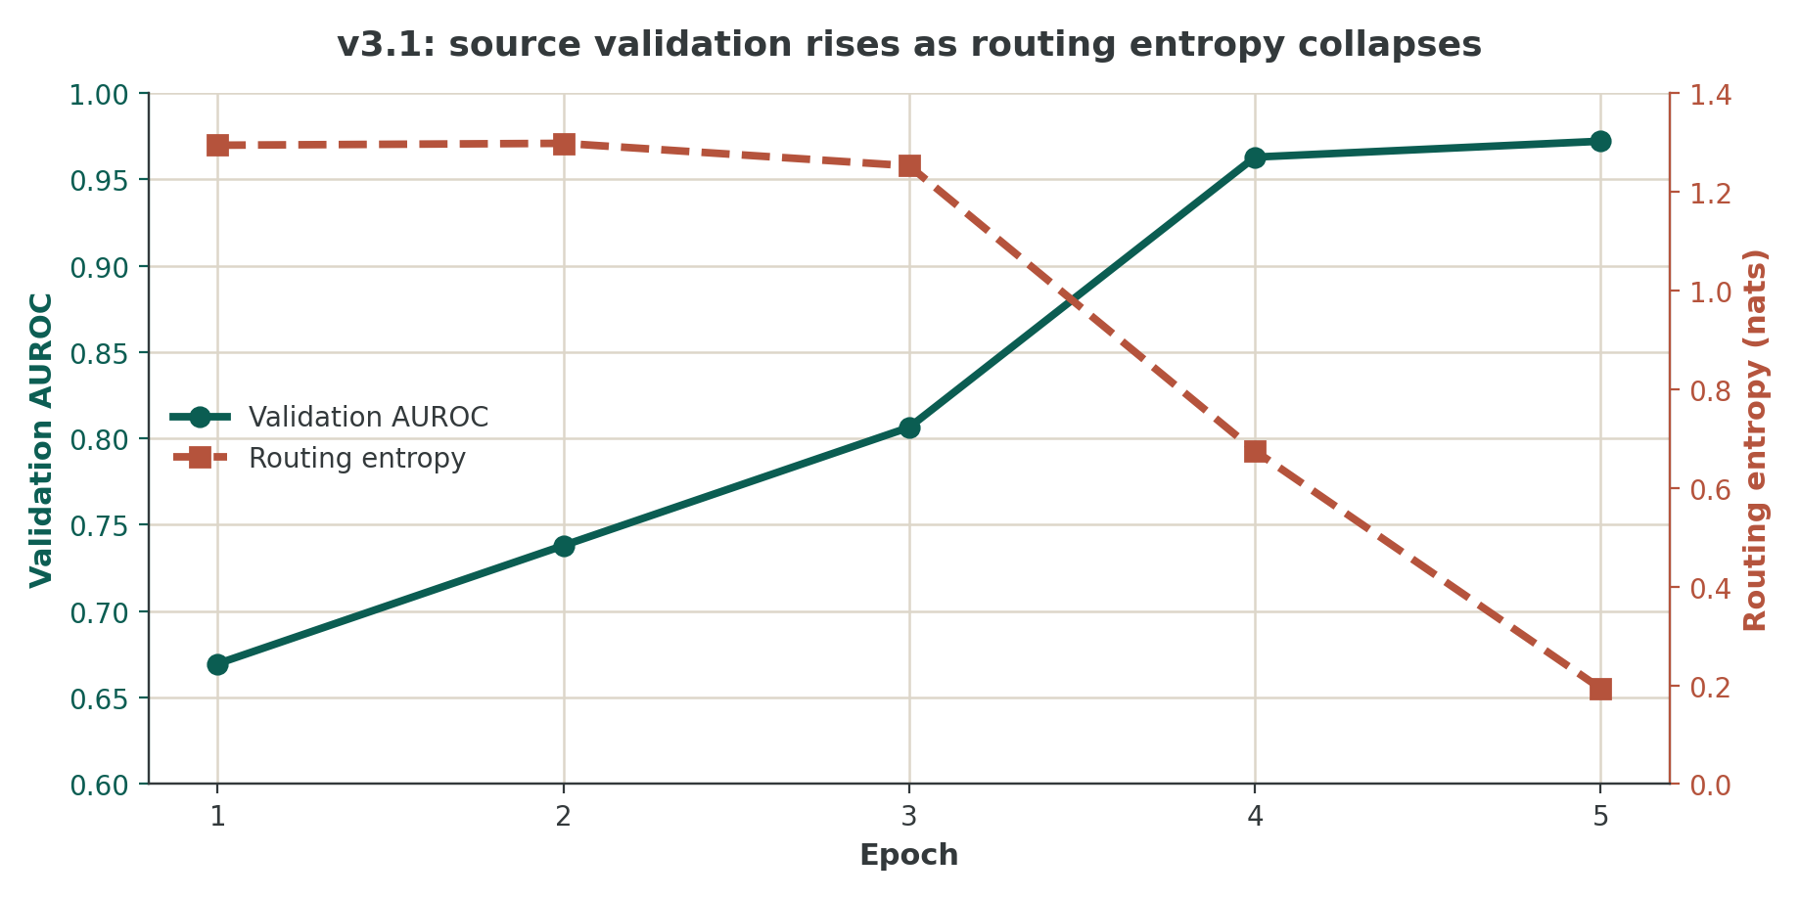
Figure 4.2 — Validation AUROC rises as routing entropy collapses
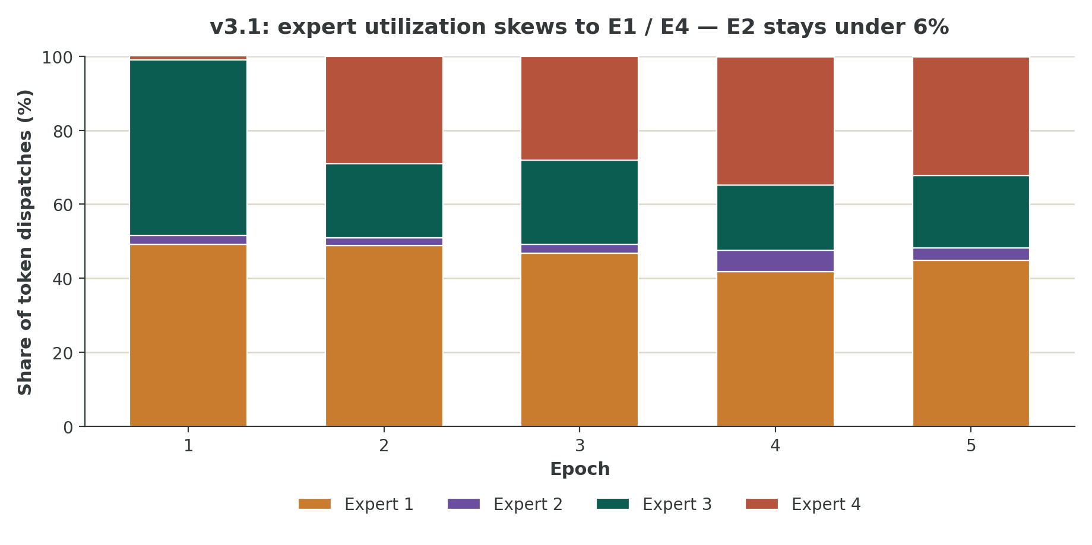
Figure 4.3 — Expert utilization skews toward E1/E4; E2 stays underused

4.6 DFDCP Result
Metric | Value
AUROC | 0.5904
AP | 0.5432
Accuracy | 0.5400
Precision | 0.5294
Recall | 0.7200
F1 | 0.6102
Balanced accuracy | 0.5400
ECE | 0.2880
Brier | 0.3194
AURC | 0.4343
Reliability AUC | 0.6655
Mean M | 0.2662
Mean S | 0.4752
Mean R | 0.5305
Mean W | 0.2907
Mean A | 0.5871
Mean C | 0.5123
Figure 4.4 — v3.1 source validation AUROC vs. DFDCP AUROC
KEY DESIGN DECISION
The source-domain result is strong, but the DFDCP screening result is weak. The 0.3816 AUROC gap is too large to attribute to random noise in a research narrative. It is a diagnostic signal that the current learned computation is domain-specific and/or the training/test computation graphs differ.

STAGE  5 | v3.1 Post-Hoc Diagnosis  Why 0.9720 source AUROC becomes 0.5904 on DFDCP

This diagram records the critical diagnosis discovered after inspecting the exact notebook. The 5-epoch run stopped at 250 optimization steps, while router/evidence gates and several MoE auxiliary losses were scheduled much later. The DFDCP test path used step = 10⁹, fully enabling the sparse and evidence-gated graph. The tested model was therefore not trained on the same computation graph that it used during final OOD evaluation.
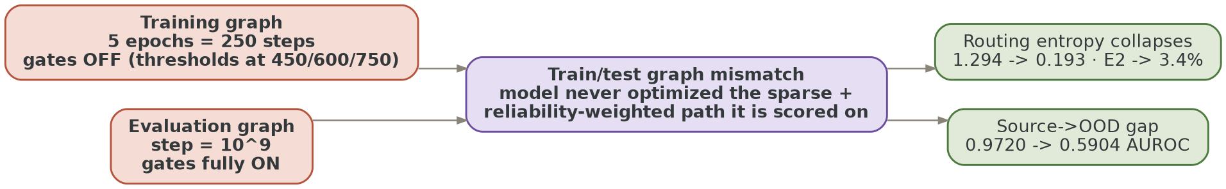
Figure 5.1 — v3.1 post-experiment training/evaluation graph mismatch
The current evidence points to a combination of objective timing, route mismatch, and architecture-induced shortcut risk rather than one isolated software defect. In particular, the absolute step schedule means the experiment never properly trains the sparse/reliability branch that is later used for OOD evaluation. The routing collapse then emerges precisely when that branch is effectively being exercised — an additional warning that the router needs explicit balancing and stability control.

5.1 Root-Cause Analysis: 21 Problems and Lessons Carried into v4
# | Issue | Severity | v4 Response
1 | Training/test graph mismatch | Critical | Train through the actual sparse + reliability-weighted graph before OOD evaluation.
2 | MoE auxiliary losses activate after the 5-epoch run | Critical | Replace hard absolute step thresholds with fractions of total training steps.
3 | Flip-based intervention breaks spatial token correspondence | Critical | Use correspondence-preserving interventions, or explicitly remap token coordinates.
4 | Global router can encode domain/style information | High | Remove raw M/S/global-context from primary routing input; route from representation geometry.
5 | Randomly initialized experts on a small DG problem | High | Initialize from a common shared transformation, then learn controlled specialization.
6 | No shared/common expert | High | Add a shared expert so common forensic structure remains available even when sparse routing is imperfect.
7 | Load-balancing loss ignores hard assignment fraction | High | Adopt a Switch-style objective using both actual dispatch f_i and mean probability P_i.
8 | No router z-loss | High | Regularize router log-partition/logit magnitude, following ST-MoE.
9 | A and diversity loss conflict | High | Measure diversity across experts globally/locally, not by forcing selected correction pairs to be dissimilar while A rewards similarity.
10 | “Hierarchical” router is not truly hierarchical | Medium | Use explicit global expert-group or prototype selection if hierarchy is claimed.
11 | Top-2 itself is not the primary problem | Medium | Retain token-choice top-2 in baseline v4; compare Expert Choice later.
12 | M/S feed the router and gate the classifier | High | Separate route identity from evidence trust to reduce cascading error.
13 | Evidence gating turns on after training | Critical | Train with evidence gating once the reliability module is ready.
14 | Alpha remains at initialization | High | Check gradient/registration and train alpha over an active evidence-gating interval.
15 | Specialization is unconstrained by forensic semantics | High | Assign interpretable specialization axes: spatial, spectral, temporal, structural.
16 | No explicit spectral debiasing | High | Add frequency-diversifying training views/constraints inspired by FreqDebias.
17 | Global invariance can over-constrain transferable factors | Medium | Learn subset/route-conditioned invariance rather than forcing all experts to agree on everything.
18 | OOD C is sensitive to nuisance transformation choice | High | Use transformations where token evidence correspondence is preserved.
19 | Route consistency may be over-strong | Medium | Penalize unstable routing selectively on confident/high-evidence tokens.
20 | DataParallel is a performance bottleneck | Medium | Use DDP for scale experiments once the research graph is frozen; keep DP only for quick confirmation.
21 | Long-run claims from 100-video DFDCP screening are premature | High | Treat DFDCP-100 as screening; validate on broader cross-domain protocols before paper-level claims.

5.2 Literature Review — Design Lessons for v4
The literature review below is not a claim that each cited method should be copied. Instead, each work supplies a design lesson that maps to a specific failure observed in v3.1.

Switch Transformers — load-aware sparse routing
Switch Transformers established a simple and effective load-balancing auxiliary objective based on the actual fraction of tokens dispatched to each expert and the average router probability for each expert. v4 implication: compute f_k from top-2 dispatch counts and P_k from mean router probabilities, then use a small Switch-style auxiliary coefficient. This directly targets the routing collapse observed in v3.1.

ST-MoE — router stability and transferability
ST-MoE studies sparse MoE stability during transfer and fine-tuning. The router z-loss constrains excessive router logits while preserving sparse routing capacity. v4 should add router z-loss and avoid relying on temperature annealing alone.

GMoE — sparse MoE for domain generalization
GMoE links sparse mixture-of-experts architecture directly to domain generalization theory, motivating the use of sparse routing as a mechanism for generalizable representation rather than only a scaling trick.

Expert Choice Routing
Expert Choice Routing changes the allocation problem by letting experts select tokens, yielding fixed expert capacity and avoiding certain token-choice imbalance patterns. It is a valuable secondary ablation for v4, but should not be the first intervention because the current experiment has more basic graph and objective mismatches.

Shared experts — DeepSeekMoE and vision-MoE work
Recent MoE designs increasingly separate common knowledge from routed specialization. DeepSeekMoE explicitly uses shared experts together with finer-grained routed experts. This maps naturally onto deepfake evidence: some forensic structure is common across manipulations, while other cues are method- or artifact-specific.

FreqDebias — recent deepfake generalization
FreqDebias identifies spectral bias as a source of poor unseen-forgery generalization and combines frequency-diversifying augmentation with local/global consistency, supporting explicit spectral diversity rather than hoping a generic visual MoE discovers frequency specialization from a small dataset.

TriMoE (2026)
TriMoE directly applies domain-specialized sparse routing to deepfake detection, using spatial, spectral, and temporal expert pools with input-adaptive top-k routing — directly relevant to explicit forensic expert axes rather than arbitrary expert identities.

Subset-shared invariance (2026)
Recent work argues that forcing globally shared invariance across all source domains can remove transferable factors that are only stable within subsets. v4 should avoid an objective that blindly forces every expert and every route to be invariant to every transformation — invariance should be conditional on evidence and route.

STAGE  6 | Stable-RouteNet v4 — Final Proposed Architecture  Route by representation, assess trust separately, train the exact evaluation graph

V4 PRINCIPLE
Route by forensic representation; assess trust separately; preserve common knowledge with a shared expert; train the exact graph that will be evaluated.
v4 separates routing from trust, introduces a shared common-knowledge expert plus meaningful forensic specialists, uses a representation-first prototype router, adopts load-aware balancing and router stabilization, keeps R = sqrt(A·C) as a trust measure, and makes the exact training graph match the evaluation graph. v4 remains a proposed design pending controlled validation.
Figure 6.1 — v4 proposed architecture

6.1 Backbone
Component | v4 Design | Reason
Backbone | Frozen DINOv2-L/14 with 4 registers | Strong general visual representation while preventing catastrophic overfitting of the backbone.
Resolution | 392 × 392 | Preserve the existing 28 × 28 token geometry.
Temporal input | 8 frames/clip | Maintain current validated computational contract.
Adapter | Residual 384-dim forensic adapter | Keep trainable capacity small and focused.

6.2 Invariant/Variant Decomposition
Continue to produce F_inv and F_var, but give them stricter responsibilities. F_inv should feed the evidence heads, forensic router, and classifier. F_var should be regularized against nuisance-sensitive leakage and should not directly control router identity.

6.3 Evidence Heads
Retain M and S, but interpret them as trust variables rather than routing variables. M asks “is there evidence of manipulation?” S asks “does this evidence persist under a defined nuisance intervention?” Their detached or weakly coupled use in routing prevents an incorrect M/S estimate from amplifying itself through the entire decision chain.

6.4 Forensic Prototype Router
Replace the unconstrained token-router MLP with a representation-first prototype router. Project each token to a normalized routing vector r_i. Learn one normalized prototype per specialist expert. Compute expert affinity by cosine similarity and apply temperature-controlled softmax with early router noise. The router therefore selects experts because the feature resembles a learned forensic attribute, rather than because a generic MLP discovers a latent domain shortcut.

6.5 Shared Expert + Specialists
Introduce one shared expert E_shared that is always evaluated, carrying common forensic structure. Each token then routes to top-2 specialist experts. The output becomes H_i = E_shared(F_inv_i) + γ · Σ_{k in Top2} p_ik E_k(F_inv_i), where γ is learned or bounded. This makes specialization additive instead of all-or-nothing.
Expert | Primary Specialization | Potential Evidence | Suggested Training Views
E1 | Spatial / local | blending seams, texture inconsistency, local artifacts | crop / blur / local perturbation
E2 | Spectral | resampling, compression, frequency artifacts | frequency mixup, JPEG/resize, band perturbation
E3 | Temporal | frame-to-frame inconsistency | temporal shuffle / mild frame dropout / sequence perturbation
E4 | Structural / semantic | identity/geometry/face-shape consistency | geometric nuisance, mild illumination/pose-like shifts
Shared | Common forensic structure | stable evidence shared across manipulations | all safe nuisance interventions

6.6 Reliability
Keep R = sqrt(A·C), but redefine the components carefully. A should measure agreement between the selected specialist corrections without simultaneously imposing anti-agreement diversity on the same pair. C should be computed only with correspondence-preserving transformations, unless a transformation-specific token mapping is explicitly applied.

6.7 Evidence Weighting
Retain the geometric weighting W = (M·S·R)^α because earlier screening indicated geometric compression of multiplicative evidence was less suppressive than hard product weighting. Activate the weight in training and inference after the reliability branch is numerically stable, rather than only in evaluation.

6.8 Alpha
Keep alpha bounded in [0.2, 0.8] and initialized at 1/3, but explicitly monitor alpha gradient norm and parameter update. If alpha remains exactly unchanged across epochs, report that as a diagnostic, not as evidence that the optimum is 1/3.

6.9 v4 Loss Function
L = L_det + λ_loc L_loc + λ_mass L_mass + λ_stab L_stab + λ_S L_S + λ_Sdist L_Sdist + λ_route L_route + λ_bal L_bal + λ_z L_z + λ_div L_div + λ_sep L_sep
Term | Purpose | v4 Rule
L_det | Real/fake discrimination | Always active
L_loc | Forensic localization | Always active
L_mass | Evidence mass alignment | Always active
L_stab | Feature stability under intervention | Active during MoE phase
L_S | Learn S from intervention-derived target | Active during MoE phase
L_Sdist | Match stability distribution | Active during MoE phase
L_route | Selective routing consistency | Only confident / high-evidence tokens
L_bal | Hard dispatch + mean-probability balance | Switch-style f_k × P_k
L_z | Router logit stabilization | Always active once router is enabled
L_div | Expert specialization | Across expert functions/batches, not selected correction pair
L_sep | F_inv/F_var separation | Avoid nuisance leakage into invariant branch

Switch-style balancing
For N experts, f_k is the fraction of hard top-2 dispatches assigned to expert k and P_k is the mean router probability. Use L_bal = N Σ_k f_k P_k with a small auxiliary coefficient. This directly targets actual dispatch imbalance, unlike the v3.1 squared probability-only penalty.

Router z-loss
Let z_i,k be the pre-softmax router logits. Add L_z = mean_i [log Σ_k exp(z_i,k)]². The coefficient should be small and monitored together with routing entropy and expert utilization.

Diversity without corrupting reliability
Do not minimize dissimilarity between the two corrections used to define A. Instead, encourage diversity between different experts on a batch-level basis — for example through prototype separation or cross-expert output covariance. Selected experts are allowed to agree on evidence even if unused experts are diverse.

6.10 v4 Curriculum and Train/Test Contract
CRITICAL
All schedules must be relative to total planned optimization steps. No module required for final evaluation may remain permanently disabled because of an absolute step threshold.
Phase | Progress | Active Modules | Goal
Phase 1 — Foundation | 0–20% | det, loc, mass, shared + soft router warm-start | Build stable forensic representation.
Phase 2 — Evidence | 20–40% | M, S targets, stability, correspondence-preserving interventions | Learn evidence and nuisance stability.
Phase 3 — MoE | 40–60% | top-2 routing, shared expert, Switch balance, z-loss, mild route consistency | Train actual sparse routing.
Phase 4 — Reliability | 60–80% | A, C, R, evidence weighting, alpha learning | Train exact trust-weighted graph.
Phase 5 — Consolidation | 80–100% | all objectives, reduced auxiliary coefficients, validation selection | Consolidate transferable representation.
At every phase, the forward path used for validation should remain the same computational graph as the final test path. Only loss terms and routing softness should vary — not whether an entire architectural branch exists.

6.11 Intervention Protocol for v4
The intervention must alter nuisance properties without invalidating spatial evidence correspondence. Recommended primary set: JPEG compression, mild blur, resize-and-return, modest photometric perturbation, and small noise injection. Horizontal flip is acceptable only if token coordinates are remapped before calculating C.
Intervention | Use for C? | Reason
JPEG quality variation | Yes | Preserves spatial correspondence
Mild Gaussian blur | Yes | Preserves token location
Resize → restore size | Yes | Mostly preserves spatial correspondence
Contrast/color shift | Yes | Photometric nuisance
Small additive noise | Yes | Local correspondence preserved
Horizontal flip | Only with token remap | Without remap, token i is compared with the wrong spatial location
Large crop/recomposition | No for tokenwise C | Breaks correspondence
Random frame reorder | No for spatial C; yes for temporal expert | Changes temporal semantics

6.12 Preventing Routing Collapse
v4 should monitor four separate phenomena: router entropy, hard dispatch fraction, expert gradient share, and expert parameter drift from the common initialization. A routing histogram alone is insufficient.
Metric | Healthy v4 Signal | Failure Signal
Entropy | Declines gradually but remains non-degenerate | Sudden collapse toward 0
Dispatch fraction | No expert persistently <10–15% without a clear reason | One expert <5% for sustained epochs
Expert gradients | All specialists receive useful gradient | Dead expert receives almost no gradient
Prototype separation | Meaningful but bounded separation | Identical prototypes or extreme orthogonality
Shared contribution | Stable baseline support | Shared branch dominates everything or is ignored

6.13 Data and Domain-Generalization Strategy
The current source data are 150 FF++ and 150 Celeb-DF training videos, with 25 + 25 validation — useful but small relative to the complexity of a four-expert video MoE. v4 should therefore use strong controlled nuisance diversity and explicit forensic-axis augmentation rather than simply increasing expert count.
For research claims, use DFDCP-100 as a screening set, then perform broader cross-dataset evaluation. The target is not merely high in-domain AUROC; the decisive metric is preservation of ranking quality on unseen manipulation domains.

6.14 v4 Ablation Plan
Ablation | Change | Question Answered
A0 | Corrected v3.1 curriculum only | Is the main failure caused by train/test graph mismatch?
A1 | A0 + Switch-style balance + z-loss | Does router stabilization prevent collapse?
A2 | A1 + shared expert | Does common knowledge stabilize transfer?
A3 | A2 + prototype router | Does representation-first routing reduce domain shortcuts?
A4 | A3 + semantic specialist axes | Does meaningful specialization improve OOD detection?
A5 | A4 + spectral debiasing | Does explicit frequency diversity improve DFDCP transfer?
A6 | A5 + selective route consistency | Does conditional invariance outperform global route matching?
A7 | A6 + Expert Choice routing | Does expert-choice capacity improve specialization/balance?
The order matters. Each stage should be evaluated with the same source split, seed family, DFDCP screening protocol, and checkpoint selection rule. Do not introduce multiple major mechanisms at once before A0/A1 establish whether the training-graph problem alone explains much of the failure.

6.15 Experimental Reporting Requirements
Category | Required Report
Performance | AUROC, AP, accuracy, F1, balanced accuracy
Calibration | ECE, Brier, reliability curve
Selective prediction | AURC
Reliability | Reliability AUC and R distributions
Routing | entropy, expert fractions, per-expert gradients, dead-expert rate
Evidence | M, S, A, C, R, W distributions by class/domain
Alpha | value, gradient norm, update magnitude
Generalization | source→OOD AUROC gap
Ablation | matched training budget and matched checkpoint selection
Compute | GPU count, global batch, time/epoch, total runtime

6.16 Expected v4 Failure Modes and Safeguards
Failure | Detection | Safeguard
Router collapse | entropy + dispatch histogram | z-loss, Switch balance, router noise, prototype temperature floor
Shared expert dominates | specialist contribution ratio | bound shared coefficient gamma
Specialists become identical | prototype/output similarity | prototype separation loss
Experts become mutually incompatible | OOD metric falls while specialization rises | cap diversity and retain shared path
M/S leakage drives routing | route changes correlate with domain | remove M/S from primary router input
C is artificially low | tokenwise similarity after intervention | correspondence-preserving transforms
Alpha stays fixed | alpha grad/update logs | verify optimizer registration and active W gradient
OOD score unstable | bootstrap CI / repeated seeds | report confidence intervals
Performance slows on T4 | step time + VRAM | DDP and fused inference after graph validation

6.17 Implementation Blueprint
The v4 codebase should be structured as explicit modules: BackboneAdapter, EvidenceHeads, ForensicRouter, SharedExpert, SpecialistPool, ReliabilityEngine, EvidenceAggregator, TemporalAggregator, and LossManager. Every module should expose both training and inference paths through the same forward graph. Avoid hidden step-dependent branches that materially change the computation during evaluation.
- forward(x, intervention_x, step_fraction, return_summary=False) returns the same core objects in all modes. Summary mode may reduce large activations for DataParallel, but must not switch from sparse to dense or turn evidence weighting on/off.
- router(F_inv) → logits, probabilities, topk_indices, topk_weights, dispatch_counts, router_z_loss, balance_loss. The router should be testable independently with a synthetic token batch.
- reliability(original, intervention, selected_expert_outputs) → A, C, R. The module must document spatial correspondence for every intervention type and must never compute C over misaligned token locations.

6.18 What v4 Changes — and What It Deliberately Does Not
Keep from v3.1 | Change in v4
Frozen DINOv2-L/14 with registers | Replace generic token router with prototype/representation-first router
F_inv / F_var decomposition | Remove M/S/global context as primary route identity
M and S evidence heads | Add shared expert
Top-2 sparse routing | Add Switch-style hard-load balancing + router z-loss
A and C reliability formulation | Separate diversity from A; preserve selected-expert agreement
R = sqrt(A·C) | Fix intervention correspondence protocol
W = (M·S·R)^α | Train W during the experiment, not only at test time
4 experts | Assign explicit spatial/spectral/temporal/structural roles
8-frame clips | Make curriculum relative to total steps
DFDCP screening | Expand evaluation before paper-level claims

6.19 Current Progress — Research Interpretation
The project has moved beyond implementation debugging. The DINO checkpoint loads, the multi-GPU path works, the complete smoke suite passes, and the 5-epoch experiment completed end-to-end. The next challenge is scientific: explain why a model that reaches 0.9720 source validation AUROC produces only 0.5904 AUROC on DFDCP.

6.20 Research Hypothesis for v4
HYPOTHESIS
If the model separates common forensic structure from route-conditioned specialist evidence, uses stable representation-based routing, trains the full sparse/reliability graph before OOD evaluation, and constrains routing with hard-load balance and router stability, then cross-domain AUROC should improve without requiring the backbone to be unfrozen.
This hypothesis is testable. A0 through A7 should be run under controlled budgets. Success should be defined not by source validation alone, but by improvement in DFDCP AUROC/AP together with improved calibration, non-collapsing routing, and meaningful reliability behavior.

6.21 Acceptance Criteria for a v4 Release
Gate | Required Condition
Code correctness | All preflight checks pass on a clean Kaggle session
Training/inference equivalence | Exact same sparse/reliability computation graph is active during final evaluation
Routing stability | No expert <5% dispatch for sustained training unless explicitly justified
Alpha learning | Alpha changes measurably, or a documented reason proves it is correctly constrained
OOD improvement | DFDCP AUROC improves over the v3.1 0.5904 baseline in matched screening
Calibration | ECE and Brier do not deteriorate materially while AUROC improves
Reliability | Reliability AUC improves or remains competitive while R remains interpretable
Ablation clarity | Each major v4 component has a matched ablation
Reproducibility | Fixed manifests, checkpoints, configs, and evaluation IDs saved

References and Research Anchors
Switch Transformers: Scaling to Trillion Parameter Models with Simple and Efficient Sparsity — Fedus et al., 2021/2022 Load balancing via actual dispatch fraction and mean routing probability.
ST-MoE: Designing Stable and Transferable Sparse Expert Models — Zoph et al., 2022 Router z-loss and stable sparse transfer.
Sparse Mixture-of-Experts are Domain Generalizable Learners — Li et al., ICLR 2023 GMoE links sparse architecture with domain generalization.
Mixture-of-Experts with Expert Choice Routing — Zhou et al., 2022 Expert-choice capacity and routing.
DeepSeekMoE: Towards Ultimate Expert Specialization — Dai et al., 2024 Shared experts plus finer-grained specialization.
FreqDebias: Towards Generalizable Deepfake Detection via Consistency-Driven Frequency Debiasing — Kashiani et al., CVPR 2025 Spectral bias, frequency diversification, and consistency.
TRIMOE: Three-Domain Mixture-of-Experts Framework for Deepfake Identification — Dutta et al., CVPR 2026 Workshop Spatial/spectral/temporal expert pools with adaptive top-k routing.
Learning Subset-Shared Invariances for Domain Generalization with Mixture-of-Experts — Nguyen et al., 2026 Route-conditioned/subset-shared invariance rather than global invariance.
D³: Scaling Up Deepfake Detection by Learning from Discrepancy — Yang et al., CVPR 2025 Multiple-generator training and challenges in generalizable deepfake detection.
cite-style citations are intentionally omitted from the DOCX; this section points to the original project notes and literature sources.

Research URLs
- https://www.microsoft.com/en-us/research/publication/sparse-mixture-of-experts-are-domain-generalizable-learners/
- https://arxiv.org/abs/2202.08906
- https://arxiv.org/abs/2202.09368
- https://openaccess.thecvf.com/content/CVPR2025/html/Kashiani_FreqDebias_Towards_Generalizable_Deepfake_Detection_via_Consistency-Driven_Frequency_Debiasing_CVPR_2025_paper.html
- https://openaccess.thecvf.com/content/CVPR2026W/PPMisDet/html/Dutta_TRIMOE_Three-Domain_Mixture-of-Experts_Framework_for_Deepfake_Identification_CVPRW_2026_paper.html
- https://arxiv.org/abs/2606.25665

Appendix A — v3.1 Source Data and Output Contract
Artifact | Purpose
config.json | Exact experiment settings
data_manifest.json | Fixed train/validation video IDs
metrics.csv / metrics.json | Epoch-level training/validation metrics
routing_stats.csv / json | Expert utilization and entropy
checkpoint_epoch_01..05.pt | Per-epoch state
checkpoint_best.pt | Best validation checkpoint
dfdcp_100_clip_scores.csv | Per-clip OOD scores
dfdcp_100_video_scores.csv | Per-video aggregated scores
dfdcp_100_metrics.json | Final DFDCP metrics
STABLE_ROUTENET_V3_COMPLETE_REPORT.json | Single-file research record

Appendix B — v3.1 Computational Findings
The 2× T4 autotuner selected global batch 12, approximately 6 videos per GPU, with peak memory around 61.5% on GPU0 and 60.3% on GPU1. The run then required approximately 18.4 minutes per epoch and 92.3 minutes for 5 epochs. This indicates that memory was not the principal limiting resource; frozen FP32 DINO compute and DataParallel overhead dominate. For v4, correctness should remain the primary gate, followed by DDP and mixed-precision optimization once the research graph is stable.
NEXT EXPERIMENT
Recommended next action: implement A0 — corrected curriculum + exact train/test graph equivalence — before introducing specialist axes. This is the cleanest experiment for determining how much of the v3.1 DFDCP failure is caused by the current training schedule.

Appendix C — Source Traceability for This Chronology
- Initial concept and research positioning: project research report “Stable Forensic Evidence MoE for DeepFake Detection.”
- v2 research-corrected implementation branches: stable-routenet-v2-safe-20epochs-final-v2 and related fixed-preflight notebooks.
- v2.3 controlled screening: stable-routenet-reliability-discovery-6config-5epoch-v2 and its fixed-dashboard variants; the six configurations are explicitly enumerated in the project notebook.
- v2.2/v2.3 DFDCP evaluators: robust A/B/C/D evaluation notebooks; these are evaluation harnesses rather than new architecture stages.
- v3.1 canonical implementation and 5-epoch confirmation: Stable-RouteNet v3.1 notebook/report attached during this research cycle.
- v4 proposal: current Stable-RouteNet v4 research architecture document and the MoE/domain-generalization literature discussed in its literature review.
End of chronological architecture record.

