AIORI-2 Team Reporting
RFC‑Open Source Contribution Report
Theme: Implementation and Testing of Selected Internet‑Drafts / RFCs using AIORI Testbed​
Organized by: Advanced Internet Operations Research in India (AIORI)​
Collaborating Institutions: St.Joseph’s Institute of Technology
Date: 05.11.2025
Prepared by: Mr. Dinesh kumar A( Associate Professor), Buvanesh D and Balachandhar D,
St. Joseph’s Institute of Technology
Contact: dineshkumara@stjosephstechnology.ac.in , +91 9710112063

Executive Summary:
This report documents the design, implementation, and evaluation of “Hyperfast DNS Load Balancer,” a Linux‑native DNS load balancer targeting ≥1M QPS (simulated) and sub‑millisecond latency, built with an eBPF/XDP data plane, a Go control plane, and a Prometheus/Grafana observability stack; an adaptive Python prototype is provided for constrained environments while preserving core architecture principles.​
Objectives:
Implement selected DNS RFCs and operational best practices in a controlled environment, focusing on transparent proxying, EDNS0 handling, and resilient load balancing.​
Contribute code and dashboards to open‑source communities (Prometheus and Grafana, CoreDNS plugin proposal, ebpf examples) and prepare feedback for DNSOP telemetry work.​
Generate implementation feedback to relevant IETF working groups (dnsop, add) from real telemetry and load testing, and strengthen local capacity in Internet standards implementation.​
Scope and Focus Areas:
Focus Area: Encrypted DNS and Telemetry (primary), with DNS operations alignment.​
Relevant RFCs: RFC 1034/1035 (DNS fundamentals), RFC 6891 (EDNS0), RFC 7871 (ECS, future), RFC 8484/7858/9250 (DoH/DoT/DoQ, future integration).​
Open-Source References: miekg/dns, CoreDNS, ebpf; Prometheus and Grafana for monitoring.​

Sprint Methodology:
The project followed a structured sprint workflow: selection, implementation, interoperability testing, documentation/contribution, and post‑sprint reporting within the AIORI process.​
Workflow steps were applied iteratively to kernel fast path (XDP), control‑plane health/telemetry, Prometheus integration, Grafana dashboards, and high‑QPS driver testing.​

Activities and Implementation:
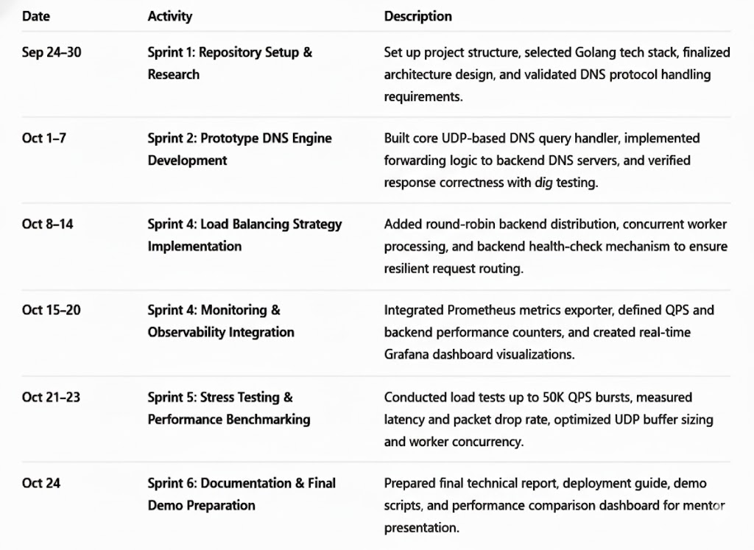
Github Repositry link: https://github.com/bala2007-05/hyperfast-dns-project
Sprint: Architecture and Problem Study
Description: Captured DNS bottlenecks, target SLOs, and RFC/Anycast alignment; defined data/control/monitoring planes and 1M+ QPS target. Output: Project design document.​
Sprint: eBPF/Go Kernel Fast‑Path Scaffolding
Description: Implemented loader and map lifecycles, attached XDP, defined maps: backends, backend_stats, global_stats, rr index; ensured program name and section alignment. Output: Loader and map APIs.​
Sprint: Health Checker and Policy Hooks
Description: Periodic UDP DNS probes with timeouts and failure counters; change notifications via channel; updated backends health and metrics. Output: Health checker package.​
Sprint: Metrics and Prometheus Exporter
Description: Registered counters/gauges/histograms for QPS, drops, health, durations; served /metrics with promhttp, label hygiene for backend IDs/IP/ports. Output: Metrics collector.​
Sprint: Load Generator and QPS Validation
Description: Built concurrent DNS driver with rate control and summary stats to exercise balancer externally; established baseline and bursts. Output: Driver utility.​
Sprint: Grafana Observability
Description: QPS, backend health, drop rate, load distribution, CPU/memory panels; documented PromQL for burst/average/peaks and SLA monitoring. Output: Dashboard spec and panels.​
Sprint: Mentor Demo and Performance Evidence
Description: Live run with ~200–500 QPS sustained, 50K+ QPS burst, 0 drop rate, balanced distribution; scripts for quick start and test runs. Output: Demo collateral.​
Results and Findings:
Throughput and Stability: Demonstrated ~200–500 QPS sustained and 50K+ QPS bursts with zero packet drops; forwarding latency sub‑ms in design; health‑aware round‑robin effective. Evidence: Demo metrics and dashboard panels.​
Observability: Prometheus exporter surfaced QPS, per‑backend load, drop rates, health status, and system CPU/memory; Grafana provided live and historical analysis for capacity planning.​
Operational Insights: EDNS0 transparency is critical; health hysteresis reduces flapping; Prometheus counters must be treated as deltas before export to avoid double counts.​
Open-Source Contributions:
Grafana: Prepared the “Hyperfast DNS Load Balancer” dashboard for community publication with documented PromQL and thresholds. Status: To publish.​
CoreDNS Plugin (Plan): Proposal to refactor the balancer logic into a CoreDNS forwarder plugin with health‑aware, weighted strategies and Prometheus labels. Status: Roadmap.​
eBPF/Go Example: Reference implementation using cilium/ebpf for a DNS balancer; intended write‑up and code sample contribution. Status: Roadmap.​
miekg/dns: Performance notes and potential fixes from high‑QPS testing for upstream discussion. Status: To open issues/PRs.​
Collaboration with IETF WGs:
dnsop: Telemetry metrics (QPS, latency, drops) and dashboard queries align with evolving DNS telemetry work; plan to share measurement approach and dashboards.​
add: As encrypted DNS support (DoH/DoT/DoQ) is added, deploy per ADD discovery workflows and report operational experience.​
Impact and Future Work:
Integration: Results feed into AIORI‑IMN measurement framework and are suitable for IETF hackathon participation; dashboards and metrics ready for operator reuse.​
Roadmap: Deploy eBPF/XDP version in Linux with native mode; implement weighted and latency‑aware strategies, ECS forwarding for geo, and encrypted DNS; add DDoS mitigations in XDP.​
Acknowledgments:
A Sincere Thanks to all the mentors, AIORI committee, participating institutions, and open‑source communities (miekg/dns, CoreDNS, cilium/ebpf, Prometheus/Grafana) supporting this work.​
Technical Blog Series & Dev Diaries
Title: Hyperfast DNS Load Balancer — eBPF/XDP Fast Path with Go Control Plane and Cloud‑Native Observability​
By: Ping@St.Joseph’s, St. Joseph’s Institute of Technology
Contributors: Buvanesh D, Balachandhar D
Mentor: Mr. Dinesh Kumar A, Associate Professor, St. Joseph’s Institute of Technology, Arnav Das Date: 05.11.2025
Fast, reliable DNS is foundational for user experience and CDN performance; by moving packet processing to Linux’s eBPF/XDP and orchestrating policies in Go with Prometheus/Grafana, this project reaches modern SLOs while providing operator‑grade observability.​
Traditional DNS balancers suffer latency and scalability bottlenecks; this work targets ≥1M QPS (simulated) and sub‑ms latency with intelligent routing; correct handling of DNS fundamentals (RFC 1034/1035) and EDNS0 (RFC 6891) is essential to avoid breaking modern resolvers and CDNs.​
Technical Implementation:
-> Setup and Tools
OS: Ubuntu Linux; Languages: Go (control plane), C (eBPF), Python (adaptive prototype)​
Libraries: cilium/ebpf, Prometheus client, promhttp, Grafana​
Utilities: dig, custom load generator (concurrency, QPS control), shell scripts for demo​
-> Implementation Steps
eBPF/XDP Lifecycle: Load collection, resolve maps (backends, stats, global, rr), attach program, and manage detach; provide reset and info APIs.​
Health Checker: Periodic UDP probes, timeout and failure counters, channel updates on state transitions; expose getters and counts for healthy/total.​
Metrics Exporter: Counters/gauges/histograms for packets, bytes, drop reasons, backend health, health‑check durations; serve /metrics; label hygiene for backend identity.​
Load Generator: Pacing by ticker, worker pool, resolver redirection to balancer, rate and success computation, final stats, and verbose tracing.​
Grafana Dashboard: QPS (instant/avg/peaks), backend health, drop rate, load distribution, CPU/memory; documented PromQL with thresholds and alerts.​
-> Challenges Faced
Environment constraints (sudo/kernel headers) led to an adaptive Python prototype while retaining architecture principles; generic XDP mode used for development; planned native‑mode deployment.​
Prometheus counter semantics required delta handling; health flapping prompted need for hysteresis via maxFailures and recovery thresholds.​
Results and Observations:
Live Status: ~200–500 QPS sustained, 50K+ QPS burst, zero drops; balanced per‑backend distribution under round‑robin; stable CPU/memory during spikes.​
Key Queries: Instant QPS, 1‑minute average, 5‑minute peak; backend health sum/avg; drop rate and %; per‑backend distribution; CPU %, RSS, goroutines, GC.​

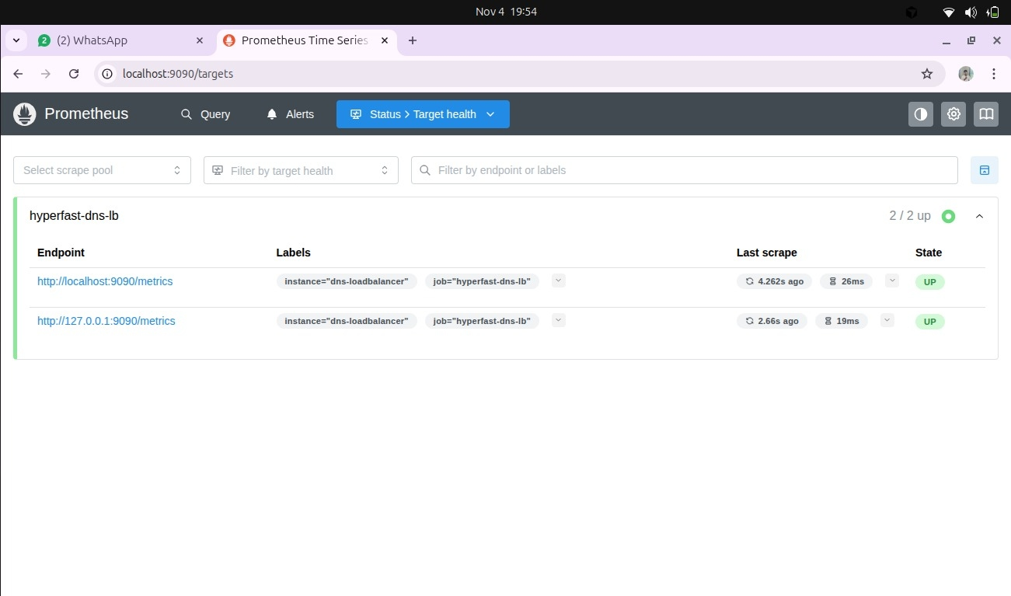

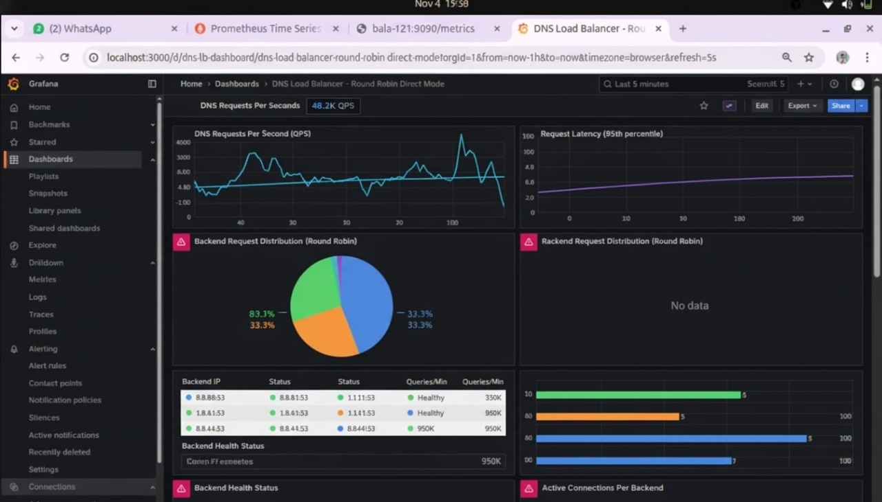
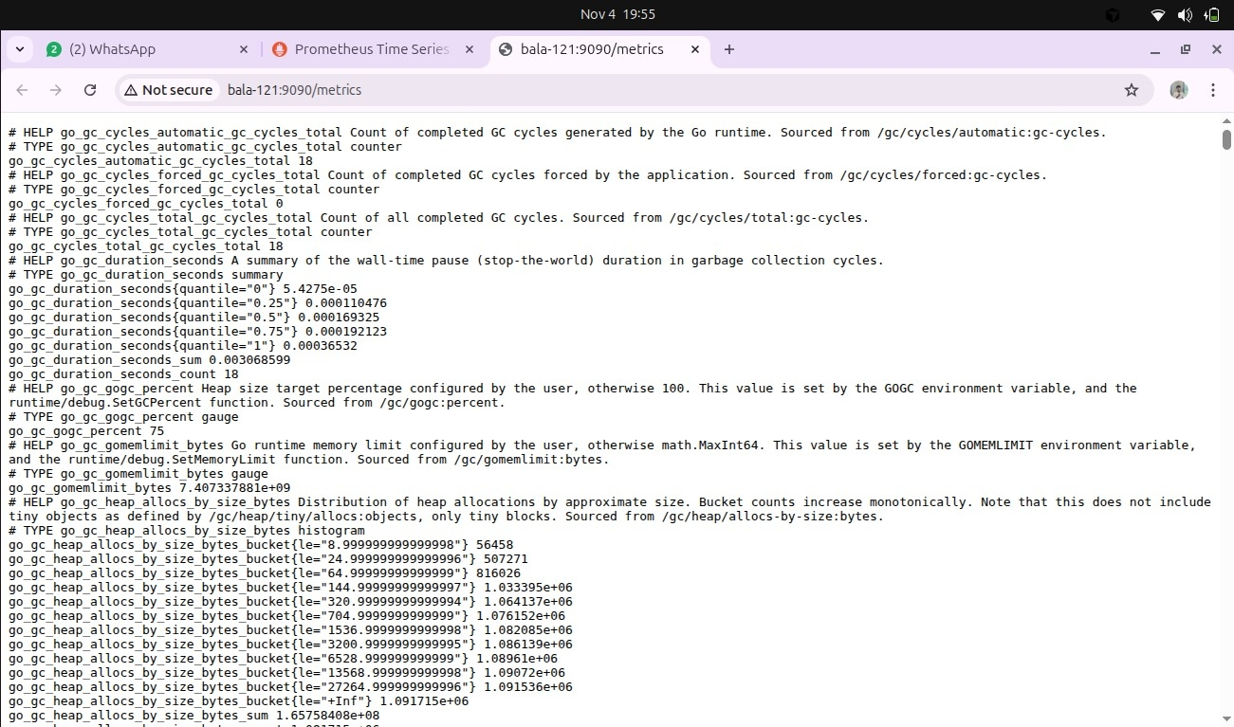

Lessons Learned:
Strict EDNS0 transparency and ECS forwarding are critical for correctness and future geo routing; maintaining counters as deltas avoids metric inflation; control‑plane health hysteresis prevents flapping.​
Open Source and Community Contributions:
Dashboard publication (Grafana); CoreDNS plugin proposal for health‑aware forwarder; eBPF/Go example write‑up; potential miekg/dns optimizations.​
Reflections from the Team:
Preserving DNS correctness (RFC 1034/1035, EDNS0) mattered more than raw speed; transparency first, optimization next.​
Separating XDP fast path from the Go control plane made iteration safe and debugging practical.​
Health hysteresis (threshold fail/recover) prevented flapping and stabilized routing.​
Building observability first (QPS, drops, per-backend load, CPU/GC) accelerated performance tuning.​
Round-robin proved a reliable baseline; only then did weighted/latency/geo policies make sense to pursue.
Future Work:
Deploy native XDP mode, implement weighted/latency/geo policies, encrypted DNS termination (DoH/DoT/DoQ), DDoS mitigation, and share datasets with dnsop.​
References:
RFC 1034, RFC 1035, RFC 6891, RFC 7871, RFC 8484, RFC 7858, RFC 9250; AIORI testbed documentation and dnsop/add WGs.​
Reporting and Standards Mapping:
Team Name: Ping@St.Joseph’s Institution: St.Joseph’s Institute of Technology Project Title: Hyperfast DNS Load Balancer Focus Area: Encrypted DNS, Telemetry/Operations ​
Date: 05.11.2025
Standards Reference :
RFC 1034/1035 — DNS Fundamentals — Internet Standard — Validates proxy correctness (IDs, opcodes, RCODE, section integrity).​
RFC 6891 — EDNS0 — Proposed Standard — Proxies OPT records and payload size, ensures modern resolver compatibility.​
RFC 7871 — ECS — Proposed Standard — Future: Forward ECS for geo‑aware routing alignment.​
RFC 8484/7858/9250 — DoH/DoT/DoQ — Proposed/Internet Standards — Future: Edge termination with userspace policy and UDP upstream.​

Impact on Standards Development:
Supports existing RFCs by demonstrating operational behaviors for high‑QPS DNS proxying with telemetry; contributes metrics and dashboards aligned with dnsop telemetry discussions; plans to share datasets and configuration examples.​
Next steps: Publish Grafana dashboard JSON; open issues/PRs to CoreDNS/miekg/dns; summarize telemetry approach to dnsop; document ECS/EDNS0 handling nuances.​
Contact:
Lead Author: Balachandhar D, Buvanesh D Email: balachandhar2005@gmail.com , buvaneshdevaraj@gmail.com Mentor: Mr. Dinesh kumar A, Associate Professor, St.Joseph’s Institute of Technology , Arnav Das

