TASK-1

1.

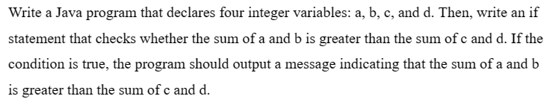

CODE:

import java.util.Scanner;

public class Main {

public static void main(String[]args){

int a=1;

int b=1;

int c=1;

int d=1;

int sum1,sum2;

sum1=a+b;

sum2=c+d;

Scanner sc=new Scanner(System.in);

sum1=sc.nextInt();

sum2=sc.nextInt();

if (sum1>sum2)

System.out.print("The sum of a and b Is greater than c and d");

}

}

INPUT:

50

40

OUTPUT:

The sum of a and b Is greater than c and d

2.



CODE:

import java.util.Scanner;

public class Main {

public static void main(String[]args){

int num;

Scanner sc=new Scanner(System.in);

num=sc.nextInt();

if (num%2==0)

System.out.print("Its a even number"); } }

INPUT:

56

OUTPUT:

It’s a even number

3. 

CODE:

import java.util.Scanner;

Public class Main{

Public static void main(String[]args){

char ch;

for (ch='A';ch<='Z';ch++)

System.out.print(ch+" ");

}

}

OUTPUT:

A B C D E F G H I J K L M N O P Q R S T U V W X Y Z

4.

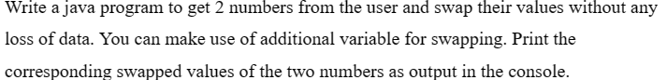

CODE:

import java.util.Scanner;

public class Main {

public static void main(String[]args){

int x=1;

int y=5;

int temp;

temp=x;

x=y;

y=temp;

System.out.print("x=" +x);

System.out.print("y=" +y);

}

}

OUTPUT:

X=5 Y=1

5. 

CODE:

6. 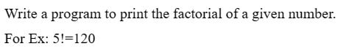

7. 

CODE:

import java.util.Scanner;

public class Main {

public static void main(String[]args){

String msg="Guvi Geek";

int length=msg.length();

System.out.println("The length of string msg is " + length ); } }

OUTPUT:

The length of string msg is 9

8. 

CODE:

import java.util.Scanner;

public class Main {

public static void main(String[]args){

for (int i=1;i<=10;i++)

System.out.println("WELCOME TO GUVI"); } }

OUTPUT:

WELCOME TO GUVI

WELCOME TO GUVI

WELCOME TO GUVI

WELCOME TO GUVI

WELCOME TO GUVI

WELCOME TO GUVI

WELCOME TO GUVI

WELCOME TO GUVI

WELCOME TO GUVI

WELCOME TO GUVI

9.

CODE:  
import java.util.Scanner;

public class Main {

public static void main(String[]args){

int age;

Scanner sc=new Scanner(System.in);

age=sc.nextInt();

if (age>60)

{

System.out.println("This person is senior citizen " + age );

}

else

{

System.out.println("This person is not a senior citizen " + age ); } } }

INPUT:

61

OUTPUT:

This person is senior citizen 61

10. 

CODE:

package Main;

import java.util.Scanner;

public class CountingDigitsInInteger {

public static void main(String args[]){

@SuppressWarnings("resource")

Scanner sc = new Scanner(System.in);

int count = 0;

System.out.println("Enter a number ::");

int num = sc.nextInt();

while(num!=0){

num = num/10;

count++;

}

System.out.println("Number of digits in the entered integer are :: "+count); } }

INPUT:

Enter a number :: 253566

OUTPUT:

Number of digits in the entered integer are :: 6