Eberhardt School of Business – Alumni & Student Tracking System
Valentina Varani
Abhishek Sonawane
Balakrishna Reddy Channa Reddy

1. Introduction

This project was created to help the Eberhardt School of Business track student journeys, including academic progress, internships, and job placements. The system collects information through a guided multi‑step form and stores the data securely in an SQLite database.
2. Project Overview
The application ensures that every student — whether currently enrolled or graduated — can easily submit their details. The data is structured into relational tables covering Programs, Students, Internships, Jobs, Employers, and Student Organizations.
3. Step-by-Step Workflow
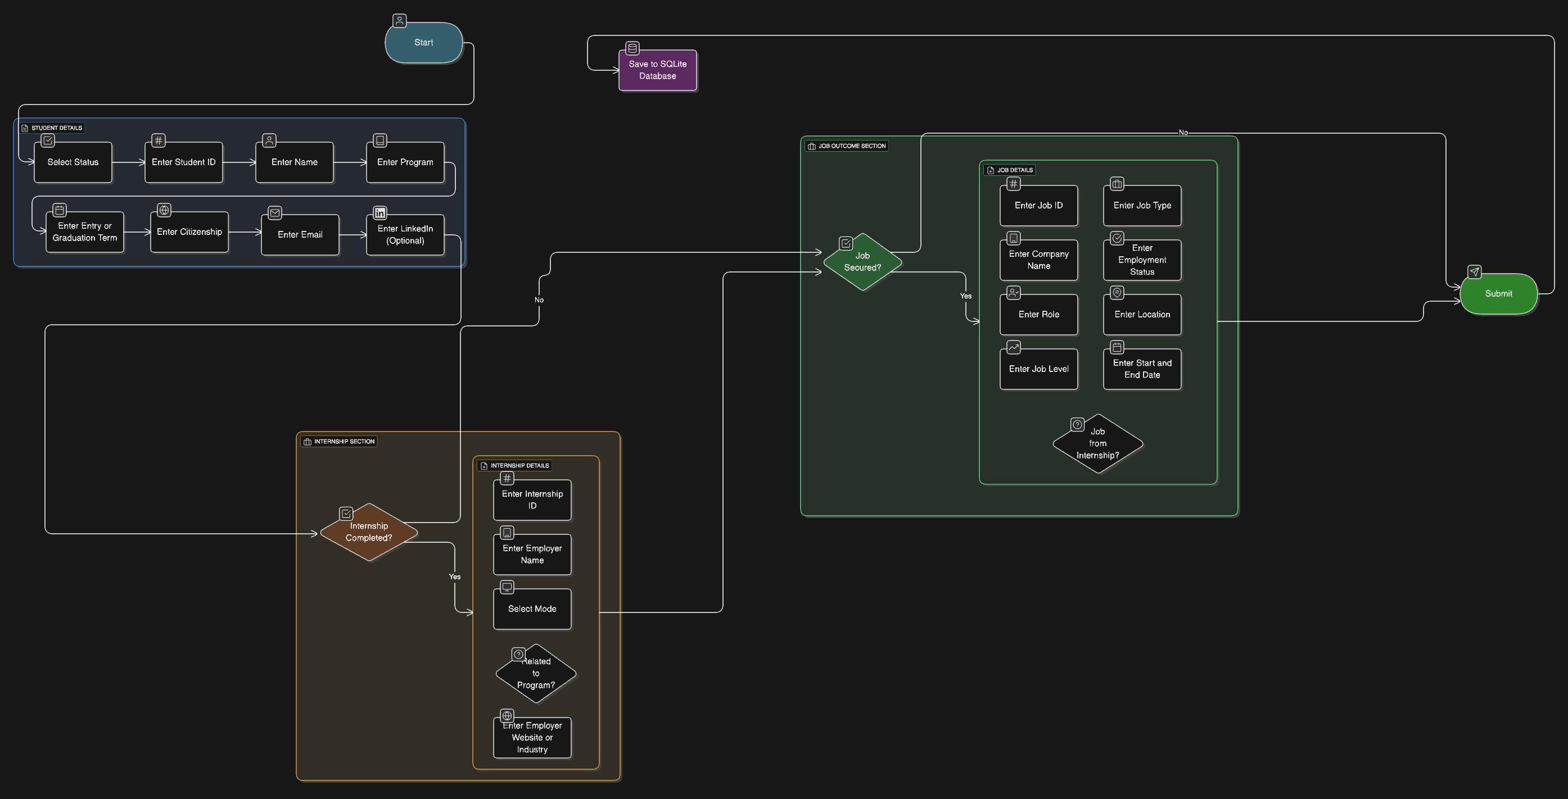
4. ERD — Entity Relationship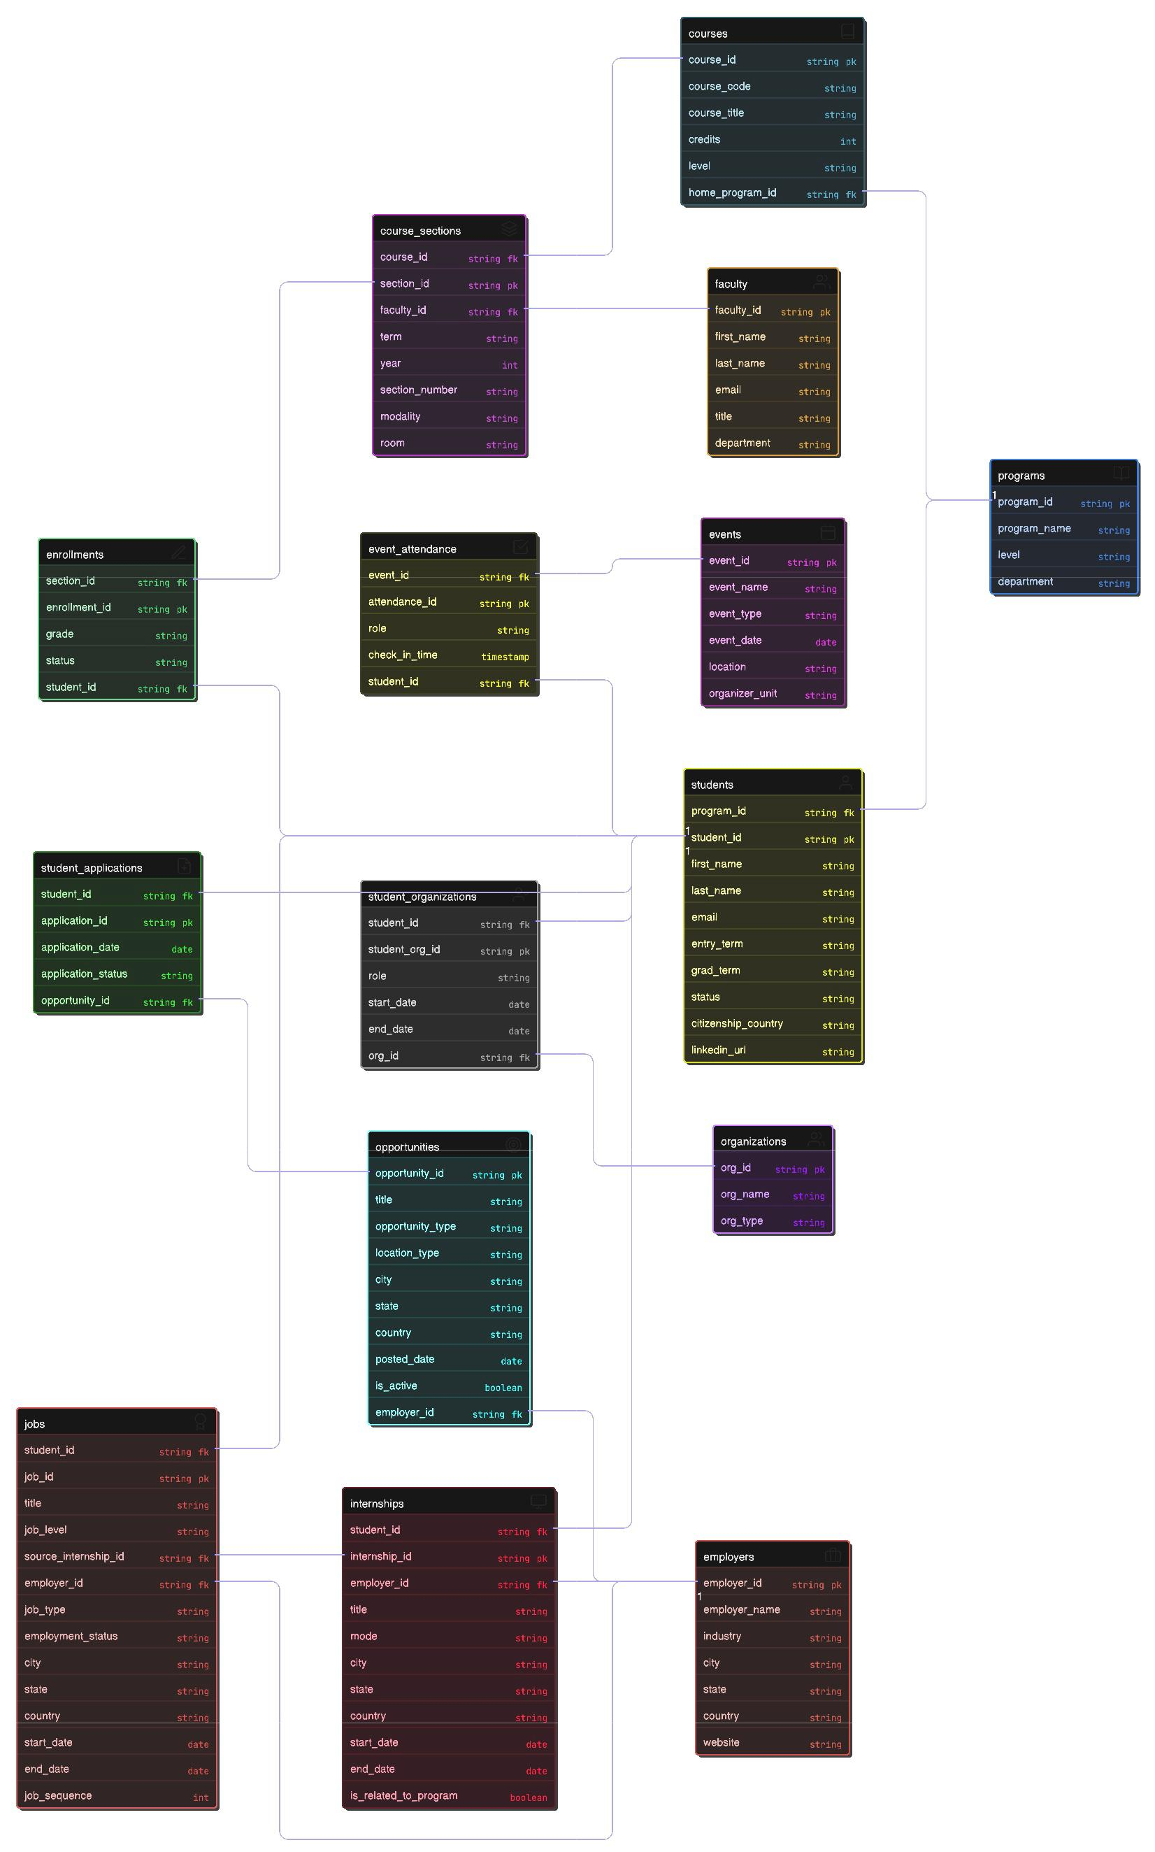

5. Conclusion

This system provides a clean, efficient, and scalable way for the Eberhardt School of Business to track student outcomes. The UI is designed to be simple and dynamic, expanding only when required, ensuring ease of use and reducing user errors.

