V.BALASUBRAMANIAM,17EUCS024@SKCET.AC.IN

CREATING A WEBSITE BY INCLUDING A PUBLIC API-EXAMLY ROUND 3

# API used:

CATEGORY:SPORTS AND FITNESS

API USED: ballsdontlie

LINK: <https://www.balldontlie.io/>

Being a sports enthusiast,I’ve used a sports related API which includes all the details about players and teams of the National Basketball Association(NBA).

**MY WEBPAGE:**

I created an simple webpage using HTML and incorporated the “ballsdontlie” API using java script.My webpage uses an button to access the data.When the user clicks the button,all information about the NBA players which are raw and unfiltered are converted into a table format and displayed as a table.

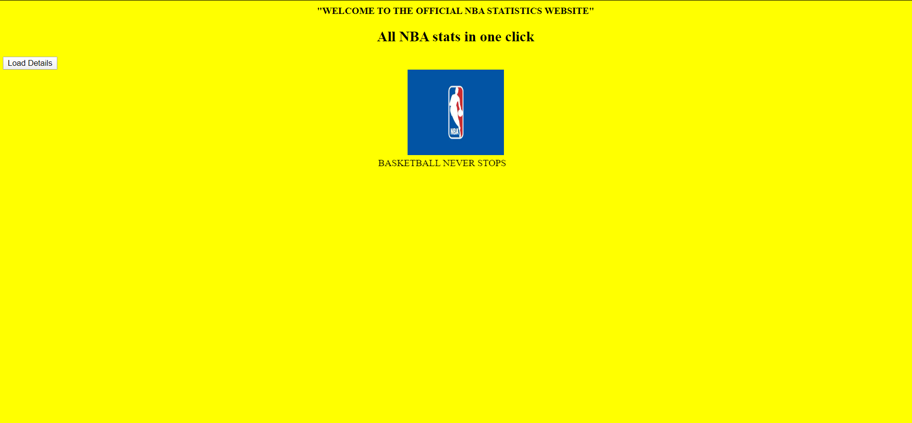

When the “Load button” is clicked,the details are displayed in the form of tables.

**CODE:**

<!DOCTYPE html>

<html>

<head>

<title>Convert JSON Data to HTML Table</title>

<style>

th, td, p, input {

font:14px Verdana;

}

table, th, td

{

border: solid 1px #DDD;

border-collapse: collapse;

padding: 2px 3px;

text-align: center;

}

th {

font-weight:bold;

}

</style>

</head>

<body bgcolor="yellow">

<head><center><b>"WELCOME TO THE OFFICIAL NBA STATISTICS WEBSITE"</b></center></head>

<h2><center>All NBA stats in one click</center></h2>

<div id="demo"></div>

<div id="demo">

<button type="button" onclick="loadXMLDoc()">Load Details</button>

<p id="showData"></p></div>

<script>

function loadXMLDoc() {

var data1;

var xhttp = new XMLHttpRequest();

xhttp.onreadystatechange = function() {

if (this.readyState == 4 && this.status == 200) {

data1=this.responseText;

data1 = data1.replace(/,"meta":{"total_pages":131,"current_page":1,"next_page":2,"per_page":25,"total_count":3268}}\s*$/, "");

createTable(data1);

//document.write(data1);

}

};

xhttp.open("GET", "https://www.balldontlie.io/api/v1/players", true);

xhttp.send();

}

function createTable(data1){

var data = data1;

var col = [];

for (var i = 0; i < data.length; i++) {

for (var key in data[i]) {

if (col.indexOf(key) === -1) {

col.push(key);

}

}

}

// CREATE DYNAMIC TABLE.

var table = document.createElement("table");

// CREATE HTML TABLE HEADER ROW USING THE EXTRACTED HEADERS ABOVE.

var tr = table.insertRow(-1); // TABLE ROW.

for (var i = 0; i < col.length; i++) {

var th = document.createElement("th"); // TABLE HEADER.

th.innerHTML = col[i];

tr.appendChild(th);

}

// ADD JSON DATA TO THE TABLE AS ROWS.

for (var i = 0; i < data.length; i++) {

tr = table.insertRow(-1);

for (var j = 0; j < col.length; j++) {

var tabCell = tr.insertCell(-1);

tabCell.innerHTML = data[i][col[j]];

}

}

// FINALLY ADD THE NEWLY CREATED TABLE WITH JSON DATA TO A CONTAINER.

var divContainer = document.getElementById("showData");

divContainer.innerHTML = "";

divContainer.appendChild(table);

}

</script><center><img src="https://turbologo.com/articles/wp-content/uploads/2019/10/NBA-logo-illustration-678x381.jpg.webp" alt="NBA LOGO" width="160" height="142"></center>

<marquee height="1000" >BASKETBALL NEVER STOPS

</marquee>

</body>

</html>

**HOSTING ON AWS:**

Using amazon S3 which is a free tier service,a bucket was created as a Static webpage bucket and my webpage page was hosted using the bucket.