Butler Bot – Documentation

1. Overview
This project implements an autonomous restaurant service robot using ROS 2 Humble, Nav2, and Gazebo.
The system consists of:
- butler_bot → Defines the custom robot (URDF, sensors, services).
- restaurant → Defines the restaurant simulation environment (world + map).
- butler_order_manager → Manages orders and robot tasks using a Behavior Tree (BT) with cancel-handling logic.
The robot:
- Waits for a customer order.
- Navigates to the kitchen.
- Waits for food loading.
- Navigates to the customer’s table.
- Waits for food unloading.
- Returns to home position.
- Handles order cancel or timeout failures gracefully.

2. Package Details

📦 butler_bot
- URDF: Defines robot geometry (base, wheels, sensors).
- Services:
  - move_to_home → Robot navigates to predefined home pose.
  - move_to_pose → Robot navigates to target pose.
- Launches:
  - Bringup launch files for simulation.

📦 restaurant
- World: Restaurant layout in SDF (kitchen, tables, pathways).
- Map: Generated map for Nav2.

📦butler_bot_interfaces
This package defines all custom service and action files used by the framework for order handling and robot execution. Currently this package is missing, but equivalent standard messages were used to test the system.

📦 butler_order_manager
This package manages the orders, dispatch, and execution logic.

Node 1 – Order Server (Service Server: Order.srv)
- Role: Acts as the entry point for orders/cancellations from the client (UI/terminal).
- Inputs:
  - new order (e.g., table_1, table_2, table_3)
  - cancel order (cancel by order ID).
- Process:
  - Maintains a JSON stack of orders (active, completed, canceled).
  - Every update (new/cancel) immediately updates this stack.
  - Notifies Order Executor about current active/canceled orders.

Node 2 – Order Dispatcher (Action Client)
- Role: Continuously monitors the order stack.
- Process:
  - Picks the top-most valid order.
  - Sends it as a goal to the Order Executor (Action Server).
  - Waits for result (success or cancel).
  - Once complete, moves to the next order.

Node 3 – Order Executor (Action Server)
- Role: Responsible for executing delivery workflow for each order.
- Main functions:
  - Movement control → Calls robot services from butler_bot:
    - /move_to_home
    - /move_to_pose (kitchen, table_1, table_2, table_3).
  - Load Machine Sensor check → Subscribes to sensor data:
    - 0 = Loaded, 1 = Unloaded.
    - Robot waits at kitchen until tray = loaded.
    - Robot waits at table until tray = unloaded.
  - Cancellation handling:
    - If order is canceled while executing:
      - If robot has already picked up food → return food to kitchen → go home.
      - If robot hasn’t picked food yet → directly go home.
    - If tray not loaded/unloaded in timeout (20 sec) → cancel order → go home.
  - Feedback & Result: Sends progress updates to dispatcher + final result.

3. Code Workflow Diagram:
OrderClient - srv
- Send theOrder
to Sever
OrderServer - stv
- Stack the order in JSON
- if Cancel order – send
trigger to Oreder Executor
OrderDispatcher – Action Client
- It continuously mointoring
the stack
- If Order in Stack
- Execute FIFO
- Feedback
OrderExecutor – Action Server
- Execte the order
- Handel Cancel Cb
- Handle Failure Cb – move
the robot to safe Pose.
- Feedback
ButlerBot – srv
- move_bot to desired
position
- Nav2
- Map
- Launch the environment

4. Workflow – Order Execution & Cancel Handling

Normal Order Flow
- Order Received
- Move to Kitchen
- Wait for Food Load (20s)
- Move to Customer Table
- Wait for Unload (20s)
- Return to Home

Root (BT - Structured)
└── Sequence
├── ReceiveOrder
├── MoveToKitchen
├── Selector (CancelCheck1)
│ ├── IfCanceled → ReturnToHome
│ └── Sequence
│ ├── WaitForLoading (with 20s timeout)
│ ├── Selector (CancelCheck2)
│ │ ├── IfCanceled → CancelOrder (BackSequence)
│ │ └── Sequence
│ │ ├── MoveToCustomer
│ │ ├── Selector (CancelCheck3)
│ │ │ ├── IfCanceled → ReturnToHome
│ │ │ └── Sequence
│ │ │ ├── WaitForUnload (with 20s timeout)
│ │ │ ├── Selector (CancelCheck4)
│ │ │ │ ├── IfCanceled → CancelOrder (BackSequence)
│ │ │ │ └── ReturnToHome (OrderSuccess)

7. How to Run

Launch Restaurant + Bot
ros2 launch butler_bot butler_restaurant_env.launch.py
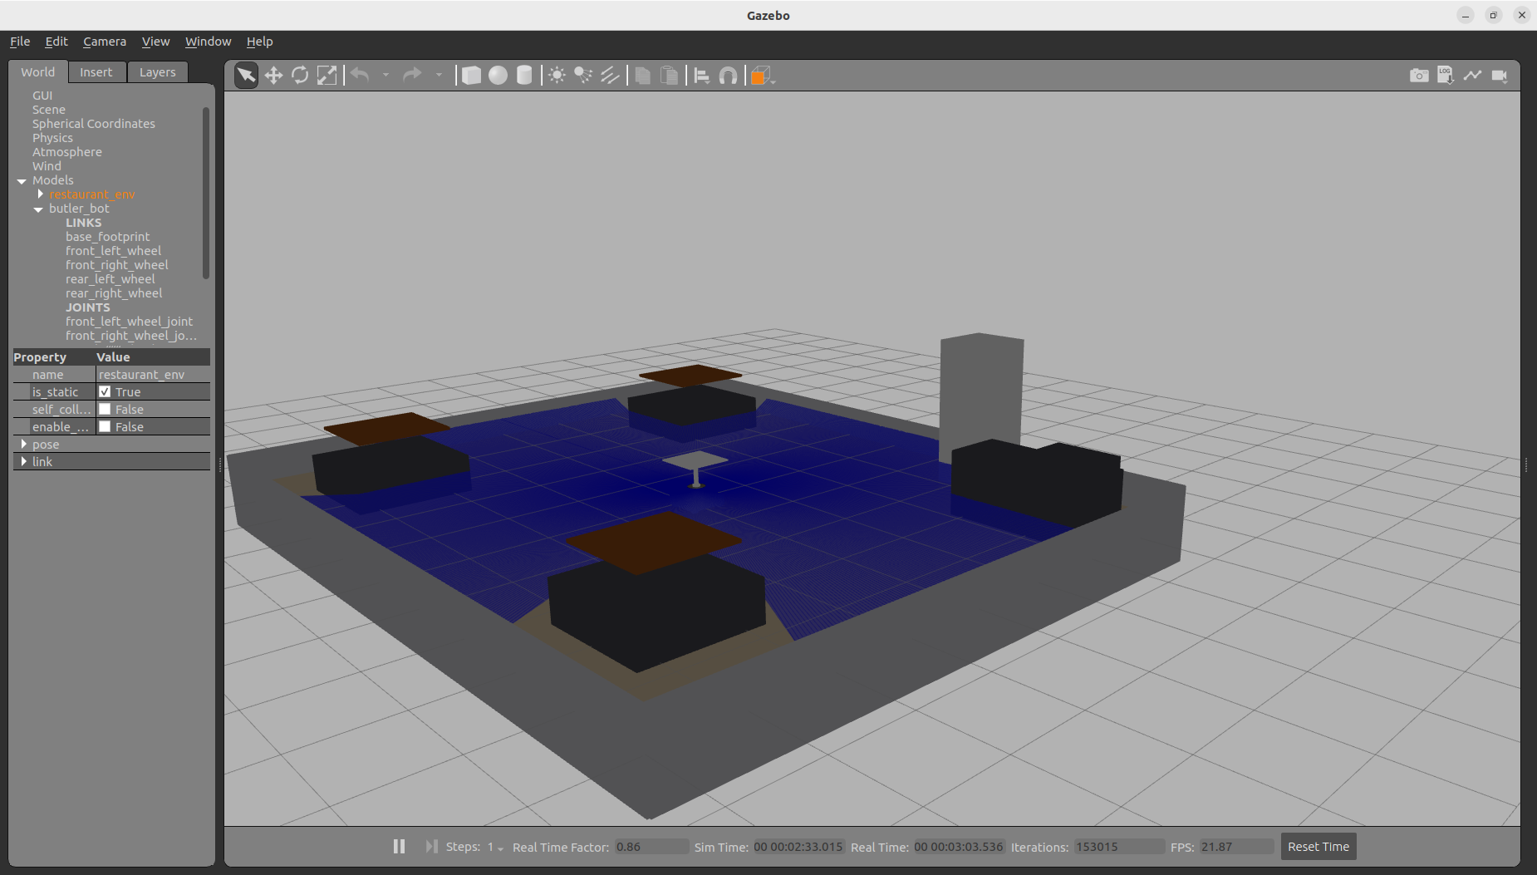

Start Order Manager
ros2 launch butler_order_manager butler_order_manager.launch.py

Order/Cancel:
ros2 run butler_order_manager order_client
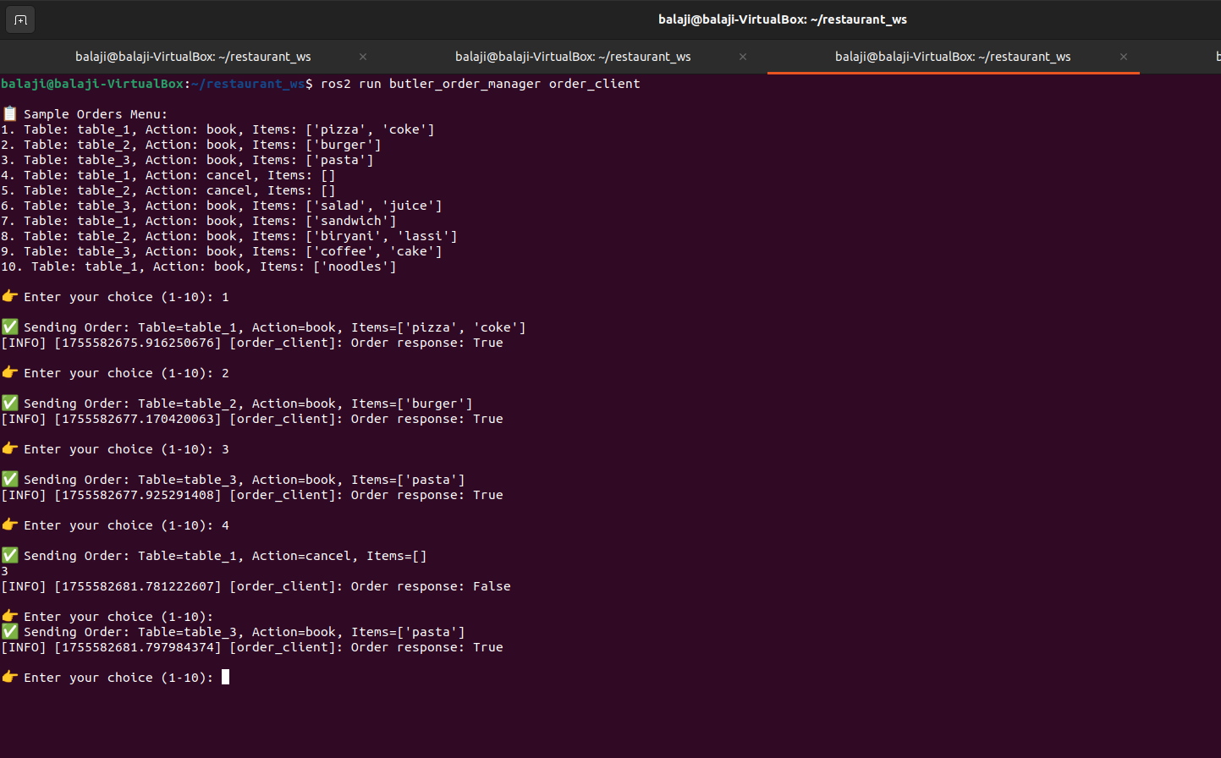

Load Machine Sensor Simulation
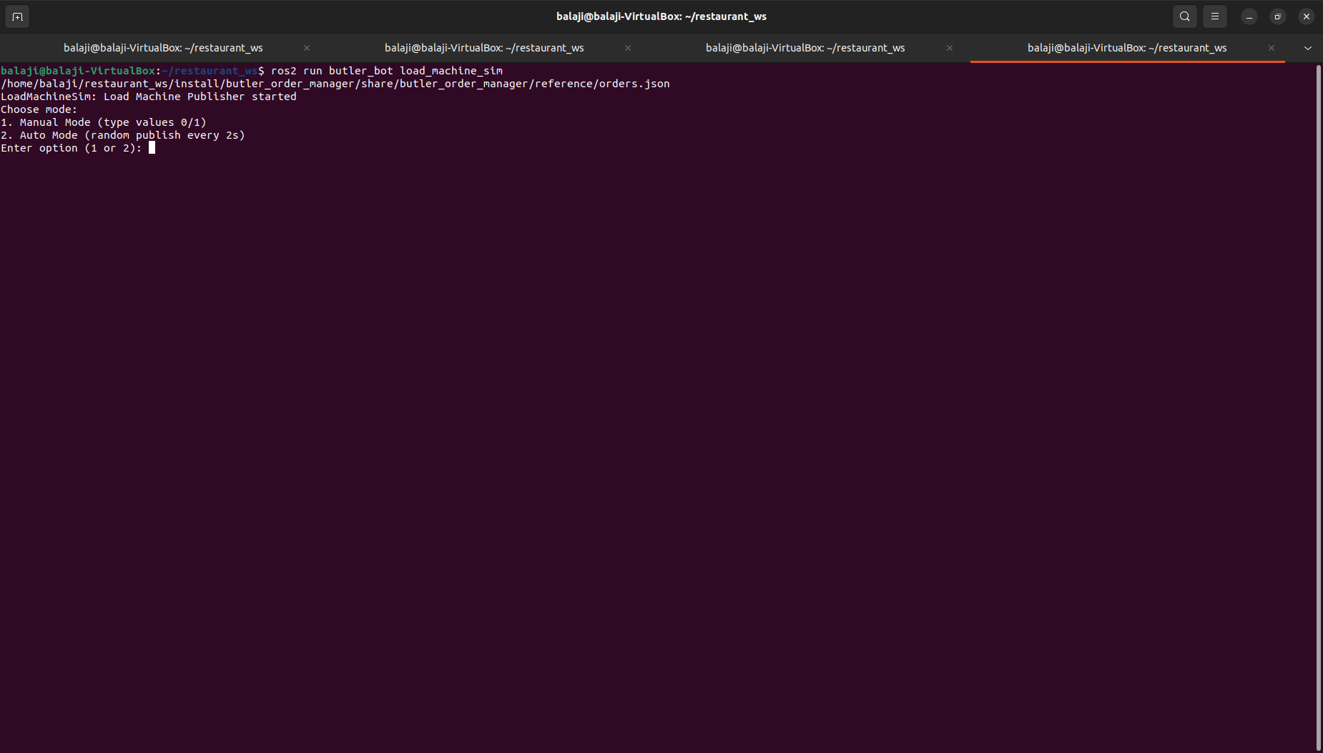
ros2 run butler_bot load_machine_sim
8. Achivements:
- Full Butler Order Manager stack functional with services and actions
- Robot movement via cmd_vel services in Gazebo
- Custom robot + restaurant environment + controllers + map created
- End-to-end order workflow operational with recovery handling
- 7/7 test cases successfully achieved in simulation

8. Completetion Summary:
Functionalities Implemented :
Robot movement: Achieved using /cmd_vel + service calls
- Order Manager Stack: Full pub/sub, services, actions flow
- Test Cases Covered (7 total):
- Place order → deliver → return home
- Cancel before pickup → abort & return home
- Cancel after pickup → return food → go home
- Timeout waiting for tray load (20s) → cancel → return home
- Multiple orders → stack management
- Load/unload tray correctly handled
- Success flow → dispatcher moves to next order
- Custom Robot Model: Mobile base + controllers configured
- Restaurant Environment: Kitchen + tables + map created
- Order feedback loop (Executor → Dispatcher → Client)

Pending / Missing Part
- Bridge between map and robot:
  - Map is generated and available
  - Robot can move with /cmd_vel services
  - Missing integration of map-based navigation (Nav2 / SLAM bridge) to connect robot to map for autonomous path planning.

Conclusion
Even without the final map integration, the project demonstrates:
- A working restaurant robot automation framework in ROS 2
- Full order workflow with cancellations, timeouts, and recovery actions
- Robot can move, accept orders, and manage tasks in simulation
- Provides a solid base to add navigation on top of the existing framework
- Reference image i attached below.
