System Architecture

hfuf
**System Architecture Diagram 1**
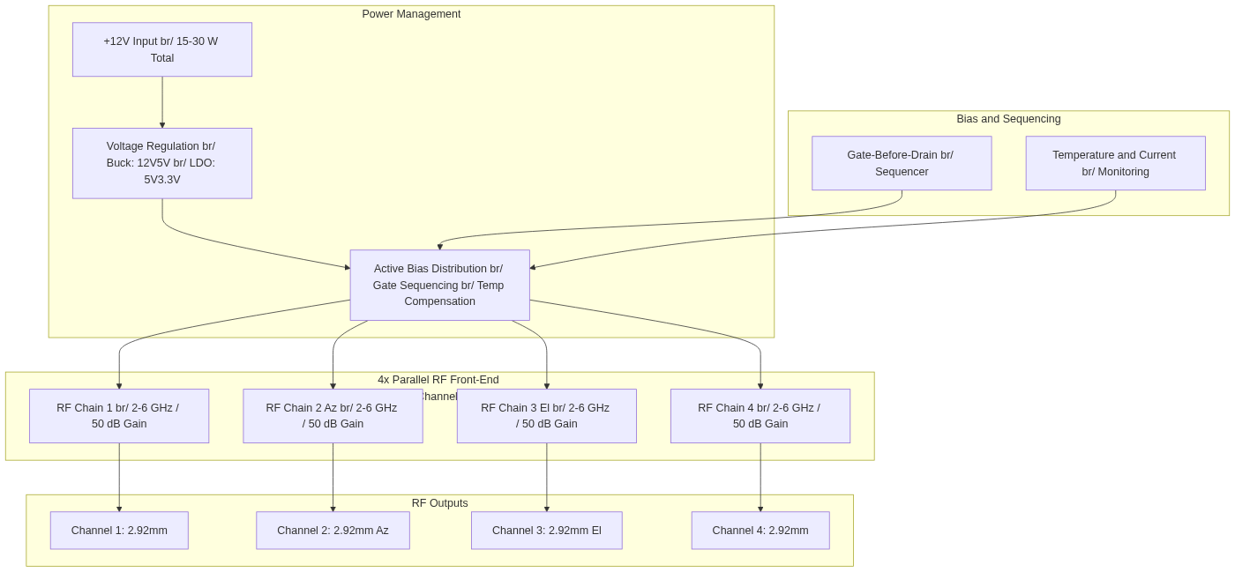
Diagram 1

