System Architecture

hjjg
**System Architecture Diagram 1** *(auto-renderer could not parse the LLM-emitted Mermaid — placeholder shown; full source is preserved below)*
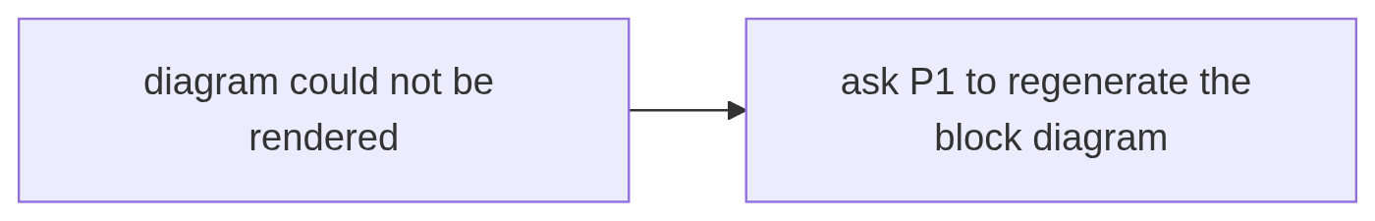
Diagram 1 placeholder
**Diagram source:**

