Software Requirements Specification (SRS)

Document Control
Version | Date | Author | Changes
1.0 | 17 April 2026 | System Architect | Initial Release

1. Introduction

1.1 Purpose
This Software Requirements Specification (SRS) defines the comprehensive software requirements for the **receiver** project firmware. This firmware executes on the embedded STM32F407VGT6 Microcontroller Unit (MCU) and the Xilinx Zynq UltraScale+ FPGA (XCZU15EG).
The purpose of this document is to:
- Specify the functional behavior of the firmware controlling the RF Front End (LNA, VGA, Mixer).
- Define the communication protocols between the MCU, FPGA, and external Host PC.
- Establish performance constraints for data processing (JESD204B) and control loops (AGC, AFC).
- Serve as the baseline for software design, implementation, and verification (V&V).

1.2 Scope
This specification covers the embedded software stack known as **Receiver Firmware v1.0**.
- **MCU Firmware:** Manages power-up sequencing, SPI control of RFICs (ADF5356, HMC698LP4), non-volatile memory (EEPROM) access, and UART-to-Host communication.
- **Firmware Scope:** Includes the Hardware Abstraction Layer (HAL), device drivers, and control logic. It explicitly excludes the high-level GUI running on the Host PC and the RTL logic for the JESD204B IP core (licensed IP).
- **Interfaces:** The software interfaces with the RF hardware via SPI and GPIO, and with the outside world via UART and Ethernet (indirectly via FPGA).

1.3 Definitions, Acronyms, and Abbreviations
Term | Definition
**ADC** | Analog-to-Digital Converter (AD9208).
**AFC** | Automatic Frequency Control. Algorithm to tune the LO for optimal reception.
**AGC** | Automatic Gain Control. Algorithm to maintain optimal signal level into the ADC.
**API** | Application Programming Interface.
**BOM** | Bill of Materials.
**BRAM** | Block RAM (FPGA internal memory).
**CPLD** | Complex Programmable Logic Device.
**CRC** | Cyclic Redundancy Check.
**CW** | Continuous Wave.
**DAC** | Digital-to-Analog Converter.
**DCD** | Data Carrier Detect.
**DMA** | Direct Memory Access.
**EMC** | Electromagnetic Compatibility.
**FFT** | Fast Fourier Transform.
**FIFO** | First In, First Out buffer.
**FPGA** | Field-Programmable Gate Array.
**FSM** | Finite State Machine.
**GLR** | Glue Logic Requirements.
**GPIO** | General Purpose Input/Output.
**HAL** | Hardware Abstraction Layer.
**HRS** | Hardware Requirements Specification.
**I2C** | Inter-Integrated Circuit (Serial bus).
**IF** | Intermediate Frequency.
**IIP3** | Input Third-order Intercept Point.
**IRQ** | Interrupt Request.
**ISR** | Interrupt Service Routine.
**JESD** | JESD204B High-speed data interface standard.
**LO** | Local Oscillator.
**LNA** | Low Noise Amplifier.
**LVDS** | Low-Voltage Differential Signaling.
**MCU** | Microcontroller Unit (STM32F407).
**MHz** | Megahertz.
**MIPS** | Million Instructions Per Second.
**MISO** | Master In Slave Out (SPI line).
**MOSI** | Master Out Slave In (SPI line).
**NF** | Noise Figure.
**NVM** | Non-Volatile Memory.
**PCB** | Printed Circuit Board.
**PLL** | Phase-Locked Loop.
**POST** | Power-On Self Test.
**PS** | Processing System (ARM core in Zynq).
**RTL** | Register Transfer Logic.
**RX** | Receive.
**SMA** | SubMiniature version A (RF connector).
**SPI** | Serial Peripheral Interface.
**SRS** | Software Requirements Specification.
**SyRS** | System Requirements Specification.
**UART** | Universal Asynchronous Receiver-Transmitter.
**VGA** | Variable Gain Amplifier (HMC698LP4).
**WDT** | Watchdog Timer.

1.4 References
- **IEEE 830-1998:** Recommended Practice for Software Requirements Specifications.
- **ISO/IEC/IEEE 29148:2018:** Systems and Software Engineering — Life Cycle Processes — Requirements Engineering.
- **STMicroelectronics:** **STM32F407VGT6 Datasheet** (DocID13587).
- **Analog Devices:** **ADF5356 Datasheet** (Wideband Synthesizer with Integrated VCO).
- **Analog Devices:** **AD9208 Datasheet** (Dual, 14-Bit, 1 GSPS ADC).
- **Hittite/Qorvo:** **HMC698LP4 Datasheet** (Digital VGA).
- **Xilinx:** **UG1085** (Zynq UltraScale+ MPSoC Register Reference).
- **Project:** **Hardware Requirements Specification (HRS)** (P2).
- **Project:** **Glue Logic Requirements (GLR)** (P6).
10. **MISRA C:2012:** Guidelines for the Use of the C Language in Critical Systems.

1.5 Overview
The remainder of this document is organized as follows:
- **Section 2 (Overall Description):** Describes the product perspective, context, and high-level functions.
- **Section 3 (Specific Requirements):** Details the external interfaces, functional requirements (REQ-SW-xxx), performance constraints, and design constraints.
- **Section 4 (Verification):** Defines the V&V strategy.
- **Section 5 (Traceability):** Maps software requirements to hardware sources.
- **Appendices:** Contains register maps, protocol definitions, and diagrams.

2. Overall Description

2.1 Product Perspective

System Context Diagram
**System Architecture Diagram 1**
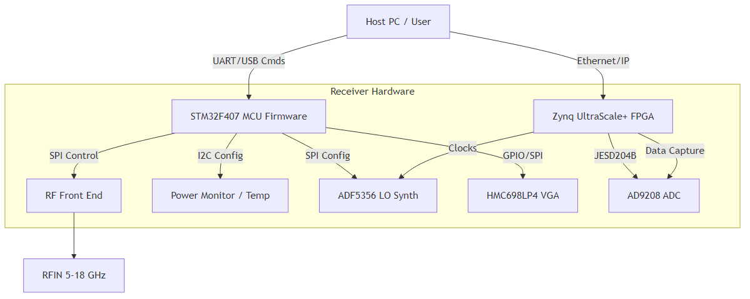
Diagram 1

Software Stack
- **Application Layer:** Command parsing, State Machine (IDLE, RX, CALIBRATE), Diagnostics.
- **Middleware:** SPI Drivers, I2C Drivers, UART Protocol Handler, CRC Libraries.
- **HAL:** STM32 HAL / LL Drivers.
- **RTOS:** FreeRTOS (Priority-based scheduling).
- **Hardware:** STM32F407, Peripherals (SPI, I2C, UART, Timers).

2.2 Product Functions
- **System Initialization:** Power-up sequencing, FPGA configuration loading, peripheral bring-up.
- **Frequency Tuning:** Programming the ADF5356 PLL via SPI.
- **Gain Control:** Setting the HMC698LP4 VGA attenuation via SPI.
- **Data Capture:** Coordinating with FPGA to receive I/Q samples via JESD204B (conceptual control).
- **Temperature Monitoring:** Reading on-board sensors via I2C.
- **Power Monitoring:** Reading voltage/current via LT2991 via I2C.
- **Fault Management:** Watchdog handling, Over-temperature shutdown.
- **Communication:** UART Packet parsing (Read/Write Registers).
- **Calibration:** Storing/Retrieving calibration tables from EEPROM.
10. **LED Indication:** Status updates (Power, Lock, Error).

2.3 User Characteristics
- **Firmware Engineers:** Develop, debug, and maintain the code using IAR/GCC.
- **Test Engineers:** Use UART commands and Python scripts to automate RF testing.
- **Integrators:** Install the receiver into a larger system, requiring knowledge of the UART protocol.

2.4 Constraints
- **MISRA-C:2012:** All C code shall comply with MISRA-C:2012 standards.
- **Real-Time:** SPI transactions must complete within 1ms to avoid timing violations with the AGC loop.
- **Memory:** MCU Flash usage < 80%; RAM usage < 60% (Available 192KB SRAM).
- **Power:** The MCU supports low-power modes but system latency requirements dictate Run mode usage.
- **Environment:** Operates in 0°C to +50°C ambient.

2.5 Assumptions and Dependencies
- **Clock Stability:** The 125 MHz oscillator is stable within 50ppm.
- **FPGA Ready:** The FPGA asserts the `FPGA_DONE` signal before the MCU attempts JESD204B link setup.
- **Power Rails:** The +12V input is regulated to +5V/+6V by the LTM4644 before the MCU exits reset.

3. Specific Requirements

3.1 External Interface Requirements

3.1.1 Hardware Interfaces

3.1.1.1 SPI Interface (RF Control)
The MCU acts as the SPI Master. The RFICs (ADF5356, HMC698LP4) act as Slaves.
**Parameters:**
- **Clock (SCK):** Max 10 MHz.
- **Mode:** Mode 0 (CPOL=0, CPHA=0).
- **Frame Size:** 8-bit / 32-bit configurable.
- **CS Management:** GPIO controlled (Chip Select per device).
**Driver API:**

3.1.1.2 I2C Interface (Sensors/EEPROM)
**Parameters:**
- **Clock:** 100 kHz (Standard) / 400 kHz (Fast).
- **Addressing:** 7-bit addressing.
- **Devices:** CAT24C256 (EEPROM), NCT75 (Temp), LT2991 (Power).
**Driver API:**

3.1.2 Software Interfaces

3.1.2.1 FPGA Control Interface (Memory Mapped)
The MCU accesses FPGA registers via a parallel bus or SPI-to-Bridge (implemented as SPI in this spec for simplicity, consistent with GLR).
**Register Map Definition:**

3.1.3 Communication Interfaces
**UART Frame Format (Host <-> MCU)**
All communication is Big-Endian (MSB first).
Command | CMD byte | Frame Structure | Response
Single Write | 0x57 ('W') | `[0x57][ADDR_H][ADDR_L][DATA_H][DATA_L]` | `[0x06] ACK`
Single Read | 0x52 ('R') | `[0x52][ADDR_H\ | 0x80][ADDR_L]`
Bulk Write | 0x42 ('B') | `[0x42][ADDR_H][ADDR_L][N][D0_H][D0_L]...[Dn_H][Dn_L]` | `[0x06] ACK`
Bulk Read | 0x62 ('b') | `[0x62][ADDR_H\ | 0x80][ADDR_L][N]`
Error NAK | 0x15 | Sent by Firmware on invalid command/address | —

- **Addressing:** 16-bit Address space.
- **Bulk Count N:** Max 64 registers.
- **Timeout:** Host must wait < 10ms for response; Firmware resets parser after 50ms gap.
- **Delimiters:** None (Binary Protocol).

3.2 Functional Requirements

3.2.1 System Initialization (REQ-SW-001 to REQ-SW-015)
ID | Requirement Statement | Source | Priority | Verification
REQ-SW-001 | The software SHALL complete the Power-On Self-Test (POST) within 500ms of +12V power application. | HRS §2.2 | M | T
REQ-SW-002 | The software SHALL verify the Board ID (read from EEPROM @ 0x0000) matches 0xA50A on startup; if mismatch, the system SHALL halt and assert ERROR_LED. | HRS §2 | M | T
REQ-SW-003 | The software SHALL configure the ADF5356 LO frequency to 11.5 GHz (default) within 100ms of initialization completion. | HRS §3.1.3 | M | T
REQ-SW-004 | The software SHALL poll the ADF5356 MUXOUT pin for "Digital Lock" and assert a "LOCKED" status flag in Register 0x0001 once acquired. | GLR §4 | M | T
REQ-SW-005 | The software SHALL initialize the UART peripheral to 3,000,000 baud (8N1) on startup. | GLR §5 | M | I
REQ-SW-006 | The software SHALL load Gain Calibration coefficients from EEPROM (offset 0x0100) into RAM. | HRS §3.1 | D | I
REQ-SW-007 | The software SHALL configure the Watchdog Timer (WDT) to 1000ms and service it every 500ms in the main loop. | HRS §3.4 | M | T
REQ-SW-008 | The software SHALL initialize the LT2991 power monitor IC to scan all 4 rails every second. | HRS §3.3 | M | T
REQ-SW-009 | The software SHALL set the HMC698LP4 VGA gain to 0dB (mid-range) on startup. | HRS §3.1 | M | T
REQ-SW-010 | The software SHALL configure the JESD204B subclass via the FPGA SPI bridge to Subclass 1 (SYSREF enabled). | GLR §5 | M | I
REQ-SW-011 | The software SHALL enable the +5V and +6V DC-DC converters via GPIO enable pins in a specific sequence: +5V first, then +6V after 10ms delay. | HRS §2.3 | M | T
REQ-SW-012 | The software SHALL read the FPGA temperature sensor (XADC) and ensure it is below 60°C before enabling the RF Front End. | HRS §3.3 | M | A
REQ-SW-013 | The software SHALL initialize the I2C bus to 400kHz (Fast Mode) for sensor polling. | HRS §3.1 | D | I
REQ-SW-014 | The software SHALL verify external reference clock (125 MHz) presence via the FPGA Status Register before attempting PLL lock. | GLR §5 | M | T
REQ-SW-015 | The software SHALL log the firmware version string (v1.0.0) to the UART console upon successful boot. | HRS §1 | M | I

3.2.2 UART Communication Driver (REQ-SW-016 to REQ-SW-025)
ID | Requirement Statement | Source | Priority | Verification
REQ-SW-016 | The UART driver SHALL support the Single Write command (0x57) to write to any 16-bit register address defined in the memory map. | GLR §7 | M | T
REQ-SW-017 | The UART driver SHALL support the Single Read command (0x52) and return the 16-bit contents of the requested register. | GLR §7 | M | T
REQ-SW-018 | The UART driver SHALL support the Bulk Read command (0x62) to return up to 64 consecutive 16-bit words in one transaction. | GLR §7 | M | T
REQ-SW-019 | The UART driver SHALL respond to an invalid command byte with a NAK (0x15) within 200 microseconds. | GLR §7 | M | T
REQ-SW-020 | The UART driver SHALL verify the checksum (if enabled in config) of the incoming packet; if incorrect, it SHALL ignore the packet. | GLR §7 | D | T
REQ-SW-021 | The software SHALL map Register Address 0x0010 to the Frequency Setting (MHz) of the LO. | GLR §7 | M | I
REQ-SW-022 | The software SHALL map Register Address 0x0020 to the Gain Setting (dB) of the VGA. | GLR §7 | M | I
REQ-SW-023 | The UART driver SHALL use a circular DMA buffer of 512 bytes for RX data to prevent overruns at 3Mbps. | HRS §3.3 | D | A
REQ-SW-024 | The software SHALL echo the received ASCII characters in "Debug Mode" for terminal visibility. | GLR §7 | O | T
REQ-SW-025 | The UART ISR SHALL clear the Overrun Error (ORE) flag automatically to prevent lockup. | GLR §7 | M | I

3.2.3 RF Control & Monitoring (REQ-SW-026 to REQ-SW-040)
ID | Requirement Statement | Source | Priority | Verification
REQ-SW-026 | The software SHALL calculate the ADF5356 INT, FRAC, and MOD registers based on a desired RF Input Frequency equation. | HRS §3.1.3 | M | A
REQ-SW-027 | The software SHALL write the ADF5356 registers in the specific order required by the datasheet (Reg 0 -> Reg 1... -> Function Latch). | ADF5356 DS | M | I
REQ-SW-028 | The software SHALL support frequency tuning steps of no greater than 1 MHz across the 5-18 GHz band. | HRS §3.1.3 | M | T
REQ-SW-029 | The software SHALL implement a 32-bit integer accumulator for Fractional tuning to minimize phase noise. | ADF5356 DS | M | I
REQ-SW-030 | The software SHALL read the HMC698LP4 temperature sensor via SPI every 10 seconds and log it to the internal status array. | HRS §3.3 | M | T
REQ-SW-031 | The software SHALL calculate the VGA gain setting required to achieve a target ADC Full Scale Voltage (e.g., -1dBFS). | HRS §3.1 | D | A
REQ-SW-032 | The software SHALL execute the AGC loop only when the ADC Over-range flag is NOT asserted. | HRS §3.1 | M | T
REQ-SW-033 | The software SHALL provide a manual override mode where AGC is disabled and gain is set via UART command. | HRS §3.1 | O | T
REQ-SW-034 | The software SHALL read the RSSI value from the detector (if present) and store it in Register 0x0030. | HRS §3.1 | D | T
REQ-SW-035 | The software SHALL assert the RF_ENABLE pin only when the PLL is locked and the FPGA is ready. | HRS §3.1 | M | T
REQ-SW-036 | The software SHALL implement a frequency sweep function that increments the LO by 10 MHz, waits for lock, and measures power. | HRS §3.1 | O | D
REQ-SW-037 | The software SHALL update the Display (if local) or Status Register with current Frequency, Gain, and Temperature. | HRS §1 | M | D
REQ-SW-038 | The software SHALL check the ADC JESD204B Link Status (FPGA Register) every 1 second. | GLR §5 | M | T
REQ-SW-039 | The software SHALL clear the "PLL Lost Lock" interrupt flag only after re-initializing the PLL sequence. | GLR §4 | M | T
REQ-SW-040 | The software SHALL limit the maximum RF Input time to 5 minutes if input power exceeds +30 dBm (based on flag from external limiter). | HRS §3.2.3 | M | T

3.2.4 Data Handling & FPGA Interface (REQ-SW-041 to REQ-SW-050)
ID | Requirement Statement | Source | Priority | Verification
REQ-SW-041 | The software SHALL configure the FPGA to output 16-bit I and 16-bit Q samples. | HRS §3.2.1 | M | I
REQ-SW-042 | The software SHALL assert the FPGA_RESET signal for 10ms during system boot. | GLR §5 | M | T
REQ-SW-043 | The software SHALL read the ADC Test Pattern count (via FPGA Register) to verify data integrity. | AD9208 DS | M | T
REQ-SW-044 | The software SHALL implement a DMA transfer to capture I/Q samples from the FPGA FIFO into MCU memory for analysis. | HRS §3.2.1 | D | I
REQ-SW-045 | The software SHALL check the K28.5 comma character alignment in the JESD204B lane status register. | GLR §5 | M | I
REQ-SW-046 | The software SHALL be capable of stopping the DMA capture and closing the file gracefully upon a Stop Command. | HRS §3.2.1 | M | T
REQ-SW-047 | The software SHALL not modify the FPGA JESD204B Lane Rate configuration while the link is active. | AD9208 DS | M | I
REQ-SW-048 | The software SHALL map Register 0x0040 to the ADC Sample Rate Control (Divisor). | GLR §7 | M | T
REQ-SW-049 | The software SHALL verify the FPGA Bitstream ID matches the expected PCB revision. | HRS §2 | M | T
REQ-SW-050 | The software SHALL handle the FPGA "Buffer Full" interrupt by pausing data acquisition and setting an overflow flag. | GLR §5 | M | T

3.2.5 Power Management & Diagnostics (REQ-SW-051 to REQ-SW-065)
ID | Requirement Statement | Source | Priority | Verification
REQ-SW-051 | The software SHALL monitor the +12V input rail via the LT2991 and flag an undervoltage fault if < 10.8V. | HRS §3.3 | M | T
REQ-SW-052 | The software SHALL monitor the +12V input rail and flag an overvoltage fault if > 13.2V. | HRS §3.3 | M | T
REQ-SW-053 | The software SHALL read the die temperature of the STM32F407 via the internal sensor. | STM32 DS | M | T
REQ-SW-054 | The software SHALL enter a "Throttle" mode (reduce max gain) if the PA temperature (read via I2C) exceeds +80°C. | HRS §3.3 | D | T
REQ-SW-055 | The software SHALL maintain a fault log in EEPROM with a timestamp (seconds since boot) and error code. | HRS §3.4 | M | T
REQ-SW-056 | The fault log SHALL be circular and overwrite the oldest entry once full (Max 50 entries). | HRS §3.4 | M | I
REQ-SW-057 | The software SHALL assert the FAULT_GPIO pin high upon detection of any Critical Failure (Overtemp, Overvoltage, PLL Unlock). | GLR §5 | M | T
REQ-SW-058 | The software SHALL disable the RF Output path immediately upon Critical Failure detection. | HRS §3.1 | M | T
REQ-SW-059 | The software SHALL measure the current consumption of the +5V and +6V rails and report them in Registers 0x0051 and 0x0052. | HRS §3.3 | M | T
REQ-SW-060 | The software SHALL perform a periodic memory checksum (CRC-16) of the firmware flash space every hour. | HRS §3.4 | D | A
REQ-SW-061 | The software SHALL track the uptime in seconds and store it in a 32-bit register (wrapping at 2^32). | HRS §3.4 | M | I
REQ-SW-062 | The software SHALL support a "Factory Reset" command that erases the EEPROM calibration sector. | HRS §3.1 | O | T
REQ-SW-063 | The software SHALL blink the Status LED at 2Hz during normal operation and 10Hz during firmware update mode. | HRS §1 | M | D
REQ-SW-064 | The software SHALL report the Serial Number (read from EEPROM @ 0x0010) in Register 0x0000. | HRS §2 | M | I
REQ-SW-065 | The software SHALL log the last 10 UART commands received to assist in debugging. | HRS §3.4 | O | I

3.2.6 Calibration & Configuration (REQ-SW-066 to REQ-SW-075)
ID | Requirement Statement | Source | Priority | Verification
REQ-SW-066 | The software SHALL store the VGA Flatness Table (16 entries) in EEPROM to correct gain ripples. | HRS §3.2 | D | T
REQ-SW-067 | The software SHALL apply the VGA Flatness correction whenever the frequency changes by more than 500 MHz. | HRS §3.2 | D | T
REQ-SW-068 | The software SHALL allow the host to read/write the calibration table via Bulk Read/Write UART commands. | GLR §7 | M | T
REQ-SW-069 | The software SHALL calculate a CRC-32 checksum of the calibration data on boot and validate it against a stored magic number. | HRS §3.4 | M | T
REQ-SW-070 | The software SHALL load default hard-coded calibration values if EEPROM CRC is invalid. | HRS §3.4 | M | T
REQ-SW-071 | The software SHALL support a "Calibration Mode" where the gain is manually stepped and values recorded. | HRS §3.1 | O | D
REQ-SW-072 | The software SHALL store the I/Q Offset Correction values (DC bias) in EEPROM. | HRS §3.2 | D | T
REQ-SW-073 | The software SHALL write the I/Q Offset Correction values to the FPGA digital down-converter upon initialization. | GLR §5 | M | T
REQ-SW-074 | The software SHALL support saving the current configuration (Freq, Gain) as a "Boot Preset". | HRS §3.1 | O | T
REQ-SW-075 | The software SHALL verify that all external I2C devices acknowledge their addresses during POST. | HRS §3.1 | M | T

3.3 Performance Requirements
ID | Requirement Statement | Verification
REQ-PERF-001 | The frequency tuning speed (change LO from 5 GHz to 18 GHz) SHALL be ≤ 10 ms. | T
REQ-PERF-002 | The AGC loop response time SHALL be ≤ 5 ms for a 10 dB step change in input power. | T
REQ-PERF-003 | The UART command latency (Host-to-Action) SHALL be ≤ 2 ms for single register writes. | T
REQ-PERF-004 | The SPI clock speed for ADC configuration SHALL be ≥ 10 MHz. | I
REQ-PERF-005 | The Boot-to-Operational time SHALL be ≤ 2.0 seconds. | T
REQ-PERF-006 | The Watchdog Timer SHALL reset the MCU if the main loop stalls for > 1000 ms. | T
REQ-PERF-007 | The I2C transaction for reading temperature SHALL complete within 2 ms. | A
REQ-PERF-008 | The firmware SHALL consume ≤ 5% of CPU utilization when idle (waiting for commands). | A
REQ-PERF-009 | The context switch time of the RTOS SHALL be ≤ 10 microseconds. | A
REQ-PERF-010 | The firmware SHALL support a continuous data capture duration of ≥ 60 minutes without data loss. | T

3.4 Design Constraints
- **MISRA-C:** All code shall adhere to MISRA-C:2012 mandatory rules.
- **Compiler:** IAR EWARM or ARM GCC (GNU Tools for STM32).
- **Static Analysis:** Code must pass PC-Lint Plus with zero errors.
- **Float Usage:** Floating point operations shall be minimized in ISRs; Fixed-point math preferred for AGC.
- **Dynamic Memory:** `malloc` and `free` are strictly prohibited.
- **Interrupt Nesting:** Max interrupt nesting level is 2.
- **Stack Size:** Main Stack Size configured to 4KB; Interrupt Stack to 2KB.

3.5 Software System Attributes

3.5.1 Reliability
- **Availability:** 99.9% uptime (excluding maintenance).
- **MTBF:** > 10,000 hours.
- **Recovery:** Automatic Watchdog reset on deadlock.

3.5.2 Maintainability
- **Modularity:** RF control, UART, and diagnostics shall be in separate C files.
- **Comments:** All functions shall have Doxygen headers.

3.5.3 Security
- Write access to Calibration EEPROM shall be protected by a "Unlock Sequence" (Write 0xAA, 0x55 to specific registers).
- Firmware updates via UART (Bootloader) shall utilize a CRC-32 check before flashing.

3.5.4 Portability
- Hardware abstraction via `STM32F4xx_HAL_Driver`.
- Pin definitions in a separate `board_hw_def.h` file.

4. Verification and Validation

4.1 Unit Test Requirements
- **ADF5356 Driver:** Mock SPI interface; verify correct register calculation for 5 test frequencies.
- **UART Parser:** Send sequences of valid and invalid frames; verify ACK/NAK responses.
- **CRC Module:** Test vectors from ISO 3309.
- **EEPROM Driver:** Write/Read verify across address boundaries.

4.2 Integration Test Requirements
- **MCU <-> FPGA:** Verify register read/write latency.
- **MCU <-> RFIC:** Verify PLL lock at band edges (5 GHz, 18 GHz).
- **Full Chain:** Inject CW tone at 10 GHz, tune LO, verify ADC sees signal via SPI status.

4.3 System Test Requirements
- **Thermal:** Operate at +50°C ambient for 24 hours (-soak test).
- **EMC:** Verify no emission violations during high-speed SPI bursts.
- **Endurance:** Cycle relays/gain settings 100,000 times.

5. Requirements Traceability Matrix
REQ-SW-xxx | Description | Traces To (REQ-HW-xxx / GLR Section)
REQ-SW-001 | POST < 500ms | HRS §2.2
REQ-SW-003 | LO Freq 11.5GHz Default | HRS §3.1.3
REQ-SW-004 | PLL Lock Detection | GLR §4 (ADF5356)
REQ-SW-007 | WDT 1000ms | HRS §3.4
REQ-SW-009 | VGA 0dB Default | HRS §3.1 (Gain Control)
REQ-SW-011 | Power Sequencing | HRS §2.3 (Power Supply)
REQ-SW-016 | UART Single Write | GLR §7 (Protocol)
REQ-SW-017 | UART Single Read | GLR §7 (Protocol)
REQ-SW-019 | UART NAK Error | GLR §7 (Protocol)
REQ-SW-026 | ADF5356 Calc | HRS §3.1.3 (LO Synth)
REQ-SW-028 | Freq Step 1MHz | HRS §3.1.3
REQ-SW-031 | AGC Target | HRS §3.2.1 (Signal Proc)
REQ-SW-040 | Input Power Limit | HRS §3.2.3 (Max Input)
REQ-SW-041 | I/Q 16-bit | HRS §3.2.1 (ADC)
REQ-SW-051 | Input UV Fault | HRS §3.3 (Power)
REQ-SW-066 | Cal Table EEPROM | HRS §3.2 (Perf)
... | ... | ...

6. Appendices

Appendix A — Error Codes

Appendix B — Register Map Summary
Base Address | Block | Offset | Register Name | Width | R/W | Reset Value | Description
0x0000 | SYS | 0x00 | BOARD_ID | 16 | R | 0xA50A | Board Identifier
0x0000 | SYS | 0x01 | FIRMWARE_VER | 16 | R | 0x0100 | Firmware v1.0
0x0000 | SYS | 0x02 | STATUS | 16 | R | 0x0000 | Bitmask: PLL_Lock, Fault
0x0000 | SYS | 0x03 | COMMAND | 16 | W | 0x0000 | Cmd: Reset, Self-Test
0x0010 | RF | 0x10 | LO_FREQ_MHZ | 32 | W | 11500 | LO Frequency in MHz
0x0010 | RF | 0x14 | VGA_GAIN_DB | 16 | W | 0x0000 | VGA Gain (Signed int)
0x0020 | ADC | 0x20 | ADC_SAMPLE_RATE | 32 | W | 200000000 | ADC Sample Rate (Hz)
0x0020 | ADC | 0x24 | ADC_STATUS | 16 | R | - | Bitmask: JJOL, Overrange
0x0030 | SENS | 0x30 | TEMP_DEGC | 16 | R | - | Temperature (0.1°C units)
0x0030 | SENS | 0x31 | VIN_MV | 16 | R | - | Input Voltage mV

Appendix C — Mermaid Diagrams

System Initialization Sequence
**System Architecture Diagram 2**
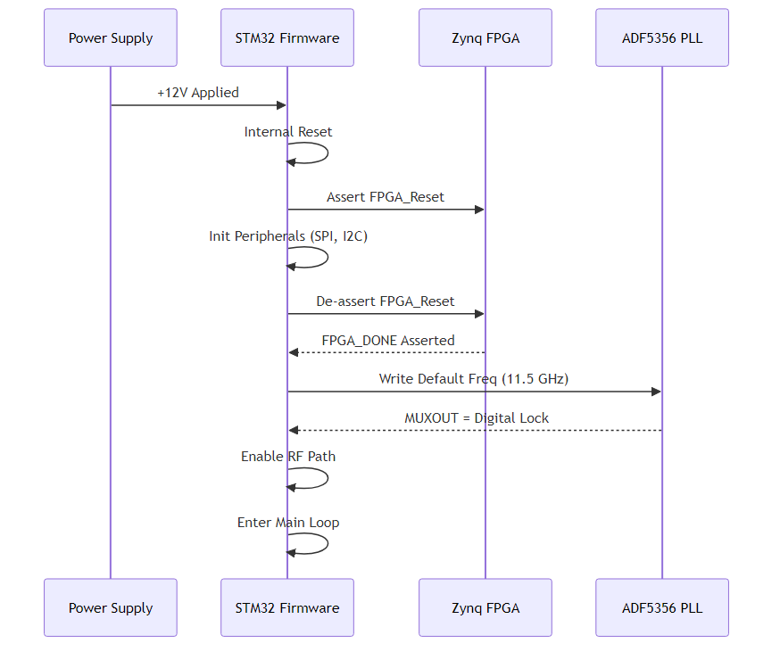
Diagram 2

UART Protocol Interaction
**System Architecture Diagram 3**
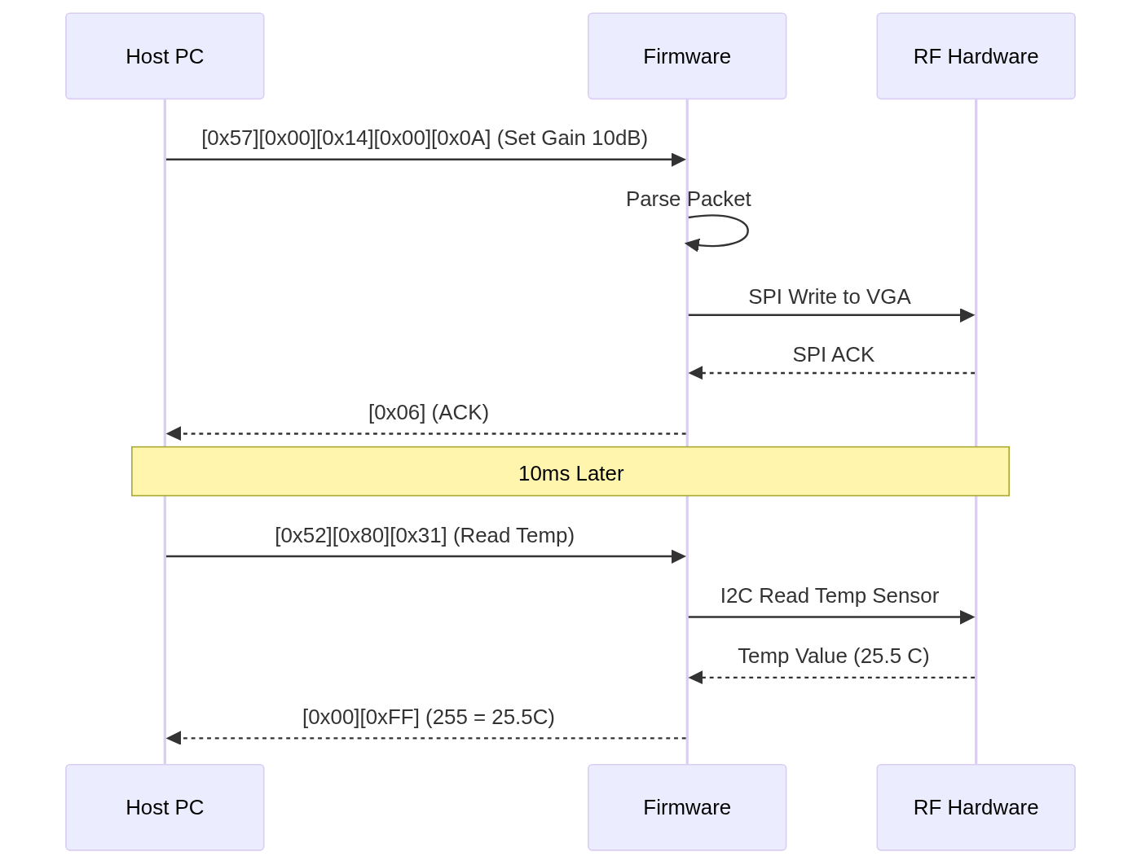
Diagram 3

AGC State Machine
**System Architecture Diagram 4**
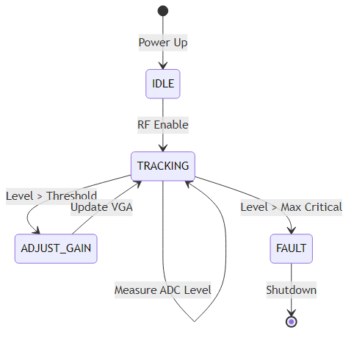
Diagram 4

Software Module Architecture
**System Architecture Diagram 5**
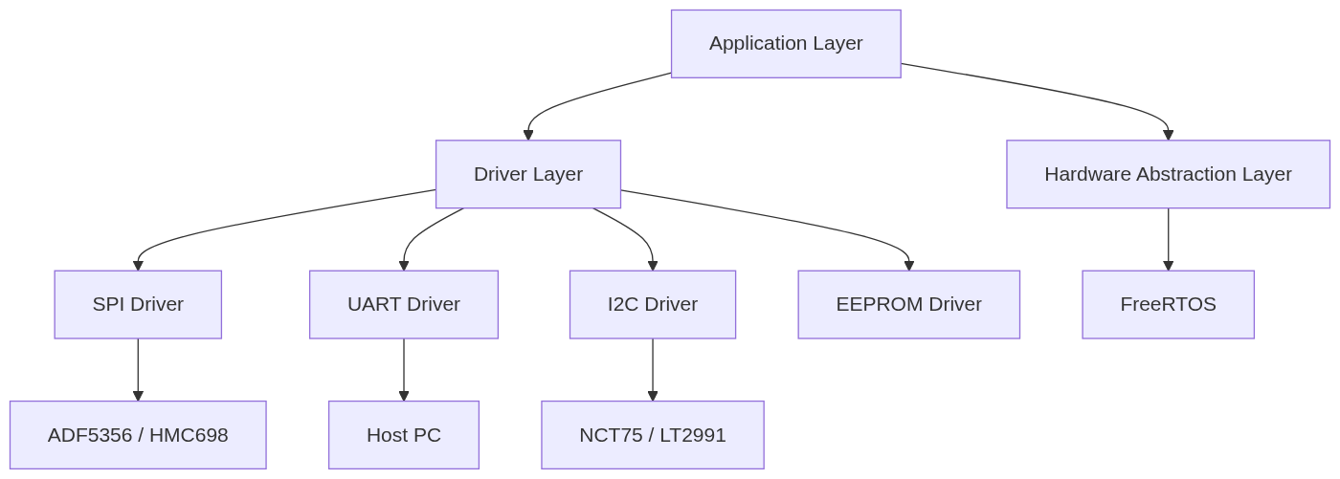
Diagram 5

Interrupt Priority Map
**System Architecture Diagram 6**
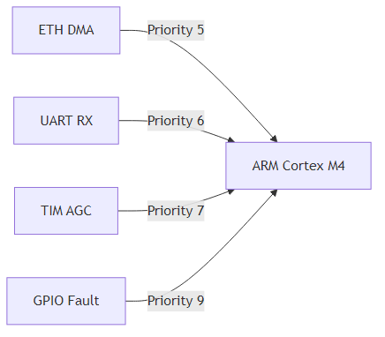
Diagram 6

Appendix D — Acronyms and Glossary
*See Section 1.3.*

Appendix E — Document Revision History
Rev | Date | Author | Description
1.0 | 17 April 2026 | System Architect | Initial Release

