System Block Diagram

rx band
System Architecture Diagram 1
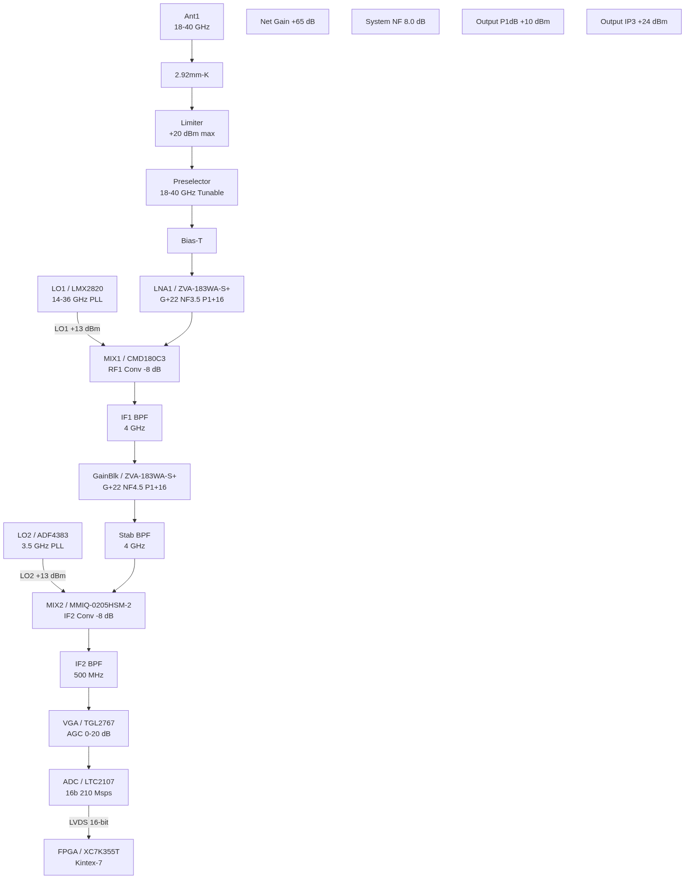
Diagram 1

