VERSION DEFINITION DOCUMENT
FOR
5-18GHz 18-Input and 6-Output Switch Matrix along 2-BITE Input Distribution Module

DOCUMENT TITLE | VERSION DEFINITION DOCUMENT FOR 5-18GHz 18-Input and 6-Output Switch Matrix along 2-BITE Input Distribution Module
DOCUMENT REFERENCE | DP-RFSS-7148-V1-01-VDD-1V00
VERSION NUMBER | 1.00
VERSION DATE | May 11, 2026
PREPARED BY | Name: Abiseck K M  Sign:
DOCUMENT REVIEW BY | Name: Balamurali  Sign:
TECHNICAL REVIEW BY | Name: Sathish kumar K  Sign:
PROCESS REVIEW BY | Name: Balamurali  Sign:
APPROVED BY | Name: Sathish kumar K  Sign:

Copyright by Data Patterns
All right reserved. These materials are proprietary to Data Patterns and no part of these materials should be reproduced, published in any form by any means, electronic or mechanical including photocopy or any information storage or retrieval system nor should the materials be disclosed to third parties without the written authorization of Data Patterns

Revision History
S. NO. | VER. NO. | VER. DATE | CHANGED BY | SECTION (S) CHANGED | DESCRIPTION  OF CHANGE
1 | 0V01 | May 11, 2026 | Abiseck K M | All | Initial
2 | 1V00 | May 11, 2026 | Abiseck K M | - | Baseline to CMO

Table of Contents
1. Scope 1
1.1 Identification 1
2. Unit details 2
3. Programmable file details 3
3.1 Software Check sum 3
3.1.1 Application Executable 3
3.1.2 Library Executable 4
3.1.3 Report Generator Utility Executable 4
3.2 Firmware File Details 5
3.2.1 FPGA/CPLD Programmable Files 5
3.3 Database Details 6
3.3.1 Database 6
4. Source File Details 7
4.1 Software Source 7
4.1.1 Application Source 7
4.1.2 Library Source 8
4.1.3 Application Installer Source 9
4.2 Firmware Source 10
4.2.1 FPGA / CPLD Source 10
5. Tools Details 11
6. Development tools and utilities (For development team only) 12
6.1 Report Generator Templates Output 12
6.1.1 Report Generator Templates 12
6.2 Configuration Definer Executable 12
6.3 Parameter Definer Executable 13
6.3.1 Report Generator Templates 14

Scope
This document specifies the programming file and check sum details of programmable devices in
DP-RFSS-7148 (Switch Matrix) module.

Identification
The following Table provides the title and abbreviation of the system to which this document applies.

Document Reference | DP-RFSS-7148-V1-01-VDD-1V00
Title | Version Definition Document for DP-RFSS-7148
Type ID (Optional) | 01
Module Name | Module name of the product
Version | 1.00
Date | May 11, 2026

Unit details

UNIT INFORMATION

S/No | TITLE | DETAILS
1 | Unit Name | 5-18GHz 18-Input and 6-Output Switch Matrix along 2-BITE Input Distribution Module
2 | Unit Part Number | DP-RFSS-7148-600
3 | Unit Version | 1.00
4 | Unit MOD Details | -

Programmable file details

Software Check sum

Application Executable
S/NO | ITEM | FILE NAME
1 | Executable File | DP-RFSS-7148-V1-01-AO-X86-W10-1V00.zip
1 | CI Reference | DP-RFSS-7148-V1-01-AO-X86-W10-1V00
1 | Version | 1V00
1 | Check sum [MD5] | 9A913BFE4A0C0B5277E7813540DF9E39
1 | Application About box Checksum | 0XFCE9CBB3
1 | Run Time Environment | Architecture | x86
1 | Run Time Environment | OS | Windows 10

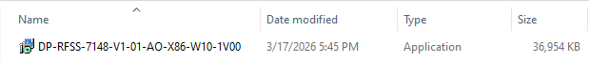
Screen shot of CI Folder:

Library Executable
S/NO | ITEM | FILE NAME
1 | Executable File | DP-RFSS-7148-V1-01-LIBO-X86-W10-1V00.zip
1 | CI Reference | DP-RFSS-7148-V1-01-LIBO-X86-W10-1V00
1 | Version | 1V00
1 | Check sum [MD5] | 8010FE986C5C82DC4E18661BD255EFCC
1 | Run Time Environment | Architecture | x86
1 | Run Time Environment | OS | Windows 10 – 32 bit

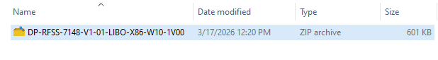
Screen shot of CI Folder:

Report Generator Utility Executable
S/NO | ITEM | FILE NAME
1 | Executable File | DP-RFSS-7148-V1-01-UO-RPTGEN-X86-W10-1V00.7z
1 | CI Reference | DP-RFSS-7148-V1-01-UO-RPTGEN-X86-W10-1V00
1 | Version | 1V00
1 | Check sum [MD5] | 8D3FF611A23B56479D1E38797D549FC2
1 | Run Time Environment | Architecture | x86
1 | Run Time Environment | OS | Windows 10 – 32 bit

Screen shot of CI Folder:
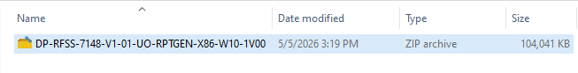

Firmware File Details

FPGA/CPLD Programmable Files
S/NO | ITEM | FILE NAME
1 | File | DP-CRF-7232-V1-07-U14-R1-0006F2DF5.zip
1 | CI Reference | DP-CRF-7232-V1-07-U14-R1-0006F2DF5.mcs
1 | Version | R1
1 | MCS Checksum(MD5) | 87FA3F09D53D83327F44E196DC3D45E3
1 | Read back Checksum | 0006F2DF5
1 | Board ID | DP_CRF_7232
1 | IC Reference | U19
1 | FPGA | XC6SLX9-2TQG144I & U19
1 | PROM | S25FL256SAGNFI001 & U14
1 | Design Tool | Xilinx ISE Design Suite 14.7
1 | JTAG header Reference | JP1
1 | Programming Mode | Serial

Directory of CI bundle reference contains the following files
- DP-CRF-7232-V1-07-U14-R1-0006F2DF5.zip
Screen shot of CI Folder:

Database Details

Database
S/NO | ITEM | FILE NAME
1 | Executable File | DP-RFSS-7148-V1-01-TAB-X86-MariaDB10V2_7-1V00.zip
1 | CI Reference | DP-RFSS-7148-V1-01-TAB-X86-MariaDB10V2_7-1V00
1 | Version | 1V00
1 | Check sum [MD5] | 999BD15A7814ED94B1A231A71849BA1F
1 | Run Time Environment | Architecture | x86
1 | Run Time Environment | Tool | MariaDB
1 | Run Time Environment | Version | 10.2.7
1 | Run Time Environment | OS | Windows 10 – 32 bit

Screen shot of CI Folder:
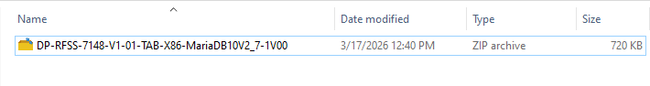

Source File Details

Software Source

Application Source
S/NO | ITEM | FILE NAME
1 | File | DP-RFSS-7148-V1-01-AS-X86-W10-1V00.zip
1 | CI Reference | DP-RFSS-7148-V1-01-AS-X86-W10-1V00
1 | Version | 1V00
1 | Checksum [MD5] | 9A98B4660E00E83797BD718D64FDCC88
1 | Development Environment | Architecture | x86
1 | Development Environment | OS | Windows 10
1 | Development Environment | Compiler Version | MinGW 7.3.0
1 | Development Environment | IDE | Qt Creator 4.11.1
1 | Development Environment | Qt Version | Qt 5.14.2
1 | Run Time Environment | Architecture | X86
1 | Run Time Environment | OS | Windows 10 – 32 bit

Screen shot of CI Folder:
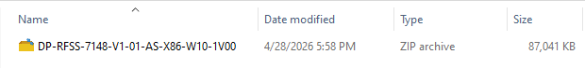

Library Source
S/NO | ITEM | FILE NAME
1 | File | DP-RFSS-7148-V1-01-LIBS-X86-W10-1V00.zip
1 | CI Reference | DP-RFSS-7148-V1-01-LIBS-X86-W10-1V00
1 | Version | 1V00
1 | Checksum [MD5] | 9394EEB3AD4D16E093BBD082DE6B989F
1 | Development Environment | Architecture | x86
1 | Development Environment | OS | Windows 10
1 | Development Environment | Compiler Version | MinGW 7.3.0
1 | Development Environment | IDE | Qt Creator 4.11.1
1 | Development Environment | Qt Version | Qt 5.14.2
1 | Run Time Environment | Architecture | X86
1 | Run Time Environment | OS | Windows 10 – 32 bit

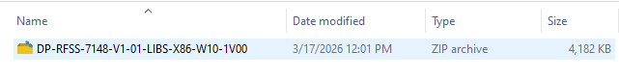
Screen shot of CI Folder:

Report Generator Utility Source
S/NO | ITEM | FILE NAME
1 | File | DP-RFSS-7148-V1-01-US-RPTGEN-X86-W10-1V00.zip
1 | CI Reference | DP-RFSS-7148-V1-01-US-RPTGEN-X86-W10-1V00
1 | Version | 1V00
1 | Checksum [MD5] | 0B7FF3E0C06AF10F3364220A54FB3718
1 | Development Environment | Architecture | x86
1 | Development Environment | OS | Windows 10
1 | Development Environment | Compiler Version | MinGW 7.3.0
1 | Development Environment | IDE | Qt Creator 4.11.1
1 | Development Environment | Qt Version | Qt 5.14.2
1 | Run Time Environment | Architecture | x86
1 | Run Time Environment | OS | Windows 10 – 32 bit

Screen shot of CI Folder:
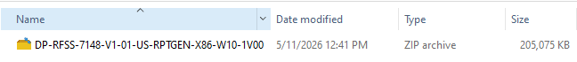

Application Installer Source
S/NO | ITEM | FILE NAME
1 | File | DP-RFSS-7148-V1-01-IS-X86-W10-1V00.zip
1 | CI Reference | DP-RFSS-7148-V1-01-IS-X86-W10-1V00
1 | Version | 1V00
1 | Checksum (Md5) | 24302E71AD20A00496C1C5B342DC6018
1 | Development Environment | Architecture | x86
1 | Development Environment | OS | Windows 10
1 | Development Environment | Compiler Version | Inno Setup 5.5.8
1 | Run Time Environment | Architecture | x86
1 | Run Time Environment | OS & Version | Windows 10 – 32 bit

Screen shot of CI Folder:
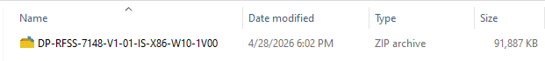

Firmware Source

FPGA / CPLD Source
S/NO | ITEM | FILE NAME
 | CI Reference | DP-CRF-7232-V1-07-GDS-U19-R1.7z
 | Version | R1
 | MCS Checksum(MD5) | 87FA3F09D53D83327F44E196DC3D45E3
 | Read back Checksum | 0006F2DF5
 | Development Environment | Xilinx ISE Design Suite 14.7

Directory of CI bundle reference contains the following files
DP-CRF-7232-V1-07-GDS-U19-R1.7z

Screen shot of CI Folder:

Tools Details
Refer the latest VDD document of DP-RFSS-7139 (Document ID: DP-RFSS-7139-V1-01-VDD-xVyz) for below tools.
- NI- VISA 15.0.1

Refer the latest VDD document of DP-SPL-6976 (Document ID: DP-SPL-6976-V1-01-VDD-ATE-xVyz) for below tools.
- MariaDB 10.11.13

Development tools and utilities (For development team only)
Refer the latest VDD document of DP-RFSS-7139 (Document ID: DP-RFSS-7139-V1-01-VDD-xVyz) for below development tools.
- JasperSoft studio 6.20.6
- JDK21

Report Generator Templates Output

Report Generator Templates
S/NO | ITEM | FILE NAME
1 | Executable File | DP-RFSS-7148-V1-01-UO-RPTTEMP-X86-W10-1V00.zip
1 | CI Reference | DP-RFSS-7148-V1-01-UO-RPTTEMP-X86-W10-1V00
1 | Version | 1V00
1 | Check sum [MD5] | 9F4FFEF477A95FF961C41C433BB6E68C
1 | Run Time Environment | Architecture | x86
1 | Run Time Environment | OS | Windows 10 – 32 bit

Screen shot of CI Folder:
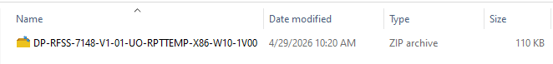

Configuration Definer Executable
S/NO | ITEM | FILE NAME
1 | Executable File | DP-RFSS-7148-V1-01-UO-CFGDEF-X86-W10-1V00.zip
1 | CI Reference | DP-RFSS-7148-V1-01-UO-CFGDEF-X86-W10-1V00
1 | Version | 1V00
1 | Check sum [MD5] | CB78181EC6E1E2BAEAD9C05AE6F83C7F
1 | Run Time Environment | Architecture | x86
1 | Run Time Environment | OS | Windows 10 – 32 bit

Screen shot of CI Folder:
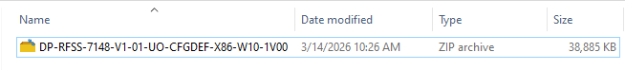

Parameter Definer Executable
S/NO | ITEM | FILE NAME
1 | Executable File | DP-RFSS-7148-V1-01-UO-PARAMDEF-X86-W10-1V00.zip
1 | CI Reference | DP-RFSS-7148-V1-01-UO-PARAMDEF-X86-W10-1V00
1 | Version | 1V00
1 | Check sum [MD5] | 57BD176DB00AB92E6824ED29CA85D6A3
1 | Run Time Environment | Architecture | x86
1 | Run Time Environment | OS | Windows 10 – 32 bit

Screen shot of CI Folder:

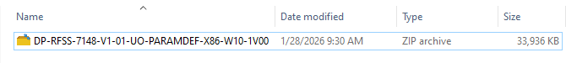

Report Generator Templates
S/NO | ITEM | FILE NAME
1 | File | DP-RFSS-7148-V1-01-US-RPTTEMP-X86-W10-1V00.zip
1 | CI Reference | DP-RFSS-7148-V1-01-US-RPTTEMP-X86-W10-1V00
1 | Version | 1V00
1 | Checksum [MD5] | A007FB4B32EF6247EE8B4EFB7503D679
1 | Development Environment | Architecture | x86
1 | Development Environment | OS | Windows 10 – 32bit
1 | Development Environment | IDE | Jaspersoft Studio 6.20.6
1 | Run Time Environment | Architecture | x86
1 | Run Time Environment | OS | Windows 10 – 32 bit

Screen shot of CI Folder:
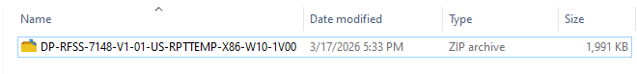

Configuration Definer Utility Source
S/NO | ITEM | FILE NAME
1 | File | DP-RFSS-7148-V1-01-US-CFGDEF-X86-W10-1V00.7z
1 | CI Reference | DP-RFSS-7148-V1-01-US-CFGDEF-X86-W10-1V00
1 | Version | 1V00
1 | Checksum [MD5] | 73D5FA3BF1003F6EB9FB877AC09529D4
1 | Development Environment | Architecture | x86
1 | Development Environment | OS | Windows 10
1 | Development Environment | Compiler Version | MinGW 7.3.0
1 | Development Environment | IDE | Qt Creator 4.11.1
1 | Development Environment | Version | Qt 5.14.2 MinGW 32-bit
1 | Run Time Environment | Architecture | x86
1 | Run Time Environment | OS | Windows 10 – 32 bit

Screen shot of CI Folder:
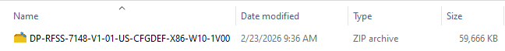

Parameter Definer Utility Source
S/NO | ITEM | FILE NAME
1 | File | DP-RFSS-7148-V1-01-US-PARAMDEF-X86-W10-1V00.7z
1 | CI Reference | DP-RFSS-7148-V1-01-US-PARAMDEF-X86-W10-1V00
1 | Version | 1V00
1 | Checksum [MD5] | 46381EEC972F8ECEAA5C92C50AF44168
1 | Development Environment | Architecture | x86
1 | Development Environment | OS | Windows 10
1 | Development Environment | Compiler Version | MinGW 7.3.0
1 | Development Environment | IDE | Qt Creator 4.11.1
1 | Development Environment | Version | Qt 5.14.2 MinGW 32-bit
1 | Run Time Environment | Architecture | x86
1 | Run Time Environment | OS | Windows 10 – 32 bit

Screen shot of CI Folder:
