Computer Networks (CCNA)
Server Virtualization & Cloud Computing
Exam-focused revision notes with original slide diagrams

Topics covered
- Server hardware and servers before virtualization
- Virtualization: Type 1 vs Type 2 hypervisors, why virtualize
- Connecting VMs to the network (vNIC, vSwitch, VLANs, trunks)
- Cloud services: on-premises vs colocation vs cloud
- NIST SP 800-145: 5 characteristics, 3 service models, 4 deployment models
- Benefits of cloud computing and how to connect to cloud resources
- Quick revision, exam points, and doubts

Colour guide: red bold = important keyword · yellow box = definition · green box = exam tip · 📷 = original slide.
Note: these slides contain no Cisco IOS commands. One optional, clearly-labelled switch-side example is added in the vSwitch section because it is commonly asked alongside this topic.

1. Server Hardware

1. Concept
A server is a powerful computer that provides services (web, email, database, file sharing) to clients such as PCs. Physical servers are built to run non-stop and are usually mounted in racks in a data center.

Key Points
- Cisco is best known for routers, switches and firewalls, but it also sells hardware servers called UCS (Unified Computing System).
- Largest server vendors: Dell EMC, HPE, IBM.
- The image shows common server shapes: thin rack-mount servers (1U / 2U) and a blade chassis holding many server blades in one enclosure.

Example
PC → Access Switch → Router → Server. When you open the company website, your request travels through the network to a physical server in a rack that runs the web application.

📷 Image / Diagram
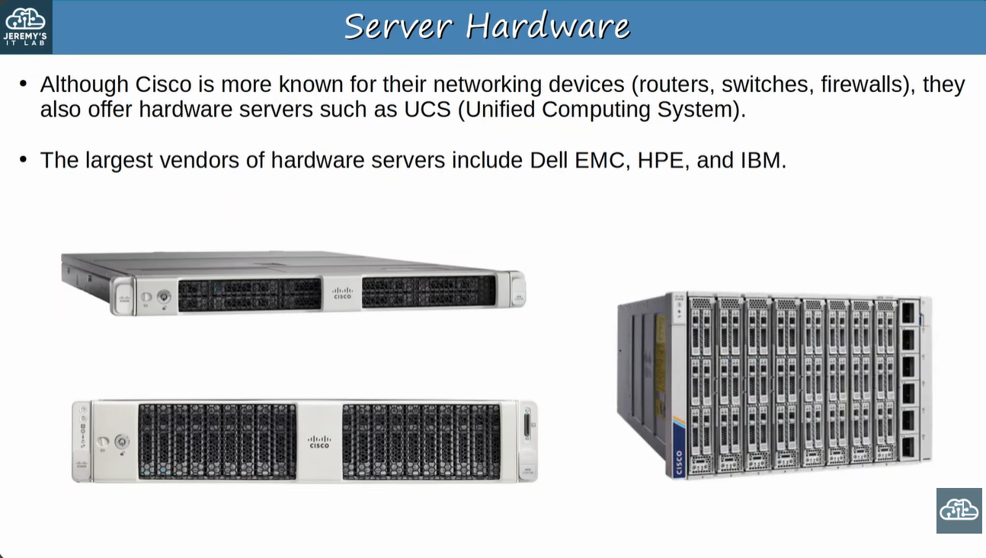
Slide: Server Hardware (Cisco UCS rack servers and blade chassis)

2. Servers Before Virtualization

1. Concept
Before virtualization there was a strict one physical server = one operating system relationship. Each service ran on its own box.

Key Points
- Stack (bottom to top): Hardware (CPU, RAM, Storage, NIC) → Operating System → Apps (web server, email server, etc.).
- Typical design: one server for web, one for email, one for database.
- Problem 1 – Cost: every physical server is expensive and uses space, power and cooling.
- Problem 2 – Under-utilised: CPU, RAM, storage and NIC on each server are mostly idle.

Example
A company has 3 servers (web, email, database). Each uses only a small part of its hardware, yet the company pays for, powers and cools all three. Virtualization lets all three run on one machine.

📷 Image / Diagram
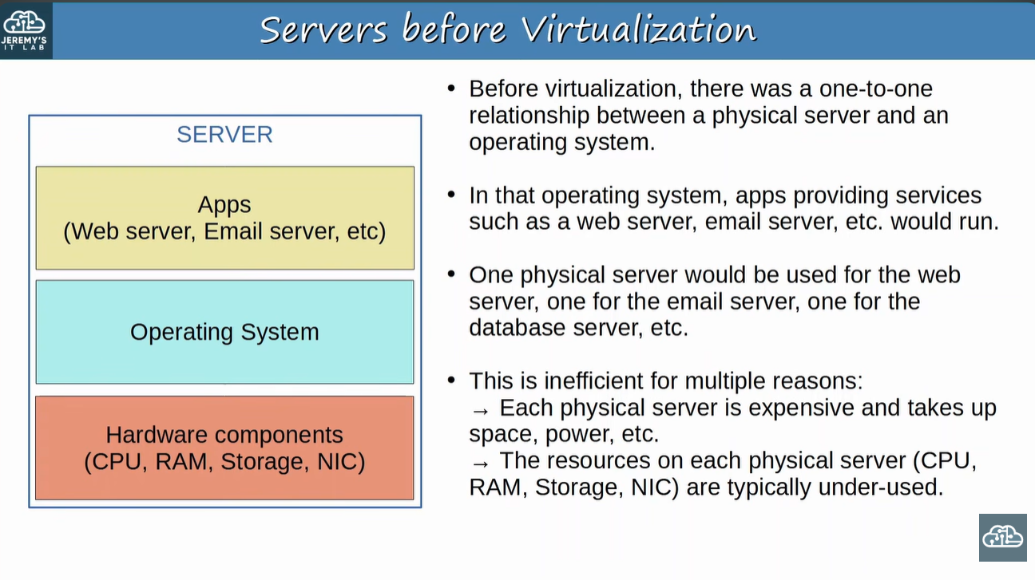
Slide: Servers before Virtualization

3. Virtualization and Type 1 Hypervisor

1. Concept
Virtualization: breaks the one-to-one link between hardware and OS so that multiple operating systems run on a single physical server.
Hypervisor: software that manages and allocates hardware resources (CPU, RAM, etc.) to each VM. Also called VMM (Virtual Machine Monitor).

Key Points
- Each OS instance is a VM (Virtual Machine) with its own OS and apps.
- Type 1 hypervisor runs directly on the hardware, with no OS underneath.
- Also called bare-metal or native hypervisor.
- Examples: VMware ESXi, Microsoft Hyper-V.
- This is the type used in data centers.

Example
One physical server runs ESXi. On it you create 3 VMs: a web VM, an email VM and a database VM. ESXi decides how much CPU and RAM each VM gets.

📷 Image / Diagram
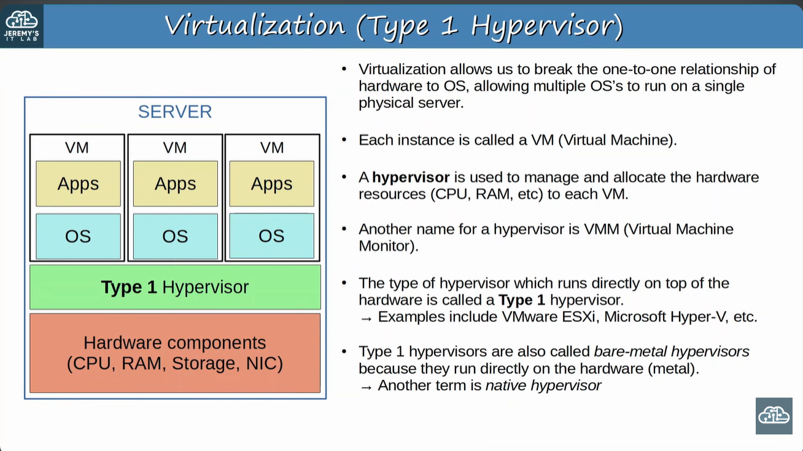
Slide: Virtualization (Type 1 Hypervisor)

4. Type 2 Hypervisor

1. Concept
A Type 2 hypervisor is installed like a normal program on top of an existing operating system. The VMs then run inside that program.

Key Points
- Examples: VMware Workstation, Oracle VirtualBox.
- The OS running directly on hardware = Host OS. The OS inside a VM = Guest OS.
- Also called hosted hypervisor.
- Rarely used in data centers, but common on personal devices, for example a Mac/Linux user who needs an app that only runs on Windows (or vice versa).
- Normal apps can run on the Host OS beside the hypervisor (the single "Apps" box in the diagram).

Comparison: Type 1 vs Type 2
Feature | Type 1 Hypervisor | Type 2 Hypervisor
Runs on | Directly on hardware | On top of a Host OS
Other names | Bare-metal, native | Hosted hypervisor
Examples | VMware ESXi, Microsoft Hyper-V | VMware Workstation, Oracle VirtualBox
Typical use | Data centers / servers | Personal computers / labs
OS in VM | Guest OS | Guest OS (OS on hardware = Host OS)
Layers (bottom → top) | Hardware → Hypervisor → VMs | Hardware → Host OS → Hypervisor → VMs

🎯 Exam tip: "Which hypervisor runs directly on hardware?" → Type 1. "Which needs a host OS?" → Type 2. Remember: Type 1 = 1st layer above hardware.

📷 Image / Diagram
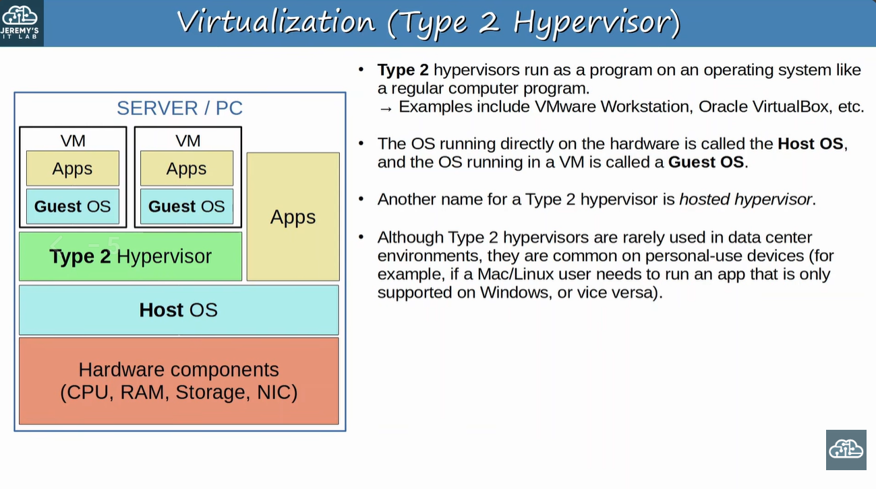
Slide: Virtualization (Type 2 Hypervisor)

5. Why Virtualization?

1. Concept
VMware lists four core properties of virtualization, plus a set of business benefits.

Key Points
Property | Meaning | Easy example
Partitioning | Run multiple OSs on one physical machine and divide resources between VMs. | One server hosts Windows and Linux VMs together.
Isolation | Fault and security isolation at hardware level; resource controls preserve performance. | If VM1 crashes or is infected, VM2 keeps running.
Encapsulation | Entire VM state is saved to files; move/copy a VM like moving/copying files. | Copy a VM file to another server as a backup.
Hardware independence | Provision or migrate any VM to any physical server. | Move a VM from an old server to a new one with different hardware.

📷 Image / Diagram
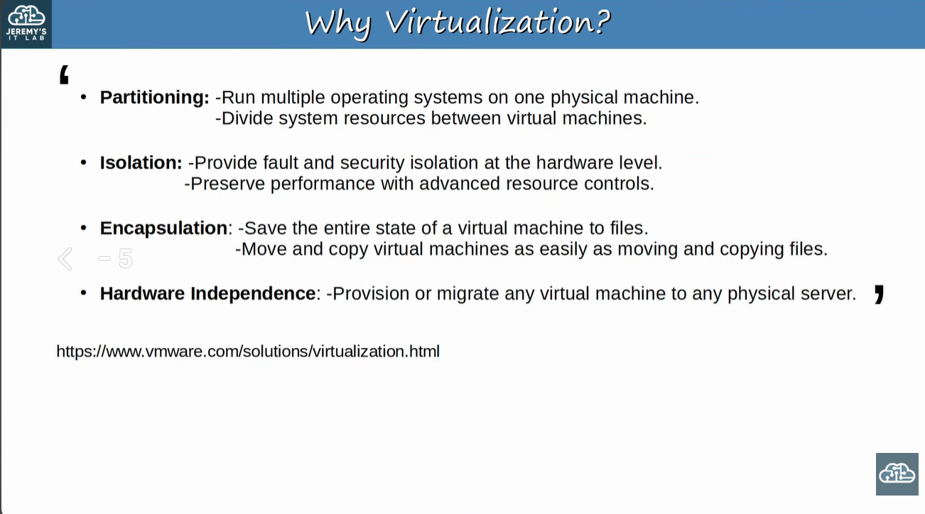
Slide: Why Virtualization? (four properties)

Business Benefits (second slide)
- Reduced capital and operating costs (fewer servers, less power and space).
- Minimized or eliminated downtime.
- Increased IT productivity, efficiency, agility and responsiveness.
- Faster provisioning of applications and resources.
- Greater business continuity and disaster recovery.
- Simplified data center management.
- Availability of a true Software-Defined Data Center.
🎯 Exam tip: Learn the four property names with the memory word P-I-E-H: Partitioning, Isolation, Encapsulation, Hardware independence.

📷 Image / Diagram
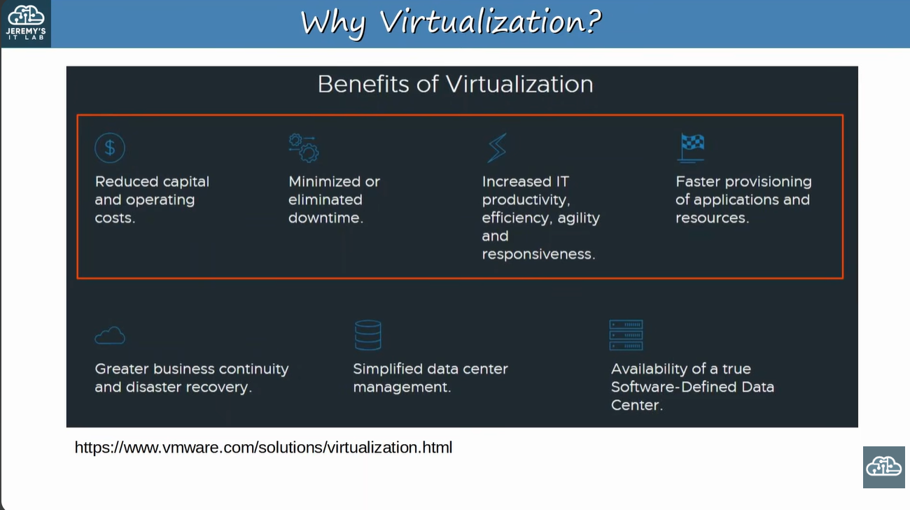
Slide: Benefits of Virtualization

6. Connecting VMs to the Network

1. Concept
VMs talk to each other and to the outside network through a virtual switch (vSwitch) that runs inside the hypervisor. It behaves like a normal Layer 2 switch.

Key Points
- Each VM has a virtual network card, the vNIC, which connects to a port on the vSwitch.
- vSwitch ports can be access ports or trunk ports and use VLANs to separate VMs at Layer 2.
- Other vSwitch interfaces connect to the server's physical NIC(s), which reach the external network (the physical switches).
- In the diagram: two VMs are in VLAN 10, one is in VLAN 20. The vSwitch uplinks are trunks that carry both VLANs to the physical switches. The two NIC links appear grouped as one logical trunk for redundancy and bandwidth.

Example
VM1 and VM2 (both VLAN 10) communicate directly through the vSwitch at Layer 2. VM3 (VLAN 20) cannot talk to them unless a router / Layer 3 switch performs inter-VLAN routing. Path to the outside: VM → vNIC → vSwitch → trunk → physical NIC → physical switch → router.

Related Cisco configuration (extra – not on the slide)
The physical switch port facing the hypervisor host is normally a trunk so it can carry VLANs 10 and 20. Configured on the physical switch in interface configuration mode:
Switch(config)# interface GigabitEthernet0/1
Switch(config-if)# switchport mode trunk
Switch(config-if)# switchport trunk allowed vlan 10,20
switchport mode trunk makes the port a trunk. switchport trunk allowed vlan 10,20 limits the trunk to VLANs 10 and 20. On older Catalyst models you may first need switchport trunk encapsulation dot1q.

📷 Image / Diagram
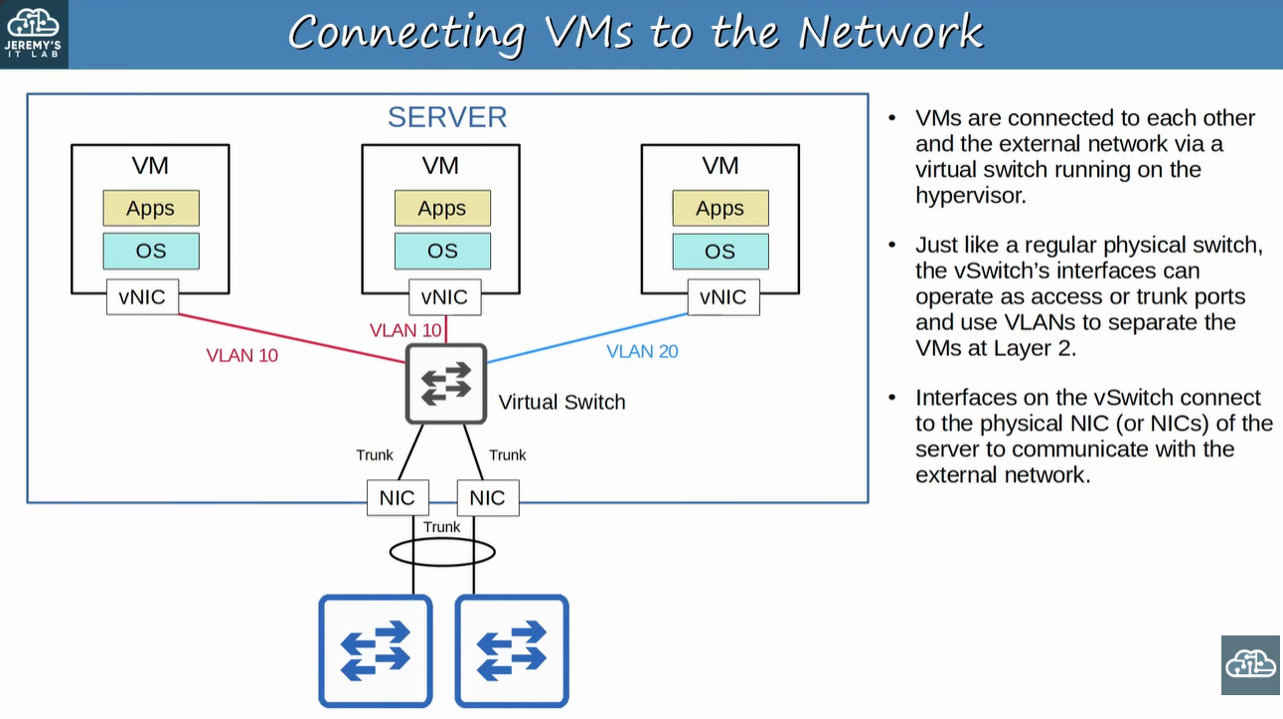
Slide: Connecting VMs to the Network (vNIC, vSwitch, VLANs, trunks)

7. Cloud Services: On-Premises, Colocation, Cloud

1. Concept
Traditional IT used some mix of on-premises and colocation. Cloud services are a very popular alternative and still growing.

Key Points
Feature | On-Premises | Colocation | Cloud
Where is equipment? | On company property | In a rented space in a data center | In the provider's data centers
Who owns equipment? | Company | Customer | Provider
Space, power, cooling | Company is responsible | Data center provides | Provider handles
Servers / network devices | Company manages | Still customer's responsibility | Consumed as a service

- Most people think "cloud" means public cloud providers such as AWS, but that is only one use of cloud services.

📷 Image / Diagram
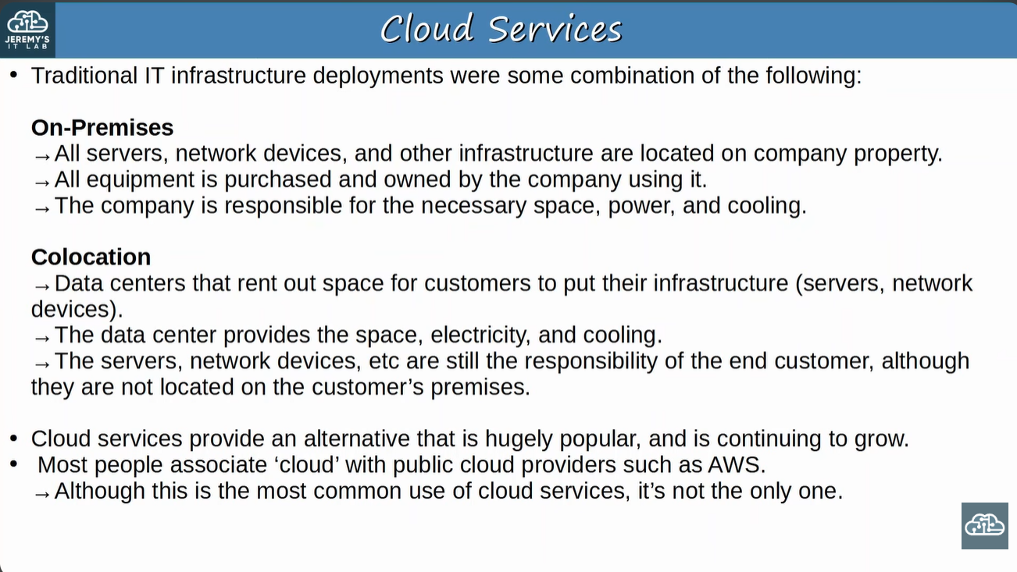
Slide: Cloud Services (on-premises and colocation)

8. NIST Definition of Cloud Computing

1. Concept
NIST SP 800-145: Cloud computing is a model for ubiquitous, convenient, on-demand network access to a shared pool of configurable computing resources (networks, servers, storage, applications, services) that can be rapidly provisioned and released with minimal management effort or service provider interaction.

Key Points
- Defined by the American NIST (National Institute of Standards and Technology) in Special Publication 800-145 (free to read).
- The model has 5 essential characteristics, 3 service models, 4 deployment models.
🎯 Exam tip: Remember the numbers 5 – 3 – 4.

📷 Image / Diagram
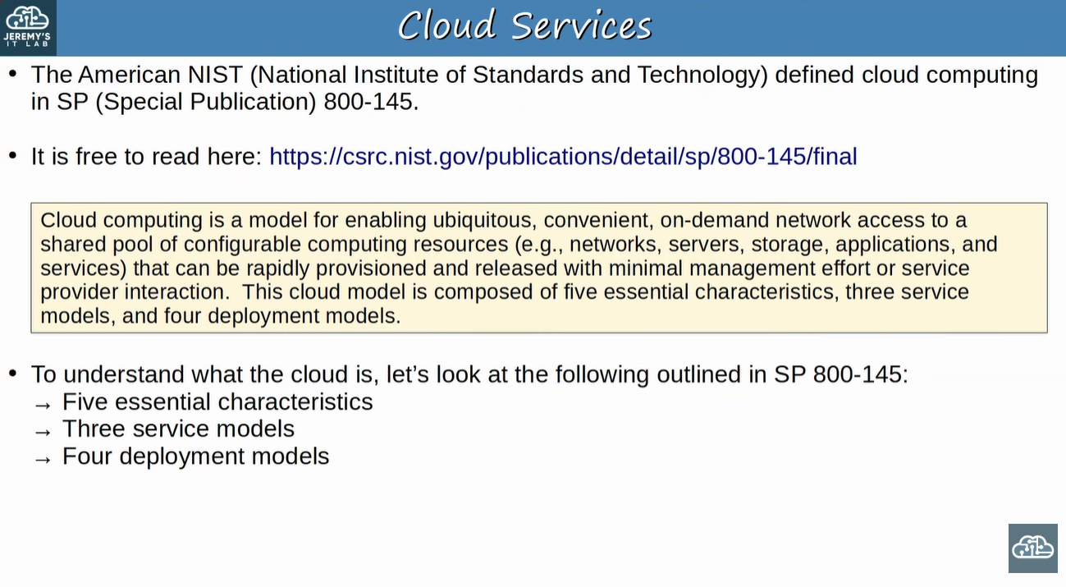
Slide: Cloud Services (NIST SP 800-145 definition)

9. Five Essential Characteristics of Cloud

1. Concept
Five features that a service must have to be called cloud computing: On-demand self-service, Broad network access, Resource pooling, Rapid elasticity, Measured service.

Key Points
Characteristic | Meaning | Easy example
On-demand self-service | Customer provisions (or stops) resources automatically, via a web portal, without human interaction with the provider. | Create a VM from a web console in minutes, no phone call.
Broad network access | Service is available over the network (Internet or private WAN) from many device types (phones, tablets, laptops, workstations). | Open your cloud email from a phone or a laptop.
Resource pooling | Provider resources are pooled for multiple customers (multi-tenant) and dynamically assigned by demand. Customer usually does not know exact location (may pick country/region). | A new VM gets CPU/RAM from the provider's shared pool.
Rapid elasticity | Resources scale out and in quickly, even automatically, to match demand. | Add servers for a sale day, remove them afterwards.
Measured service | Usage is monitored, controlled and reported, so you pay for what you use. | Billing per hour of VM or per GB stored.

Rapid elasticity and measured service have no separate slide in this set; their meaning above is from the NIST definition and they appear in the summary slide (section 12).

On-Demand Self-Service
The customer can start or stop using the service freely through a web portal, with no direct communication with the provider.

📷 Image / Diagram
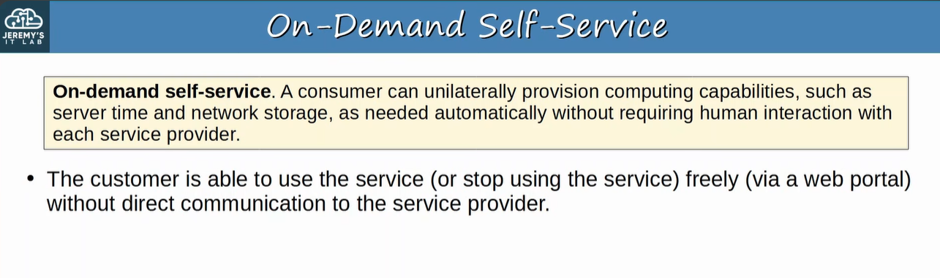
Slide: On-Demand Self-Service

Broad Network Access
Service is reachable through standard network connections (Internet or private WAN) from many kinds of devices.

📷 Image / Diagram
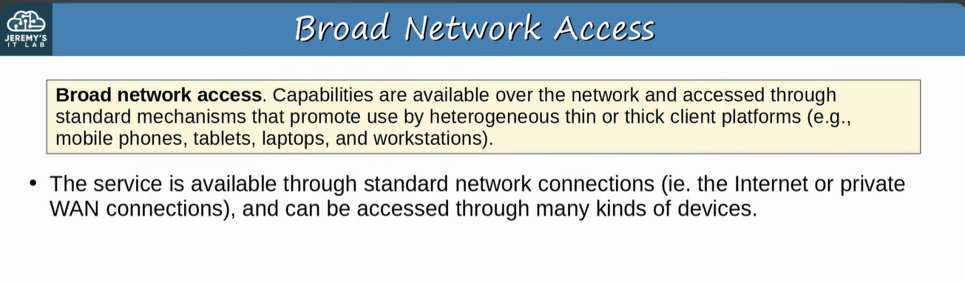
Slide: Broad Network Access

Resource Pooling
A shared pool of resources is provided by the provider. When a customer requests a service (for example, creates a new VM), resources are allocated from that pool. Different customers share the same physical hardware (multi-tenant).

📷 Image / Diagram
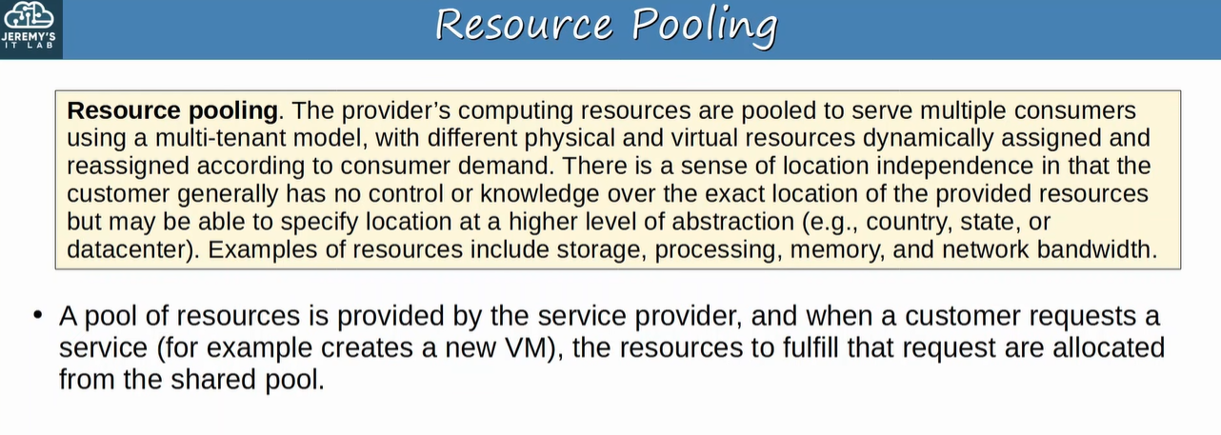
Slide: Resource Pooling

10. Three Service Models: SaaS, PaaS, IaaS

1. Concept
In cloud, everything is offered as a service ("___ as a Service" or "__aaS"). Instead of buying a server, racking it, installing a hypervisor and creating VMs, the provider offers all of that as a service.

Key Points
- SaaS – Software as a Service
- PaaS – Platform as a Service
- IaaS – Infrastructure as a Service

📷 Image / Diagram
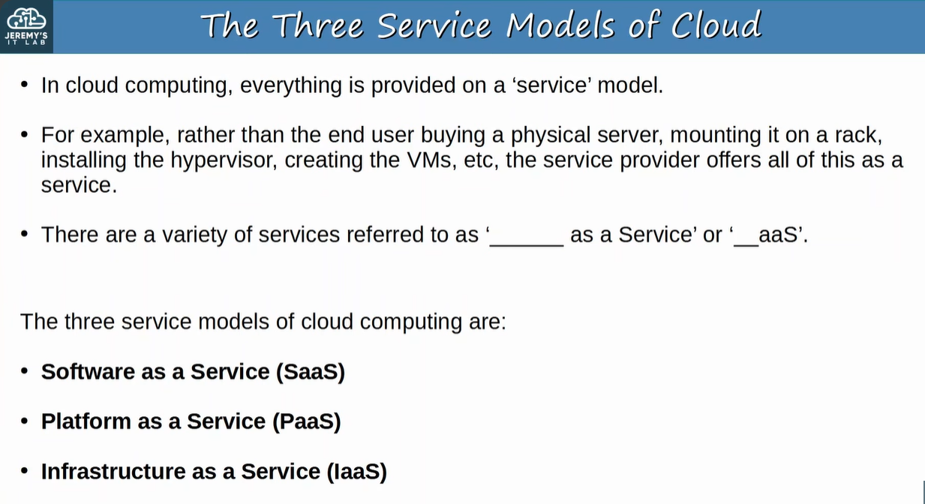
Slide: The Three Service Models of Cloud

Software as a Service (SaaS)
SaaS: consumer uses the provider's applications running on cloud infrastructure, through a web browser or program interface. Consumer does not manage network, servers, OS, storage, or even individual app capabilities (except limited user settings).
- Example: Microsoft Office 365. In the diagram the SaaS bracket covers all layers, so the provider manages everything.

📷 Image / Diagram
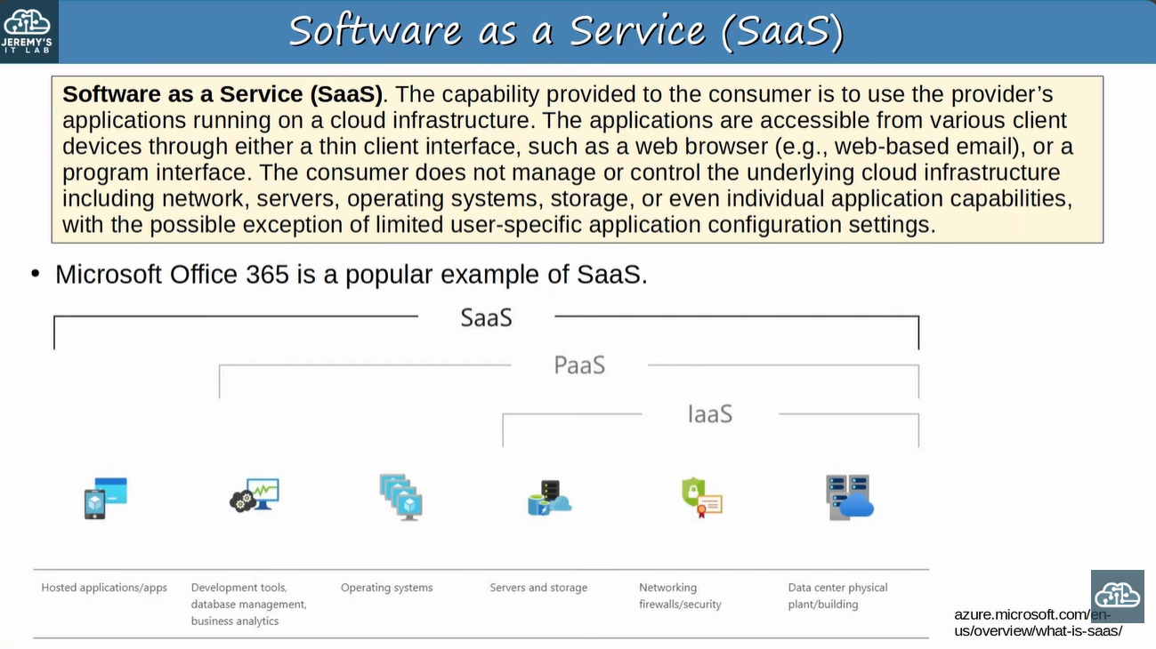
Slide: Software as a Service (SaaS) with the SaaS / PaaS / IaaS stack diagram

Platform as a Service (PaaS)
PaaS: consumer deploys their own (or acquired) applications onto the cloud using languages, libraries, services and tools supported by the provider. Consumer does not manage network, servers, OS or storage, but controls the deployed applications and some hosting-environment settings.
- Examples: AWS Lambda, Google App Engine.

📷 Image / Diagram
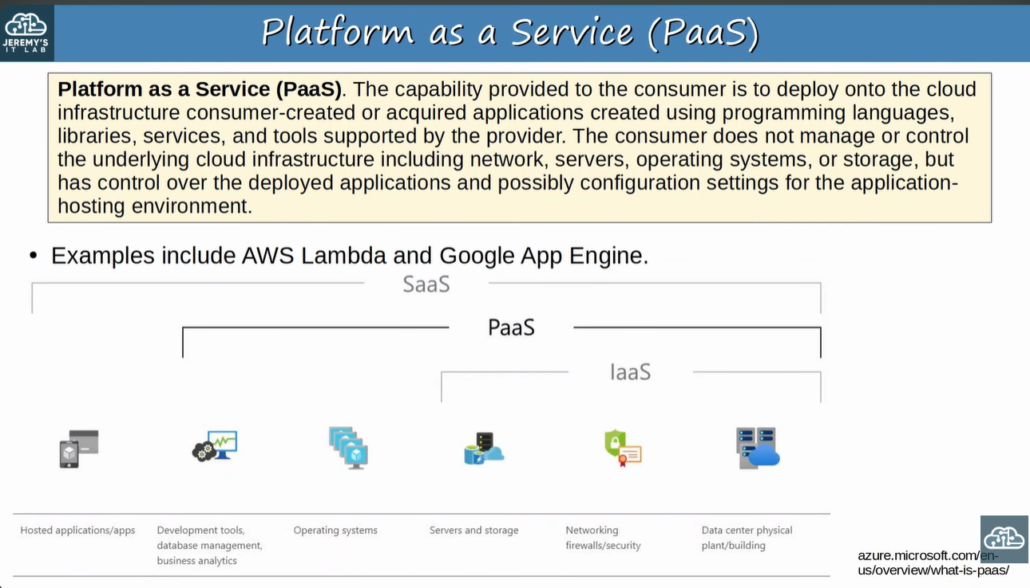
Slide: Platform as a Service (PaaS)

Infrastructure as a Service (IaaS)
IaaS: consumer provisions processing, storage, networks and other fundamental resources and can run arbitrary software, including operating systems. Consumer does not manage the underlying infrastructure but controls the OS, storage, deployed applications and possibly limited networking (e.g., host firewalls).
- Examples: Amazon EC2, Google Compute Engine.

📷 Image / Diagram
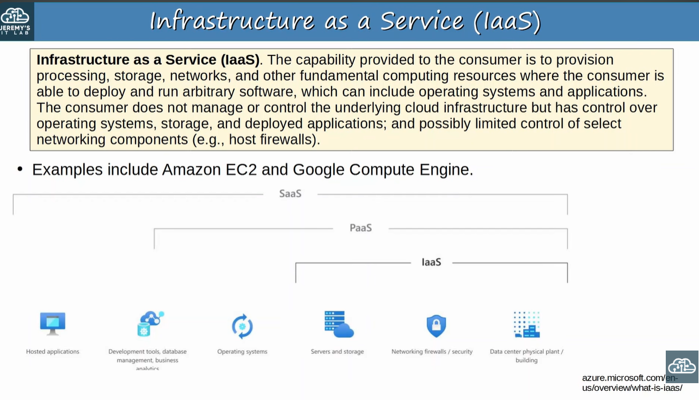
Slide: Infrastructure as a Service (IaaS)

Comparison: who manages what?
Layer (from the diagram) | SaaS | PaaS | IaaS
Hosted applications / apps | Provider | You | You
Dev tools, database mgmt, business analytics | Provider | Provider | You
Operating systems | Provider | Provider | You
Servers and storage | Provider | Provider | Provider
Networking, firewalls / security | Provider | Provider | Provider
Data center physical plant / building | Provider | Provider | Provider
Example | Office 365 | AWS Lambda, Google App Engine | Amazon EC2, Google Compute Engine

🎯 Exam tip: IaaS = most control for you (you run the OS). SaaS = least control (just use the app). PaaS = in the middle (you bring the app/code). Quick match: Office 365 → SaaS, Lambda → PaaS, EC2 → IaaS.

11. Four Deployment Models of Cloud

1. Concept
Most people think "cloud" = public cloud (AWS, Azure, GCP). Public cloud is the most common deployment model, but not the only one.

Key Points
Model | Meaning (NIST)
Private cloud | Cloud infrastructure used by a single organization (may be owned/operated by the organization or a third party, on or off premises).
Community cloud | Used by a specific community of organizations with shared concerns (e.g., same mission or security requirements).
Public cloud | Open for use by the general public; owned by a provider such as AWS, Azure, GCP.
Hybrid cloud | Combination of two or more of the above infrastructures that stay separate but are connected.

The slide lists only the four names; the meanings above are from the NIST definition.

📷 Image / Diagram
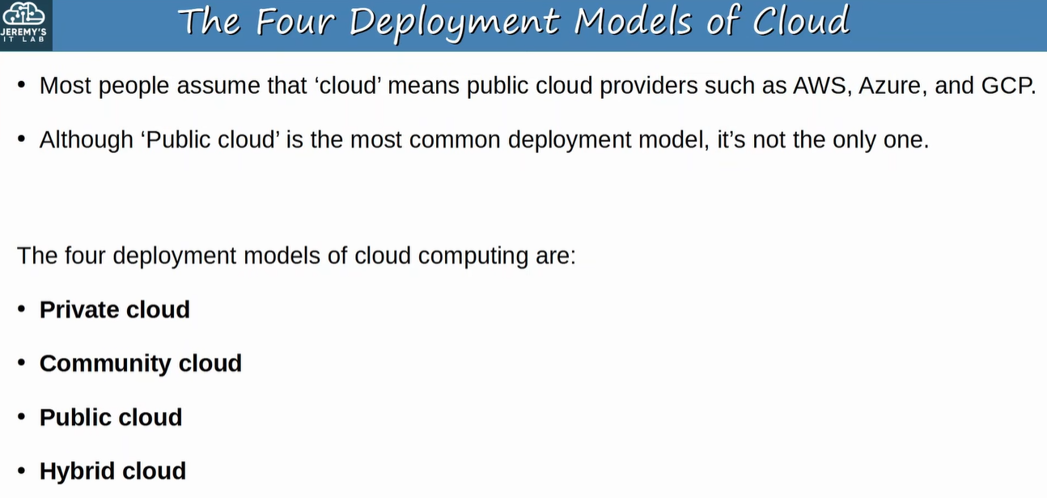
Slide: The Four Deployment Models of Cloud

12. Cloud Summary Slide

1. Concept
One-page summary of the whole NIST cloud model. Memorise this slide.

Key Points
5 Characteristics | 3 Service Models | 4 Deployment Models
On-demand self-service | Software as a Service (SaaS) | Private cloud
Broad network access | Platform as a Service (PaaS) | Community cloud
Resource pooling | Infrastructure as a Service (IaaS) | Public cloud
Rapid elasticity |  | Hybrid cloud
Measured service

📷 Image / Diagram
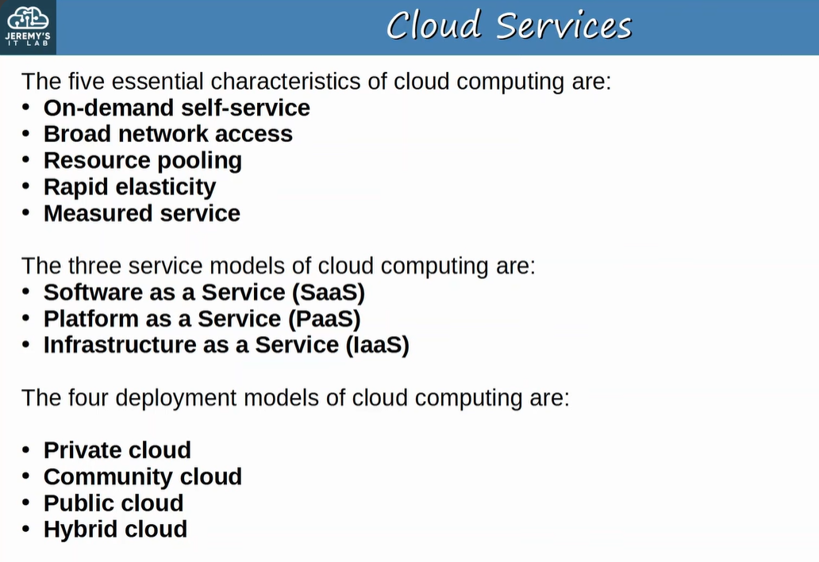
Slide: Cloud Services (summary of characteristics, service models, deployment models)

13. Benefits of Cloud Computing

1. Concept
Why companies move to cloud instead of building everything on-premises.

Key Points
Benefit | Explanation
Cost | CapEx (capital expenses) for hardware, software and data centers is reduced or eliminated.
Global scale | Services scale worldwide quickly and can be offered from a location close to customers. (The slide spells it "Glocal Scale".)
Speed / Agility | Services are on demand; vast resources can be provisioned within minutes.
Productivity | Removes time-consuming tasks: buying servers, racking, cabling, installing and updating OSs.
Reliability | Backups are easy; data can be mirrored at multiple geographic sites for disaster recovery.

🎯 Exam tip: CapEx = money spent up front on equipment. Cloud shifts spending from CapEx to pay-as-you-go OpEx (operating expense).

📷 Image / Diagram
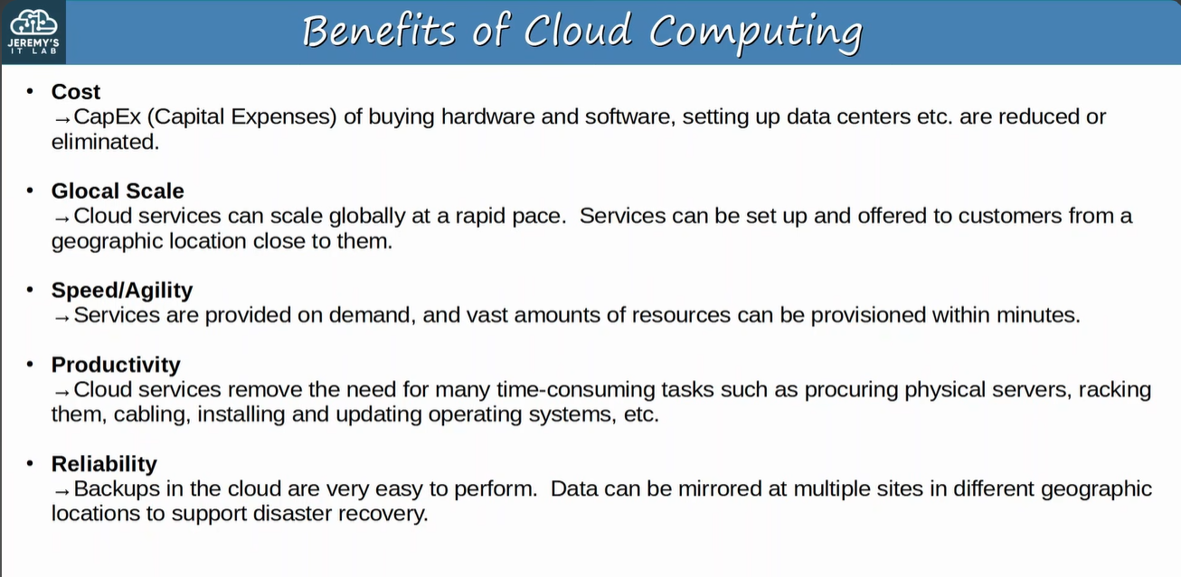
Slide: Benefits of Cloud Computing

14. Connecting to Cloud Resources

1. Concept
An enterprise network can reach cloud resources in three ways, shown in the diagram from top to bottom.

Key Points
Method | How it works | Notes
Private WAN | Enterprise router → Private WAN service provider → cloud router. | Dedicated private path, predictable performance; usually more expensive.
Internet | Enterprise router → Internet → cloud router. | Cheap and simple, but traffic is not protected by itself.
IPsec VPN over Internet | An IPsec VPN tunnel is built through the Internet between enterprise and cloud routers. | Internet cost plus encryption for security.

Example
PC → Switch → Enterprise router → (Private WAN or Internet or IPsec tunnel over Internet) → Cloud router → Cloud server (VM).

📷 Image / Diagram
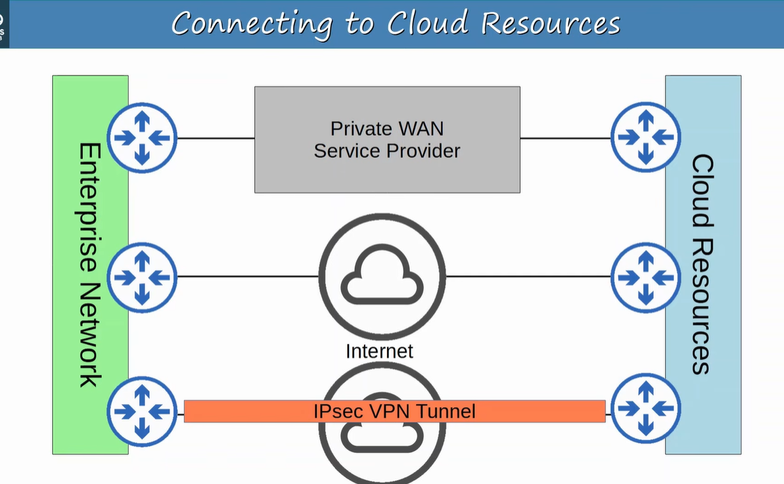
Slide: Connecting to Cloud Resources (Private WAN, Internet, IPsec VPN)

Quick Revision

Virtualization
- Before virtualization: 1 server = 1 OS; wasteful and under-used.
- VM = virtual machine; hypervisor (VMM) allocates CPU/RAM to VMs.
- Type 1 = bare-metal, on hardware, data centers (ESXi, Hyper-V). Type 2 = hosted, on Host OS, personal use (VMware Workstation, VirtualBox).
- Four properties: Partitioning, Isolation, Encapsulation, Hardware independence.
- VMs connect through vNIC → vSwitch → physical NIC; vSwitch uses VLANs, access and trunk ports.

Cloud
- Defined by NIST SP 800-145: 5 characteristics, 3 service models, 4 deployment models.
- Characteristics: On-demand self-service, Broad network access, Resource pooling, Rapid elasticity, Measured service.
- Service models: SaaS (Office 365), PaaS (AWS Lambda, Google App Engine), IaaS (EC2, Compute Engine).
- Deployment: Private, Community, Public, Hybrid.
- Connect to cloud: Private WAN, Internet, IPsec VPN.

Exam Points
- Type 1 vs Type 2 is a very common question: look for "runs directly on hardware" (Type 1) or "Host OS" (Type 2).
- Hypervisor = VMM. Another name for Type 1 = bare-metal / native. Another name for Type 2 = hosted.
- A vSwitch lives inside the hypervisor and works like a Layer 2 switch with VLANs.
- Match examples to service models: EC2 = IaaS, Lambda / App Engine = PaaS, Office 365 = SaaS.
- Resource pooling involves multi-tenancy; measured service means pay-per-use.
- Colocation: data center supplies space, power, cooling, but customer owns and manages the equipment.
- IPsec VPN gives an encrypted tunnel across the Internet, a cheaper alternative to a private WAN.

Revision Comments & Doubts
- The slide heading "Glocal Scale" is most likely a typo for Global Scale.
- AWS Lambda is classed as PaaS on the slides; many other sources call it serverless / FaaS. Use the slide answer for this course.
- Rapid elasticity and measured service were only listed in the summary slide; revise their meanings from section 9.
- Deployment model meanings (private, community, public, hybrid) are added from NIST, not shown in detail on the slides.

