NTP & Router Clock
Computer Networks (CCNA) — Short Revision Notes

1. Why Time Matters

What?
Every device has an internal clock. View it with show clock. Default zone is UTC.
⭐ Important: Accurate time is mainly needed for accurate logs (Syslog) for troubleshooting.
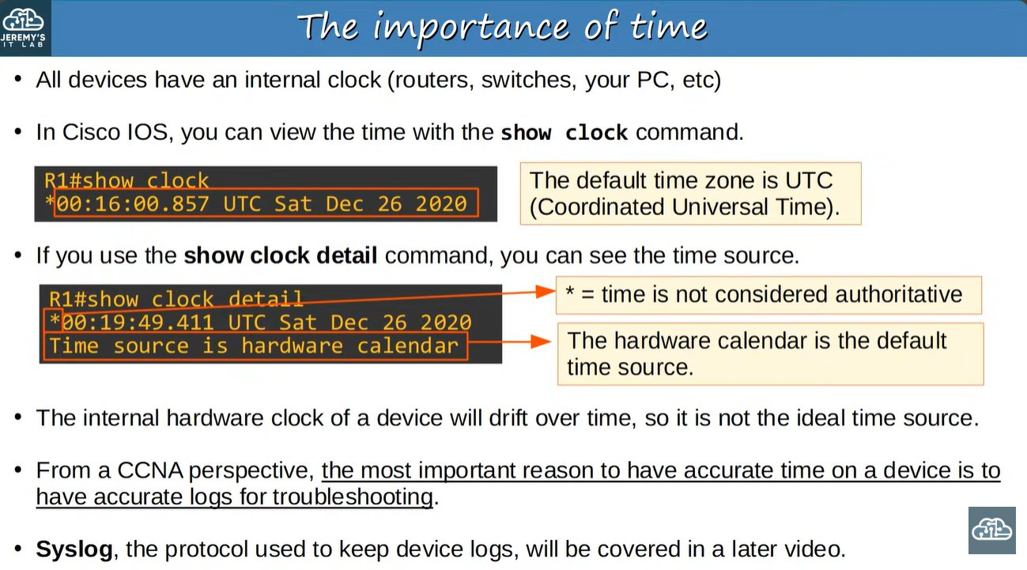 | 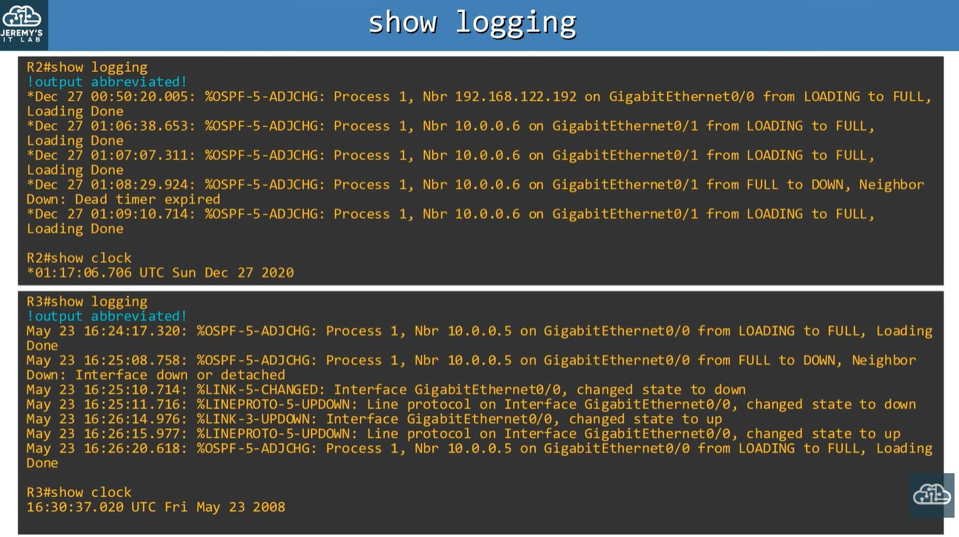
show clock / show clock detail | show logging (wrong clocks = confusing logs)
- * before the time = time is not authoritative.
- show clock detail shows the time source: hardware calendar (default), user configuration, or NTP.
- Hardware clock drifts, so it is not an ideal source.
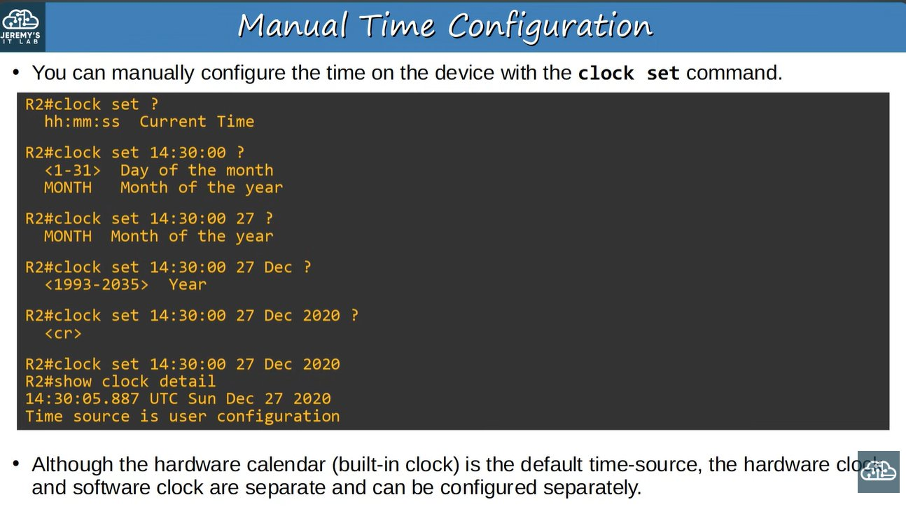 | 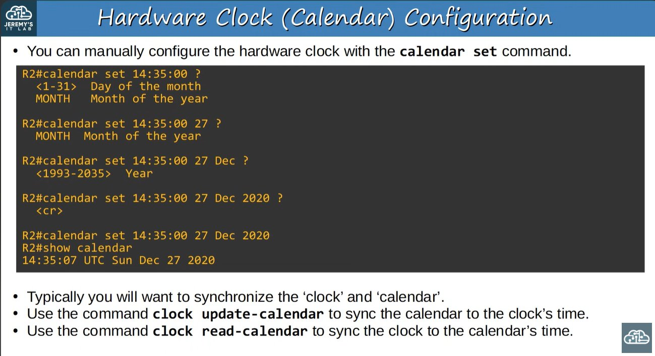
Manual time: clock set (with ? help) | calendar set

2. Clock vs Calendar
Clock | Calendar
Software clock, used by IOS | Hardware clock, survives reboot / power loss
clock set | show clock | calendar set | show calendar
Lost on reboot | Used to initialize the clock at boot

R1# show clock detail
R1# clock set 14:30:00 27 Dec 2020 ! software clock
R1# calendar set 14:35:00 27 Dec 2020 ! hardware clock
R1# clock update-calendar ! clock -> calendar
R1# clock read-calendar ! calendar -> clock

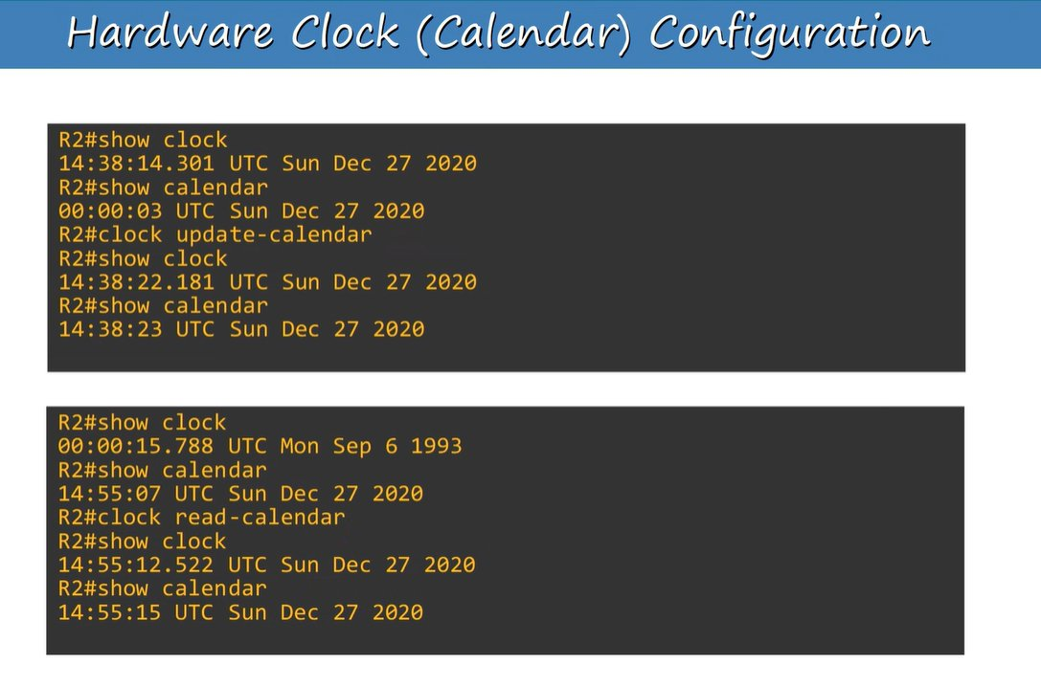
Syncing clock and calendar: update-calendar and read-calendar
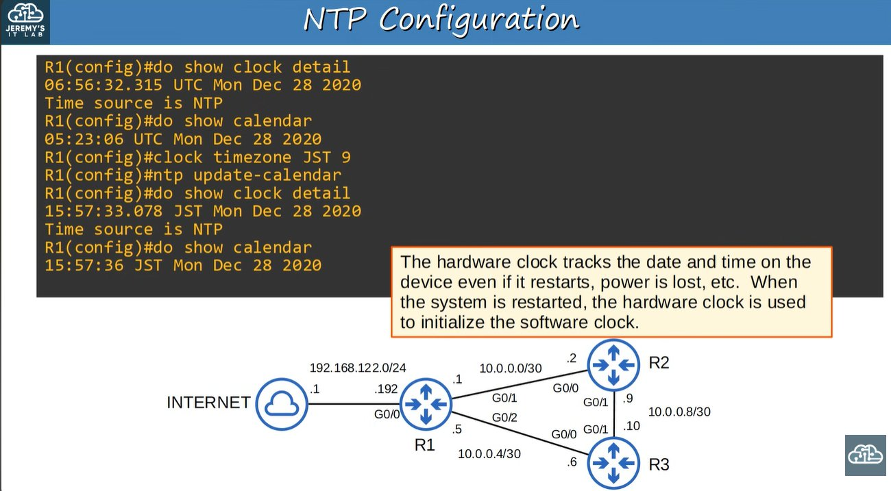
Hardware clock keeps time after restart and initializes the software clock
- They are separate; usually you want them synchronized.
- After a reboot the clock may show a default date (e.g. 1993). Fix: clock read-calendar.

3. Time Zone & DST
R1(config)# clock timezone JST 9
R1(config)# clock summer-time EDT recurring 2 Sunday March 02:00 1 Sunday November 02:00

- clock timezone name hours-offset [minutes-offset] (hours: -23 to 23).
- clock summer-time name recurring start end [offset] (offset: 1-1440 min).
- First week day month time = start of DST; second = end of DST.
- After setting a timezone, clock set takes local time.
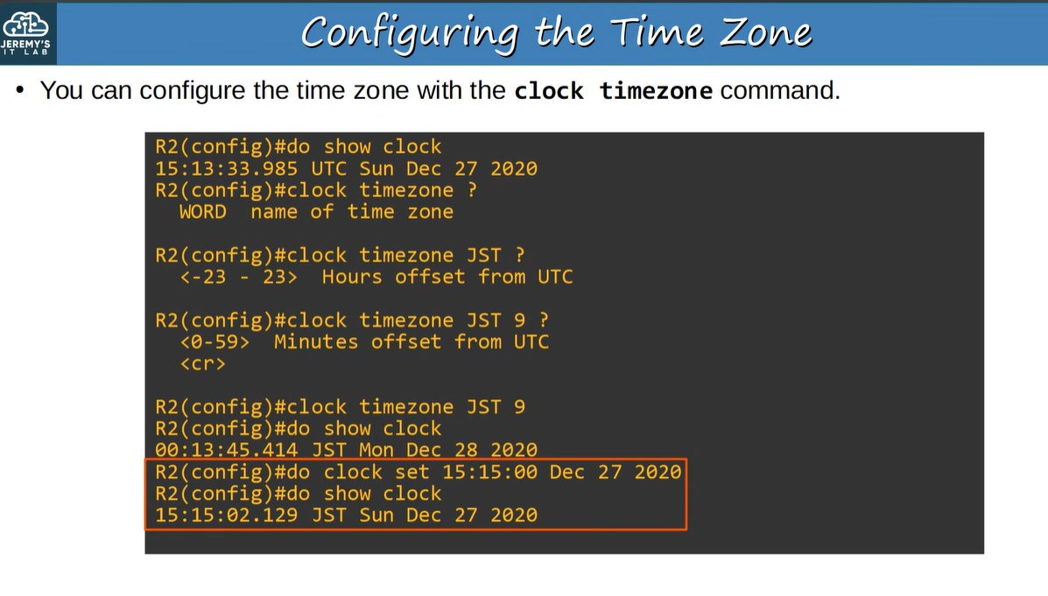 | 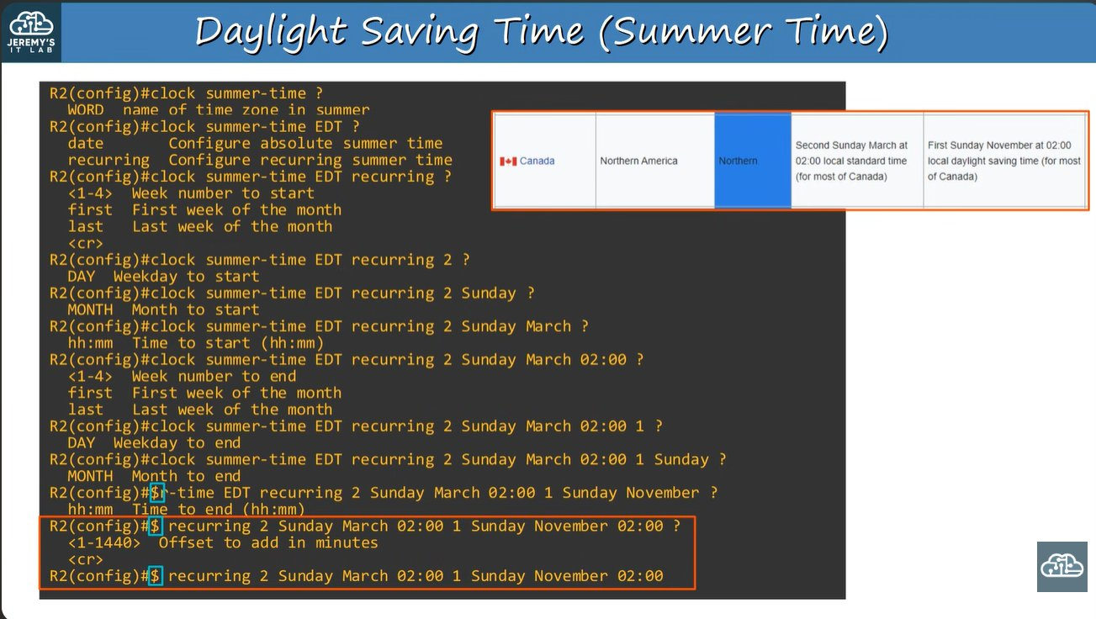
clock timezone | clock summer-time recurring
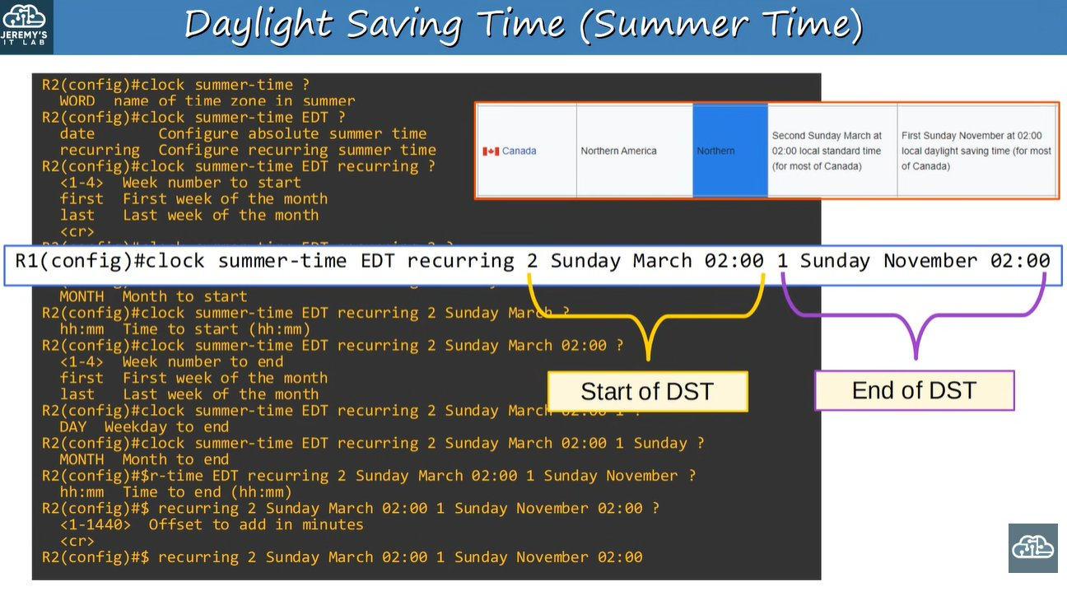 | 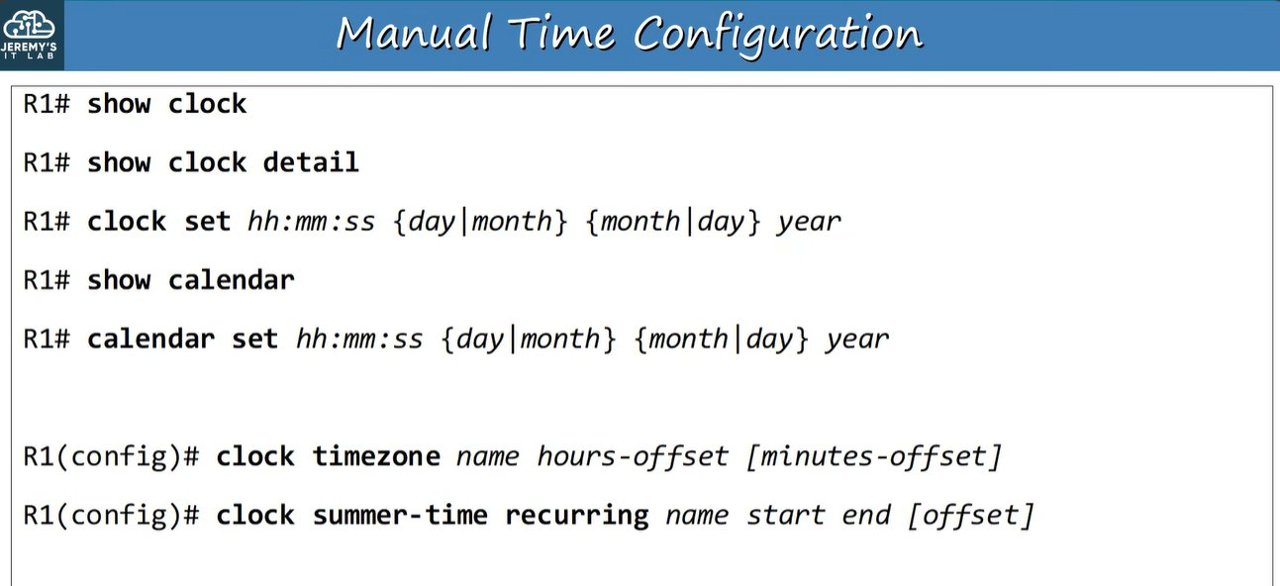
Start / End of DST | Command summary

4. NTP (Network Time Protocol)

What / Why?
NTP syncs time automatically over a network. Manual time is not scalable and drifts.
⭐ Important: NTP uses UDP port 123.
- Clients request time from servers. A device can be client and server at the same time.
- Accuracy: about 1 ms on a LAN, about 50 ms over the Internet.
- Stratum = distance from the reference clock.
- NTP works only in UTC, so set the timezone on each device.
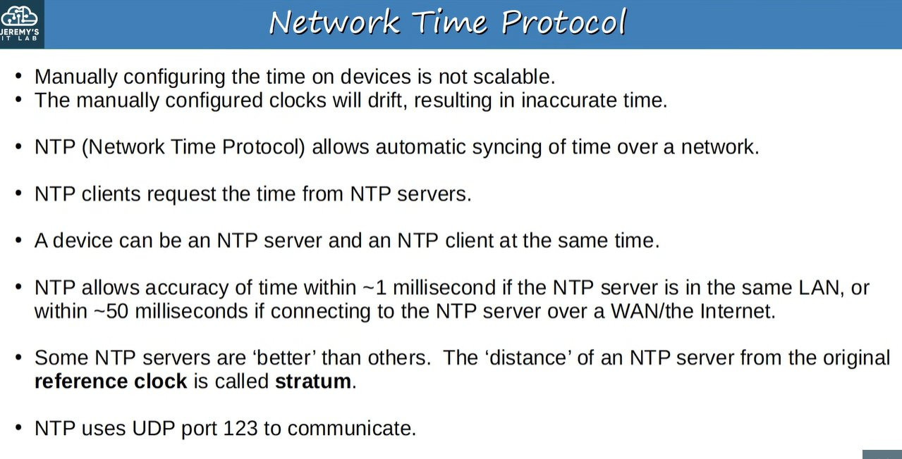
NTP basics
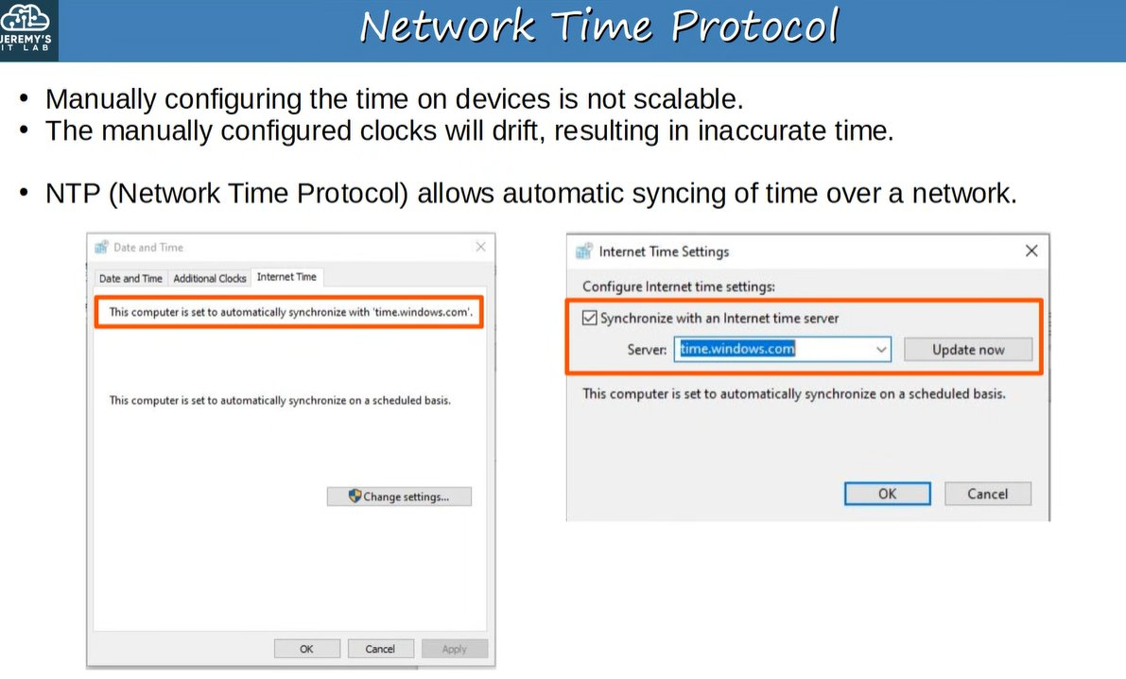 | 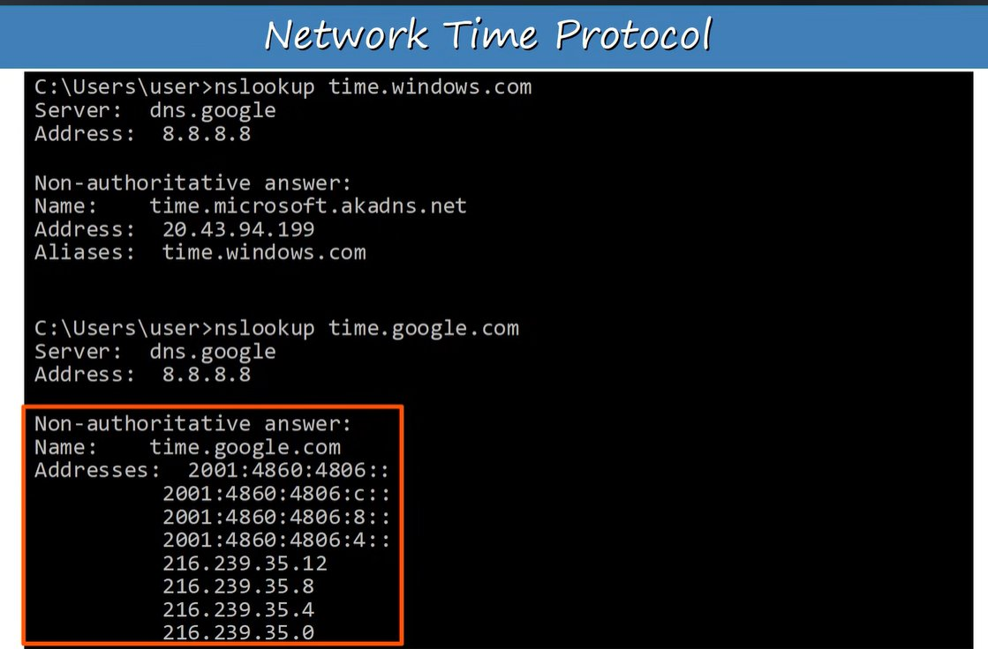
Example: PC syncing to time.windows.com | nslookup shows the NTP server IPs

Stratum Hierarchy
Reference clock (atomic / GPS) = Stratum 0
|
Stratum 1 (primary servers) <-> peers
|
Stratum 2 (secondary servers: server + client mode)
|
Stratum 3 ... max usable = 15

- Lower stratum = preferred.
- Devices at the same stratum can peer to improve accuracy.
- A client can sync to multiple servers.
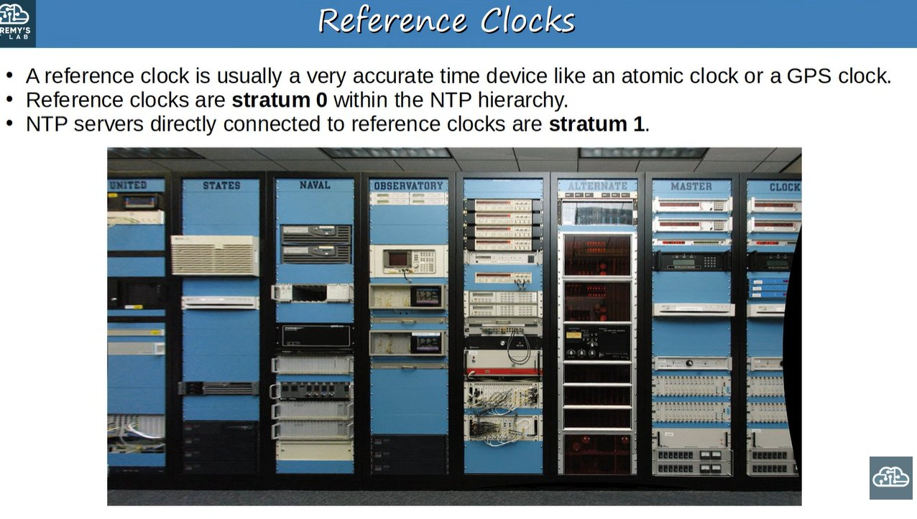
Reference clocks = stratum 0
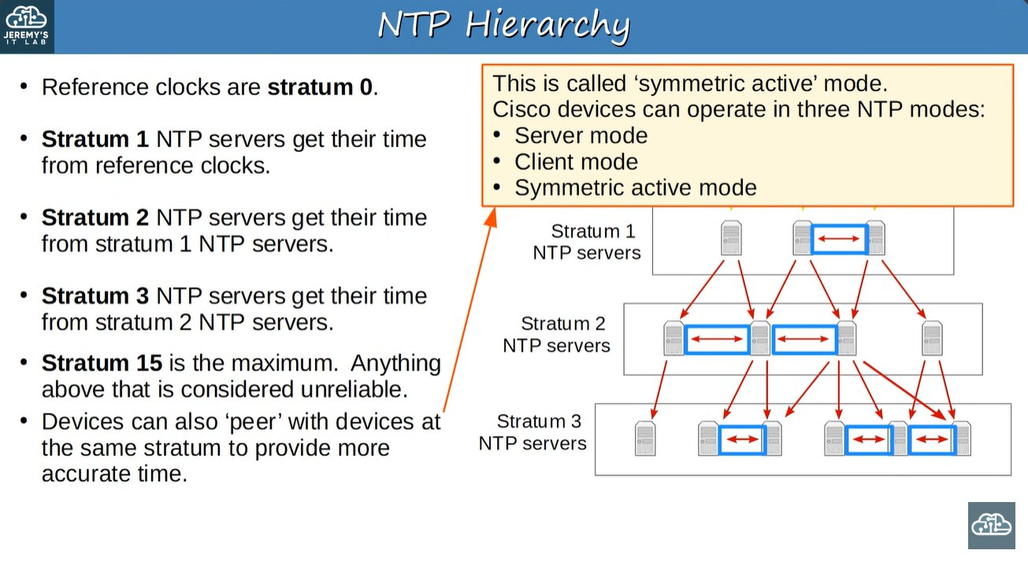 | 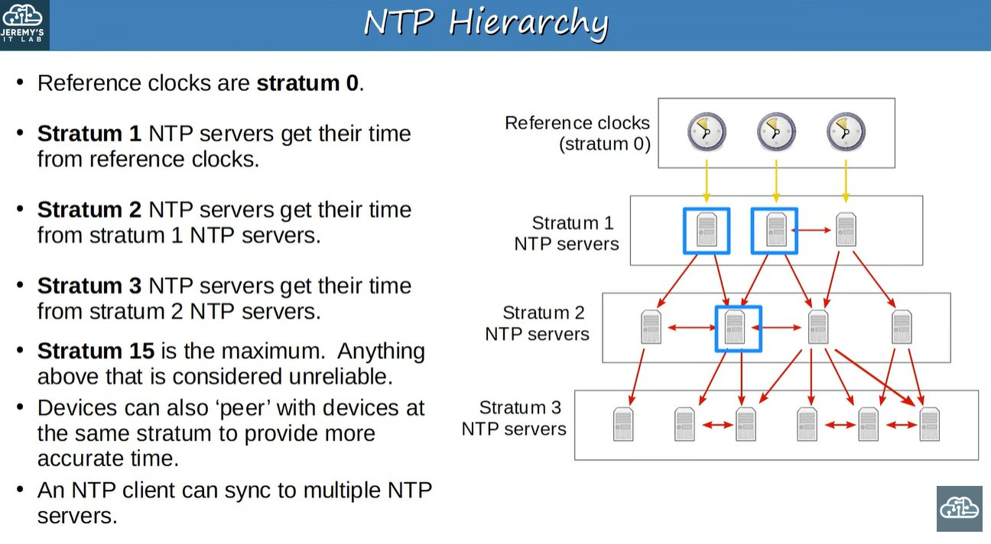
NTP hierarchy (symmetric active mode = peering)
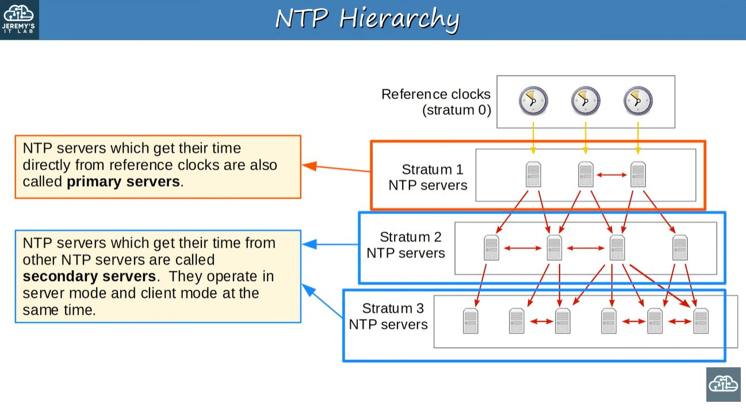
Primary vs secondary servers

Cisco NTP Modes
Mode | Command
Client | ntp server <ip>
Server | ntp master [stratum] (or a synced client acts as a server)
Symmetric active (peer) | ntp peer <ip>

5. NTP Configuration
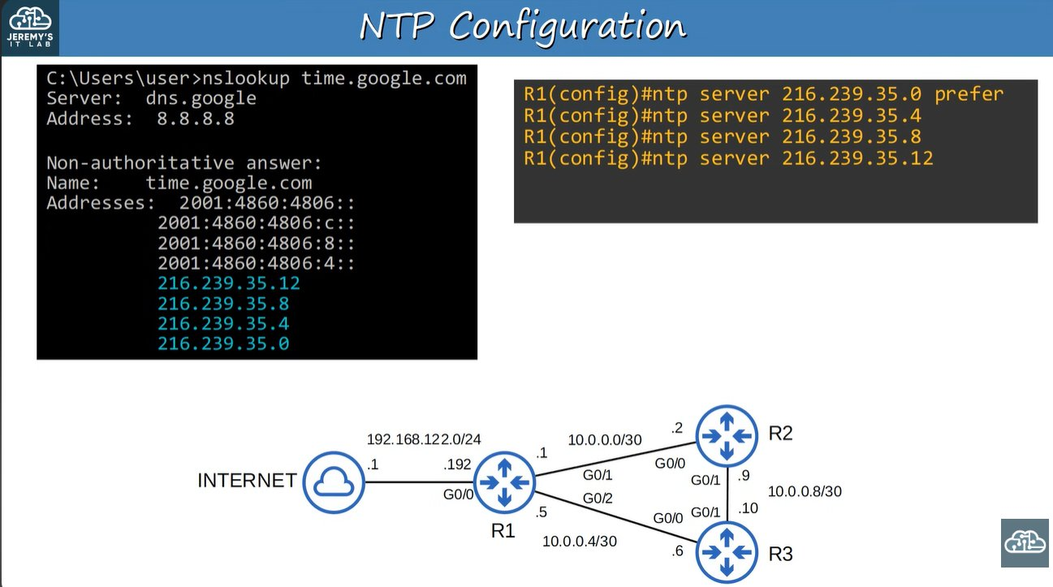
Lab topology: R1 syncs to Google servers
R1(config)# ntp server 216.239.35.0 prefer ! prefer = favoured server
R1(config)# ntp server 216.239.35.4
R1(config)# ntp peer 10.0.23.2 ! same-stratum peer
R1(config)# ntp update-calendar ! NTP time -> hardware calendar
R1(config)# ntp master [stratum] ! act as source (default 8)
R1(config)# ntp source loopback0 ! source interface for NTP
R1# show ntp associations
R1# show ntp status

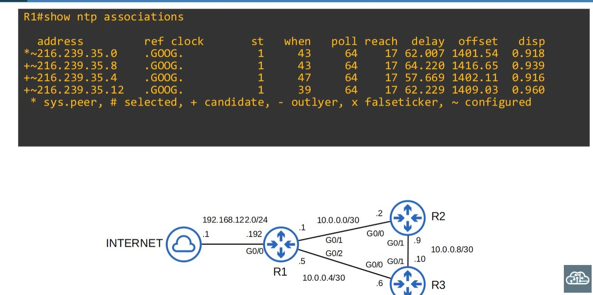
show ntp associations
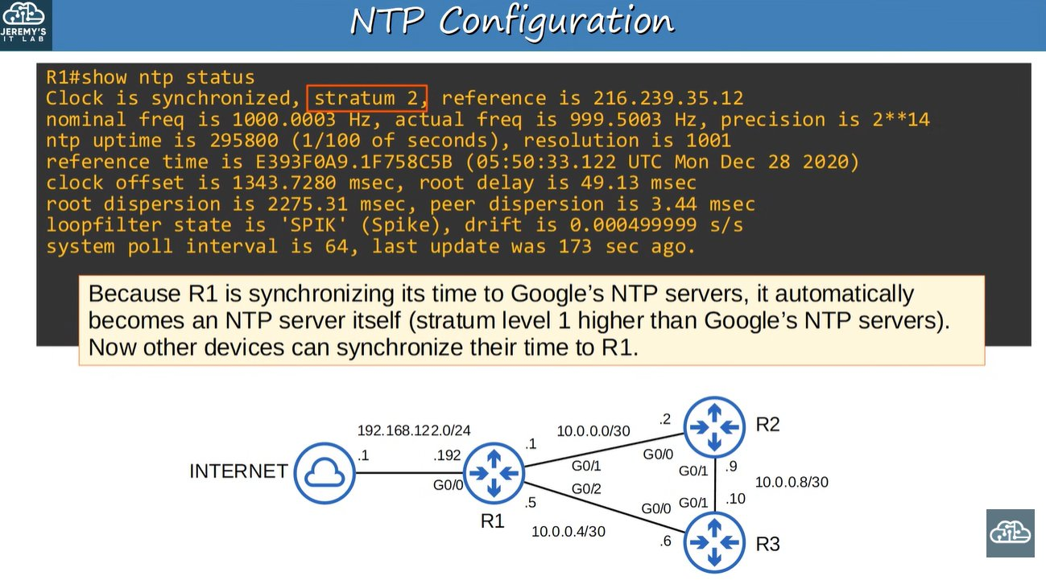
show ntp status (stratum 2, reference = Google server)
- R1 syncs to Google (stratum 1), so R1 becomes stratum 2 and can serve others.
- R2 syncs to R1, so R2 becomes stratum 3.
- show ntp status shows: synchronized or not, stratum, reference IP.

show ntp associations symbols
Symbol | Meaning
* | sys.peer (chosen server)
# | selected
+ | candidate
- | outlier
x | falseticker
~ | configured

UTC & update-calendar
⭐ Important: NTP uses only UTC. Configure the right timezone on each device.
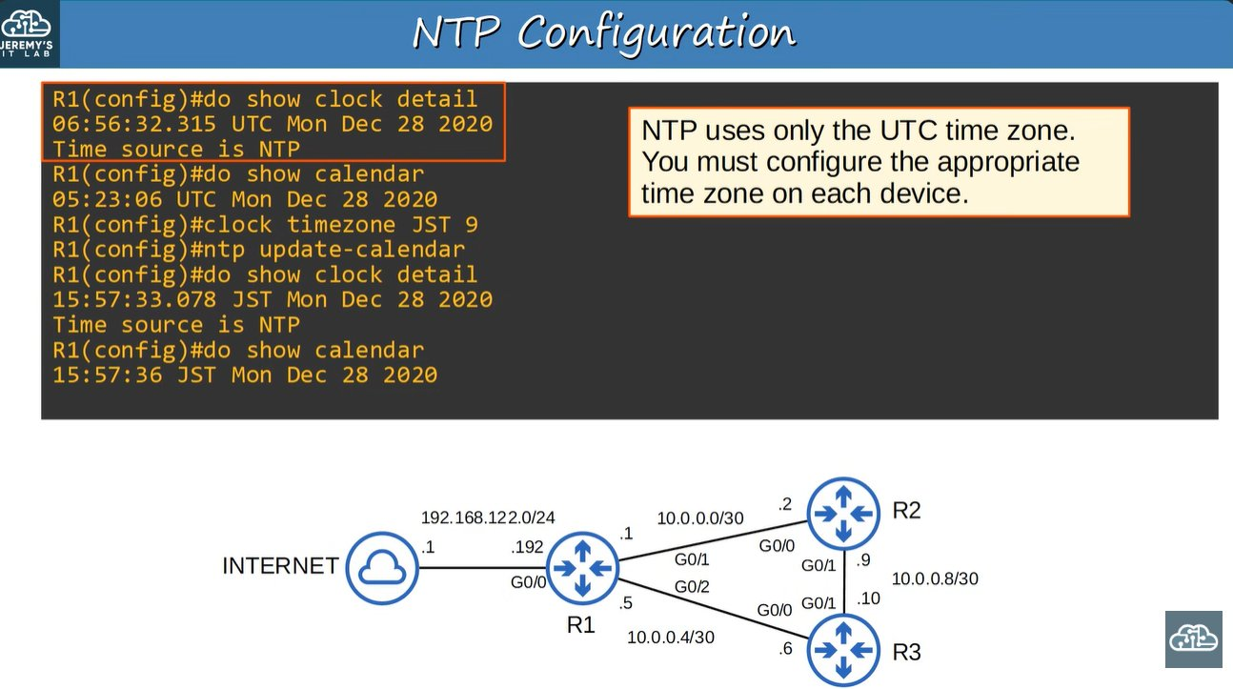 | 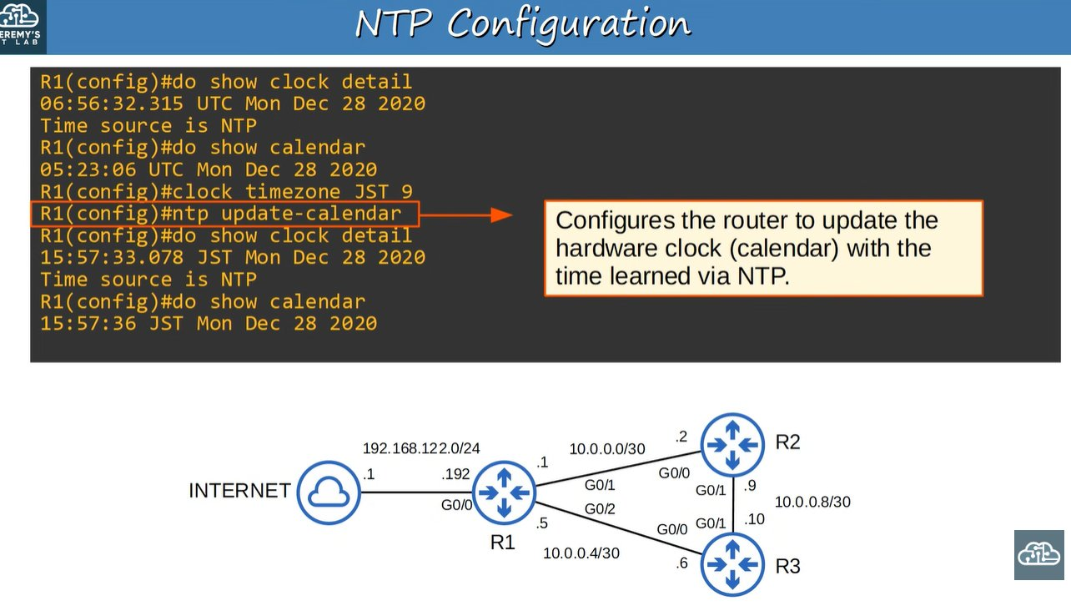
`ntp update-calendar` updates the hardware clock with NTP time

Loopback as NTP source
- ntp source loopback0 uses the loopback IP as the source, so it is stable even if a physical link fails.
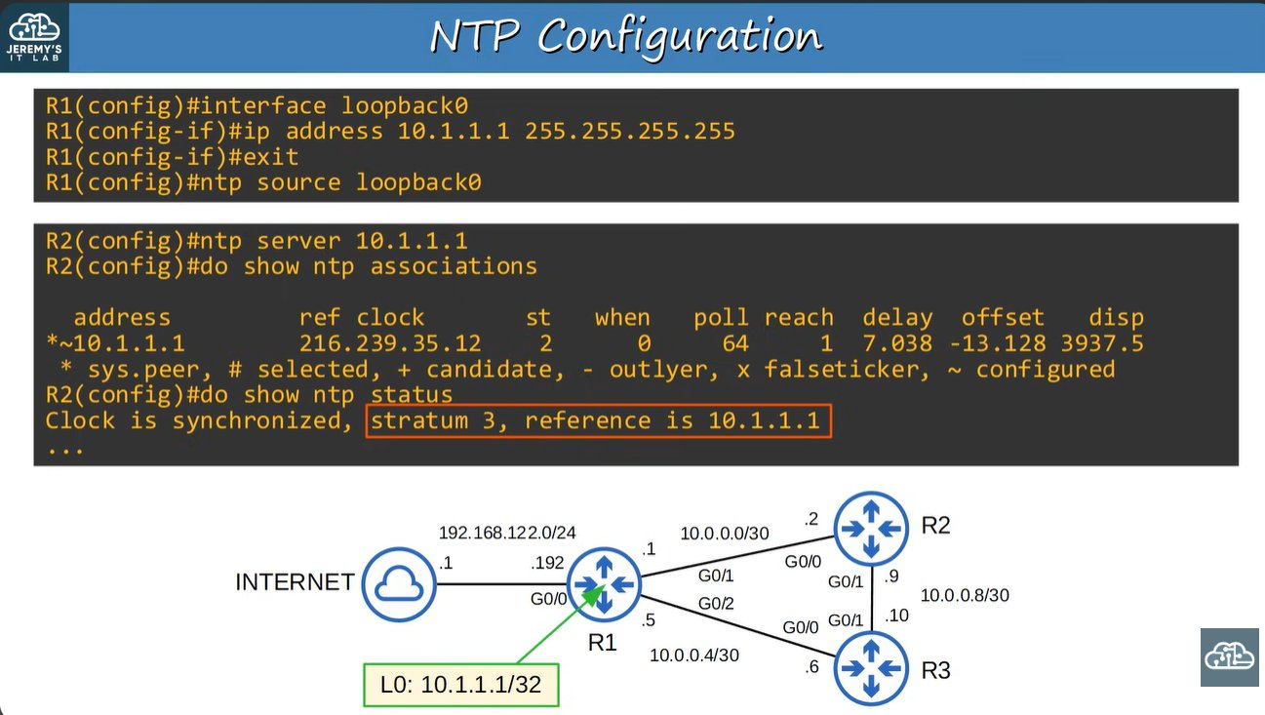
R1 loopback 10.1.1.1 as NTP source; R2 becomes stratum 3
- When a client has 2 servers, the lower stratum is preferred.
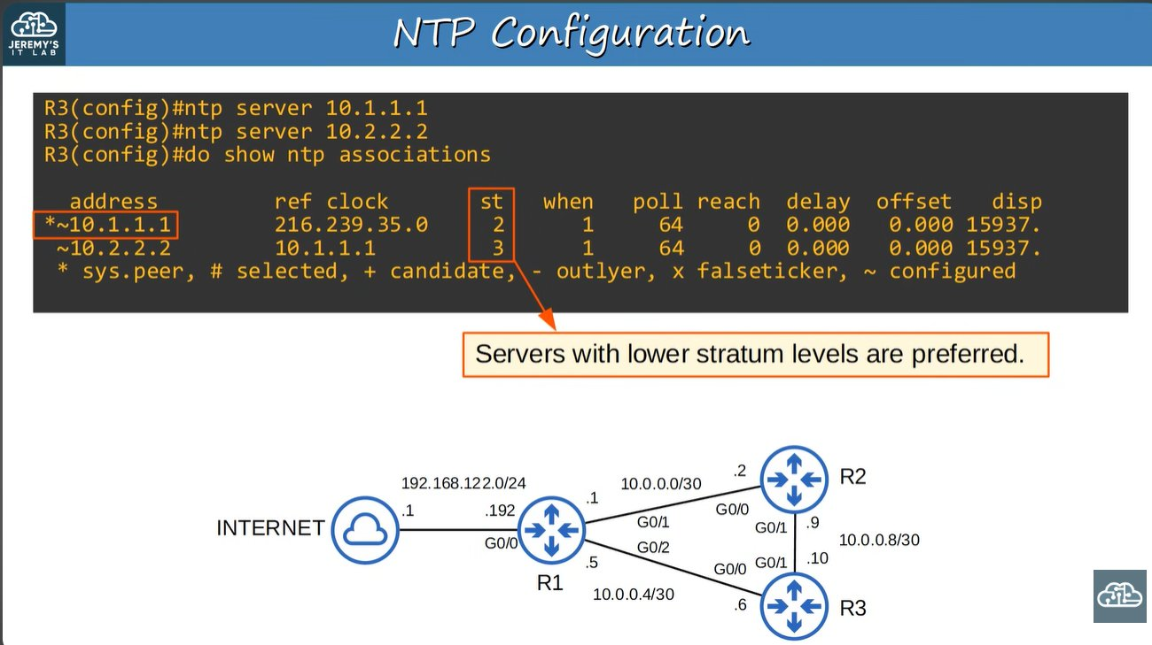
R3 with two servers: stratum 2 chosen over stratum 3

NTP server mode (ntp master)
- ntp master makes the router a time source when it has no real one.
- Default stratum = 8. Range 1-15.
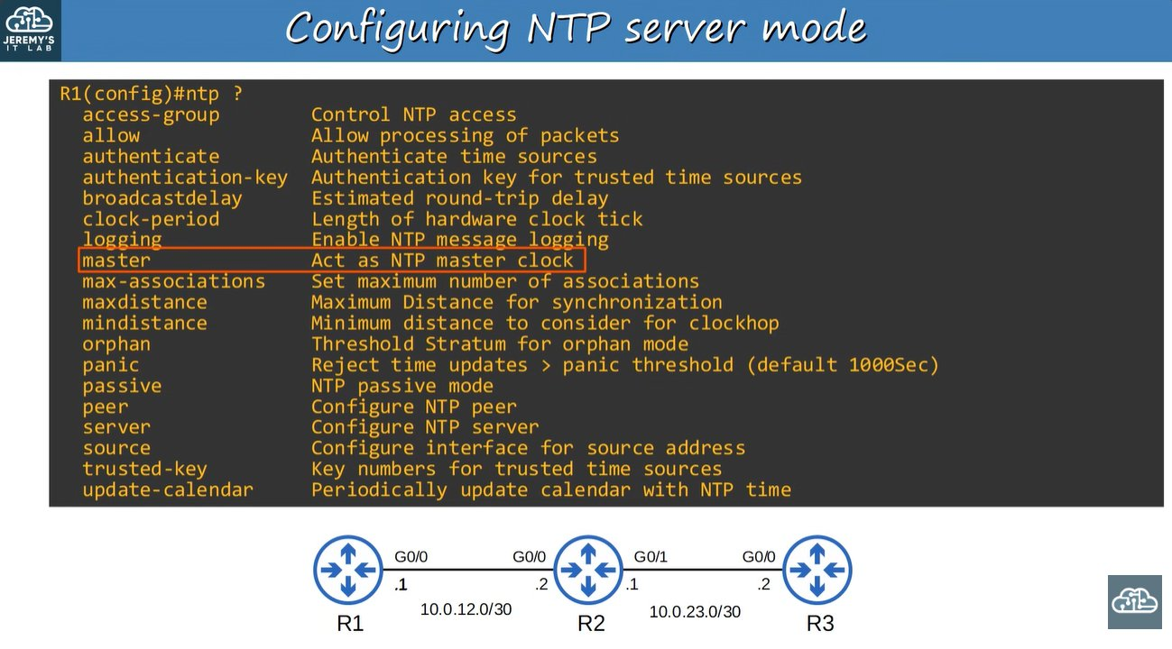 | 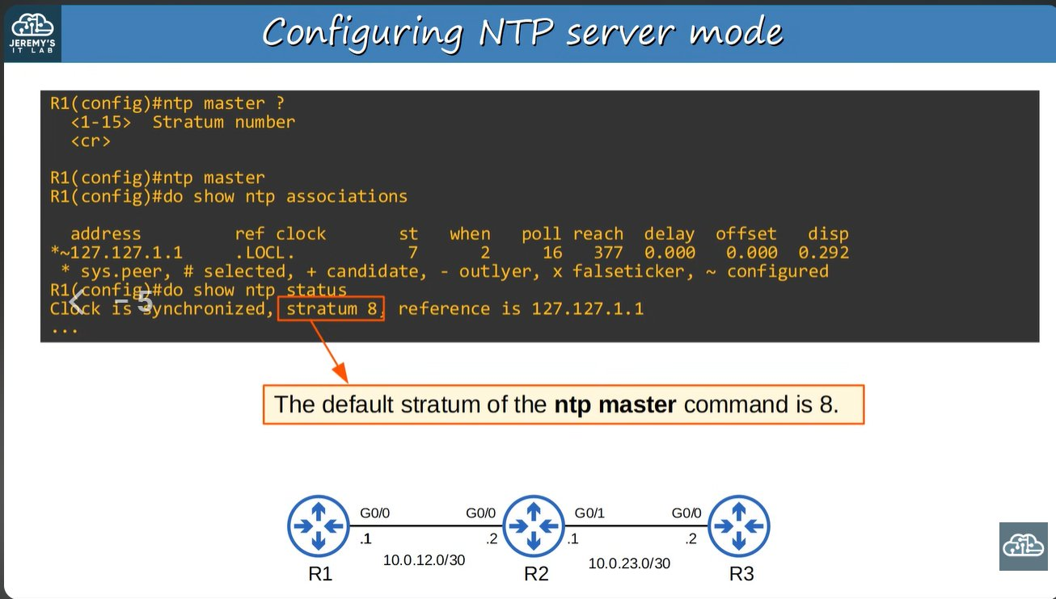
`ntp` options list | `ntp master` gives stratum 8

6. NTP Authentication (Optional)

Why?
Clients sync only to intended (trusted) servers.
ntp authenticate ! enable
ntp authentication-key 1 md5 <key> ! create key
ntp trusted-key 1 ! trust the key
ntp server <ip> key 1 ! use key for this server
ntp peer <ip> key 1 ! for peers

- The server (R1) needs only the first 3 commands. Clients also need ntp server ... key.
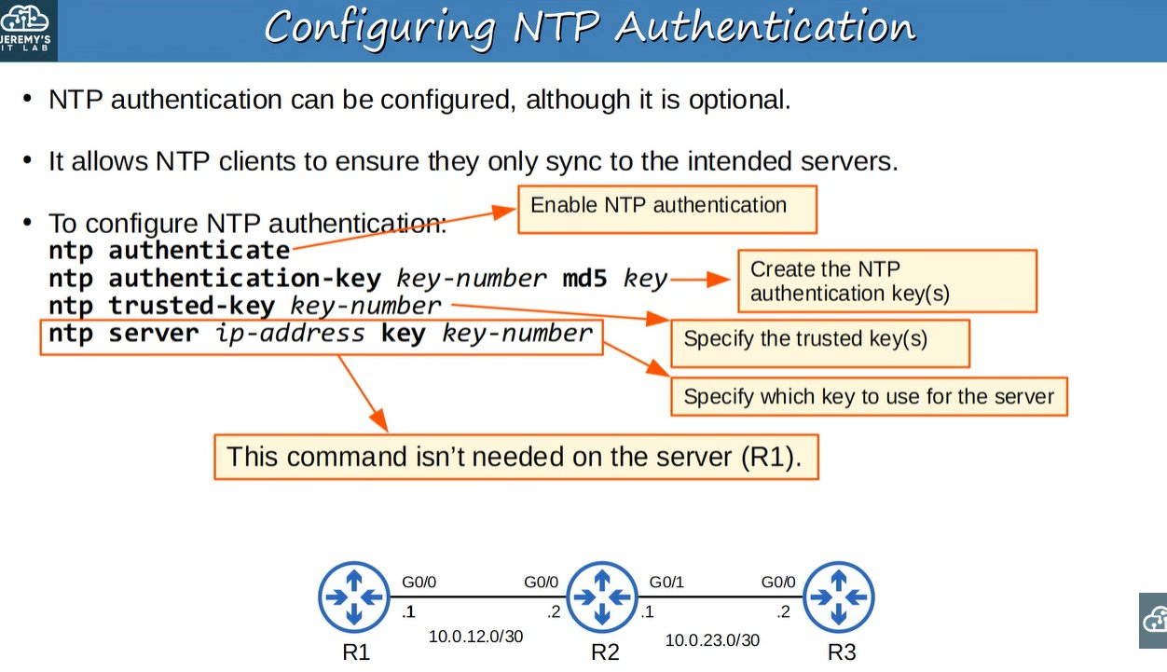
Authentication commands
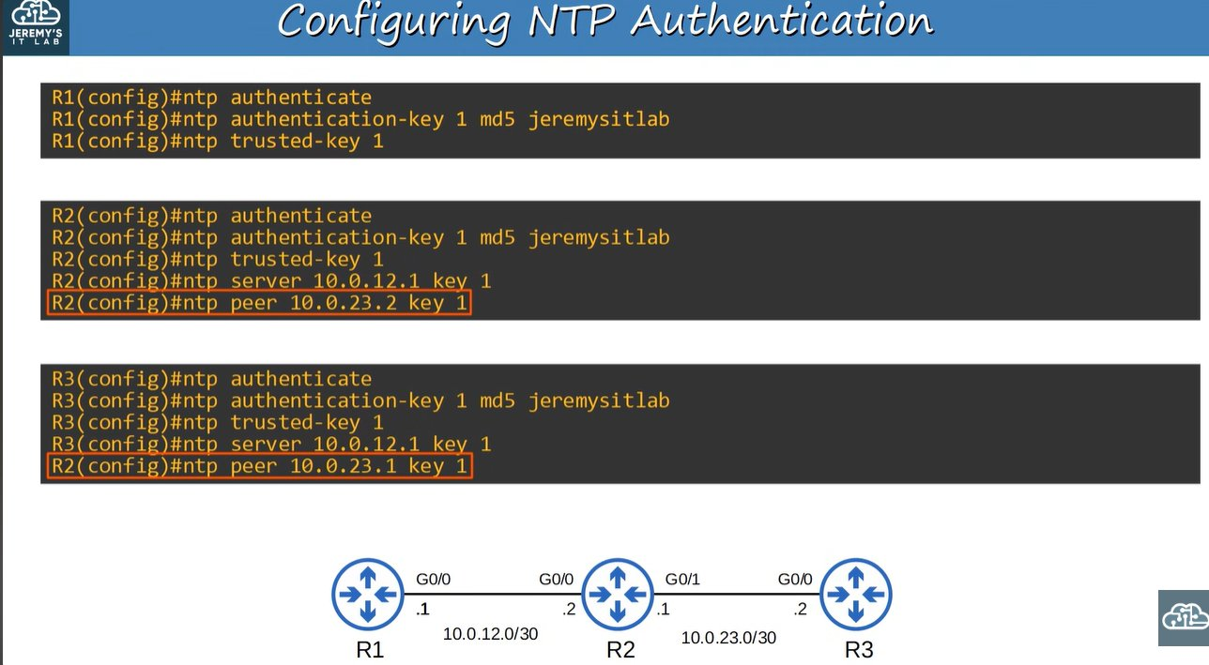
Authentication config on R1, R2, R3 (see correction in Doubts)

Full command summary
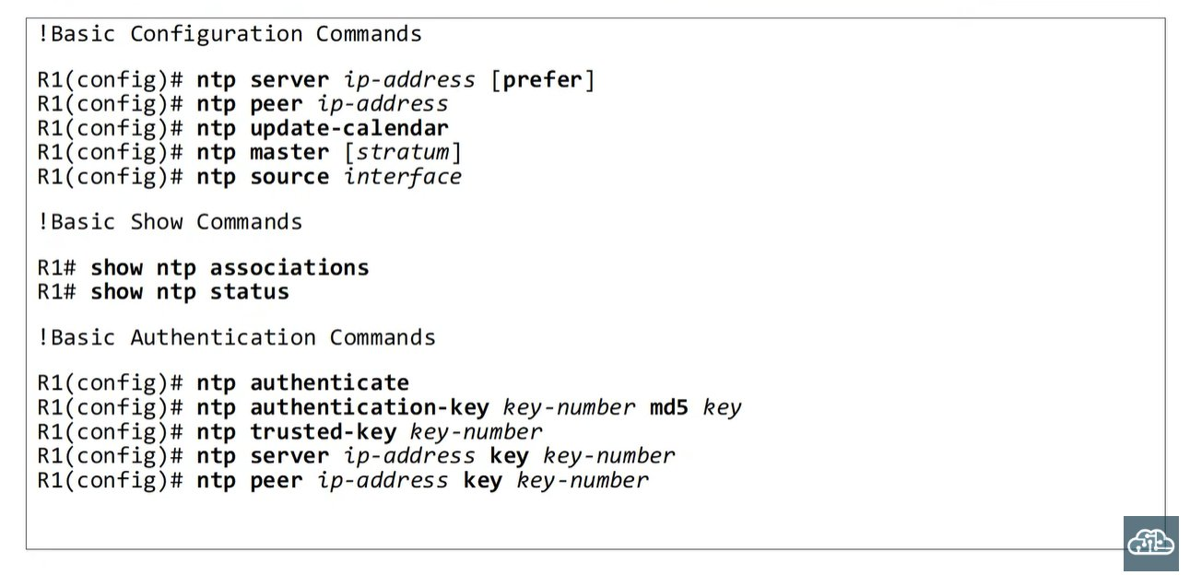

🔥 Quick Revision
- Accurate time = accurate logs = easier troubleshooting.
- Clock = software, calendar = hardware. Sync with clock update-calendar / clock read-calendar.
- NTP: UDP 123, works in UTC, set timezone per device.
- Stratum 0 = reference clock, 1 = primary, max 15. Lower is preferred.
- ntp server = client, ntp peer = symmetric active, ntp master = server (default 8).
- * in show ntp associations = chosen peer.
- Authentication uses MD5 keys and is optional.

📝 Revision Comments & Doubts
No handwritten doubts were in the slides. These are the points to fix or watch.

Correction: typo in R3 authentication slide
Answer: The R3 block shows R2(config)#ntp peer 10.0.23.1 key 1. It should be R3(config)#ntp peer 10.0.23.1 key 1.
Remember: Each router peers with the OTHER router's IP.

Doubt: Stratum 15 vs 16
Answer: 15 is the highest usable stratum. Stratum 16 means unsynchronized.
Remember: Max usable = 15.

Doubt: Why use ntp update-calendar?
Answer: NTP sets only the software clock. Without this command the calendar stays wrong and re-initializes the clock incorrectly after a reboot.
Remember: NTP updates clock; update-calendar also updates hardware.

Note: MD5 is weak
Answer: MD5 is what CCNA covers, but it is considered weak in real networks. Authentication protects who you sync from, not the time data.
Remember: Authentication = trusted source, not encryption.

🎯 Exam Points
Item | Value
NTP port | UDP 123
Default timezone | UTC
Default time source | Hardware calendar (* = not authoritative)
ntp master default stratum | 8
Max stratum | 15
Accuracy | ~1 ms (LAN), ~50 ms (Internet)
Clock to calendar | clock update-calendar
Calendar to clock | clock read-calendar
Peer mode name | Symmetric active

Common questions
- Which command syncs the calendar to the clock? clock update-calendar
- What is stratum? Distance from the reference clock.
- Which NTP server is preferred? The lowest stratum.
- Which command is NOT needed on the NTP server for authentication? ntp server ... key
- Why does NTP need a timezone configured? NTP only carries UTC.

All commands
clock set | calendar set | clock timezone | clock summer-time recurring
clock update-calendar | clock read-calendar
ntp server | ntp peer | ntp master | ntp source | ntp update-calendar
ntp authenticate | ntp authentication-key | ntp trusted-key
show clock [detail] | show calendar | show ntp associations | show ntp status

