Week 1

Q1: Write a simple poem and represent it as a web page. Give a title for the poem.

Make rhyming words in the poem as bold.

Code:

<!DOCTYPE html>

<html lang="en">

<head>

<meta charset="UTF-8">

<meta name="viewport" content="width=device-width, initial-scale=1.0">

<title>Q1 - Poem</title>

</head>

<body>

<div style="text-align: center; height: 100%; justify-content: center; align-items: center; display: flex; margin: 0;">

<p>

In the quiet of the <b>night</b>, <br>

Stars above, so pure, so <b>bright</b>. <br>

Whispers dance on the cool <b>breeze</b>, <br>

Telling tales of distant <b>seas</b>. <br>

A moment's peace, a soft <b>refrain</b>, <br>

All the world, a gentle <b>gain</b>. <br>

</p>

</div>

</body>

</html>

Website:

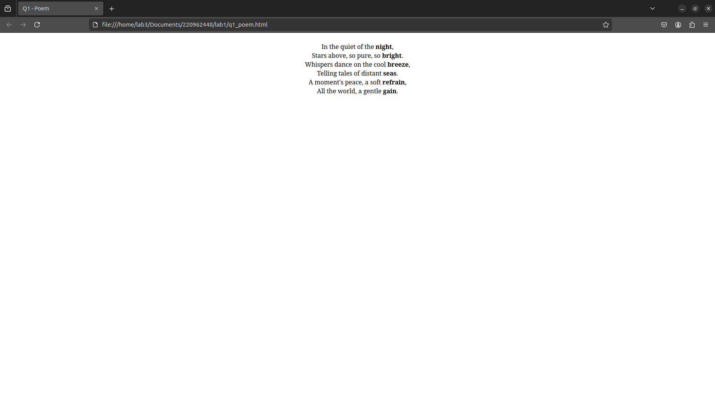

Q2: Assume you have brought a new car. Write down the list of additional

accessories you need for the car as an unordered list in HTML. Also, list the

travel plans on the car as an ordered list.

Code:

<!DOCTYPE html>

<html lang="en">

<head>

<meta charset="UTF-8">

<meta name="viewport" content="width=device-width, initial-scale=1.0">

<title>Q2 - Car List</title>

</head>

<body>

<h4 style="margin-bottom: 0;">Additional Accessories Needed: </h4>

<ul style="margin-top: 0;">

<li>Side Mirror</li>

<li>Parking Camera</li>

<li>360 Camera</li>

<li>Seat Covers</li>

<li>Steering Wheel Covers</li>

<li>Seat Warmers</li>

<li>Chrome Bumper</li>

<li>Lighting</li>

</ul>

<br>

<h4 style="margin-bottom: 0;">Travel Plans: </h4>

<ol style="margin-top: 0;">

<li>Mumbai to Manipal</li>

<li>Mumbai to Chennai</li>

<li>Manipal to Cannur</li>

<li>Manipal to Kudremukh</li>

<li>Manipal to Mangalore to Bangalore</li>

</ol>

</body>

</html>

Website:

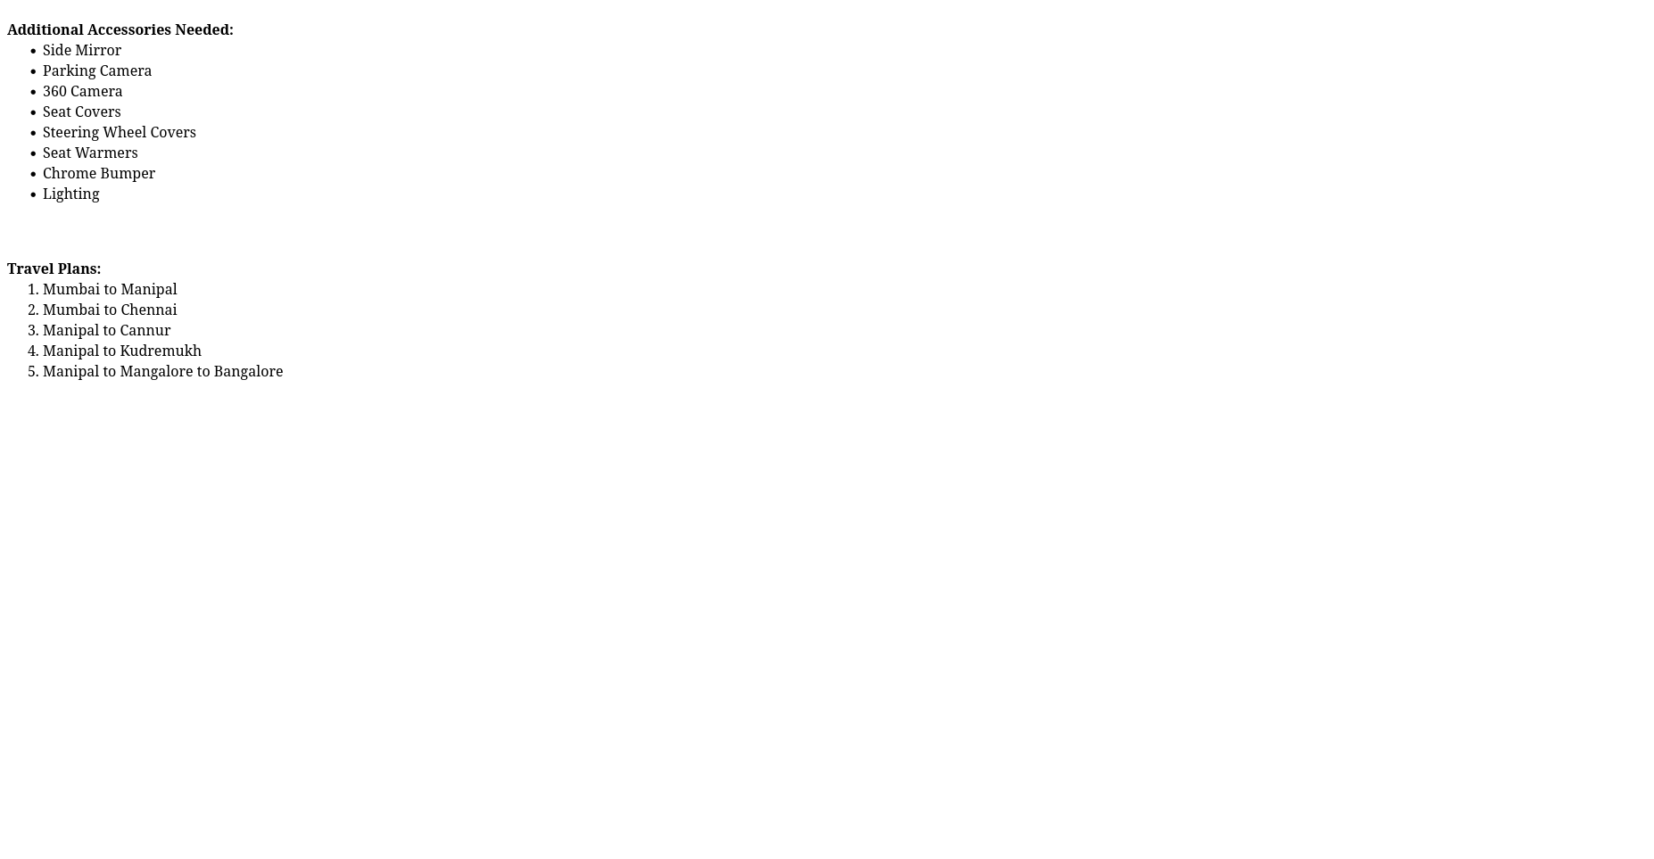

Q3: Complete the following website name “Share your Winter Vacation Videos”.

The required video files are located inside the compressed folder “Week 1

Assignment Files/Media/”.

Code:

<!DOCTYPE html>

<html>

<head>

<meta charset="utf-8">

<title>Q3 - Share your Winter Vacation Videos</title>

<style>

#topnav {

width: 100%;

position: fixed;

top: 0;

left: 0;

background-color: Black;

font-family: Arial, sans-serif;

font-size: 15px;

}

.nav-link {

display: inline-block;

width: fit-content;

height: 55px;

color: White;

text-align: center;

line-height: 55px;

text-decoration: none;

padding: 3px;

}

#logo {

width: fit-content;

background-color: RoyalBlue;

font-weight: bold;

}

#about {

position: absolute;

top: 0;

right: 0;

padding-right: 10px;

}

</style>

</head>

<body>

<nav id="topnav">

<a id="logo" class="nav-link" href="#">Share Your Travels</a>

<a id="about" class="nav-link" href="#">|||</a>

</nav>

<br>

<div style="margin-left: 0; width: 100%; background: linear-gradient(to bottom, blue 20%, white 80%)">

<h1 style="padding-top: 20px; color: white;">HTML5 Videos</h1>

<div style="display: flex; justify-content: center; gap: 20px; max-width: 100%; margin-top: 5px;">

<video controls style="height: auto; max-width: 30%;">

<source src="https://videos.pexels.com/video-files/2169880/2169880-uhd_2560_1440_30fps.mp4" type="video/mp4">

</video>

<video controls style="height: auto; max-width: 30%;">

<source src="https://videos.pexels.com/video-files/3015510/3015510-hd_1920_1080_24fps.mp4" type="video/mp4">

</video>

<video controls style="height: auto; max-width: 30%;">

<source src="https://videos.pexels.com/video-files/2252797/2252797-uhd_2560_1440_30fps.mp4" type="video/mp4">

</video>

</div>

</div>

</body>

</html>

Website:

