Q1: Design the student bio-data form using button, label, textbox, radio button, table and checkbox using CSS

Code:

<!-- Design the student bio-data form using button, label, textbox, radio button, table and

checkbox using CSS. -->

<!DOCTYPE html>

<html lang="en">

<head>

<meta charset="UTF-8">

<meta name="viewport" content="width=device-width, initial-scale=1.0">

<title>Student Biodata Form</title>

<link rel="stylesheet" href="https://maxcdn.bootstrapcdn.com/bootstrap/3.4.1/css/bootstrap.min.css">

<script src="https://maxcdn.bootstrapcdn.com/bootstrap/3.4.1/js/bootstrap.min.js"></script>

</head>

<body>

<div class="container">

<h1 class="text-center">Student Biodata Form</h1>

<form>

<div class="form-group">

<label for="name">Name:</label>

<input type="text" class="form-control" id="name" name="name" placeholder="Enter your name">

</div>

<div class="form-group">

<label for="student">Are You a Student?</label><br>

<label class="radio-inline">

<input type="radio" name="student" id="yes" value="yes"> Yes

</label>

<label class="radio-inline">

<input type="radio" name="student" id="no" value="no"> No

</label>

</div>

<div class="form-group">

<label for="course">Select Your Courses:</label><br>

<label class="checkbox-inline">

<input type="checkbox" name="course" id="dsa" value="dsa"> DSA

</label>

<label class="checkbox-inline">

<input type="checkbox" name="course" id="dbs" value="dbs"> DBS

</label>

<label class="checkbox-inline">

<input type="checkbox" name="course" id="os" value="os"> OS

</label>

<label class="checkbox-inline">

<input type="checkbox" name="course" id="ai" value="ai"> AI

</label>

<label class="checkbox-inline">

<input type="checkbox" name="course" id="ml" value="ml"> ML

</label>

</div>

<div class="form-group">

<label for="table">Fee Table:</label>

<table class="table table-bordered" id="feeTable">

<thead>

<tr>

<th>Course</th>

<th>Fee</th>

</tr>

</thead>

<tbody>

<tr>

<td>DSA</td>

<td>35,000</td>

</tr>

<tr>

<td>DBS</td>

<td>30,000</td>

</tr>

<tr>

<td>OS</td>

<td>28,000</td>

</tr>

<tr>

<td>AI</td>

<td>40,000</td>

</tr>

<tr>

<td>ML</td>

<td>38,000</td>

</tr>

</tbody>

</table>

</div>

<div class="form-group text-center">

<button type="submit" class="btn btn-primary">Submit</button>

</div>

</form>

</div>

</body>

</html>

Screenshot:

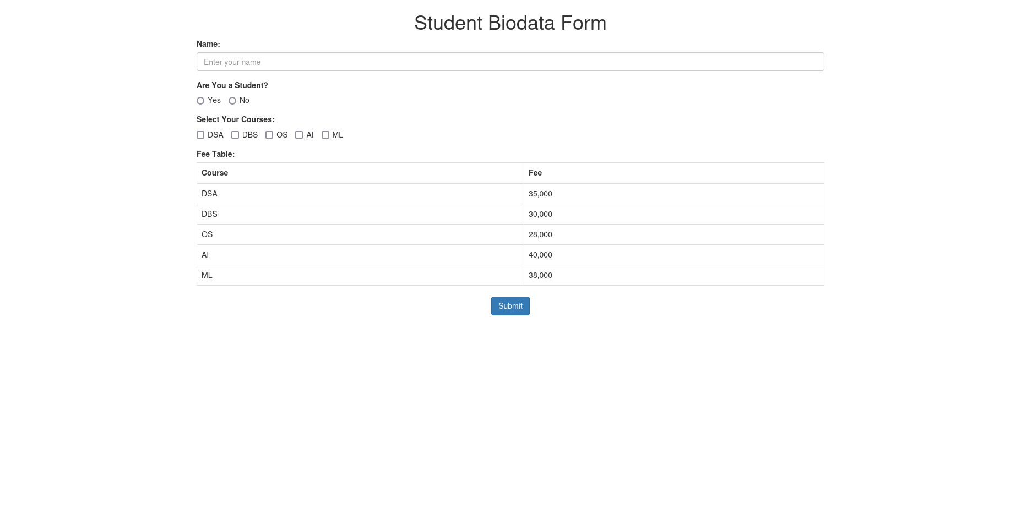

Q3: Create a web page using bootstrap as mentioned. Divide the page in to 2 parts top and bottom, then divide the bottom into 3 parts and design each top and bottom part using different input groups, input, badges, buttons and button groups. Make the design more attractive using bootstrap.

Code:

<!-- Create a web page using bootstrap as mentioned. Divide the page in to 2 parts top and

bottom, then divide the bottom into 3 parts and design each top and bottom part using

different input groups, input, badges, buttons and button groups. Make the design more

attractive using bootstrap. -->

<!DOCTYPE html>

<html lang="en">

<head>

<meta charset="UTF-8">

<meta name="viewport" content="width=device-width, initial-scale=1.0">

<title>Top and Bottom</title>

<link rel="stylesheet" href="https://cdn.jsdelivr.net/npm/bootstrap@5.3.3/dist/css/bootstrap.min.css">

<script src="https://cdn.jsdelivr.net/npm/bootstrap@5.3.3/dist/js/bootstrap.bundle.min.js"></script>

</head>

<body>

<!-- top -->

<nav class="navbar navbar-expand-lg navbar-dark bg-dark">

<div class="container-fluid">

<a class="navbar-brand" href="#">bala</a>

<button class="navbar-toggler" type="button" data-bs-toggle="collapse" data-bs-target="#navbarNav" aria-controls="navbarNav" aria-expanded="false" aria-label="Toggle navigation">

<span class="navbar-toggler-icon"></span>

</button>

<div class="collapse navbar-collapse" id="navbarNav">

<div class="navbar-nav">

<a class="nav-link active" href="#">Home</a>

<a class="nav-link" href="#">About</a>

<a class="nav-link" href="#">Contact Me</a>

<a class="nav-link" href="#">Notifications <span class="badge bg-danger">3</span></a>

<a class="nav-link disabled" href="#" tabindex="-1" aria-disabled="true">Donate</a>

</div>

</div>

</div>

</nav>

<!-- bottom -->

<div class="container mt-5">

<!-- part 1 -->

<div class="row mb-4">

<div class="col-md-12">

<h4>What's on your mind?</h4>

<div class="input-group">

<textarea class="form-control" placeholder="Write something..." aria-label="Write a post" rows="3"></textarea>

<button class="btn btn-primary" type="button">Post</button>

</div>

</div>

</div>

<!-- part 2 -->

<div class="row mb-4">

<div class="col-md-12">

<div class="card">

<div class="card-body">

<h5 class="card-title">Bala</h5>

<p class="card-text">Bootstrap seems actually useful man</p>

<button class="btn btn-outline-primary btn-sm">Like</button>

<button class="btn btn-outline-success btn-sm">Comment</button>

<button class="btn btn-outline-info btn-sm">Share</button>

</div>

<div class="card-footer text-muted">

2 hours ago

</div>

</div>

</div>

</div>

<div class="row mb-4">

<div class="col-md-12">

<div class="card">

<div class="card-body">

<h5 class="card-title">Anuj</h5>

<p class="card-text">Bootstrap has so many random classes its hard to use</p>

<button class="btn btn-outline-primary btn-sm">Like</button>

<button class="btn btn-outline-success btn-sm">Comment</button>

<button class="btn btn-outline-info btn-sm">Share</button>

</div>

<div class="card-footer text-muted">

2 hours ago

</div>

</div>

</div>

</div>

<!-- part 3 -->

<div class="row mt-5">

<div class="col-md-12">

<h4>Trending</h4>

<div class="row">

<div class="col-md-4 mb-4">

<div class="card">

<div class="card-body">

<h5 class="card-title">#WP-LAB</h5>

<p class="card-text">Today's WP lab is pretty interesting</p>

</div>

<div class="card-footer text-muted">

3 hours ago

</div>

</div>

</div>

<div class="col-md-4 mb-4">

<div class="card">

<div class="card-body">

<h5 class="card-title">#Placements</h5>

<p class="card-text">How do I get better placements?</p>

</div>

<div class="card-footer text-muted">

1 day ago

</div>

</div>

</div>

<div class="col-md-4 mb-4">

<div class="card">

<div class="card-body">

<h5 class="card-title">#water</h5>

<p class="card-text">Clean drinking water is very important for people.</p>

</div>

<div class="card-footer text-muted">

5 hours ago

</div>

</div>

</div>

</div>

</div>

</div>

</div>

</body>

</html>

Screenshot:

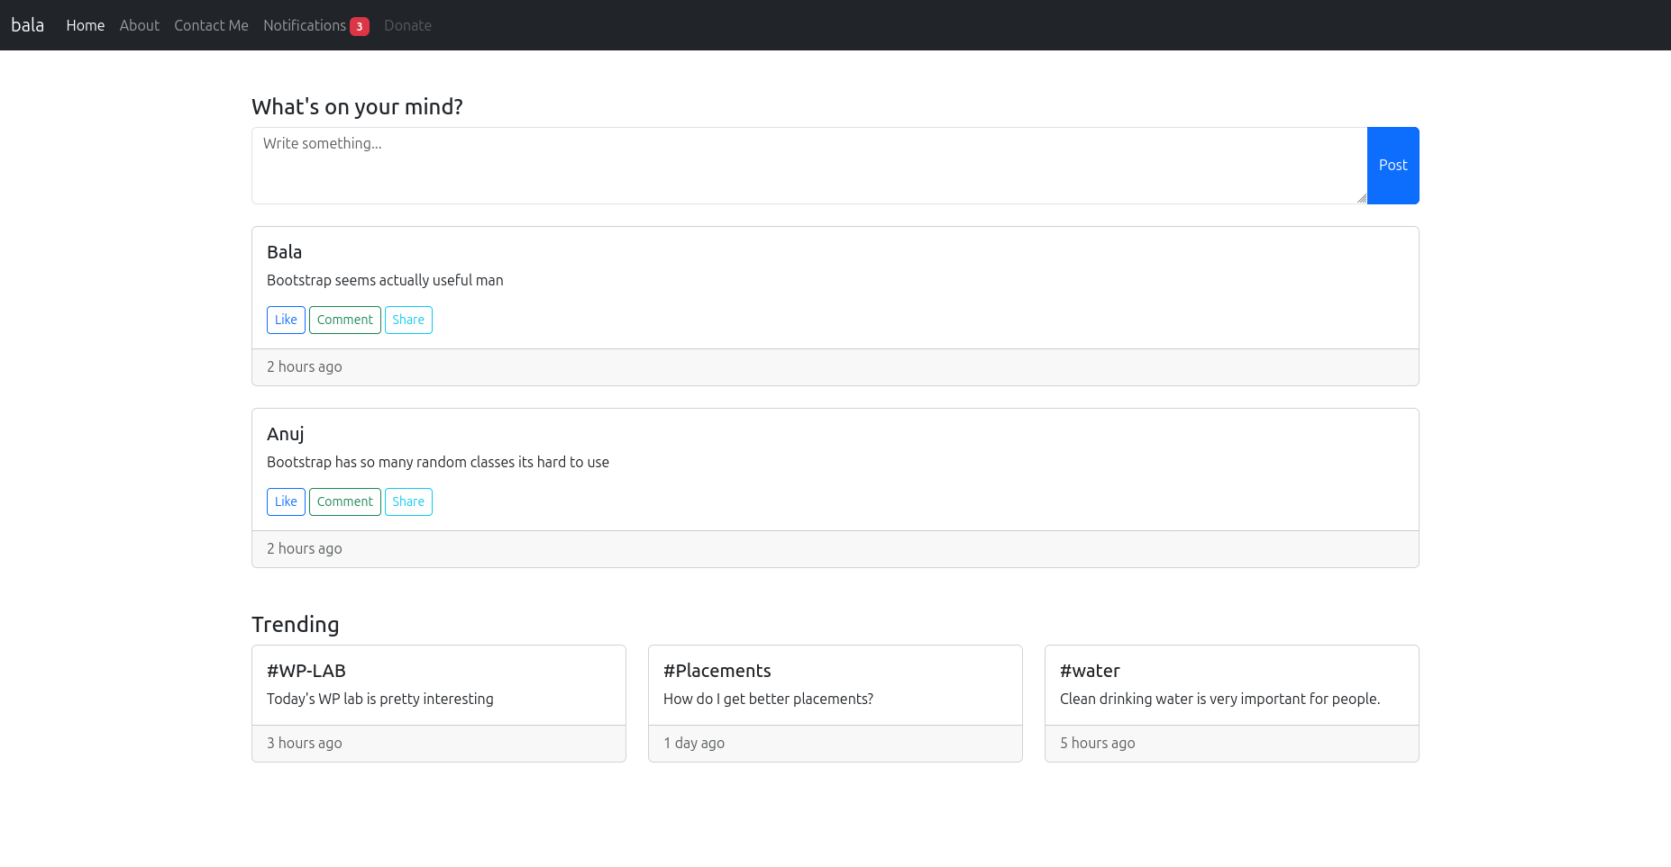

Q4: Design your class timetable using bootstrap table and carousel.

Code:

<!-- Design your class timetable using bootstrap table and carousel. -->

<!DOCTYPE html>

<html lang="en">

<head>

<meta charset="UTF-8">

<meta name="viewport" content="width=device-width, initial-scale=1.0">

<title>Timetable</title>

<link rel="stylesheet" href="https://cdn.jsdelivr.net/npm/bootstrap@5.3.3/dist/css/bootstrap.min.css">

<script src="https://cdn.jsdelivr.net/npm/bootstrap@5.3.3/dist/js/bootstrap.bundle.min.js"></script>

</head>

<body>

<div id="carouselExampleIndicators" class="carousel slide" data-bs-ride="carousel">

<div class="carousel-indicators">

<button type="button" data-bs-target="#carouselExampleIndicators" data-bs-slide-to="0" class="active" aria-current="true" aria-label="Monday"></button>

<button type="button" data-bs-target="#carouselExampleIndicators" data-bs-slide-to="1" aria-label="Tuesday"></button>

<button type="button" data-bs-target="#carouselExampleIndicators" data-bs-slide-to="2" aria-label="Wednesday"></button>

</div>

<div class="carousel-inner">

<div class="carousel-item active">

<h2 class="text-center">Monday</h2>

<div class="container">

<table class="table table-bordered">

<thead>

<tr>

<th scope="col">Timing</th>

<th scope="col">Class</th>

<th scope="col">Professor</th>

</tr>

</thead>

<tbody>

<tr>

<td>8:00 - 9:00</td>

<td>WP</td>

<td>Ms. Ancilla Pinto</td>

</tr>

<tr>

<td>9:00 - 10:00</td>

<td>PE-1 (NLP)</td>

<td>Dr. Jashma Suresh</td>

</tr>

<tr>

<td>10:30 - 11:30</td>

<td>EEFM</td>

<td>Dr. Sunith Hebbar</td>

</tr>

<tr>

<td>11:30 - 12:30</td>

<td>PE-2 (Speech Processing)</td>

<td>Mr. Ashwath Rao B</td>

</tr>

</tbody>

</table>

</div>

</div>

<div class="carousel-item">

<h2 class="text-center">Tuesday</h2>

<div class="container">

<table class="table table-bordered">

<thead>

<tr>

<th scope="col">Timing</th>

<th scope="col">Class</th>

<th scope="col">Professor</th>

</tr>

</thead>

<tbody>

<tr>

<td>9:00 - 11:30</td>

<td>DL Lab</td>

<td>Dr. Ashalatha Nayak</td>

</tr>

<tr>

<td>1:00 - 2:00</td>

<td>EEFM</td>

<td>Dr. Sunith Hebbar</td>

</tr>

<tr>

<td>2:00 - 3:00</td>

<td>OE - Linear Algebra</td>

<td>Not Known</td>

</tr>

</tbody>

</table>

</div>

</div>

<div class="carousel-item">

<h2 class="text-center">Wednesday</h2>

<div class="container">

<table class="table table-bordered">

<thead>

<tr>

<th scope="col">Timing</th>

<th scope="col">Class</th>

<th scope="col">Professor</th>

</tr>

</thead>

<tbody>

<tr>

<td>8:00 - 9:00</td>

<td>EEFM</td>

<td>Dr. Sunith Hebbar</td>

</tr>

<tr>

<td>9:00 - 10:00</td>

<td>PE-2 (Speech Processing)</td>

<td>Mr. Ashwath Rao B</td>

</tr>

<tr>

<td>10:30 - 11:30</td>

<td>DL</td>

<td>Dr. Ashalatha Nayak</td>

</tr>

<tr>

<td>11:30 - 12:30</td>

<td>OE - Linear Algebra</td>

<td>Not Known</td>

</tr>

</tbody>

</table>

</div>

</div>

</div>

<button class="carousel-control-prev" type="button" data-bs-target="#carouselExampleIndicators" data-bs-slide="prev">

<span class="carousel-control-prev-icon" aria-hidden="true"></span>

<span class="visually-hidden">Previous</span>

</button>

<button class="carousel-control-next" type="button" data-bs-target="#carouselExampleIndicators" data-bs-slide="next">

<span class="carousel-control-next-icon" aria-hidden="true"></span>

<span class="visually-hidden">Next</span>

</button>

</div>

</body>

</html>

Screenshot:

