Question: Write a JavaScript program to perform an online quiz

Code:

<!DOCTYPE html>

<html lang="en">

<head>

<meta charset="UTF-8">

<meta name="viewport" content="width=device-width, initial-scale=1.0">

<title>Online Quiz</title>

<link rel="stylesheet" href="https://cdn.jsdelivr.net/npm/bootstrap@5.3.3/dist/css/bootstrap.min.css">

</head>

<script>

function validateForm() {

var name = document.getElementById("name").value;

var reg = document.getElementById("regno").value;

if (name == "") {

alert('Please enter a name!');

return false;

}

var regpattern = /\d{9}/;

if (!regpattern.test(reg)) {

alert('Please enter a valid registration number');

return false;

}

return true;

}

function calculateScore() {

var q1 = document.querySelector('input[name="q1"]:checked')?.value;

var q2 = document.querySelector('input[name="q2"]:checked')?.value;

var q3 = document.querySelector('input[name="q3"]:checked')?.value;

var q4 = document.querySelector('input[name="q4"]:checked')?.value;

var q5 = document.querySelector('input[name="q5"]:checked')?.value;

var score = 0;

if (q1 == "yes") score += 1;

if (q2 == "1") score += 1;

if (q3 == "yes") score += 1;

if (q4 == "yes") score += 1;

if (q5 == "yes") score += 1;

alert(`You scored ${score}/5 in this quiz!`);

return false;

}

</script>

<body>

<div class="container mt-5">

<h1 class="text-center mb-4">Online Quiz</h1>

<form onsubmit="return validateForm() && calculateScore()">

<div class="mb-3">

<label for="name" class="form-label">Name:</label>

<input type="text" class="form-control" id="name" name="name" placeholder="Enter your name">

</div>

<div class="mb-3">

<label for="regno" class="form-label">Registration No.:</label>

<input type="number" class="form-control" id="regno" name="regno" placeholder="Enter your registration number" pattern="\d{9}">

</div>

<div class="mb-3">

<label for="q1" class="form-label">1. Is water wet?</label>

<div>

<label class="form-check-label me-3">

<input type="radio" class="form-check-input" name="q1" value="yes"> Yes

</label>

<label class="form-check-label">

<input type="radio" class="form-check-input" name="q1" value="no"> No

</label>

</div>

</div>

<div class="mb-3">

<label for="q2" class="form-label">2. How many holes does a straw have?</label>

<div>

<label class="form-check-label me-3">

<input type="radio" class="form-check-input" name="q2" value="1"> 1

</label>

<label class="form-check-label">

<input type="radio" class="form-check-input" name="q2" value="2"> 2

</label>

</div>

</div>

<div class="mb-3">

<label for="q3" class="form-label">3. Are you human?</label>

<div>

<label class="form-check-label me-3">

<input type="radio" class="form-check-input" name="q3" value="yes"> Yes

</label>

<label class="form-check-label">

<input type="radio" class="form-check-input" name="q3" value="no"> No

</label>

</div>

</div>

<div class="mb-3">

<label for="q4" class="form-label">4. Is Hitler bad?</label>

<div>

<label class="form-check-label me-3">

<input type="radio" class="form-check-input" name="q4" value="yes"> Yes

</label>

<label class="form-check-label">

<input type="radio" class="form-check-input" name="q4" value="no"> No

</label>

</div>

</div>

<div class="mb-3">

<label for="q5" class="form-label">5. Is the world a simulation?</label>

<div>

<label class="form-check-label me-3">

<input type="radio" class="form-check-input" name="q5" value="yes"> Yes

</label>

<label class="form-check-label">

<input type="radio" class="form-check-input" name="q5" value="no"> No

</label>

</div>

</div>

<div class="text-center">

<button type="submit" class="btn btn-primary">Submit</button>

</div>

</form>

</div>

</body>

</html>

Image:

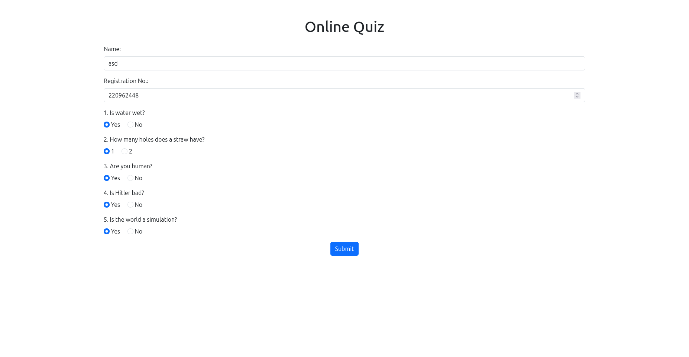

Q2: Write a JavaScript program to Wish a user at different hours of a day. Use appropriate dialog boxes for wishing the user. Display the dynamic clock on the web page. Make use of CSS and HTML5 elements for creative and attractive design.

Code:

<!DOCTYPE html>

<html lang="en">

<head>

<meta charset="UTF-8">

<meta name="viewport" content="width=device-width, initial-scale=1.0">

<title>Wishing</title>

<link rel="stylesheet" href="https://cdn.jsdelivr.net/npm/bootstrap@5.3.3/dist/css/bootstrap.min.css">

</head>

<body class="bg-light text-center py-5">

<div class="container p-4 bg-white rounded shadow">

<div class="h3" id="greeting"></div>

<div class="display-4" id="clock"></div>

</div>

<script>

function updateTime() {

const today = new Date();

const h = today.getHours();

const m = today.getMinutes();

const s = today.getSeconds();

const formattedTime = `${h < 10 ? '0' : ''}${h}:${m < 10 ? '0' : ''}${m}:${s < 10 ? '0' : ''}${s}`;

document.getElementById('clock').textContent = formattedTime;

let greetingMessage;

if (h >= 5 && h < 12) {

greetingMessage = "Good Morning!";

} else if (h >= 12 && h < 17) {

greetingMessage = "Good Afternoon!";

} else if (h >= 17 && h < 21) {

greetingMessage = "Good Evening!";

} else {

greetingMessage = "Good Night!";

}

document.getElementById('greeting').textContent = greetingMessage;

const randomTimes = ["10:05:54", "10:06:45"];

if (randomTimes.includes(formattedTime)) {

alert(greetingMessage);

}

}

setInterval(updateTime, 1000);

</script>

</body>

</html>

Image:

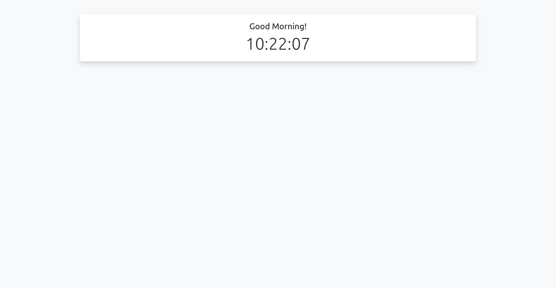

Q3: Write the java script program to display the grade [A, B,C,D] based on the marks entered by student(take the input into text boxes). Enter the marks of 4 subjects and calculate the average( using button). If the avg>90 then A, avg>80 then B, if avg>70 then C, if avg>60 then D.

Code:

<!DOCTYPE html>

<html lang="en">

<head>

<meta charset="UTF-8">

<meta name="viewport" content="width=device-width, initial-scale=1.0">

<title>Grade Calculator</title>

<link rel="stylesheet" href="https://cdn.jsdelivr.net/npm/bootstrap@5.3.3/dist/css/bootstrap.min.css">

</head>

<body class="bg-light text-center py-5">

<div class="container p-4 bg-white rounded shadow">

<h3>Grade Calculator</h3>

<div class="mb-3">

<input type="number" id="subject1" class="form-control mb-2" placeholder="Enter marks for Subject 1">

<input type="number" id="subject2" class="form-control mb-2" placeholder="Enter marks for Subject 2">

<input type="number" id="subject3" class="form-control mb-2" placeholder="Enter marks for Subject 3">

<input type="number" id="subject4" class="form-control mb-2" placeholder="Enter marks for Subject 4">

</div>

<button class="btn btn-primary" onclick="calculateGrade()">Calculate Grade</button>

<h4 class="mt-4" id="result"></h4>

</div>

<script>

function calculateGrade() {

const marks1 = parseFloat(document.getElementById('subject1').value);

const marks2 = parseFloat(document.getElementById('subject2').value);

const marks3 = parseFloat(document.getElementById('subject3').value);

const marks4 = parseFloat(document.getElementById('subject4').value);

if (isNaN(marks1) || isNaN(marks2) || isNaN(marks3) || isNaN(marks4)) {

document.getElementById('result').textContent = "Please enter valid marks for all subjects.";

return;

}

const avg = (marks1 + marks2 + marks3 + marks4) / 4;

let grade;

if (avg > 90) grade = 'A';

else if (avg > 80) grade = 'B';

else if (avg > 70) grade = 'C';

else if (avg > 60) grade = 'D';

else grade = 'F';

document.getElementById('result').textContent = `Average: ${avg.toFixed(2)} - Grade: ${grade}`;

}

</script>

</body>

</html>

Image:

