Q1:

Write a web page which contains table with 3 X 3 dimensions (fill some data) and one

image. Style the rows with alternate color. Move the table and image together from

right to left when button is clicked.

Code:

<!-- Write a web page which contains table with 3 X 3 dimensions (fill some data) and one

image. Style the rows with alternate color. Move the table and image together from

right to left when button is clicked. -->

<!DOCTYPE html>

<html lang="en">

<head>

<meta charset="UTF-8">

<meta name="viewport" content="width=device-width, initial-scale=1.0">

<title>Table Image Moving</title>

</head>

<script src="https://code.jquery.com/jquery-3.7.1.min.js"></script>

<style>

.container {

display: flex;

flex-direction: column;

padding: 20px;

width: 100%;

justify-content: center;

align-items: center;

overflow: hidden;

position: relative;

}

.content {

display: flex;

align-items: center;

position: relative;

right: -100%;

transition: right 1s ease;

}

img {

height: 100px;

}

.main_table {

width: 100%;

border-collapse: collapse;

margin-bottom: 20px;

}

.main_table th,

.main_table td {

border: 1px solid #ddd;

padding: 10px;

text-align: center;

}

.main_table tr:nth-child(odd) {

background-color: white;

}

.main_table tr:nth-child(even) {

background-color: yellow;

}

.submit-button {

padding: 10px;

border-radius: 5px;

}

</style>

<body>

<div class="container">

<div class="content">

<table class="main_table">

<tr>

<th>

Company

</th>

<th>

Model

</th>

<th>

Photo

</th>

</tr>

<tr>

<td>

Suzuki

</td>

<td>

Gixxer

</td>

<td>

<img

src="https://imgd.aeplcdn.com/664x374/n/bw/models/colors/suzuki-select-model-glass-sparkle-black-1671516577831.png?q=80">

</td>

</tr>

<tr>

<td>

Hero

</td>

<td>

Xtreme 160R 4V

</td>

<td>

<img src="https://m.media-amazon.com/images/I/7179pAMOsUL._AC_UF1000,1000_QL80_.jpg">

</td>

</tr>

<tr>

<td>

Honda

</td>

<td>

CB Hornet 160R

</td>

<td>

<img

src="https://imgd.aeplcdn.com/1056x594/n/bw/models/colors/honda-cb-hornet-160r-2018-striking-green-1522404272077.jpg?20190103151915&q=80">

</td>

</tr>

</table>

</div>

<button class="submit-button">Submit</button>

</div>

<script>

$(document).ready(function () {

$(".submit-button").click(function () {

$(".content").animate({

right: "0",

}, 1000);

})

})

</script>

</body>

</html>

Image:

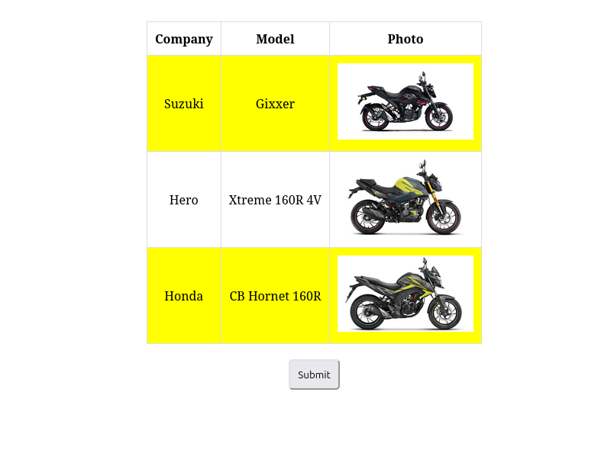

Q2:

Design a calculator to perform basic arithmetic operations. Use textboxes and buttons

to design web page.

Code:

<!-- Design a calculator to perform basic arithmetic operations. Use textboxes and buttons

to design web page. -->

<!DOCTYPE html>

<html lang="en">

<head>

<meta charset="UTF-8">

<meta name="viewport" content="width=device-width, initial-scale=1.0">

<title>Calculator</title>

<script src="https://code.jquery.com/jquery-3.7.1.min.js"></script>

<style>

table {

border: 1px solid black;

margin-left: auto;

margin-right: auto;

}

input[type="button"] {

/* width: 100%; */

padding: 20px 40px;

background-color: grey;

color: black;

font-size: 24px;

font-weight: bold;

border: none;

border-radius: 5px;

}

input[type="text"] {

padding: 20px 30px;

font-size: 24px;

font-weight: bold;

border: none;

border-radius: 5px;

border: 2px solid black;

}

.full-width {

width: 100%;

grid-column: span 4;

}

.calculator-container {

display: grid;

grid-template-columns: repeat(4, 1fr);

gap: 10px;

width: 50%;

}

</style>

</head>

<body>

<div class="container">

<div class="calculator-container">

<input type="text" id="result" class="full-width" readonly>

<input type="button" value="clear" class="full-width" id="clear">

<input type="button" value="1">

<input type="button" value="2">

<input type="button" value="3">

<input type="button" value="/">

<input type="button" value="4">

<input type="button" value="5">

<input type="button" value="6">

<input type="button" value="*">

<input type="button" value="7">

<input type="button" value="8">

<input type="button" value="9">

<input type="button" value="-">

<input type="button" value="0">

<input type="button" value=".">

<input type="button" value="=">

<input type="button" value="+">

</div>

</div>

<script>

$(document).ready(function () {

let currentInput = '';

$('input[type="button"]').not('#clear').not('#result').click(function () {

const value = $(this).val();

currentInput += value;

$('#result').val(currentInput);

});

$('#clear').click(function () {

currentInput = '';

$('#result').val(currentInput);

});

$('input[value="="]').click(function () {

try {

currentInput = currentInput.replace(/[^0-9+\-*/().]/g, '');

let result = eval(currentInput);

if (result === Infinity || result === -Infinity || isNaN(result)) {

throw new Error("Invalid result");

}

currentInput = result.toString();

$('#result').val(currentInput);

} catch (error) {

$('#result').val('Error');

currentInput = '';

}

});

});

</script>

</body>

</html>

Image:

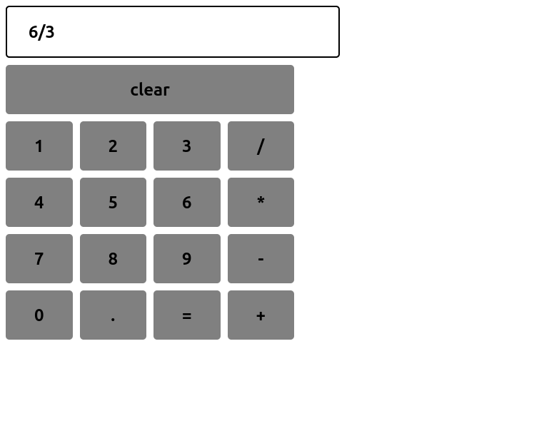

Q3:

Create a web page to design a birthday card shown below.

Code:

<!-- Create a web page to design a birthday card shown below. -->

<!DOCTYPE html>

<html lang="en">

<head>

<meta charset="UTF-8">

<meta name="viewport" content="width=device-width, initial-scale=1.0">

<title>Birthday Card</title>

<script src="https://code.jquery.com/jquery-3.7.1.min.js"></script>

<style>

.container {

display: flex;

justify-content: space-between;

}

.form {

width: 45%;

padding: 10px;

}

label {

font-size: 12px;

}

.preview {

width: 45%;

padding: 10px;

}

.card {

padding: 20px;

text-align: center;

border-radius: 10px;

transition: all 0.3s;

}

.card img {

width: 100%;

max-width: 200px;

margin-bottom: 20px;

}

.card-text {

font-size: 24px;

font-weight: bold;

margin-bottom: 10px;

}

</style>

</head>

<body>

<div class="container">

<div class="form">

<form>

<label for="bg-color">Choose a background color:</label> <br>

<select name="bg-color" id="bg-color">

<option value="white">White</option>

<option value="yellow">Yellow</option>

<option value="blue">Light Blue</option>

</select> <br>

<label for="font-select">Choose a font:</label> <br>

<select name="font-select" id="font-select">

<option value="verdana">Verdana</option>

<option value="arial">Arial</option>

</select> <br>

<label for="border-style">Choose a border style:</label> <br>

<input type="radio" id="none" name="border-style" value="none">

<label for="none">None</label> <br>

<input type="radio" id="double" name="border-style" value="double">

<label for="double">Double</label> <br>

<input type="radio" id="solid" name="border-style" value="solid">

<label for="solid">Solid</label> <br>

<input type="checkbox" id="addpic" name="addpic">

<label for="addpic">Add the default picture</label> <br>

<label for="greeting-text">Enter the greeting text below:</label> <br>

<input type="text" name="greeting-text" id="greeting-text"> <br>

<input type="button" value="Update" id="update">

</form>

</div>

<div class="preview">

<div class="card" id="card">

<div class="card-text" id="card-text">Your Greeting Text Here!</div>

<img id="card-img"

src="https://img.freepik.com/premium-vector/happy-birthday-greeting-card-with-colorful-confetti-stars_123891-119576.jpg"

style="display:none;">

</div>

</div>

</div>

<script>

$(document).ready(function () {

$('#bg-color').change(function () {

$('#card').css('background-color', $(this).val());

});

$('#font-select').change(function () {

$('#card-text').css('font-family', $(this).val());

});

$('input[name="border-style"]').change(function () {

let borderStyle = $('input[name="border-style"]:checked').val();

if (borderStyle === 'none') {

$('#card').css('border', 'none');

} else if (borderStyle === 'double') {

$('#card').css('border', '5px double black');

} else if (borderStyle === 'solid') {

$('#card').css('border', '5px solid black');

}

});

$('#addpic').change(function () {

if (this.checked) {

$('#card-img').show();

} else {

$('#card-img').hide();

}

});

$('#greeting-text').on('input', function () {

$('#card-text').text($(this).val());

});

$('#update').click(function () {

alert('Card Updated!');

});

});

</script>

</body>

</html>

Image:

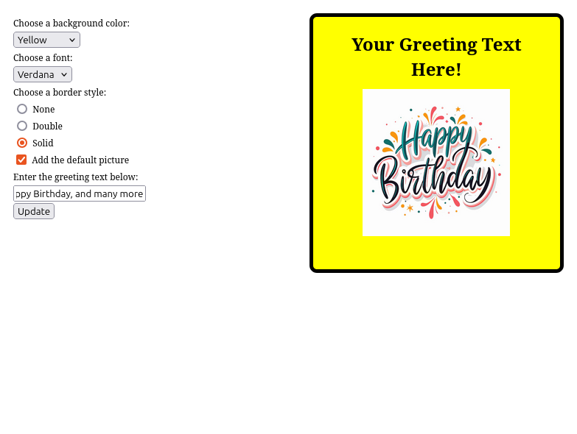

Q4:

Design a webpage. The page contains:

• Dropdown list with HP, Nokia, Samsung, Motorola, Apple as items.

• Checkbox with Mobile and Laptop as items. Textbox where you enter quantity.

• There is a button with text as ‘Produce Bill’.

On Clicking Produce Bill button, alert should be displayed with total amount.

Code:

<!DOCTYPE html>

<html lang="en">

<head>

<meta charset="UTF-8">

<meta name="viewport" content="width=device-width, initial-scale=1.0">

<title>Bill Generator</title>

<style>

body {

font-family: Arial, sans-serif;

display: flex;

justify-content: center;

align-items: center;

height: 100vh;

margin: 0;

background-color: #f4f4f4;

}

.container {

padding: 20px;

background-color: #fff;

border-radius: 10px;

box-shadow: 0 4px 8px rgba(0, 0, 0, 0.1);

text-align: center;

width: 300px;

}

h1 {

margin-bottom: 20px;

font-size: 24px;

}

select,

input[type="number"] {

padding: 8px;

margin: 10px 0;

width: 100%;

box-sizing: border-box;

}

button {

background-color: #007BFF;

color: white;

padding: 10px 15px;

border: none;

border-radius: 5px;

cursor: pointer;

}

button:hover {

background-color: #0056b3;

}

</style>

</head>

<body>

<div class="container">

<h1>Bill Generator</h1>

<select id="brand">

<option value="hp">HP</option>

<option value="nokia">Nokia</option>

<option value="samsung">Samsung</option>

<option value="motorola">Motorola</option>

<option value="apple">Apple</option>

</select>

<br><br>

<input type="checkbox" id="mobile"> Mobile

<input type="checkbox" id="laptop"> Laptop

<br><br>

<input type="number" id="quantity" value="1" min="1">

<br><br>

<button id="produce-bill">Produce Bill</button>

</div>

<script src="https://code.jquery.com/jquery-3.7.1.min.js"></script>

<script>

$(function () {

const prices = { hp: 500, nokia: 300, samsung: 600, motorola: 400, apple: 1000 };

$('#produce-bill').click(function () {

let brand = $('#brand').val(),

qty = $('#quantity').val(),

total = 0;

if ($('#mobile').is(':checked')) total += prices[brand] * qty;

if ($('#laptop').is(':checked')) total += (prices[brand] + 200) * qty;

alert('Total Amount: $' + total);

});

});

</script>

</body>

</html>

Image:

