Q1: Create a web form which allows the teacher to enter the student details like name,

date of birth, address, contact number, email id and marks of English, Physics and

Chemistry. After filling all the information and on clicking submit button, details

should be added to a textarea displayed on the same page. Display the total

percentage of marks obtained in a label.

Code:

views.py:

from django.shortcuts import render

from .forms import StudentForm

def student_form(request):

total_percentage = None

student_data = None

if request.method == 'POST':

form = StudentForm(request.POST)

if form.is_valid():

name = form.cleaned_data['name']

dob = form.cleaned_data['dob']

address = form.cleaned_data['address']

contact_number = form.cleaned_data['contact_number']

email = form.cleaned_data['email']

english_marks = form.cleaned_data['english_marks']

physics_marks = form.cleaned_data['physics_marks']

chemistry_marks = form.cleaned_data['chemistry_marks']

total_marks = english_marks + physics_marks + chemistry_marks

total_percentage = (total_marks / 300) * 100

student_data = {

'name': name,

'dob': dob,

'address': address,

'contact_number': contact_number,

'email': email,

'english_marks': english_marks,

'physics_marks': physics_marks,

'chemistry_marks': chemistry_marks,

'total_marks': total_marks,

'total_percentage': total_percentage,

}

else:

form = StudentForm()

return render(request, 'student/student_form.html', {'form': form, 'student_data': student_data, 'total_percentage': total_percentage})

forms.py:

from django import forms

class StudentForm(forms.Form):

name = forms.CharField(max_length=100, label='Student Name')

dob = forms.DateField(widget=forms.DateInput(attrs={'type': 'date'}), label='Date of Birth')

address = forms.CharField(widget=forms.Textarea, label='Address')

contact_number = forms.CharField(max_length=15, label='Contact Number')

email = forms.EmailField(label='Email ID')

english_marks = forms.IntegerField(min_value=0, max_value=100, label='Marks in English')

physics_marks = forms.IntegerField(min_value=0, max_value=100, label='Marks in Physics')

chemistry_marks = forms.IntegerField(min_value=0, max_value=100, label='Marks in Chemistry')

student_form.html:  
<!DOCTYPE html>

<html lang="en">

<head>

<meta charset="UTF-8">

<meta name="viewport" content="width=device-width, initial-scale=1.0">

<title>Q1 - Student Form</title>

</head>

<body>

<h1>Enter Student Details</h1>

<form method="POST">

{% csrf_token %}

{{ form.as_p }}

<button type="submit">Submit</button>

</form>

{% if student_data %}

<h2>Student Details</h2>

<textarea rows="10" cols="50">

Name: {{ student_data.name }}

Date of Birth: {{ student_data.dob }}

Address: {{ student_data.address }}

Contact Number: {{ student_data.contact_number }}

Email ID: {{ student_data.email }}

English Marks: {{ student_data.english_marks }}

Physics Marks: {{ student_data.physics_marks }}

Chemistry Marks: {{ student_data.chemistry_marks }}

Total Marks: {{ student_data.total_marks }}

</textarea>

<h3>Total Percentage: {{ total_percentage }}%</h3>

{% endif %}

</body>

</html>

Image:

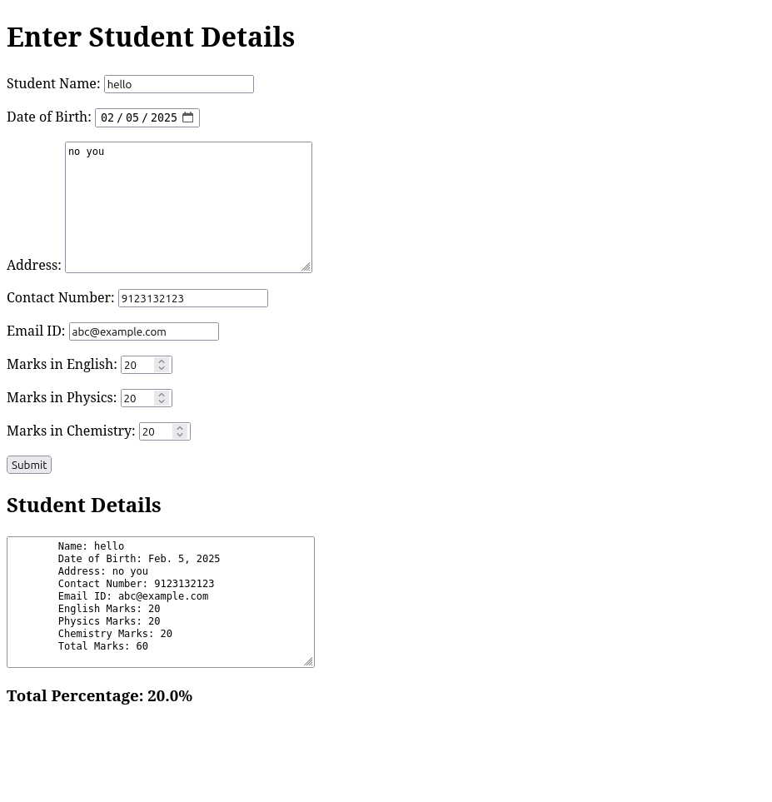

Q2: Create a web form with employee ids in dropdown list. Use a textbox for accepting

date of joining. Add a button named “Am I Eligible for Promotion”. On clicking

the button, if he has more than 5 years of experience, then display “YES” else

“NO” in the label control.

Code:

views.py:

from django.shortcuts import render

from .forms import EmployeePromotionForm

from datetime import datetime

# Create your views here.

def employee_form(request):

current_date = datetime.today()

date_format = r"%d/%m/%Y"

employee_data = None

promoted = None

if request.method == 'POST':

form = EmployeePromotionForm(request.POST)

if form.is_valid():

join_date_string = form.cleaned_data['doj']

join_date = datetime.strptime(join_date_string, date_format)

time_elapsed = current_date - join_date

if (time_elapsed.days / 365.25) > 5:

promoted = True

else:

promoted = False

employee_data = {

'doj': join_date_string,

'promoted': promoted,

}

else:

form = EmployeePromotionForm()

return render(

request,

'webapp/employee_form.html',

{

'form': form,

'employee_data': employee_data,

'promoted': "YES" if promoted else "NO" if promoted is not None else "N/A"

}

)

forms.py:

from django import forms

class EmployeePromotionForm(forms.Form):

employee_id_choices = [

('E01', 'Employee 1'),

('E02', 'Employee 2'),

('E03', 'Employee 3'),

]

employee_id = forms.ChoiceField(choices=employee_id_choices, label="Employee ID")

doj = forms.CharField(max_length=100, label='Date of Joining')

employee_form.html:

<!DOCTYPE html>

<html lang="en">

<head>

<meta charset="UTF-8">

<meta name="viewport" content="width=device-width, initial-scale=1.0">

<title>Employee Promotion Form</title>

</head>

<body>

<h1>Enter Employee Details:</h1>

<form method="POST">

{% csrf_token %}

{{ form.as_p }}

<button type="submit">Am I Eligible for Promotion?</button>

</form>

{% if employee_data %}

<h2>Employee Details:</h2>

<p>Date of Joining: {{ employee_data.doj }}</p>

<h3>Promotion Status: {{ promoted }}</h3>

{% endif %}

</body>

</html>

Image:

