Q1: Develop a simple web page to perform basic arithmetic operations. Take two

integer inputs from the user, select the operation to be performed using a

dropdown. Include a button “Calculate” to perform the selected operation, and

then display the result in the same web page.

Code:

views.py:

from django.shortcuts import render

from django.http import HttpResponse

def index(request):

result = None

if request.method == 'POST':

num1 = int(request.POST.get('num1', 0))

num2 = int(request.POST.get('num2', 0))

operation = request.POST.get('ops')

if operation == 'add':

result = num1 + num2

elif operation == 'sub':

result = num1 - num2

elif operation == 'mul':

result = num1 * num2

elif operation == 'div':

if num2 != 0:

result = num1 / num2

else:

result = "Error: Division by zero"

return render(request, 'base.html', {'result': result})

templates/base.html:

<!DOCTYPE html>

<html lang="en">

<head>

<meta charset="UTF-8">

<meta name="viewport" content="width=device-width, initial-scale=1.0">

<title>Calculator</title>

<link href="https://cdn.jsdelivr.net/npm/bootstrap@5.3.0/dist/css/bootstrap.min.css" rel="stylesheet">

</head>

<body>

<div class="container mt-5">

<div class="card">

<div class="card-header">

<h2>Calculator</h2>

</div>

<div class="card-body">

<form method="post" class="row g-3">

{% csrf_token %}

<div class="col-4">

<label for="num1" class="form-label">First Number</label>

<input type="number" class="form-control" name="num1" id="num1" required>

</div>

<div class="col-2 d-flex align-items-center" style="margin-top: 48px;">

<select name="ops" id="ops" class="form-select">

<option value="add">+</option>

<option value="sub">-</option>

<option value="mul">*</option>

<option value="div">/</option>

</select>

</div>

<div class="col-4">

<label for="num2" class="form-label">Second Number</label>

<input type="number" class="form-control" name="num2" id="num2" required>

</div>

<div class="col-2">

<button type="submit" class="btn btn-primary w-100">Calculate</button>

</div>

</form>

{% if result %}

<div class="alert alert-info mt-3" role="alert">

Result: {{ result }}

</div>

{% endif %}

</div>

</div>

</div>

</body>

</html>

Image:

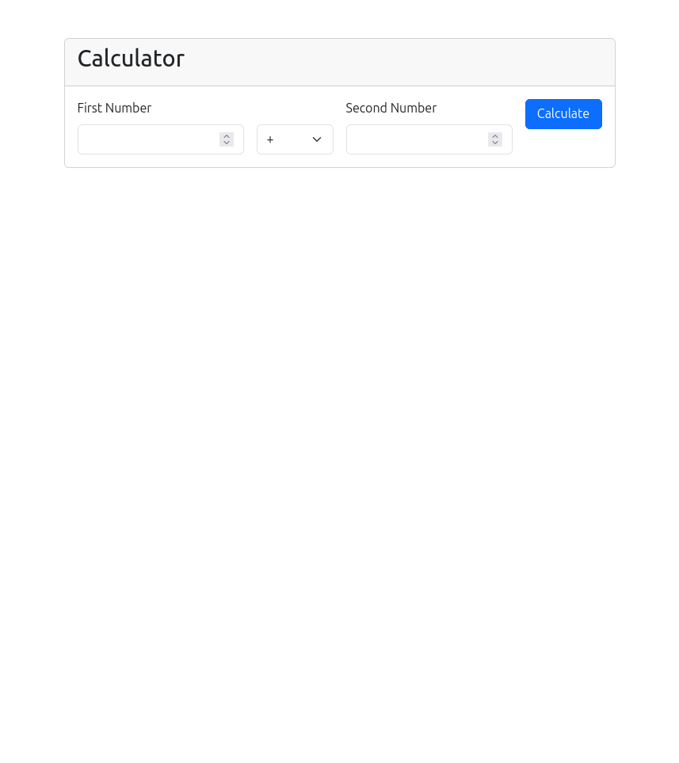

Q2: Develop a simple web form that generates the front cover for a magazine. The

form should provide the options for selecting the image, background color,

changing font size, color etc. Input messages must be taken from the user so

as to display it on the front cover with legible font family and font size. The

front cover developed should be proportionate to the web page size. Place the

css files inside static folder.

Code:

views.py:  
from django.shortcuts import render

from .forms import MagazineCoverForm

def create_cover(request):

if request.method == 'POST':

form = MagazineCoverForm(request.POST, request.FILES)

if form.is_valid():

return render(request, 'webapp/show_cover.html', {'form': form})

else:

form = MagazineCoverForm()

return render(request, 'webapp/create_cover.html', {'form': form})

forms.py:

from django import forms

class MagazineCoverForm(forms.Form):

title = forms.CharField(max_length=100)

subtitle = forms.CharField(max_length=100)

image = forms.ImageField()

background_color = forms.CharField(max_length=7, initial="#FFFFFF")

font_color = forms.CharField(max_length=7, initial="#000000")

font_size = forms.IntegerField(initial=30)

create_cover.html:

<!DOCTYPE html>

<html lang="en">

<head>

<meta charset="UTF-8">

<title>Create Magazine Cover</title>

{% load static %}

<link rel="stylesheet" type="text/css" href="{% static 'css/styles.css' %}">

</head>

<body>

<h1>Generate Magazine Cover</h1>

<form method="post" enctype="multipart/form-data">

{% csrf_token %}

{{ form.as_p }}

<button type="submit">Generate Cover</button>

</form>

</body>

</html>

show_cover.html:

<!DOCTYPE html>

<html lang="en">

<head>

<meta charset="UTF-8">

<title>Magazine Cover</title>

{% load static %}

<link rel="stylesheet" type="text/css" href="{% static 'css/styles.css' %}">

</head>

<body>

<div class="cover" style="background-color: {{ form.cleaned_data.background_color }};">

<img src="{{ form.cleaned_data.image.url }}" alt="Cover Image">

<h1 style="color: {{ form.cleaned_data.font_color }}; font-size: {{ form.cleaned_data.font_size }}px;">

{{ form.cleaned_data.title }}

</h1>

<h2 style="color: {{ form.cleaned_data.font_color }}; font-size: {{ form.cleaned_data.font_size }}px;">

{{ form.cleaned_data.subtitle }}

</h2>

</div>

</body>

</html>

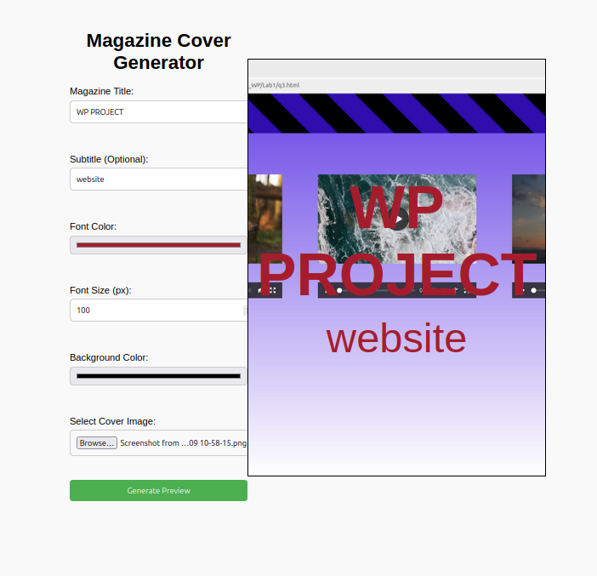Image:

Q3: Design a simple web application to provide information about a book. The

home page of the application should display the cover page of the book along

with three hyperlinks: Metadata, Reviews, Publisher info. Give provision to

revert to home page from any other page

Code:

views.py:

from django.shortcuts import render, get_object_or_404

from .models import Book

def home(request):

book = Book.objects.first() # Get the first book (MVP)

return render(request, 'webapp/home.html', {'book': book})

def metadata(request):

book = Book.objects.first()

return render(request, 'webapp/metadata.html', {'book': book})

def reviews(request):

book = Book.objects.first()

return render(request, 'webapp/reviews.html', {'book': book})

def publisher_info(request):

book = Book.objects.first()

return render(request, 'webapp/publisher_info.html', {'book': book})

models.py:

from django.db import models

class Book(models.Model):

title = models.CharField(max_length=200)

cover_image = models.ImageField(upload_to='covers/')

metadata = models.TextField()

reviews = models.TextField()

publisher_info = models.TextField()

def __str__(self):

return self.title

base.html:  
<!-- webapp/templates/webapp/base.html -->

<!DOCTYPE html>

<html>

<head>

<title>Book Details</title>

</head>

<body>

<nav>

<a href="{% url 'webapp:home' %}">Home</a>

</nav>

{% block content %}

{% endblock %}

</body>

</html>

home.html”

<!-- webapp/templates/webapp/home.html -->

{% extends 'webapp/base.html' %}

{% block content %}

<h1>Book Details</h1>

{% if book.cover_image %}

<img src="{{ book.cover_image.url }}" alt="{{ book.title }} cover" width="200">

{% endif %}

<ul>

<li><a href="{% url 'webapp:metadata' %}">Metadata</a></li>

<li><a href="{% url 'webapp:reviews' %}">Reviews</a></li>

<li><a href="{% url 'webapp:publisher_info' %}">Publisher Info</a></li>

</ul>

{% endblock %}

metadata.html:

<!-- webapp/templates/webapp/metadata.html -->

{% extends 'webapp/base.html' %}

{% block content %}

<h1>Book Metadata</h1>

<p>{{ book.metadata }}</p>

{% endblock %}

publisher_info.html:  
<!-- webapp/templates/webapp/publisher_info.html -->

{% extends 'webapp/base.html' %}

{% block content %}

<h1>Publisher Information</h1>

<p>{{ book.publisher_info }}</p>

{% endblock %}

reviews.html:  
<!-- webapp/templates/webapp/reviews.html -->

{% extends 'webapp/base.html' %}

{% block content %}

<h1>Book Reviews</h1>

<p>{{ book.reviews }}</p>

{% endblock %}

I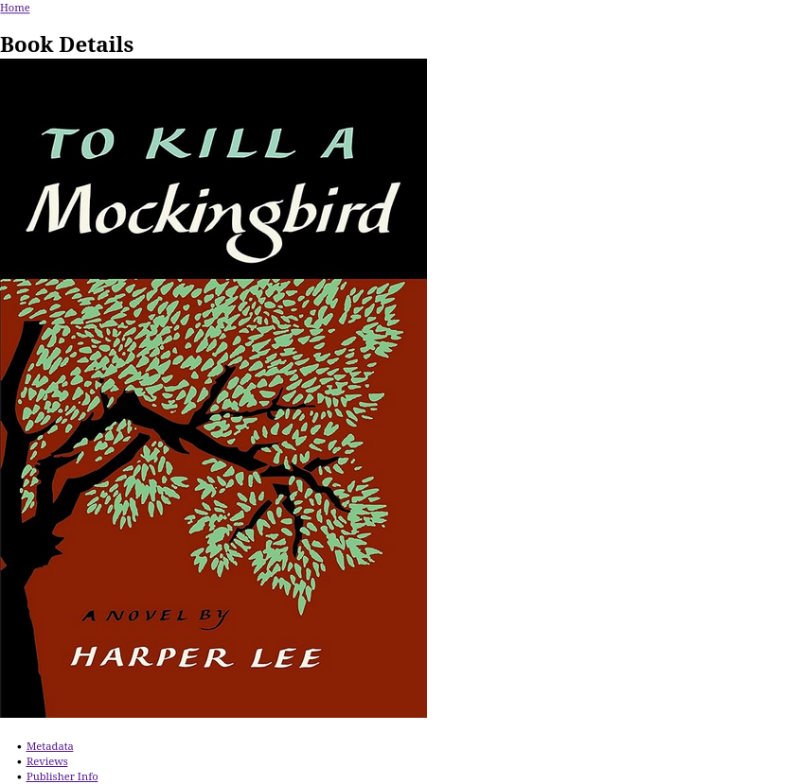mage: