Q1:Develop a web application using Django framework to demonstrate the transfer of multiple parameters between web pages. User should be presented with a dropdown list containing car manufacturers, a text box which takes model name of the manufacturer and a submit button. On submitting the web page, the user is forwarded to a new page. This new page should display the selected car manufacturer name and the model name.

Code:

index.html:

<!DOCTYPE html>

<html>

<head>

<title>Car Selection</title>

<link href="https://cdn.jsdelivr.net/npm/bootstrap@5.3.0/dist/css/bootstrap.min.css" rel="stylesheet">

</head>

<body>

<div class="container mt-5">

<h2>Car Selection</h2>

{% if not result %}

<form method="post" class="mt-3">

{% csrf_token %}

<div class="mb-3">

<label class="form-label">{{ form.manufacturer.label }}</label>

{{ form.manufacturer }}

</div>

<div class="mb-3">

<label class="form-label">{{ form.model.label }}</label>

{{ form.model }}

</div>

<button type="submit" class="btn btn-primary">Submit</button>

</form>

{% else %}

<div class="mt-3">

<h3>Result</h3>

<p><strong>Manufacturer:</strong> {{ result.manufacturer }}</p>

<p><strong>Model:</strong> {{ result.model }}</p>

<a href="{% url 'car_view' %}" class="btn btn-secondary">Back</a>

</div>

{% endif %}

</div>

<script src="https://cdn.jsdelivr.net/npm/bootstrap@5.3.0/dist/js/bootstrap.bundle.min.js"></script>

</body>

</html>

forms.py:

from django import forms

class CarForm(forms.Form):

MANUFACTURERS = [

('toyota', 'Toyota'),

('honda', 'Honda'),

('ford', 'Ford'),

('bmw', 'BMW'),

]

manufacturer = forms.ChoiceField(choices=MANUFACTURERS, label='Car Manufacturer')

model = forms.CharField(max_length=100, label='Model Name')

views.py:

from django.shortcuts import render

from .forms import CarForm

def car_view(request):

result = None

if request.method == 'POST':

form = CarForm(request.POST)

if form.is_valid():

result = {

'manufacturer': form.cleaned_data['manufacturer'],

'model': form.cleaned_data['model']

}

else:

form = CarForm()

return render(request, 'index.html', {

'form': form,

'result': result

})

Image:

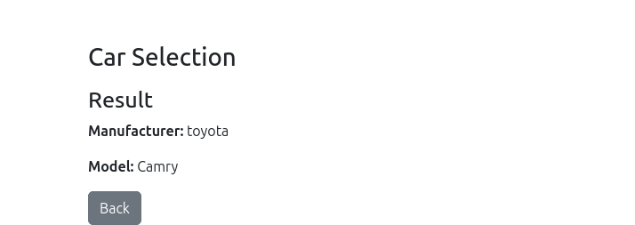

Q2: Create a page firstPage.html with two TextBoxes [Name, Roll], DropDownList [Subjects], and a button. Create another page secondPage.html with a label and a button. When the user clicks the button in first Page, he should be sent to the second page and display the contents passed from first page in the label. The button in second page should navigate the user back to firstPage. Use Django sessions to transfer information.

Code:

firstpage.html:

<!DOCTYPE html>

<html>

<body>

<form method="post">

{% csrf_token %}

{{ form.as_p }}

<button type="submit">Submit</button>

</form>

</body>

</html>

secondpage.html:

<!DOCTYPE html>

<html>

<body>

<label>{{ display_text }}</label>

<form method="post">

{% csrf_token %}

<button type="submit">Back</button>

</form>

</body>

</html>

views.py:

from django.shortcuts import render, redirect

from .forms import StudentForm

def first_page(request):

if request.method == 'POST':

form = StudentForm(request.POST)

if form.is_valid():

request.session['student_data'] = form.cleaned_data

return redirect('second_page')

else:

form = StudentForm()

return render(request, 'webapp/firstpage.html', {'form': form})

def second_page(request):

student_data = request.session.get('student_data', {})

display_text = f"Name: {student_data.get('name', '')}, Roll: {student_data.get('roll', '')}, Subject: {student_data.get('subject', '')}"

if request.method == 'POST':

return redirect('first_page')

return render(request, 'webapp/secondpage.html', {'display_text': display_text})

forms.py:

from django import forms

class StudentForm(forms.Form):

name = forms.CharField(max_length=100)

roll = forms.CharField(max_length=10)

subject = forms.ChoiceField(choices=[

('math', 'Mathematics'),

('sci', 'Science'),

('eng', 'English')

])

Image:

