Q1: Develop a Web Application for Grocery Checklist Generation as shown in the figure below. It must have checkboxes which must be populated on page load listing grocery items. On clicking the Add Item button the selected Items and their prices have to be displayed in a Table. Set the borderstyle and border width for the table and its cells.

Code:

index.html:

<!DOCTYPE html>

<html>

<head>

<title>Grocery Checklist</title>

<style>

table {

border: 2px solid black;

border-collapse: collapse;

}

td, th {

border: 1px solid black;

padding: 5px;

}

</style>

</head>

<body>

<h2>Select Item:</h2>

<form method="post">

{% csrf_token %}

{% for item in items %}

<input type="checkbox" name="{{ item.name|lower }}" id="{{ item.name }}">

<label for="{{ item.name }}">{{ item.name }}</label><br>

{% endfor %}

<button type="submit">Add Item</button>

</form>

{% if selected_items %}

<h3>Item Name Item Price</h3>

<table>

<tr>

<th>Item Name</th>

<th>Item Price</th>

</tr>

{% for item in selected_items %}

<tr>

<td>{{ item.name }}</td>

<td>{{ item.price }}</td>

</tr>

{% endfor %}

</table>

{% endif %}

</body>

</html>

views.py:

from django.shortcuts import render

from .forms import GroceryForm

def index(request):

grocery_items = [

{'name': 'Wheat', 'price': 40},

{'name': 'Jaggery', 'price': 50},

{'name': 'Dal', 'price': 80},

]

if request.method == 'POST':

form = GroceryForm(request.POST)

if form.is_valid():

selected_items = [

item for item in grocery_items

if form.cleaned_data.get(item['name'].lower())

]

return render(request, 'index.html', {

'form': form,

'items': grocery_items,

'selected_items': selected_items

})

else:

form = GroceryForm()

return render(request, 'index.html', {

'form': form,

'items': grocery_items

})

forms.py:

from django import forms

class GroceryForm(forms.Form):

wheat = forms.BooleanField(required=False)

jaggery = forms.BooleanField(required=False)

dal = forms.BooleanField(required=False)

I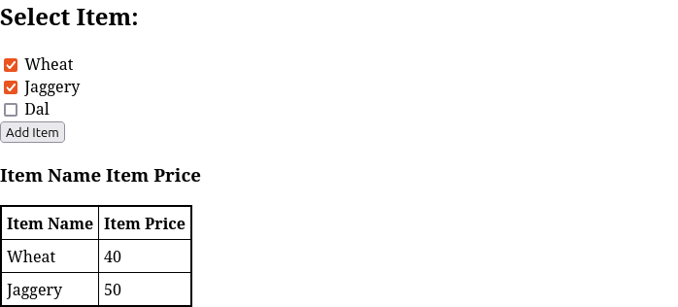mage: