Q1: Create a Register page and Success page with the following requirements:

i. Register page should contain four input TextBoxes for UserName, Password,

Email id and Contact Number and also a button to submit. Make the username as

compulsory field and other fields as optional.

ii. On button click, Success page is displayed with message "Welcome

{UserName}" and also his Email and Contact Number has to be displayed.

iii. Use secure technique to send details to the Success page (Hint: use csrftoken) 4)

Design a website with two pages

Code:

**webapp/forms.py:**

from django import forms

class RegisterForm(forms.Form):

username = forms.CharField(max_length=150, required=True)

password = forms.CharField(widget=forms.PasswordInput, required=False)

email = forms.EmailField(required=False)

contact_number = forms.CharField(max_length=15, required=False)

**webapp/views.py:**

from django.shortcuts import render

from .forms import RegisterForm

def register(request):

if request.method == 'POST':

form = RegisterForm(request.POST)

if form.is_valid():

username = form.cleaned_data['username']

email = form.cleaned_data['email']

contact_number = form.cleaned_data['contact_number']

return render(request, 'webapp/success.html', {

'username': username,

'email': email,

'contact_number': contact_number,

})

else:

form = RegisterForm()

return render(request, 'webapp/register.html', {'form': form})

def success(request):

return render(request, 'webapp/success.html')

**webapp/templates/webapp/register.html:**  
<!DOCTYPE html>

<html lang="en">

<head>

<meta charset="UTF-8">

<meta name="viewport" content="width=device-width, initial-scale=1.0">

<title>Register</title>

<link href="https://cdn.jsdelivr.net/npm/bootstrap@5.3.0/dist/css/bootstrap.min.css" rel="stylesheet">

</head>

<body class="bg-light">

<div class="container mt-5">

<div class="row justify-content-center">

<div class="col-md-6 col-lg-4">

<h1 class="display-6 mb-4 text-center">Register</h1>

<form method="post" class="bg-white p-4 rounded shadow-sm">

{% csrf_token %}

{{ form.as_p }}

<button type="submit" class="btn btn-primary w-100 mt-3">Submit</button>

</form>

</div>

</div>

</div>

</body>

</html>

**webapp/templates/webapp/success.html:**

<!DOCTYPE html>

<html lang="en">

<head>

<meta charset="UTF-8">

<meta name="viewport" content="width=device-width, initial-scale=1.0">

<title>Success</title>

<link href="https://cdn.jsdelivr.net/npm/bootstrap@5.3.0/dist/css/bootstrap.min.css" rel="stylesheet">

</head>

<body class="bg-light">

<div class="container mt-5">

<div class="row justify-content-center">

<div class="col-md-6 text-center">

<h1 class="display-6 mb-4">Welcome {{ username }}</h1>

<div class="bg-white p-4 rounded shadow-sm">

<p class="lead mb-2">Email: {{ email }}</p>

<p class="lead">Contact Number: {{ contact_number }}</p>

</div>

</div>

</div>

</div>

</body>

</html>

Im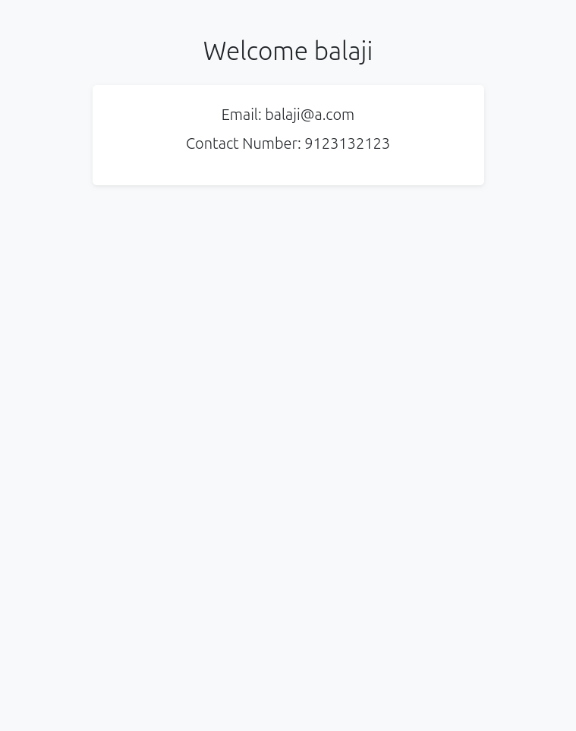age:

Q2: “How is the book ASP.NET with c# by Vipul Prakashan?” Give the user three choice : i) Good

ii) Satisfactory iii) Bad. Provide a VOTE button. After user votes, present the result in

percentage using labels next to the choices

Code:

**webapp/forms.py:**

from django import forms

from .models import Vote

class VoteForm(forms.ModelForm):

class Meta:

model = Vote

fields = ['choice']

widgets = {

'choice': forms.RadioSelect(attrs={'class': 'form-check-input'})

}

**webapp/models.py:**

from django.db import models

class Vote(models.Model):

CHOICES = [

('Good', 'Good'),

('Satisfactory', 'Satisfactory'),

('Bad', 'Bad'),

]

choice = models.CharField(max_length=15, choices=CHOICES)

created_at = models.DateTimeField(auto_now_add=True)

**webapp/views.py:**  
from django.shortcuts import render, redirect

from .models import Vote

from .forms import VoteForm

from django.db.models import Count

def index(request):

show_results = False

percentages = {}

total_votes = 0

if request.method == 'POST':

form = VoteForm(request.POST)

if form.is_valid():

form.save()

return redirect('/?results=1')

else:

form = VoteForm()

if request.GET.get('results'):

show_results = True

total_votes = Vote.objects.count()

results = Vote.objects.values('choice').annotate(count=Count('choice'))

percentages = {result['choice']: round((result['count'] / total_votes) * 100, 2)

if total_votes else 0 for result in results}

return render(request, 'webapp/index.html', {

'form': form,

'show_results': show_results,

'percentages': percentages,

'total_votes': total_votes

})

**webapp/templates/webapp/index.html:**

<!DOCTYPE html>

<html lang="en">

<head>

<meta charset="UTF-8">

<meta name="viewport" content="width=device-width, initial-scale=1.0">

<title>Book Poll</title>

<link href="https://cdn.jsdelivr.net/npm/bootstrap@5.3.0/dist/css/bootstrap.min.css" rel="stylesheet">

</head>

<body class="bg-light">

<nav class="navbar navbar-dark bg-dark">

<div class="container">

<a class="navbar-brand" href="/">Book Poll</a>

</div>

</nav>

<div class="container mt-4">

<div class="card shadow">

<div class="card-body">

{% if show_results %}

<h2 class="mb-4">Poll Results</h2>

<p class="text-muted mb-4">Total votes: {{ total_votes }}</p>

<div class="list-group">

<div class="list-group-item">

Good: {{ percentages.Good|default:0 }}%

</div>

<div class="list-group-item">

Satisfactory: {{ percentages.Satisfactory|default:0 }}%

</div>

<div class="list-group-item">

Bad: {{ percentages.Bad|default:0 }}%

</div>

</div>

<a href="/" class="btn btn-secondary mt-3">Vote Again</a>

{% else %}

<h2 class="mb-4">How is the book ASP.NET with C# by Vipul Prakashan?</h2>

<form method="post">

{% csrf_token %}

<div class="vstack gap-3 mb-4">

{% for choice in form.choice %}

<div class="form-check">

{{ choice.tag }}

<label class="form-check-label" for="{{ choice.id_for_label }}">

{{ choice.choice_label }}

</label>

</div>

{% endfor %}

</div>

<button type="submit" class="btn btn-primary mt-2">VOTE</button>

</form>

{% endif %}

</div>

</div>

</div>

<script src="https://cdn.jsdelivr.net/npm/bootstrap@5.3.0/dist/js/bootstrap.bundle.min.js"></script>

</body>

</html>

Image:

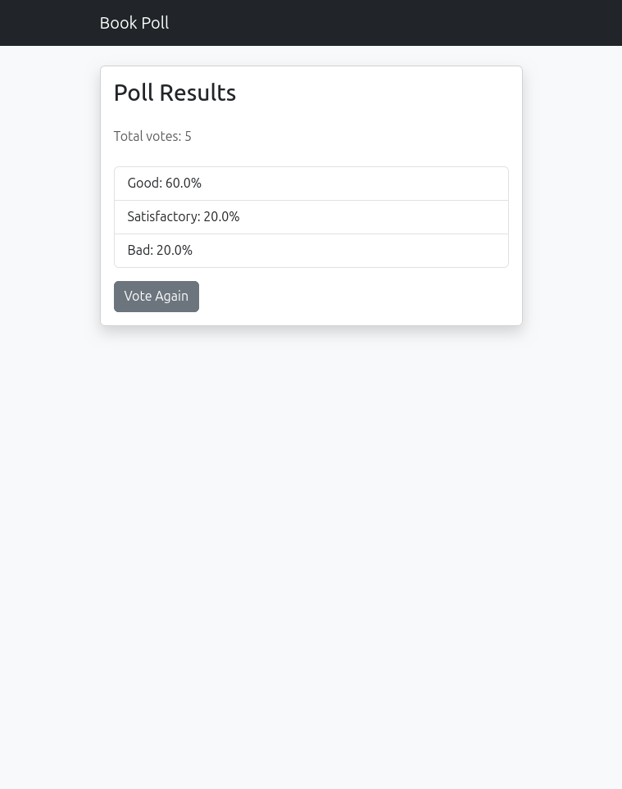

Q3: Create a website with two pages. Page 1 has two TextBoxes (name and total marks)

and one ‘Calculate’ Button as shown in the figure. On clicking the ‘Calculate’ Button,

CGPA (total marks/50) along with the name should be displayed in the Page 2. Use

Django sessions to store the information

Code:  
**webapp/forms.py:**

from django import forms

class StudentForm(forms.Form):

name = forms.CharField(

max_length=100,

widget=forms.TextInput(attrs={'class': 'form-control'})

)

total_marks = forms.IntegerField(

min_value=0,

widget=forms.NumberInput(attrs={'class': 'form-control'})

)

**webapp/views.py:**

from django.shortcuts import render, redirect

from .forms import StudentForm

def home(request):

if request.method == 'POST':

form = StudentForm(request.POST)

if form.is_valid():

request.session['name'] = form.cleaned_data['name']

request.session['cgpa'] = form.cleaned_data['total_marks'] / 50

return redirect('result')

else:

form = StudentForm()

return render(request, 'webapp/home.html', {'form': form})

def result(request):

if 'name' not in request.session or 'cgpa' not in request.session:

return redirect('home')

return render(request, 'webapp/result.html')

**webapp/templates/webapp/base.html:**  
<!DOCTYPE html>

<html>

<head>

<title>CGPA Calculator</title>

<link href="https://cdn.jsdelivr.net/npm/bootstrap@5.3.0/dist/css/bootstrap.min.css" rel="stylesheet">

</head>

<body class="container mt-5">

{% block content %}{% endblock %}

</body>

</html>

**webapp/templates/webapp/home.html:**

{% extends 'webapp/base.html' %}

{% block content %}

<div class="card shadow">

<div class="card-body">

<h2 class="mb-4">Enter Details</h2>

<form method="post">

{% csrf_token %}

<div class="mb-3">

{{ form.name.label_tag }}

{{ form.name }}

</div>

<div class="mb-3">

{{ form.total_marks.label_tag }}

{{ form.total_marks }}

</div>

<button type="submit" class="btn btn-primary">Calculate</button>

</form>

</div>

</div>

{% endblock %}

**webapp/templates/webapp/result.html:**

{% extends 'webapp/base.html' %}

{% block content %}

<div class="card shadow">

<div class="card-body">

<h2 class="mb-4">Result</h2>

<div class="alert alert-success">

<h5>Name: {{ request.session.name }}</h5>

<h5>CGPA: {{ request.session.cgpa }}</h5>

</div>

<a href="{% url 'home' %}" class="btn btn-primary">Calculate Again</a>

</div>

</div>

{% endblock %}

Im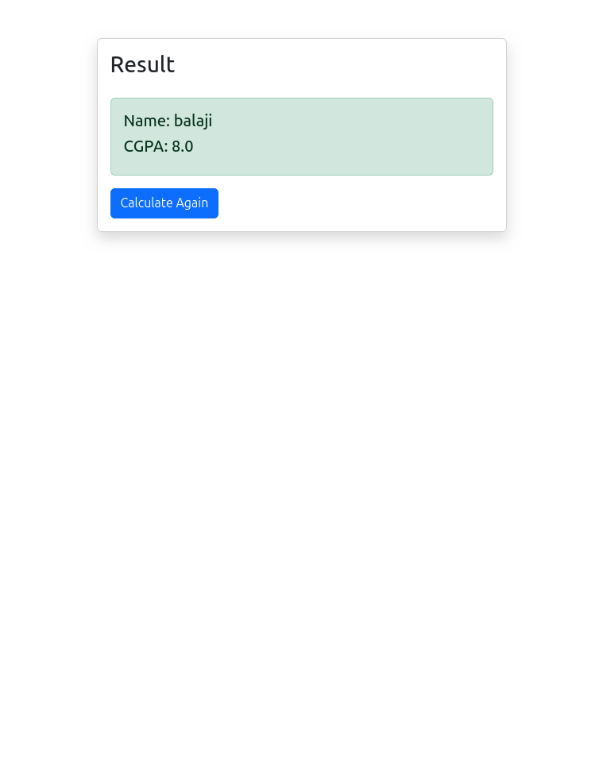age: