ASSIGNMENT-2.3

NAME: B. SAINATH ROLL NO:2403A510C3

Task Description 1:

->Use Google Gemini in Colab to write a function that reads a CSV file and calculates mean, min, max.
Prompt:

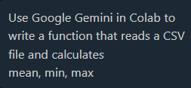

Code:

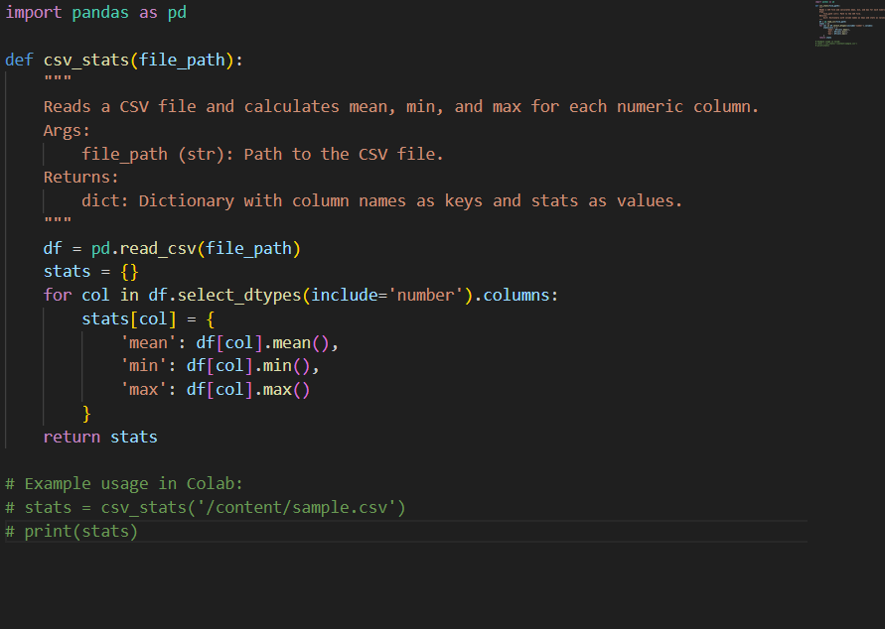

Expected Output 1:

->Functional code with output and screenshot

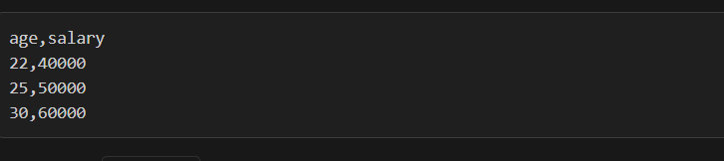

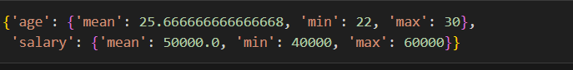

Task Description 2:
->Compare Gemini and Copilot outputs for a palindrome check function.

Prompt:

Code:

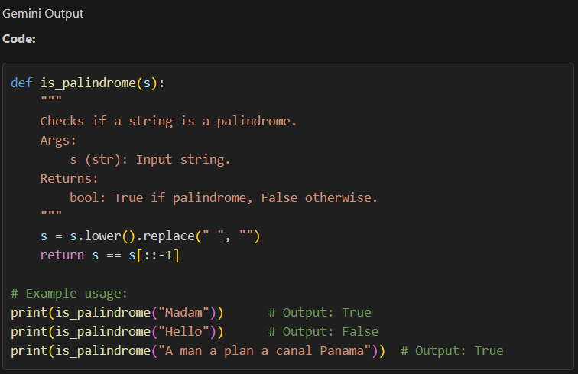

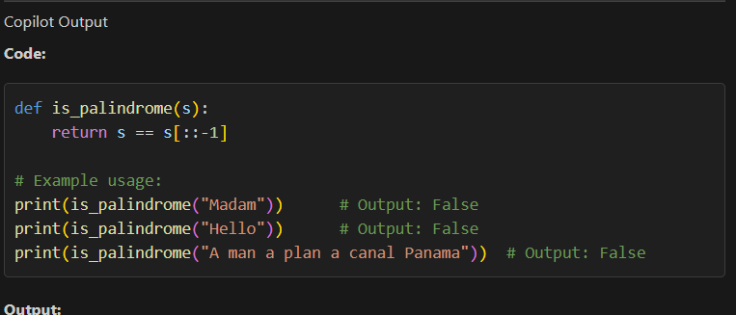

Expected Output 2:

->Side-by-side comparison and observations

Gemini output:

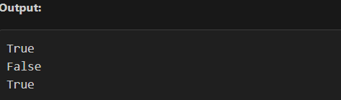

CoPilot:

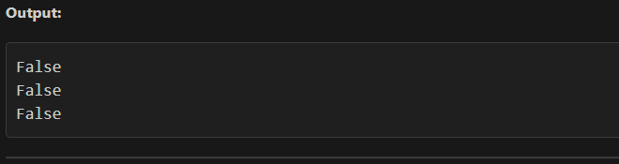

Task Description 3:
->Ask Gemini to explain a Python function (to calculate area of various shapes) line by line..

Prompt:

Code:

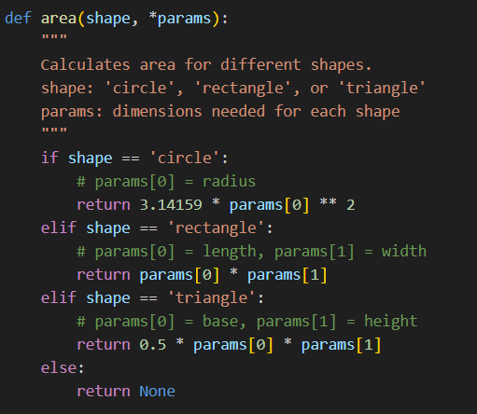

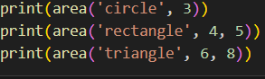

Expected Output 3:
->Detailed explanation with code snippet

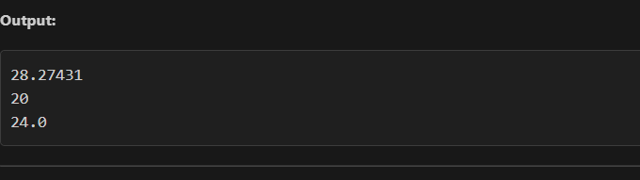

Task Description 4:
->Install and configure Cursor AI. Use it to generate a Python function (e.g., sum of
squares)

Prompt:

Code:
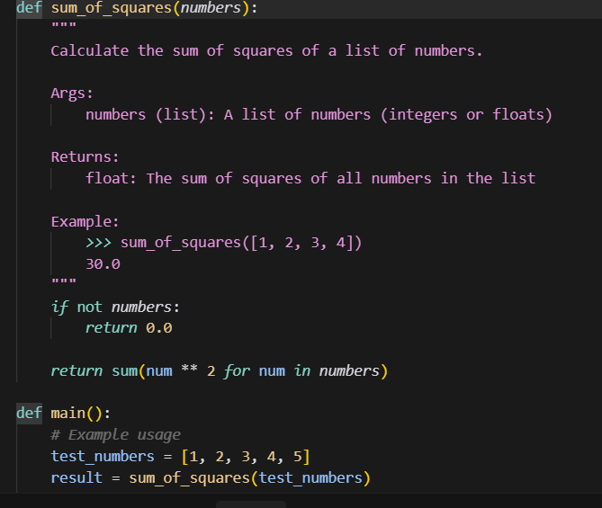

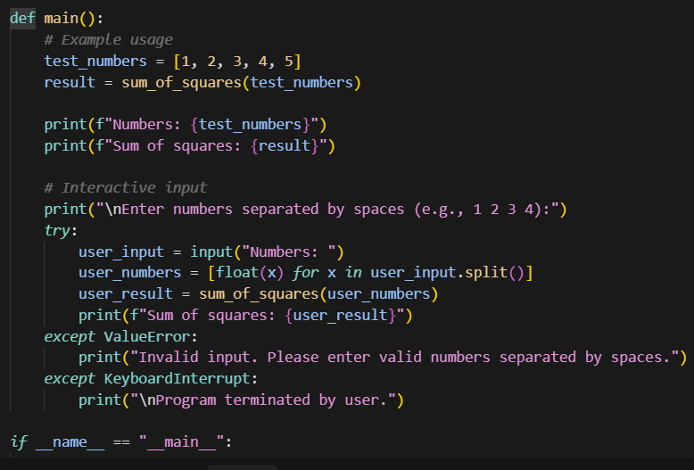

Expected Output 4:
->Screenshots of working environments with few prompts to generate python code

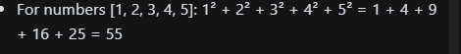

Task Description 5:
->Student need to write code to calculate sum of add number and even numbers in the list

Prompt:



Code:

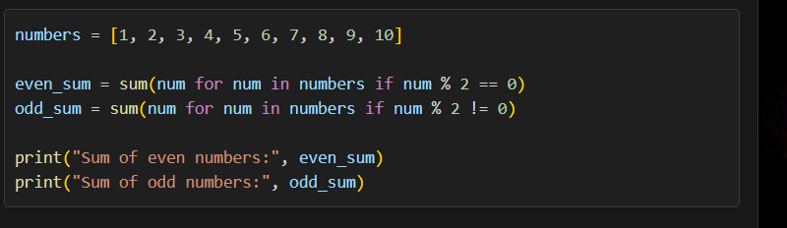

Expected Output 5:
->Refactored code written by student with improved logic



