ASSIGNMENT-4.1

NAME:B. SAI NATH ROLL NO: 2403A510C3

Task #1 – Zero-Shot Prompting with Conditional Validation
Objective
Use zero-shot prompting to instruct an AI tool to generate a function that validates an Indian mobile number.
Requirements
->The function must ensure the mobile number:
1)Starts with 6, 7, 8, or 9
2)Contains exactly 10 digits

Prompt: 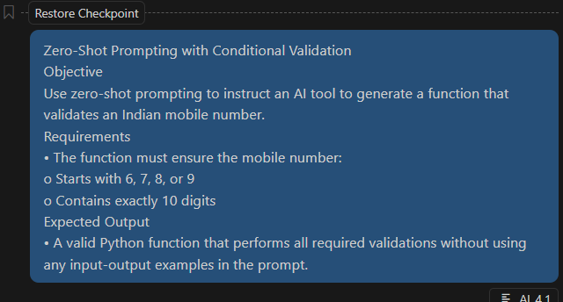

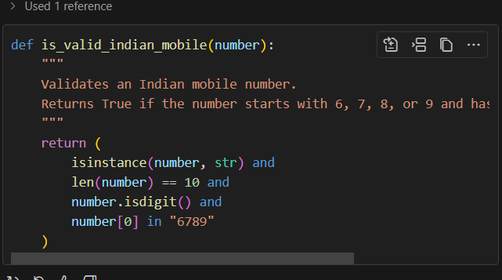
Code:
Expected Output
- A valid Python function that performs all required validations without using any input-output examples in the prompt.
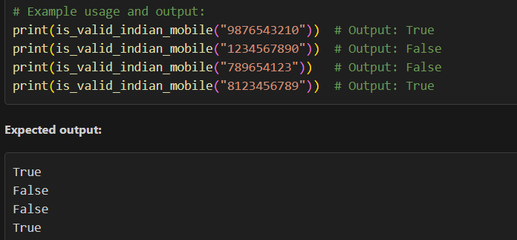

Task #2 – One-Shot Prompting with Edge Case Handling
Objective
Use one-shot prompting to generate a Python function that calculates the factorial of a number.
Requirements:
1)Provide one sample input-output pair in the prompt to guide the AI.
2)The function should handle:
0! correctly
Negative input by returning an appropriate message
Prompt:
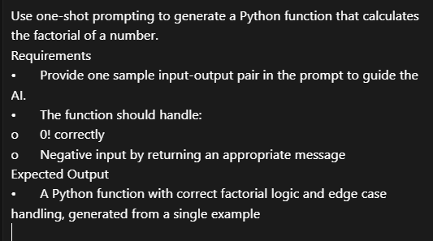
Code:
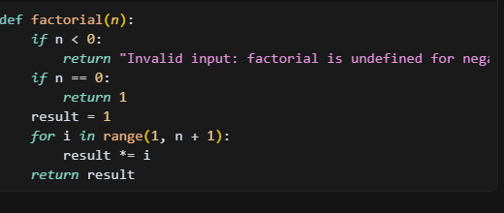

Expected Output:
-->A Python function with correct factorial logic and edge case handling, generated from a single example.
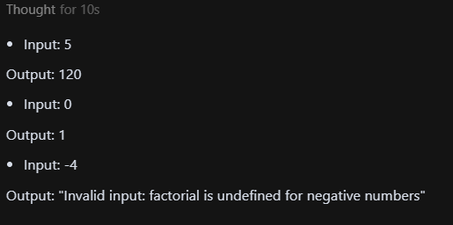

Task #3 – Few-Shot Prompting for Nested Dictionary Extraction
Objective
Use few-shot prompting (2–3 examples) to instruct the AI to create a function that parses a nested dictionary representing student information.
Requirements
The function should extract and return:
1)Full Name
2)Branch
3)GPA
Prompt:
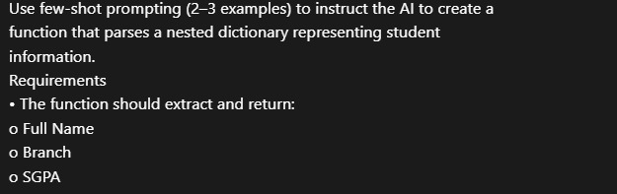
Code:

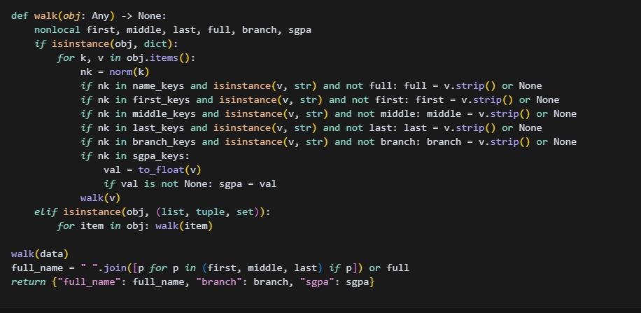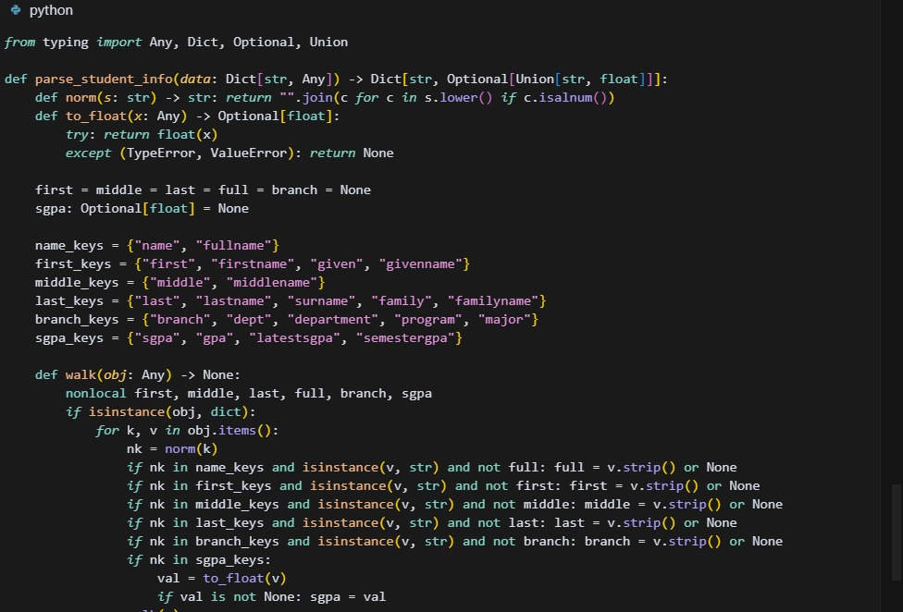
Expected Output:
A reusable Python function that correctly navigates and extracts values from nested dictionaries based on the provided examples.
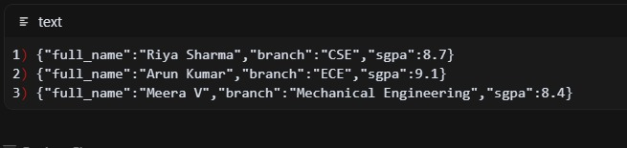

Task #4 – Comparing Prompting Styles for File Analysis
Objective:
Experiment with zero-shot, one-shot, and few-shot prompting to generate functions for CSV file analysis.
Requirements:
->Each generated function should:
->Read a .csv file
->Return the total number of rows
->Count the number of empty rows
Prompt:
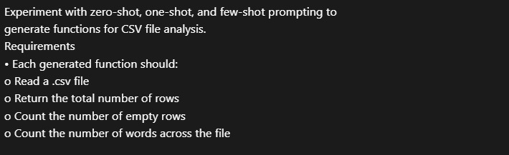
Count the number of words across the file
Code:
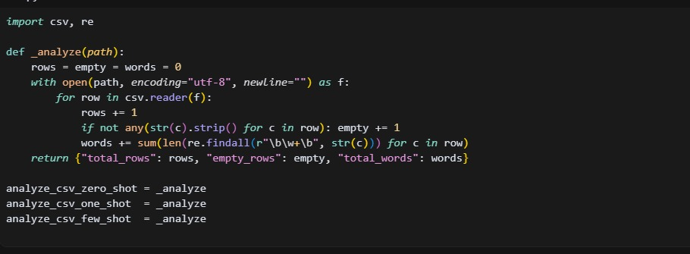

Expected Output:
Working Python functions for each prompting style, with a brief reflection comparing their accuracy, clarity, and efficiency.
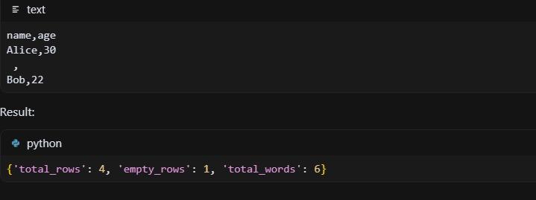

Task #5 – Few-Shot Prompting for Text Processing and Word Frequency
Objective:
Use few-shot prompting (with at least 3 examples) to generate a Python function that processes text and analyzes word frequency.
Requirements:
The function must:
1)Accept a paragraph as input
2)Convert all text to lowercase
3)Remove punctuation
4)Return the most frequently used word
Prompt:

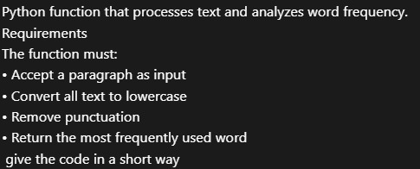

code:
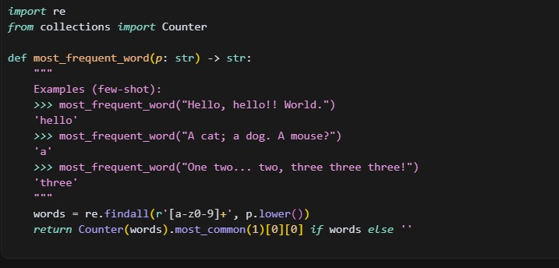

Expected Output:
A functional Python script that performs text cleaning, tokenization, and returns the most common word using only the examples provided in the prompt.
