ASSIGNMENT-4.3

NAME: B. SAI NATH ROLL NO: 2403A510C3
TASK 1:
PROMPT:
CODE:
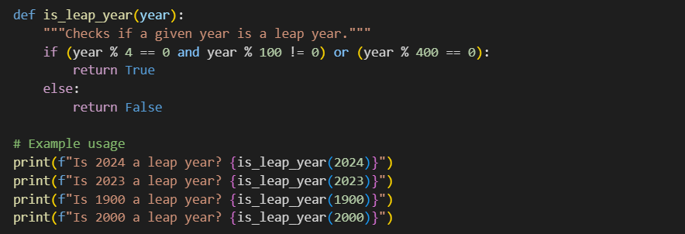
OUTPUT:
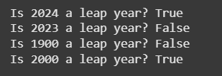
OBSERVATION:
The AI understood the task without any example and generated the correct leap year checking logic.
TASK 2:
PROMPT:

CODE:
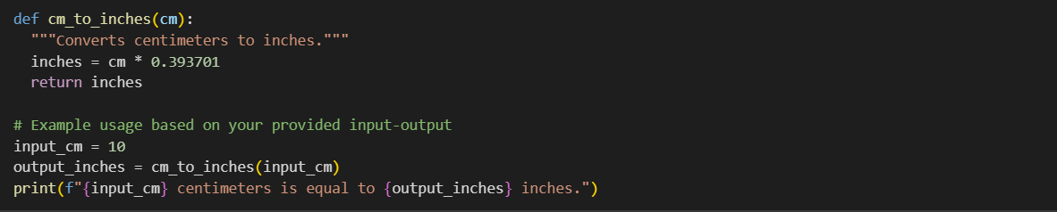
OUTPUT:
OBSERVATION:
With one input-output example, the AI learned the conversion formula and applied it correctly for general use.
TASK 3:
PROMPT:

CODE:
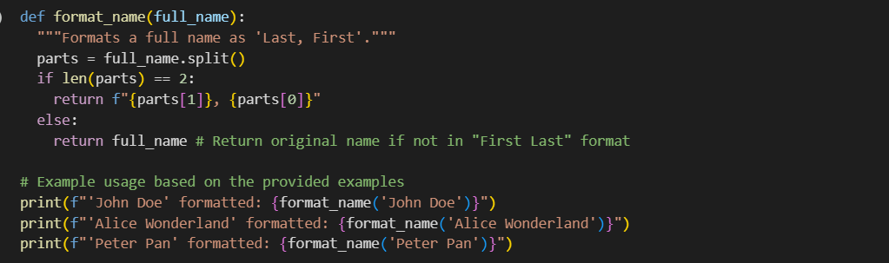
OUTPUT:
OBSERVATION:
The AI used multiple examples to clearly identify the pattern and produced a consistent function that works for different names.
Example 1: Input: "John Doe" Output: "Doe, John"
Example 2: Input: "Alice Wonderland" Output: "Wonderland, Alice"
Example 3: Input: "Peter Pan" Output: "Pan, Peter"
These examples show how a full name with a first and last name should be formatted as "Last, First".
TASK 4:
PROMPT:
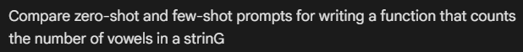
CODE:
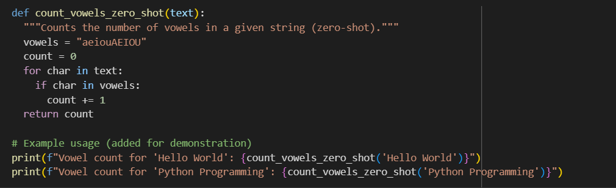
OUTPUT:
OBSERVATION:
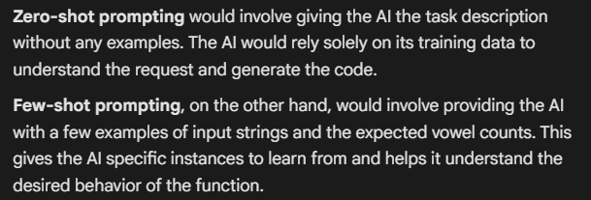
TASK 5:
PROMPT:

CODE: 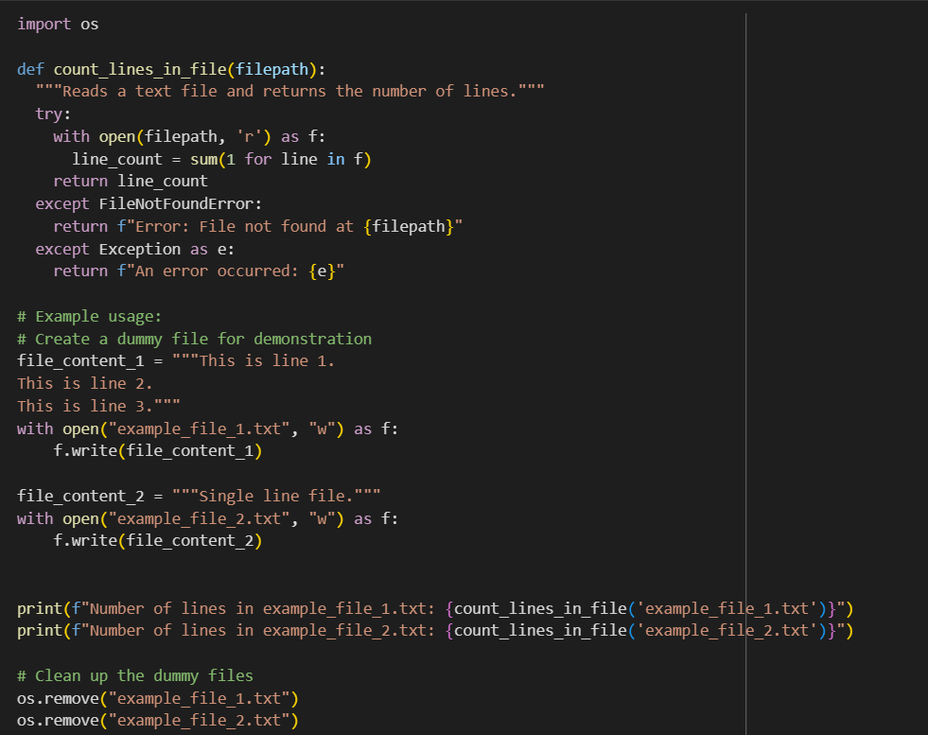
OUTPUT:

OBSERVATION:
