ASSIGNMENT-5.1
NAME: B. SAI NATH ROLL NO: 2403A510C3
Task Description #1 (Privacy in API Usage)
Task: Use an AI tool to generate a Python program that connects to a weather API.
Prompt:
"Generate code to fetch weather data securely without exposing API keys in the code."
Expected Output:
->Original AI code (check if keys are hardcoded).
->Secure version using environment variables
Prompt:
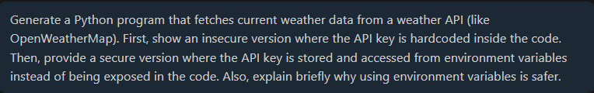
Code:
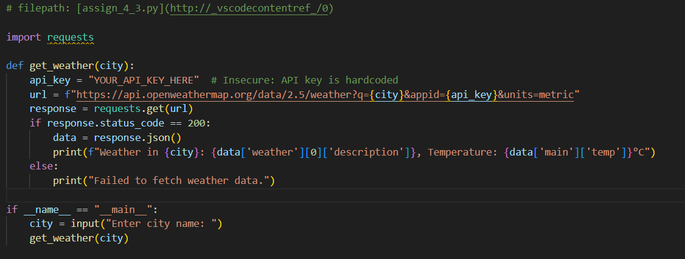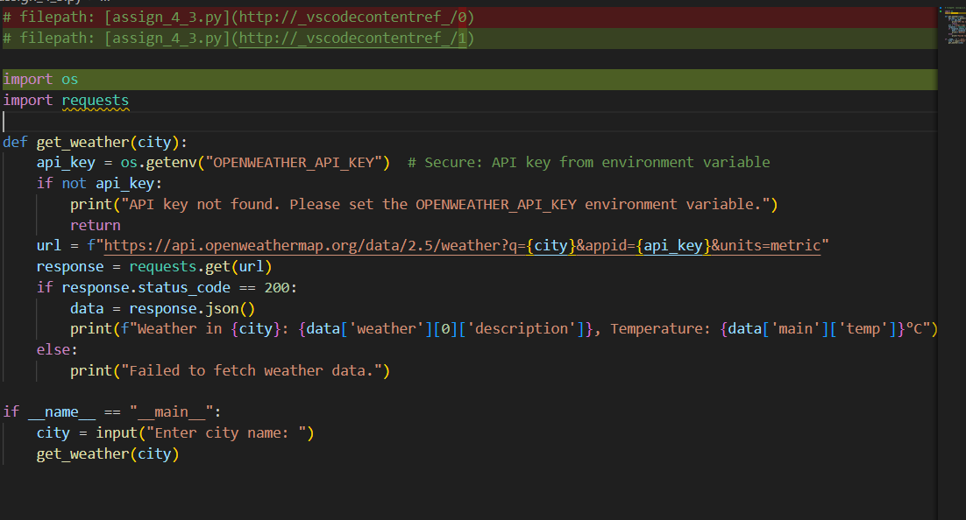
Output:
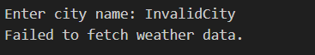
Task Description #2 (Privacy & Security in File Handling)
Task: Use an AI tool to generate a Python script that stores user data (name, email, password) in a file.
Analyze: Check if the AI stores sensitive data in plain text or without encryption.
Expected Output:
->Identified privacy risks.
->Revised version with encrypted password storage (e.g., hashing).
Prompt:
Code:
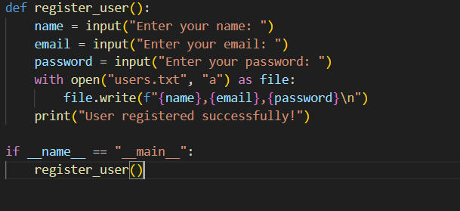
Output:
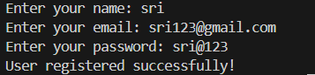

IN the file:
- Plain-text password storage: Passwords are stored exactly as entered.
- No hashing or encryption: A data breach would expose user passwords.
- Vulnerable to insider threats: Anyone with access to the file can read sensitive data.
Task Description #3 (Transparency in Algorithm Design)
Objective: Use AI to generate an Armstrong number checking function with comments and explanations.
Instructions:
- Ask AI to explain the code line-by-line.
- Compare the explanation with code functionality.
Expected Output:
- Transparent, commented code.
- Correct, easy-to-understand explanation.
Prompt:
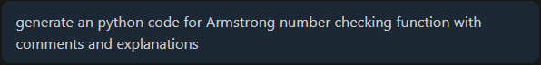
Code:
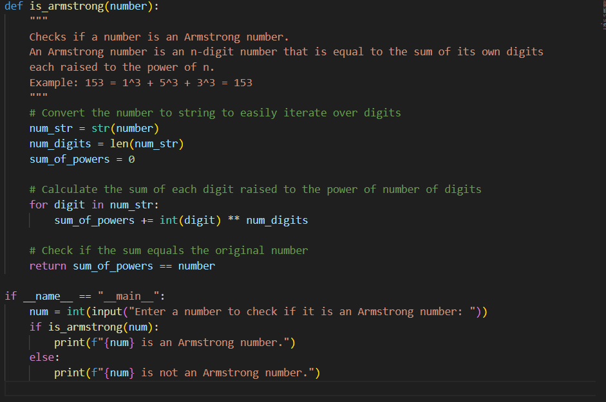
Output:
Task Description #4 (Transparency in Algorithm Comparison)
Task: Use AI to implement two sorting algorithms (e.g., QuickSort and BubbleSort).
Prompt:
"Generate Python code for QuickSort and BubbleSort, and include comments explaining step-by-step how each works and where they differ."
Expected Output:
- Code for both algorithms.
- Transparent, comparative explanation of their logic and efficiency.
Prompt:

Code:
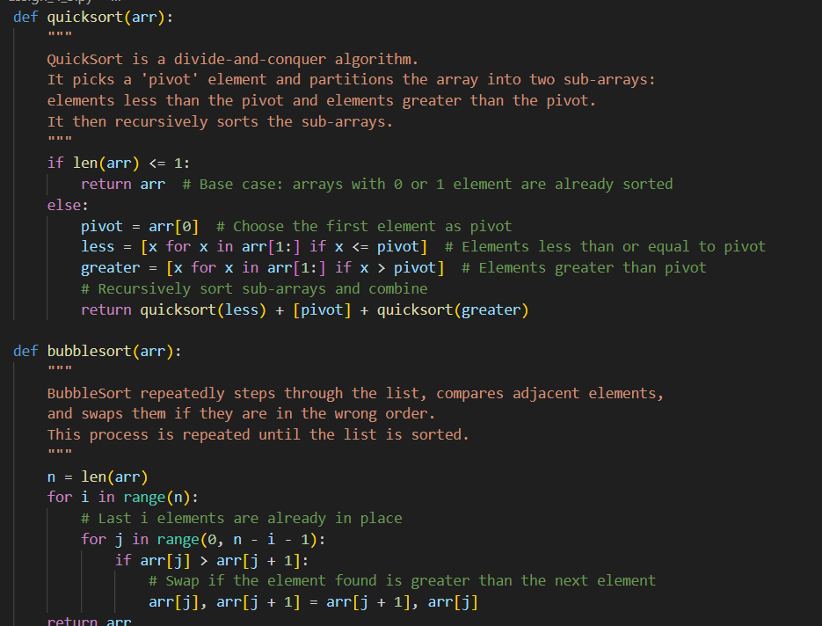
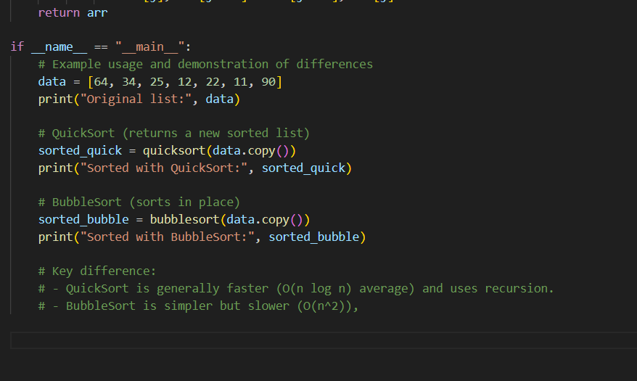
Output:
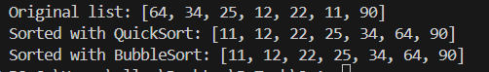

Task Description #5 (Transparency in AI Recommendations)
Task: Use AI to create a product recommendation system.
Prompt:
"Generate a recommendation system that also provides reasons for each suggestion."
Expected Output:
- Code with explainable recommendations.
- Evaluation of whether explanations are understandable.
Prompt:
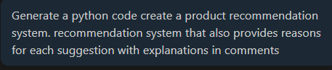
Code:
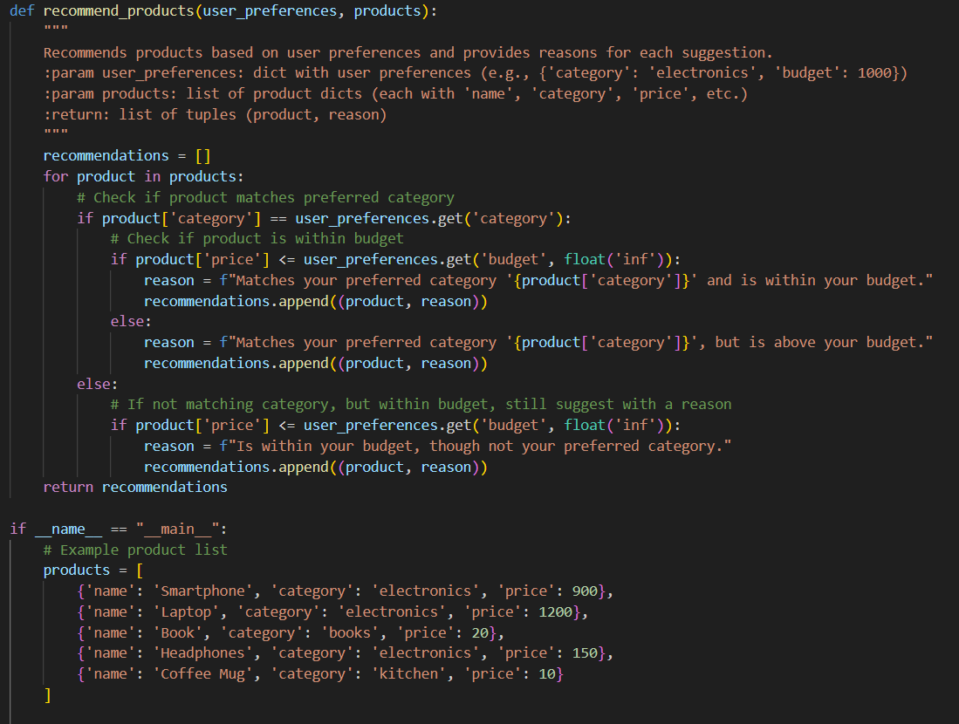
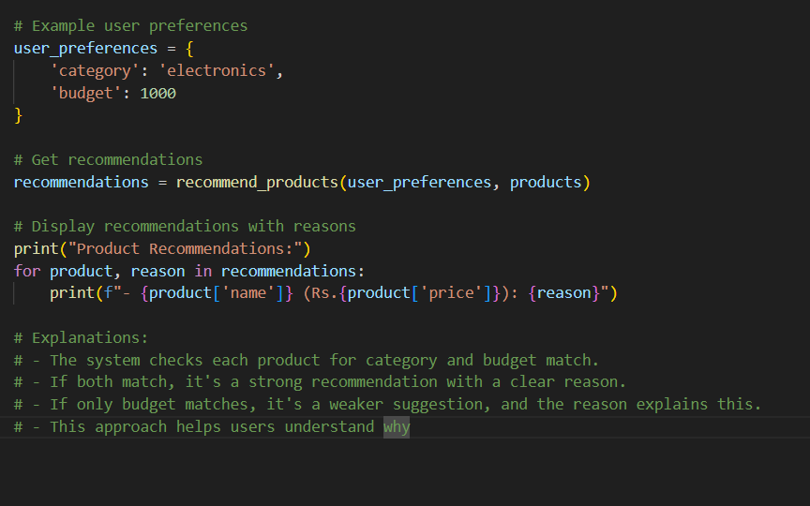

Output:
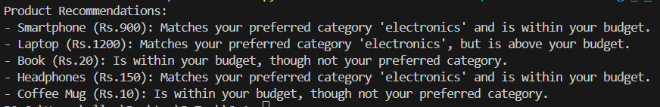

Task Description #6 (Transparent Code Generation)
Task: Ask AI to generate a Python function for calculating factorial using recursion.
Prompt:
"Generate a recursive factorial function with comments that explain each line and a final summary of the algorithm’s flow."
Expected Output:
- Fully commented code.
- Clear documentation of how recursion works.
Prompt:
Code:
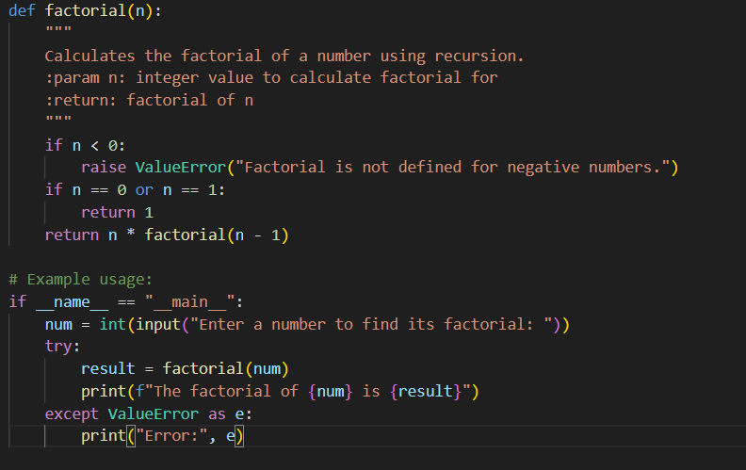
Output:
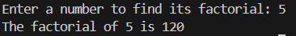

Task Description #7 (Inclusiveness in Customer Support)
Code Snippet:

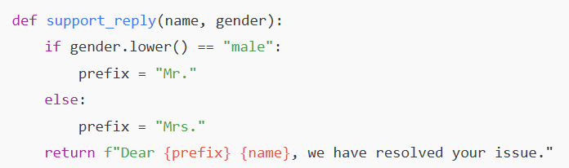

Task:
Regenerate the code so that support messages use neutral language (e.g., “Dear {name}”) and optionally accept preferred titles.
Expected Output:
- Neutral, user-friendly support responses.

Prompt:
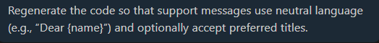
Code:
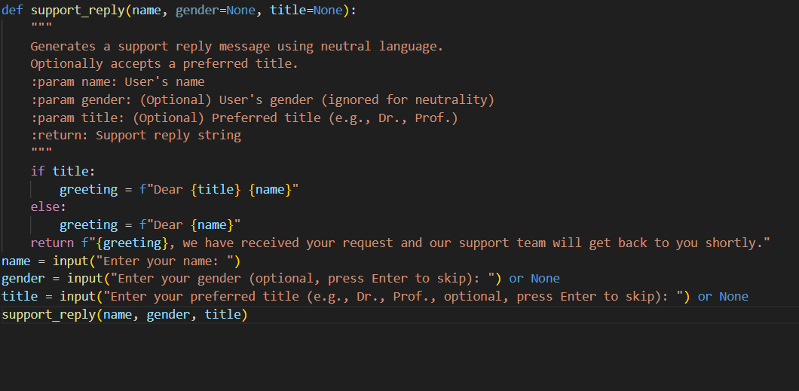
Output:

