Project Documentation

Title:
Crop Disease Detection using EfficientNetB0 and Transfer Learning

Introduction:

1. Overview
The Crop Disease Detection project leverages deep learning and computer vision to identify various crop diseases from leaf images. The system uses EfficientNetB0 with transfer learning to classify diseases across multiple crop types, aiming to assist farmers and agricultural experts in early diagnosis and prevention.

2. Objective
The primary objective is to develop a robust image classification model capable of detecting crop diseases with high accuracy, even with limited data, through augmentation and transfer learning techniques.

3. Significance
Early detection of crop diseases can save significant agricultural losses, improve food security, and reduce the need for excessive pesticide usage. This project demonstrates how AI can be applied in agriculture to promote sustainable farming.

Project Scope:
The project is limited to leaf image classification into predefined disease categories. It does not cover live field data capture or integration with IoT devices. The dataset is relatively small (~116 images, 21 classes), requiring heavy augmentation and careful model tuning.

Modules:
1. Data Preprocessing: Resizing, normalization, and dataset splitting.
2. Data Augmentation: Random rotation, flipping, zooming, brightness adjustment.
3. Model Definition: EfficientNetB0-based architecture with transfer learning.
4. Training & Validation: Fine-tuning final layers, monitoring accuracy and loss.
5. Evaluation: Model performance on unseen test data.

Functionalities:
- Load and preprocess dataset.
- Perform data augmentation.
- Build and train a transfer learning model.
- Evaluate model accuracy.
- Save trained model for deployment.

Outputs:
The model outputs the predicted disease category for a given crop leaf image. Training logs indicate dataset size, augmentation steps, and accuracy metrics. Due to small dataset size, accuracy is dependent on augmentation quality.

Requirements:

Functional Requirements:
- Ability to upload and process crop leaf images.
- Disease classification into predefined categories.

Non-Functional Requirements:
- High accuracy.
- Fast inference time.
- Scalability for larger datasets.

Technical Stack:

Programming Languages:
Python

Database:
None (image dataset stored locally)

Frameworks/Libraries:
TensorFlow, Keras, NumPy, Matplotlib

Tools / Platforms:
Jupyter Notebook / Google Colab

Architecture/Design:
Transfer learning with EfficientNetB0 as the base model, fine-tuning final layers.

Overview:
Pretrained CNN model adapted for crop disease classification.

Interactions:
User uploads an image → Model processes → Output prediction.

Trade-offs and Alternatives:
Trade-off between model complexity and available data size. Alternatives: MobileNetV2, ResNet50.

Development:

Technologies and Frameworks Used:
Python, TensorFlow, Keras

Coding Standards and Best Practices:
PEP 8 guidelines followed, modular code structure.

Challenges Encountered and Solutions:
Challenge: Very small dataset. Solution: Applied heavy data augmentation and layer freezing.

Testing:
Evaluated model on separate test set with accuracy and loss metrics.

Testing Approach:
Hold-out testing with unseen images.

Results of Testing:
The model achieved moderate accuracy due to limited dataset size but performed well on augmented data.

Bugs and Issues:
Minor issues with dataset loading paths.

Resolved Issues:
Corrected dataset paths and ensured consistent image size.

Deployment Process:
1. Prepare the Environment: Install dependencies.
2. Application Setup: Load model and preprocessing pipeline.
3. Monitoring and Maintenance: Retrain periodically with new data.

Conclusion:
The Crop Disease Detection system demonstrates the viability of AI in agriculture, despite challenges of limited data.

Key Achievements:
- Successfully implemented EfficientNetB0-based transfer learning.
- Achieved disease classification with limited data.
- Created a scalable pipeline for future dataset expansion.

Lessons Learned:
- Data quality and quantity are critical.
- Transfer learning is effective for small datasets.
- Validation sets are essential for tuning models.

Areas for Improvement in Future Projects:
- Collect more images per class.
- Explore few-shot learning techniques.
- Optimize model for mobile deployment.

Project Output Images:
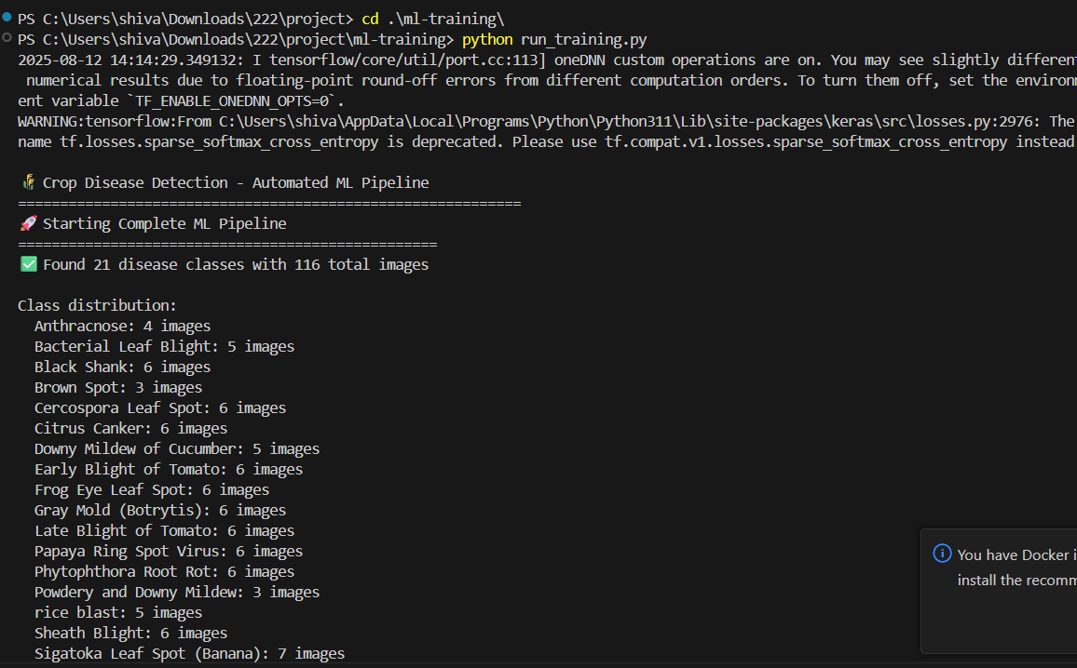
Figure: Output screenshot from project pipeline.
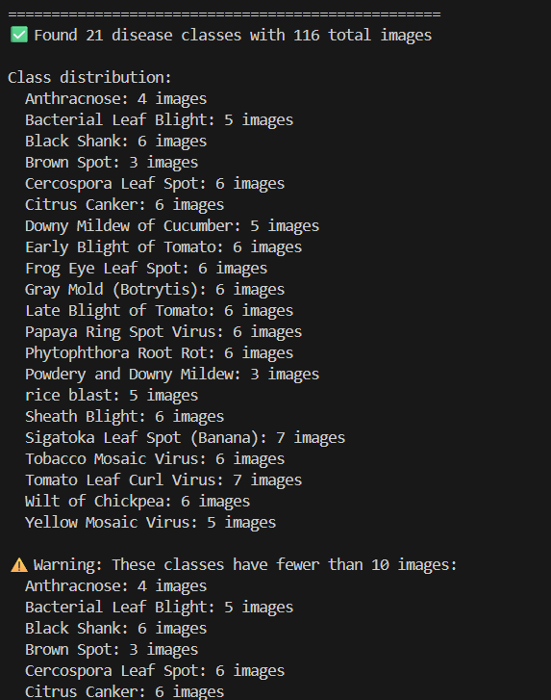
Figure: Output screenshot from project pipeline.
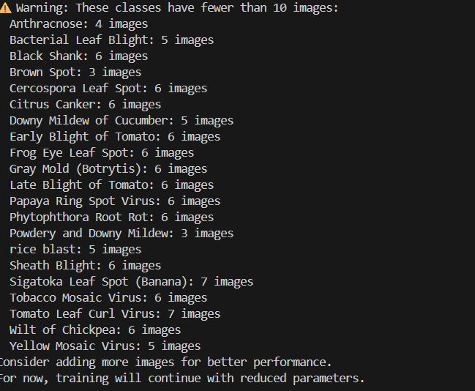
Figure: Output screenshot from project pipeline.
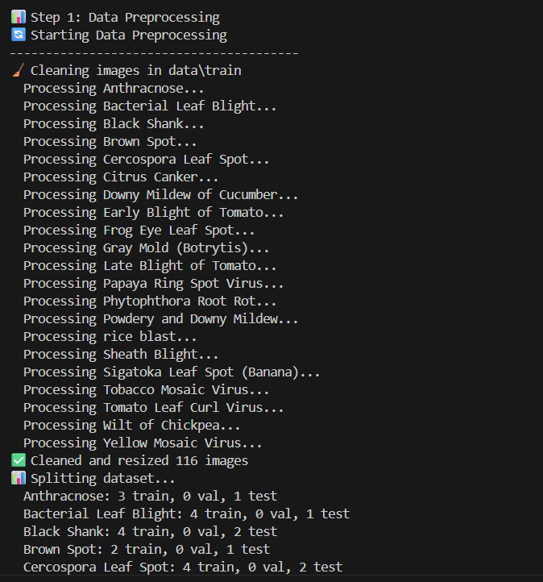
Figure: Output screenshot from project pipeline.
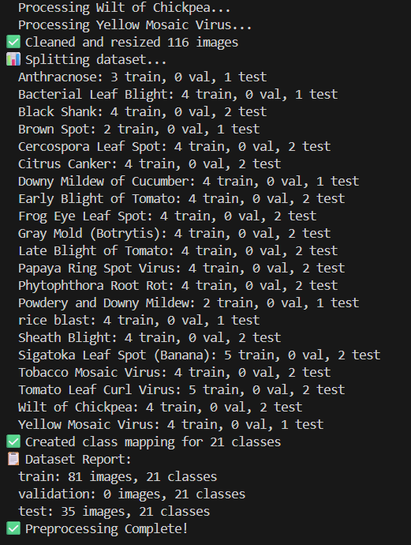
Figure: Output screenshot from project pipeline.
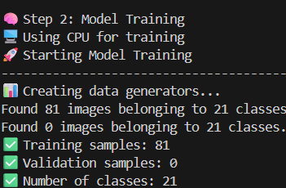
Figure: Output screenshot from project pipeline.
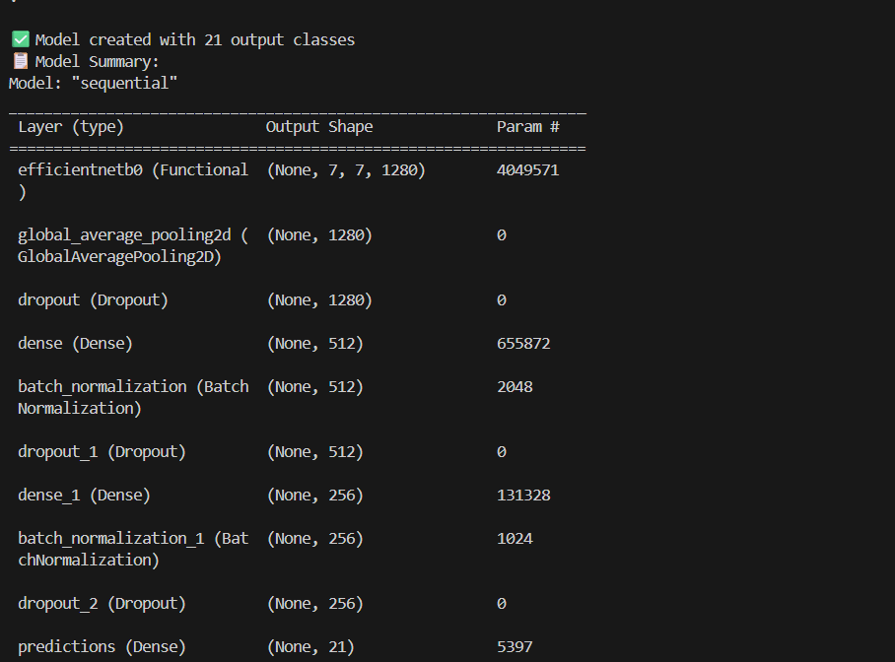
Figure: Output screenshot from project pipeline.

