|  |  |  |  |
| --- | --- | --- | --- |
| Browser | Driver | Key | class |
| Chrome | Chrome driver | webdriver.chrome.driver | ChromeDrive |
| Firefox | Geeko driver | Webdriver.geeko.drver | FirefoxDriver |
| Internet Explorer | Ie driver | Webdriver.ie.driver | InternetExploreDriver |

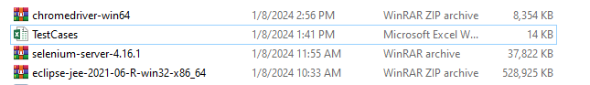

Install the above 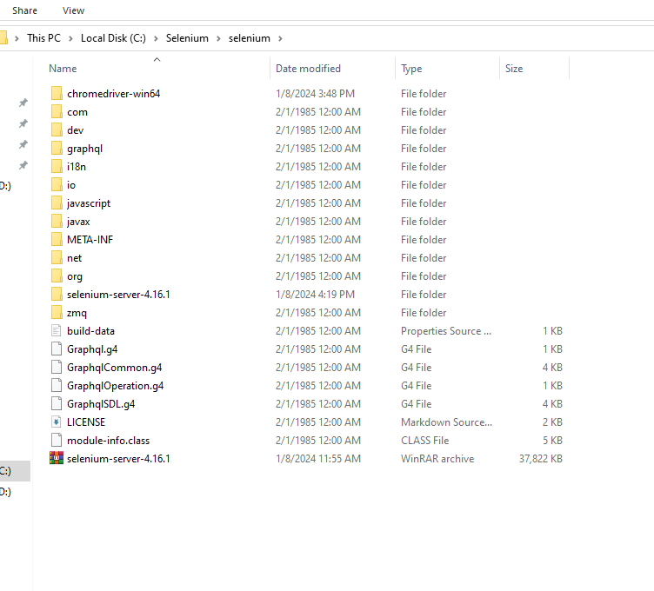 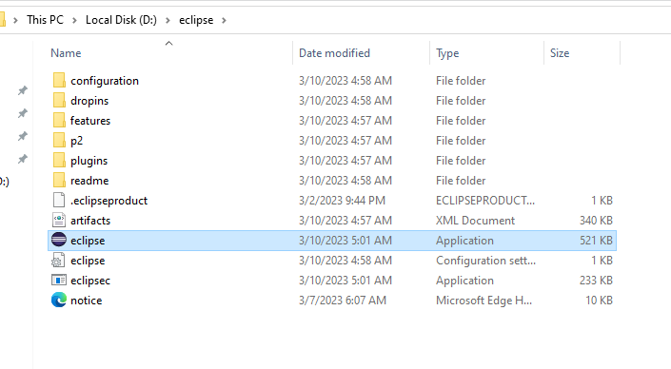

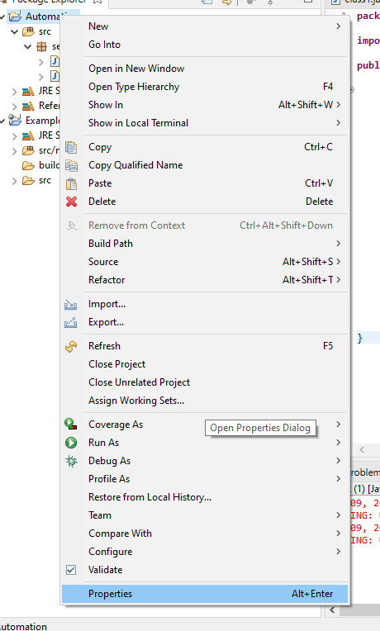 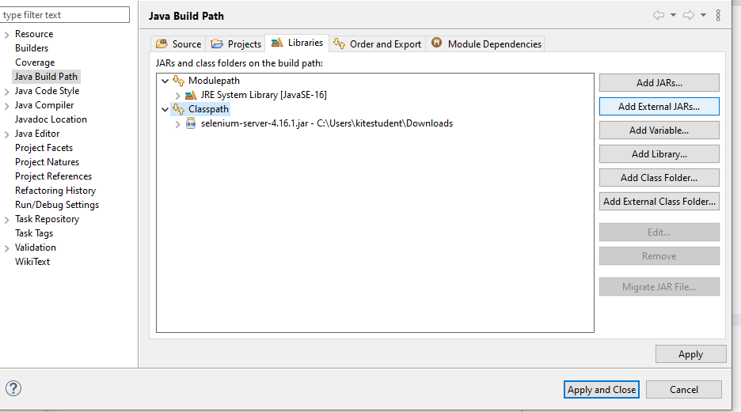 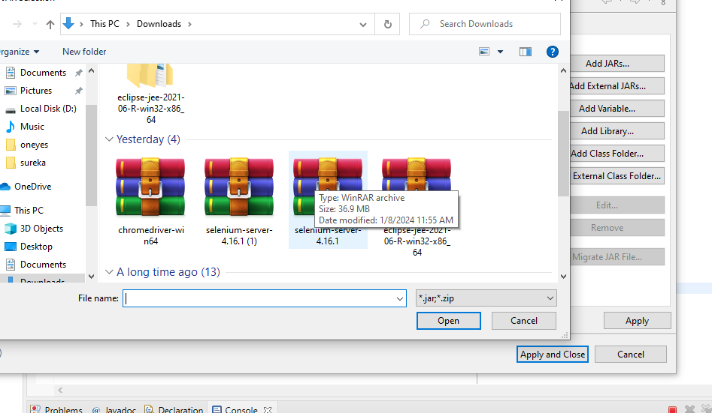

SAVE IN LIKE THIS

Selenium commands:

1. How to launch browser in selenium ?

Systrm.setProperty(“Key”,”Browserdriverpath”);

for chrome = webdriver.chrome.driver

for firefox = wedriver.gecko.driver

for edge = webdriver.edge.drive

Example code to lunch chrome:

System.setProperty(“webdriver.chrome.driver”,”Copy and give chrome driver path location”);

ChromeDriver d = new ChromeDriver();

System.setProperty(“webdriver.gecko,driver”,Copy and give the gecko driver path location”);

FirefoxDriver d = new FirefocDriver();

Version 119.0.6045.200 (Official Build) (64-bit)

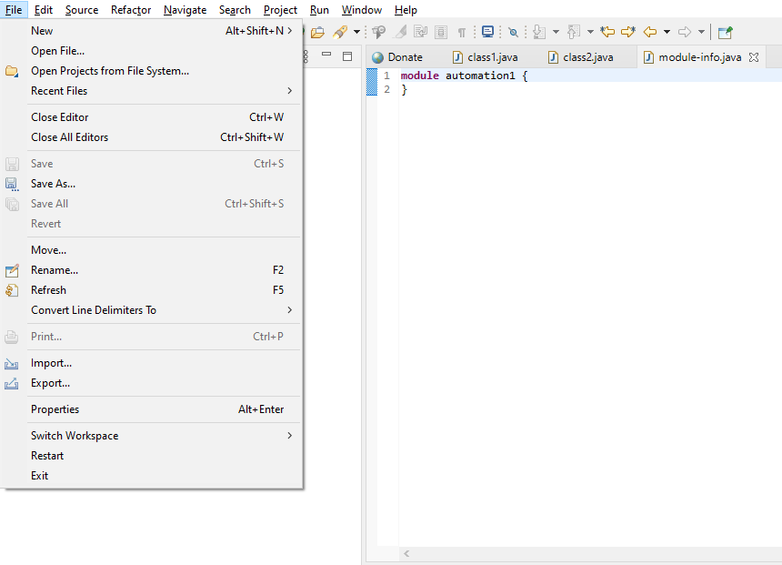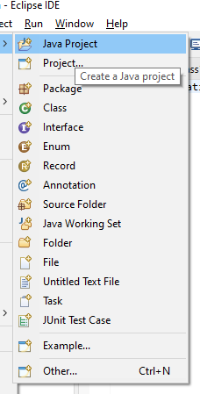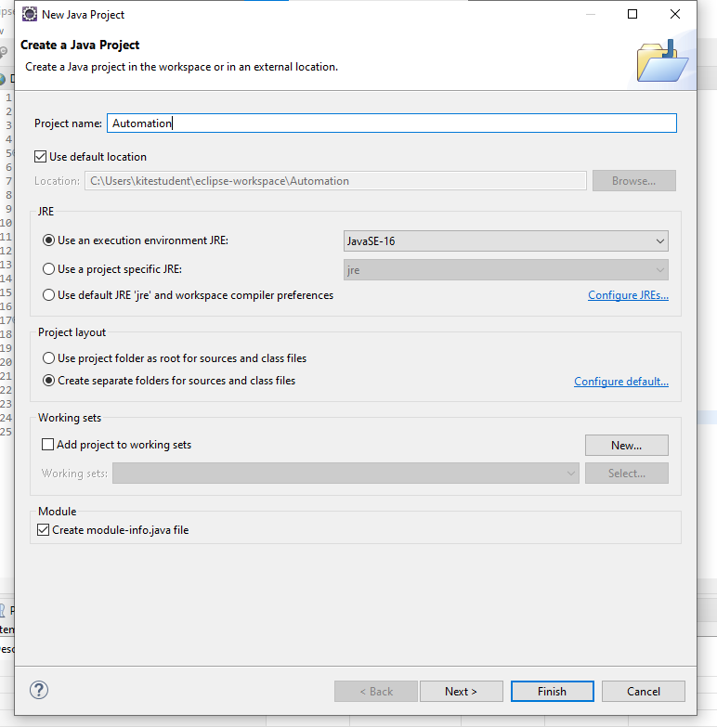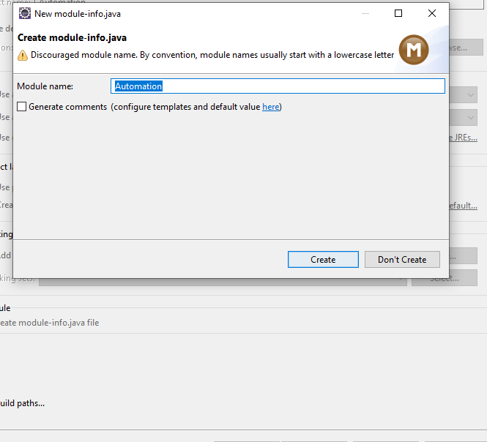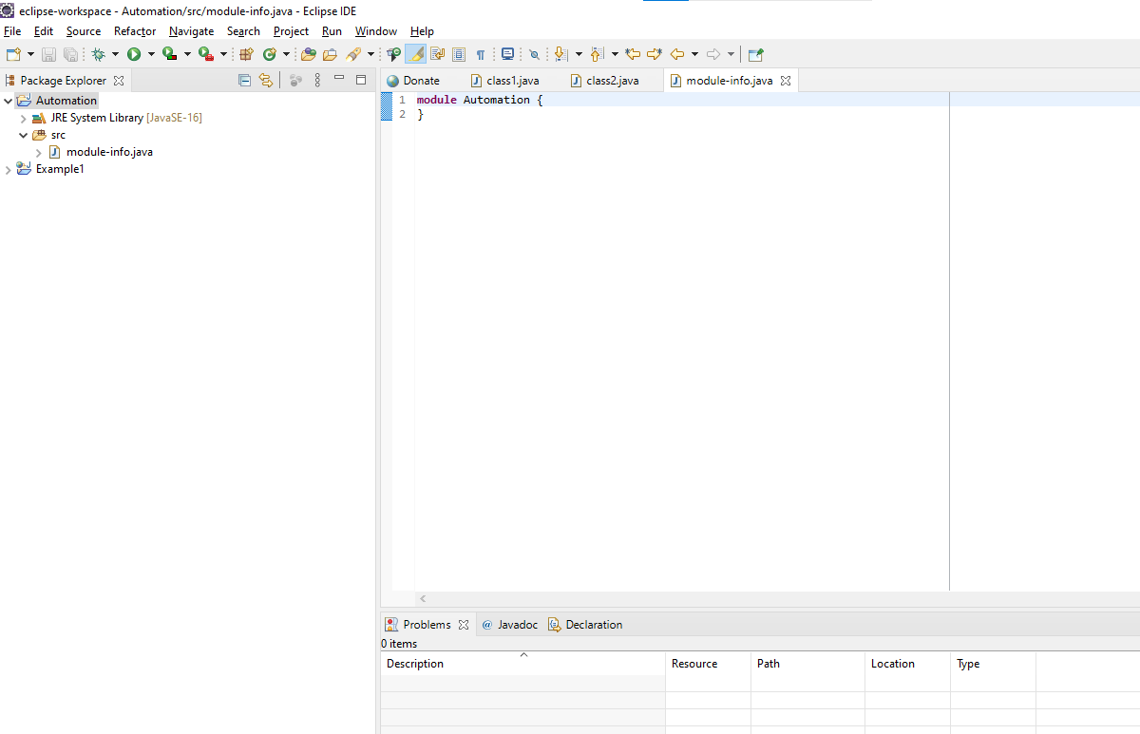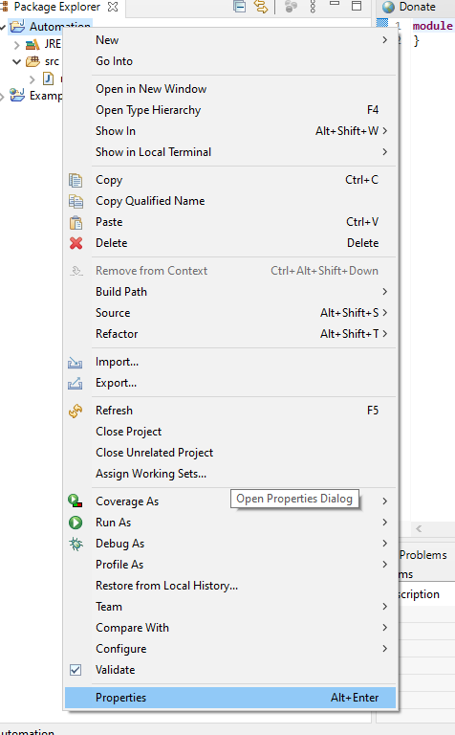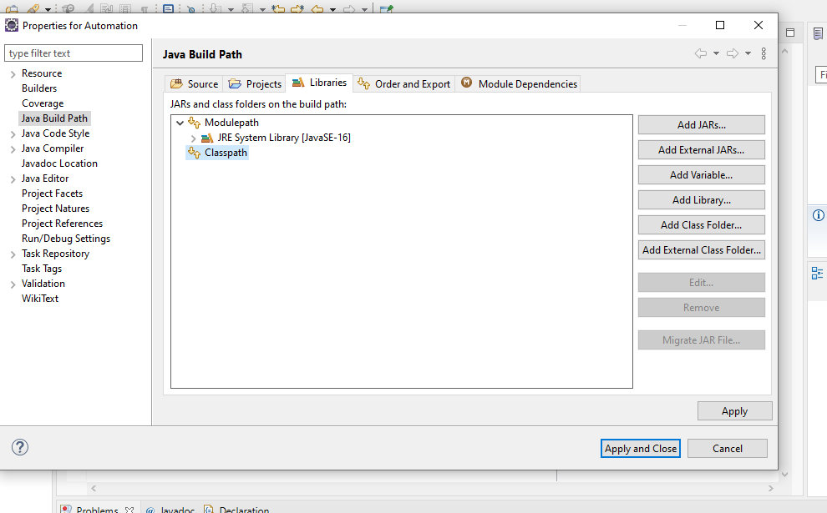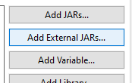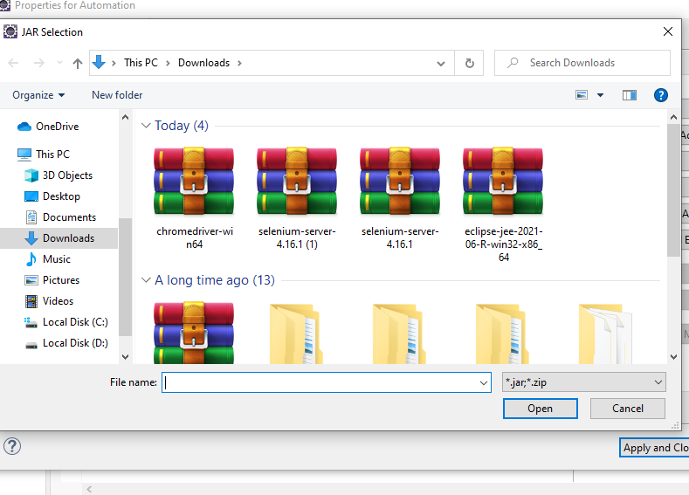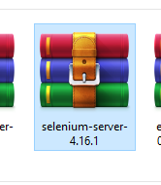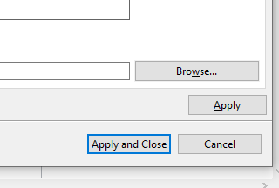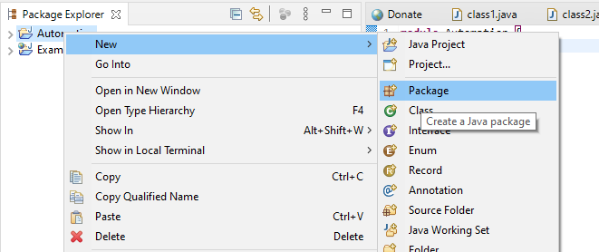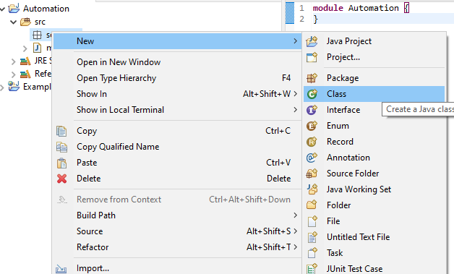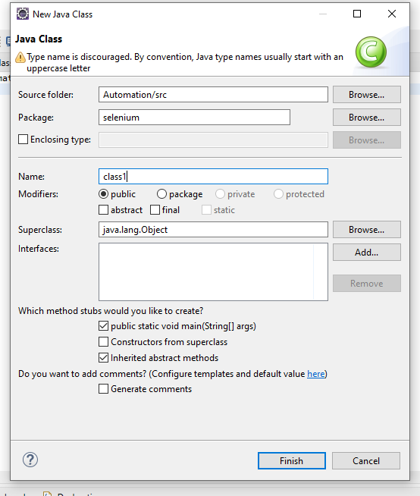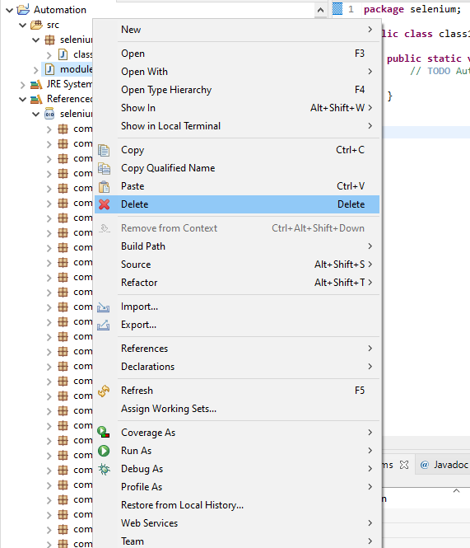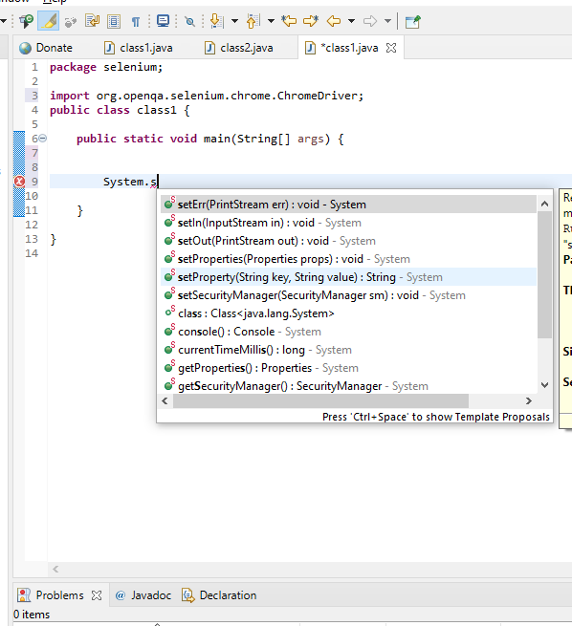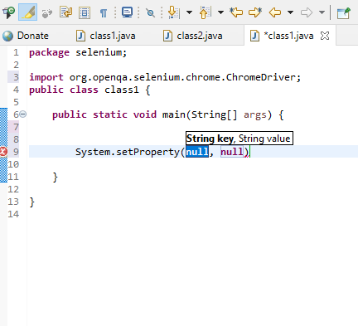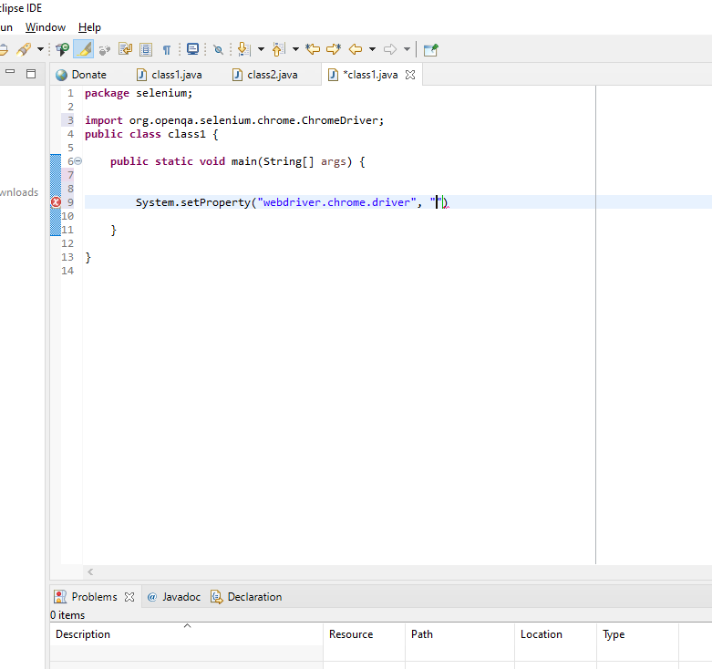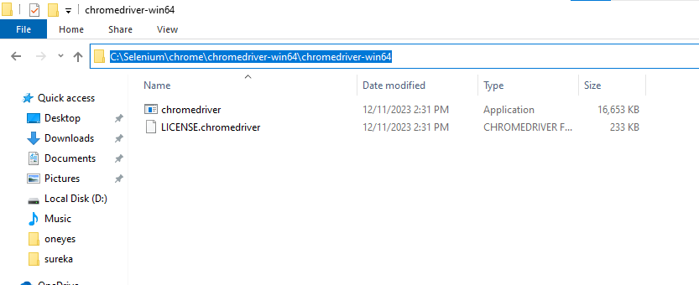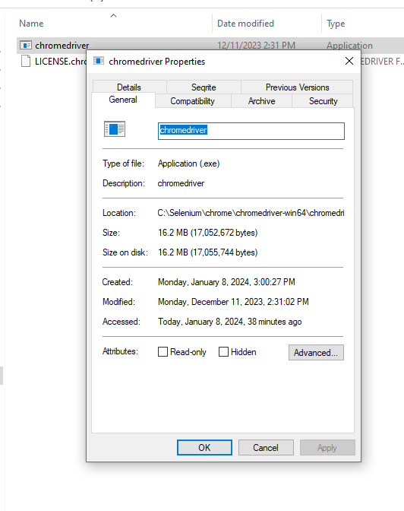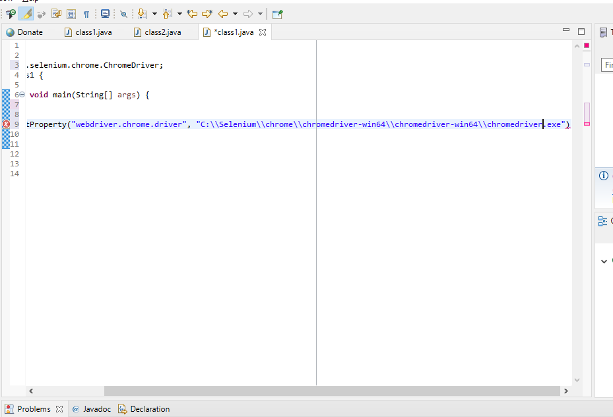

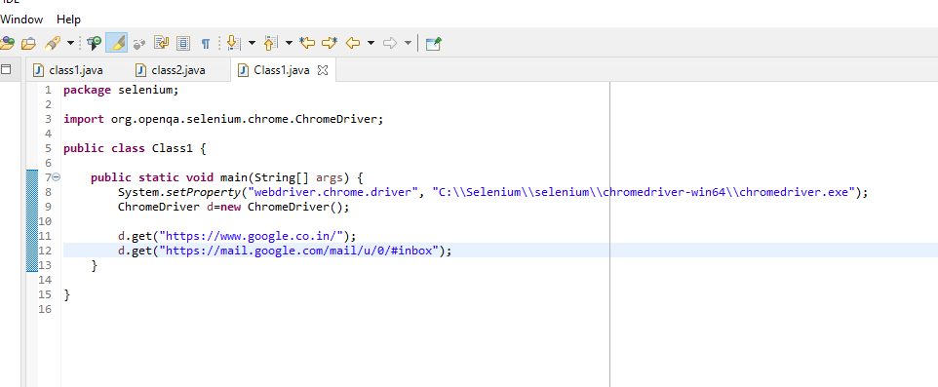

**USING 2 LINKS**

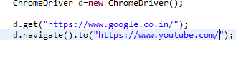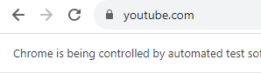

**BY USING NAVIGATE WE CAN GO FORWARD AND BACKWARD WITH THE TABS BUT USING GET WE CANNOT DO**

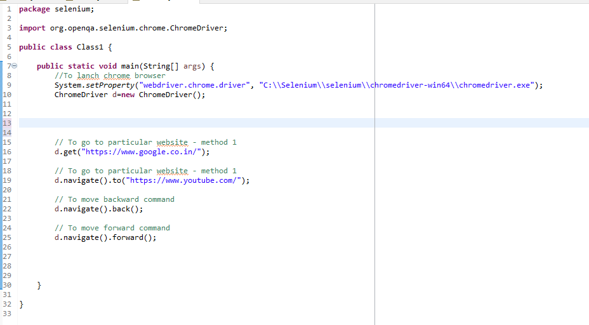

**Using Forward and backward with navigate**

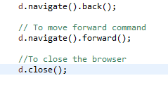 **Closing the browser with d.close();**

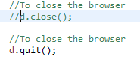 **Closing the browser with d.quit();**

|  |  |
| --- | --- |
| **CLOSE** | **QUIT** |
| **ONLY SINGLE TAB** | **ENTIRE TABS WILL BE CLOSED** |

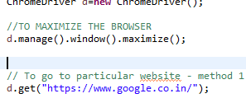 TO MAXIMIZE THE BROWSER

LOCATORS

Total 8 locators

**Static meth0d of By**

* **ID**
* **NAME**
* **CLASS NAME**
* **XPATH**
* **TAGNAME**
* **LINK TEXT**
* **PARTIALLYLINK TEXT**
* **CSSSELECTOR**

**When we neeed to preform any action in the browser , we have to find the locator.Locators used to find and macth the elements of your page that it needs to interact with.**

**In By class all the locators methods are available**

**By🡪Abstract class**

**Package🡪 selenium.By**

|  |  |  |
| --- | --- | --- |
| **METHOD** | **RETURN TYPE** | **DESCRIPTION** |
| **Driver.get(“url”);**  **(driver object name)** |  | **To launch given URL in the configured browser** |
| **Driver.gettiltle();** | **String** | **To get the title of the webpage launched** |
| **Driver.getCurrentUrl();** | **String** | **To get the url of the current webpage** |
| **Driver.quit();** |  | **To quit the browser** |
| **Driver.manage().window().maximize()** |  | **To maximize the browser** |
| **Driver.swithTo().alert()** | **Alert** | **Switch to alert** |

**Web elements**

* **All the elements in the web page like edit box , link , button, image , text area , checkbox, radio button etc,…**

|  |  |  |
| --- | --- | --- |
| **txt.sendKeys(“sequence”)** |  | **To pass any value in the textbox** |
| **btn.click()** |  | **To perform click option for buton** |
| **txt.getAttribute(“Attribiute name”)** | **string** | **To print the text in the Webelements** |
| **txt.getText()** | **string** | **To print the attribute value in the web elements** |
| **tex.getAttribute(“value”)** | **string** | **To print the values we have passed in web elements** |

**How to interact with webelements:**

**Syntax:**

**D.findElement(By.LocatorName(“LocatorValue”));** 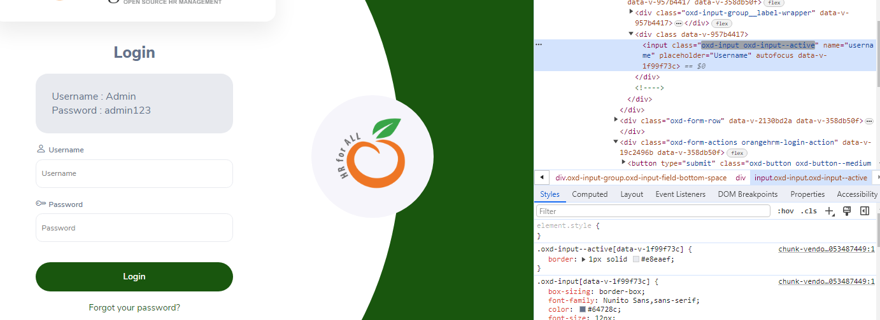

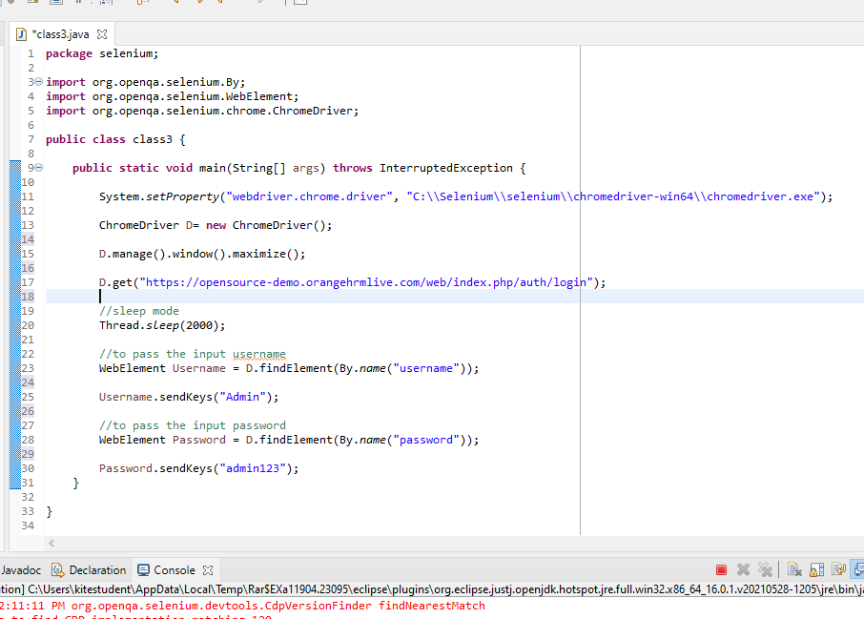

**Thread.sleep(3000) means it will wait for 3 sec**

**Username and password are created as objects using the webelement with findelement using the locator name**

**Check the login page with inspect option in that particular field**

**Using that obj pass the values**

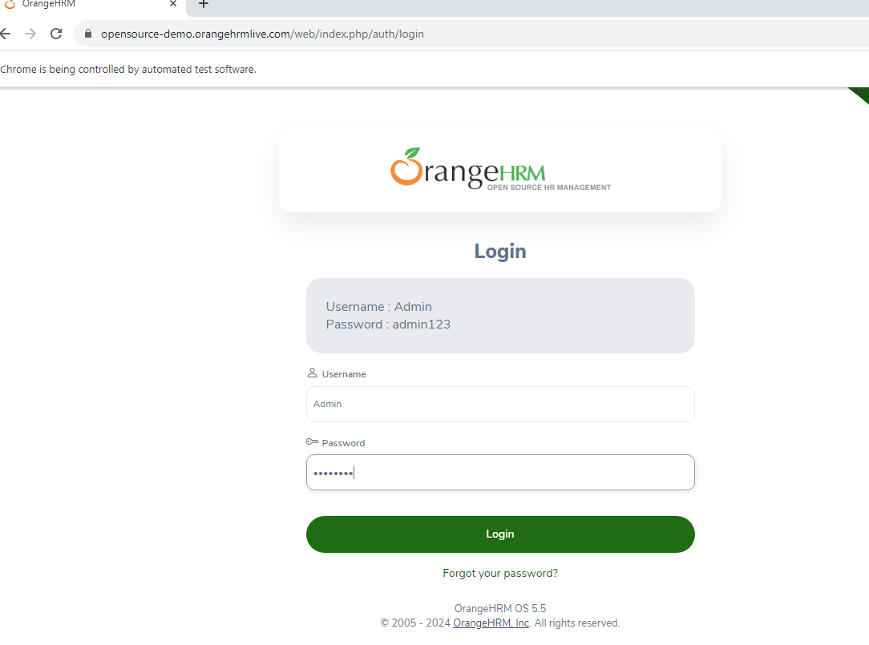

**Login button**

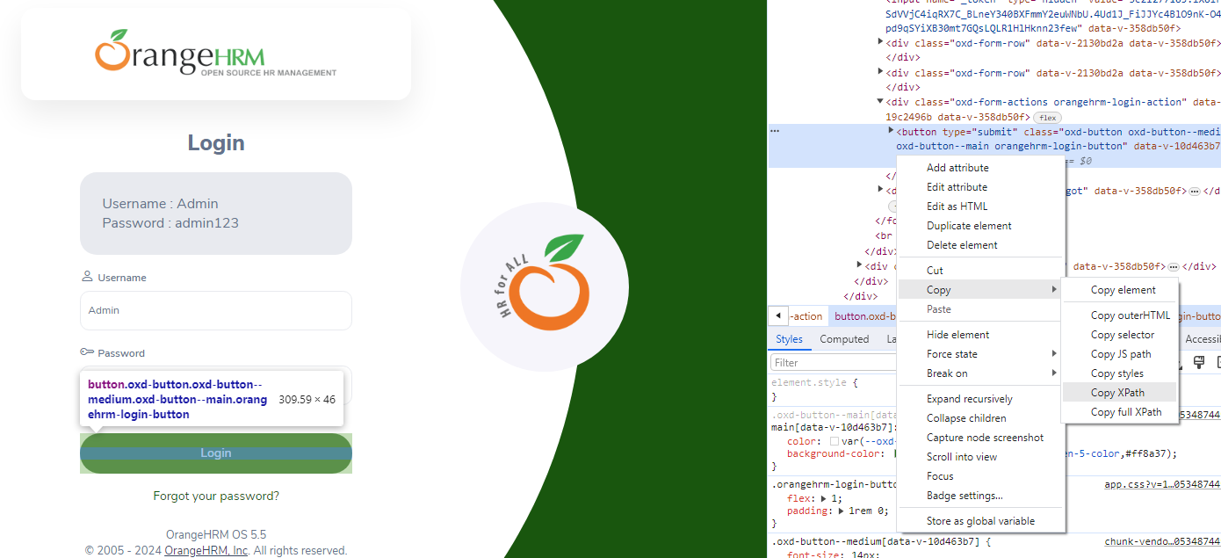

**Copy the Xpath of the Login button**

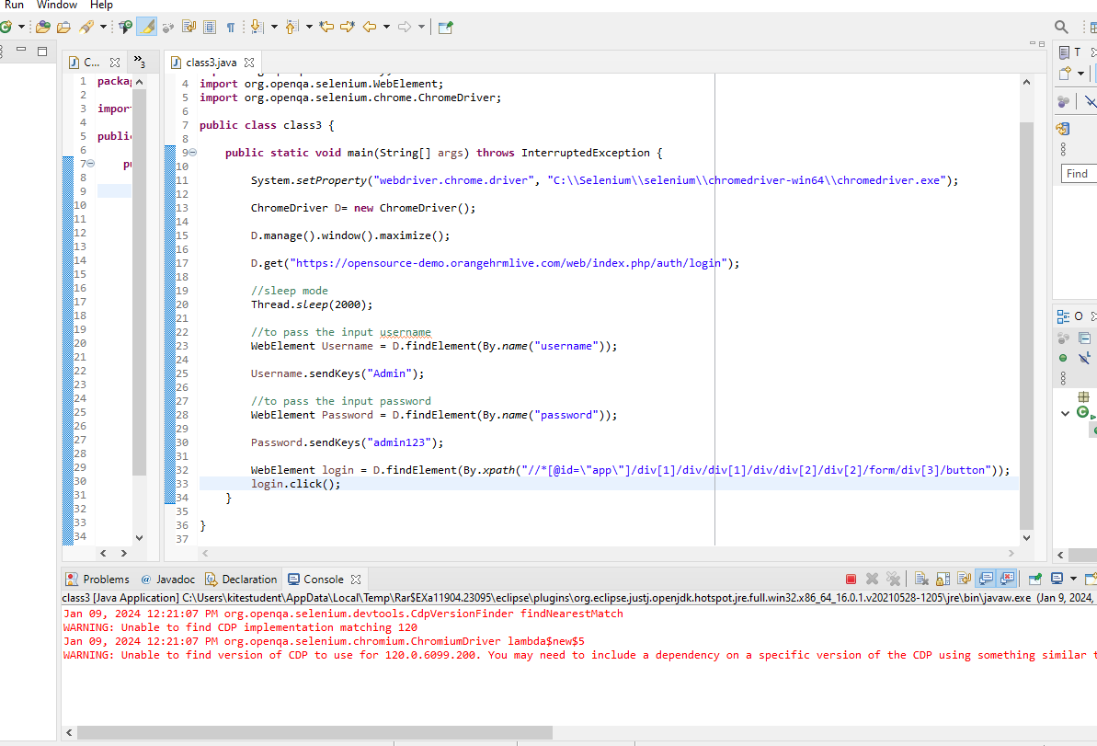



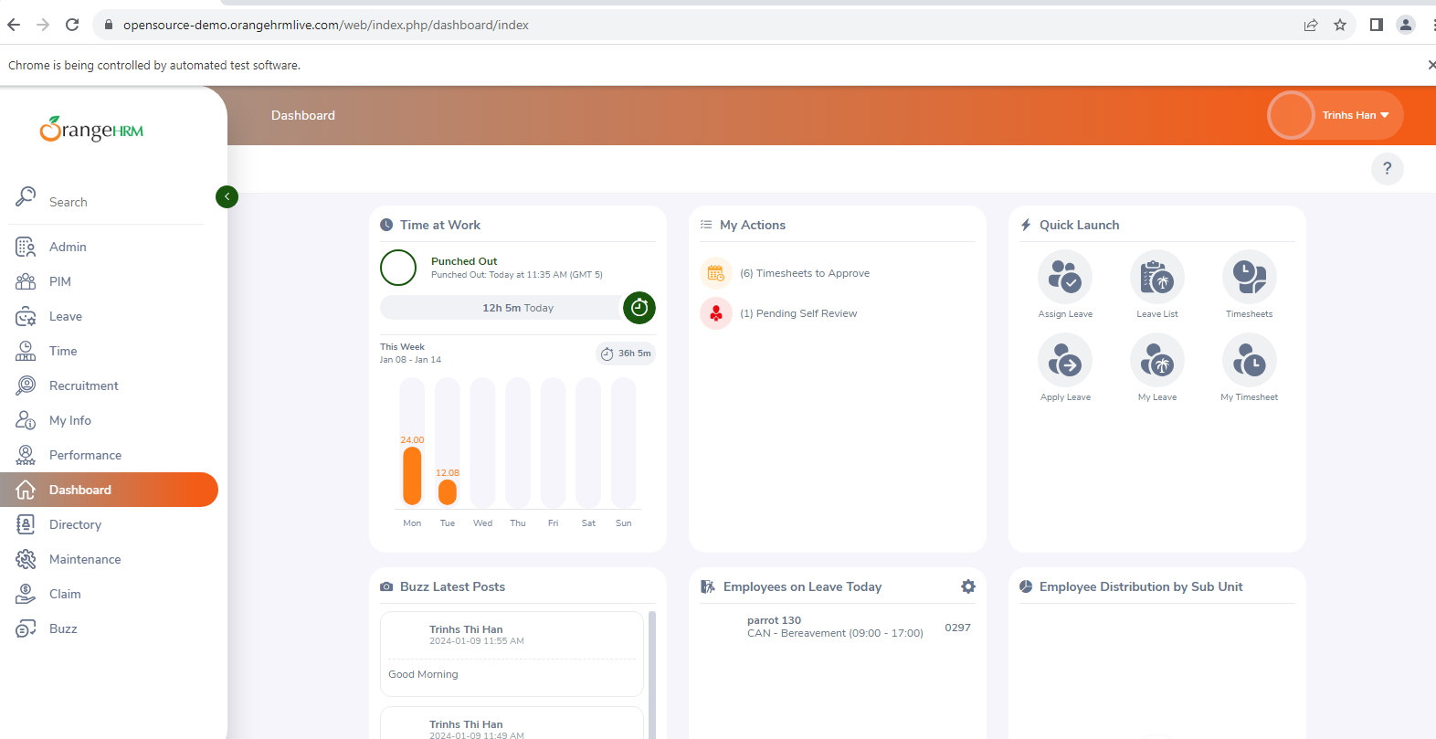

**Logined Successfully**

**TAST -🡪** [**https://demoqa.com/automation-practice-form**](https://demoqa.com/automation-practice-form)

**package** selenium;

**import** org.openqa.selenium.By;

**import** org.openqa.selenium.WebElement;

**import** org.openqa.selenium.chrome.ChromeDriver;

**public** **class** class4 {

**public** **static** **void** main(String[] args) **throws** InterruptedException {

System.*setProperty*("webdriver.chrome.driver", "C:\\Selenium\\selenium\\chromedriver-win64\\chromedriver.exe");

ChromeDriver d = **new** ChromeDriver();

d.manage().window().maximize();

d.get("https://demoqa.com/automation-practice-form");

Thread.*sleep*(3000);

WebElement fname = d.findElement(By.*id*("firstName"));

fname.sendKeys("Bala");

WebElement lname = d.findElement(By.*id*("lastName"));

lname.sendKeys("B");

WebElement email = d.findElement(By.*id*("userEmail"));

email.sendKeys("balaboseai@gmail.com");

WebElement radio = d.findElement(By.*xpath*("//*[@id=\"genterWrapper\"]/div[2]/div[1]/label"));

radio.click();

WebElement num = d.findElement(By.*id*("userNumber"));

num.sendKeys("1234567890");

WebElement h = d.findElement(By.*xpath*("//*[@id=\"hobbiesWrapper\"]/div[2]/div[3]/label"));

h.click();

WebElement ca = d.findElement(By.*id*("currentAddress"));

ca.sendKeys("CBE");

}

}

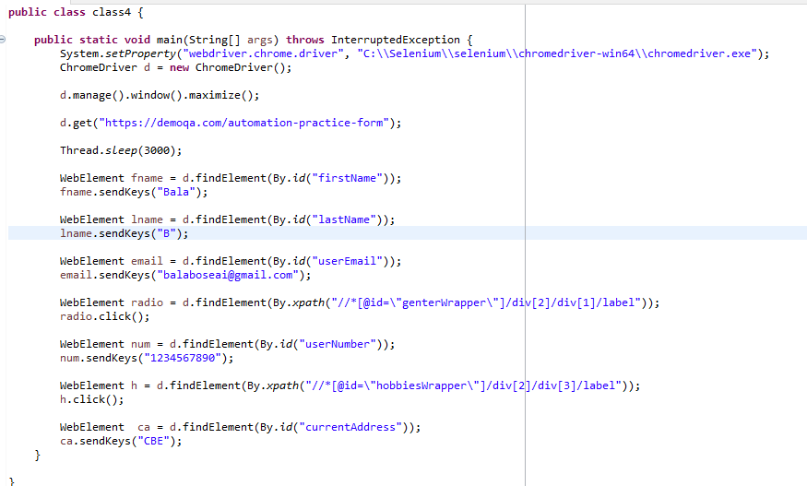

**Output**

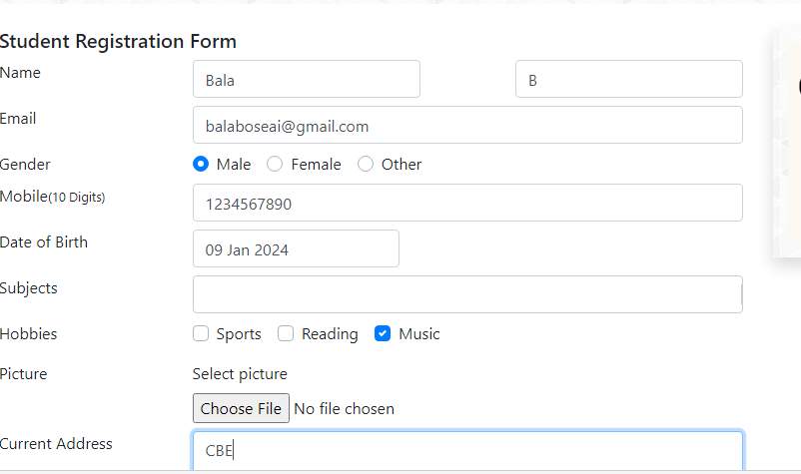

**DROPDOWN**

**Dropdown selection 3 methods**

* Select By index(0,1,…)
* Select by value
* Select by visible text 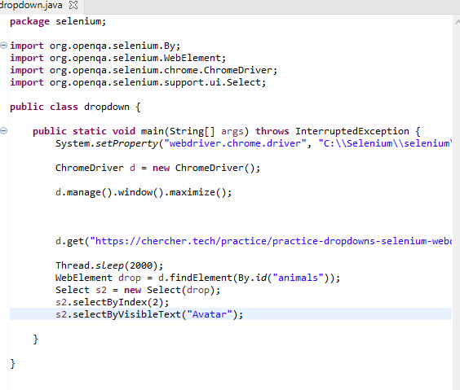 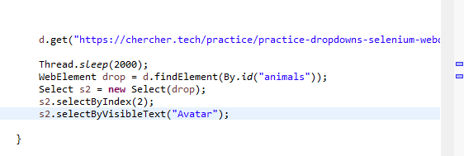 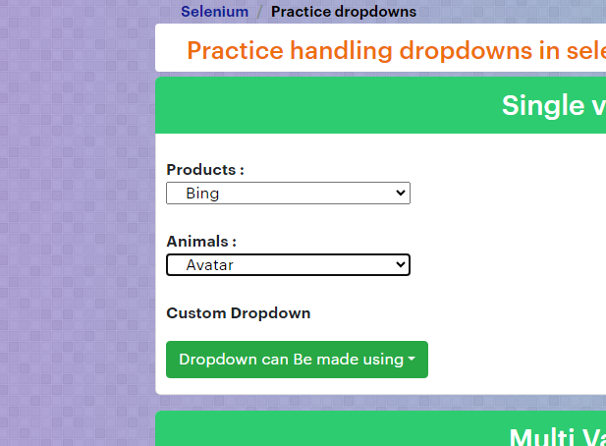

For Date and month and year

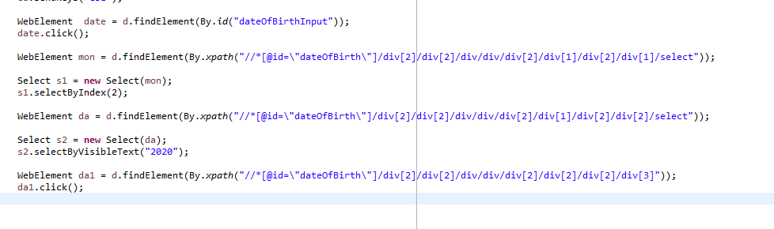 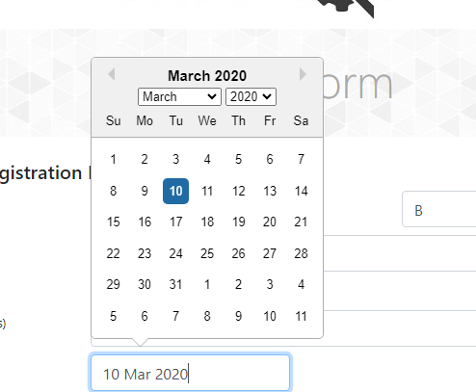

CODE:

WebElement date = d.findElement(By.*id*("dateOfBirthInput"));

date.click();

WebElement mon = d.findElement(By.*xpath*("//*[@id=\"dateOfBirth\"]/div[2]/div[2]/div/div/div[2]/div[1]/div[2]/div[1]/select"));

Select s1 = **new** Select(mon);

s1.selectByIndex(2);

WebElement da = d.findElement(By.*xpath*("//*[@id=\"dateOfBirth\"]/div[2]/div[2]/div/div/div[2]/div[1]/div[2]/div[2]/select"));

Select s2 = **new** Select(da);

s2.selectByVisibleText("2020");

WebElement da1 = d.findElement(By.*xpath*("//*[@id=\"dateOfBirth\"]/div[2]/div[2]/div/div/div[2]/div[2]/div[2]/div[3]"));

da1.click();