Project Title
Library Management System Using SQL

Project Statement

Background
A public library maintains thousands of books across multiple categories. Members borrow and return books every day, but the library currently records transactions manually.
The management wants a database system that stores book information, member details, borrowing records, and librarian information to improve efficiency and generate useful reports.
Your job as a SQL Data Analyst is to design the database, organize the data, and generate reports that answer the library's business questions.

Objective
Design a relational database and generate reports that help library management understand:
- Which books are borrowed the most
- Which members borrow the most books
- Which book categories are most popular
- Monthly borrowing trends
- Librarian performance
- Available vs issued books
- Overdue books
- Most active members
- Book return statistics

Input Data (Raw Data)

1. Members Table
member_id | member_name | city | email
M101 | John Smith | London | john@email.com
M102 | Emma Brown | Manchester | emma@email.com
M103 | David Lee | Birmingham | david@email.com

2. Books Table
book_id | book_name | category | author | copies
B101 | SQL Basics | Technology | James Lee | 10
B102 | Python Guide | Technology | David Miller | 8
B103 | Data Science | Education | Sarah Green | 5

3. Librarians Table
librarian_id | librarian_name | branch
L01 | Alice | Central
L02 | Bob | North

4. Borrow Table
borrow_id | member_id | librarian_id | borrow_date
BR001 | M101 | L01 | 2025-01-10
BR002 | M102 | L02 | 2025-02-15

5. Borrow Details Table
borrow_detail_id | borrow_id | book_id | quantity | return_date
1 | BR001 | B101 | 1 | 2025-01-20
2 | BR001 | B102 | 2 | 2025-01-25
3 | BR002 | B103 | 1 | NULL

Date: 11-07-2026

Workflow
Business Problem
↓
Requirements Gathering
↓
Database Design (ER Diagram)
↓
Create Tables
↓
Insert Sample Data
↓
Verify Data
↓
Write SQL Queries
↓
Create Views
↓
Optimize with Indexes
↓
Generate Reports
↓
Document Project (README)

Business Questions
- Which book is borrowed the most?
- Which member borrowed the highest number of books?
- Which book category is most popular?
- What are the monthly borrowing trends?
- Which librarian issued the most books?
- Which books are currently available?
- Which books are overdue?
- Which members are the most active?
- Which author has the highest number of borrowed books?
- How many books were returned each month?
- Which branch issues the highest number of books?
- Which members have never borrowed any books?
- Which books have never been borrowed?
- What is the average borrowing duration?
- Which month has the highest library activity?
This follows the same professional structure as your Sales Analytics Dashboard project and is suitable for inclusion in a SQL portfolio or resume.

------------------------------------------ LIBRARY MANAGEMENT SYSTEM ----------------------------------------------

---------------- 1. Which books are borrowed the most ?? -------------------------
----------------------------------------------------------------------------------
--------------- BOOKS TABLE ----------------------------
CREATE TABLE Books(
book_id VARCHAR(50) PRIMARY KEY,
book_name VARCHAR(50),
category VARCHAR(50),
author VARCHAR(50),
copies INT
);
INSERT INTO Books(book_id,book_name,category,author,copies) VALUES('B101','SQL Basics','Technology','James Lee',10);
INSERT INTO Books(book_id,book_name,category,author,copies) VALUES('B102','Python Guide','Technology','David Miller',8);
INSERT INTO Books(book_id,book_name,category,author,copies) VALUES('B103','Data Science','Education','Sarah Green',5);
--- SELECT *FROM Books;

------------------- BORROW TABLE --------------------------------
CREATE TABLE Borrow(
borrow_id VARCHAR(50) PRIMARY KEY,
member_id VARCHAR(50),
librarian_id VARCHAR(50),
borrow_date DATE
);
INSERT INTO Borrow(borrow_id,member_id,librarian_id,borrow_date) VALUES('BR001','M101','L01',DATE '2025-01-10');
------ SELECT *FROM Borrow;

------------------- BORROW_DETAILS TABLE ----------------------------
CREATE TABLE Borrow_details(
borrow_detail_id NUMBER PRIMARY KEY,
borrow_id VARCHAR(50),
book_id VARCHAR(50),
quantity NUMBER,
return_date DATE
);
INSERT INTO Borrow_details(borrow_detail_id,borrow_id,book_id,quantity,return_date) VALUES(1,'BR001','B101',1,DATE '2025-01-20');
INSERT INTO Borrow_details(borrow_detail_id,borrow_id,book_id,quantity,return_date) VALUES(2,'BR001','B102',2,DATE '2025-01-25');
INSERT INTO Borrow_details(borrow_detail_id,borrow_id,book_id,quantity,return_date) VALUES(3,'BR002','B103',1,NULL);
--- SELECT *FROM Borrow_details;

----------------------- Which Books are borrowed the most ???? --------------------
SELECT B.book_name,B_D.quantity AS Total_Times_Borrowed FROM Books B
JOIN Borrow_details B_D ON B.book_id=B_D.book_id
JOIN Borrow B_O ON B_D.borrow_id=B_O.borrow_id
GROUP BY B.book_name,Total_Times_Borrowed ORDER BY B_D.quantity DESC;
CREATE TABLE Books(
book_id VARCHAR(50) PRIMARY KEY,
book_name VARCHAR(50),
category VARCHAR(50),
author VARCHAR(50),
copies INT
);
INSERT INTO Books(book_id,book_name,category,author,copies) VALUES('B101','SQL Basics','Technology','James Lee',10);
INSERT INTO Books(book_id,book_name,category,author,copies) VALUES('B102','Python Guide','Technology','David Miller',8);
INSERT INTO Books(book_id,book_name,category,author,copies) VALUES('B103','Data Science','Education','Sarah Green',5);
--- SELECT *FROM Books;

------------------- BORROW TABLE --------------------------------
CREATE TABLE Borrow(
borrow_id VARCHAR(50) PRIMARY KEY,
member_id VARCHAR(50),
librarian_id VARCHAR(50),
borrow_date DATE
);
INSERT INTO Borrow(borrow_id,member_id,librarian_id,borrow_date) VALUES('BR001','M101','L01',DATE '2025-01-10');
------ SELECT *FROM Borrow;

------------------- BORROW_DETAILS TABLE ----------------------------
CREATE TABLE Borrow_details(
borrow_detail_id NUMBER PRIMARY KEY,
borrow_id VARCHAR(50),
book_id VARCHAR(50),
quantity NUMBER,
return_date DATE
);
INSERT INTO Borrow_details(borrow_detail_id,borrow_id,book_id,quantity,return_date) VALUES(1,'BR001','B101',1,DATE '2025-01-20');
INSERT INTO Borrow_details(borrow_detail_id,borrow_id,book_id,quantity,return_date) VALUES(2,'BR001','B102',2,DATE '2025-01-25');
INSERT INTO Borrow_details(borrow_detail_id,borrow_id,book_id,quantity,return_date) VALUES(3,'BR002','B103',1,NULL);
--- SELECT *FROM Borrow_details;

----------- DATE : 12-07-2026
----------------------- Which Books are borrowed the most ???? --------------------
SELECT B.book_name,B_D.quantity AS Total_Times_Borrowed FROM Books B
JOIN Borrow_details B_D ON B.book_id=B_D.book_id
JOIN Borrow B_O ON B_D.borrow_id=B_O.borrow_id
GROUP BY B.book_name,Total_Times_Borrowed ORDER BY B_D.quantity DESC;
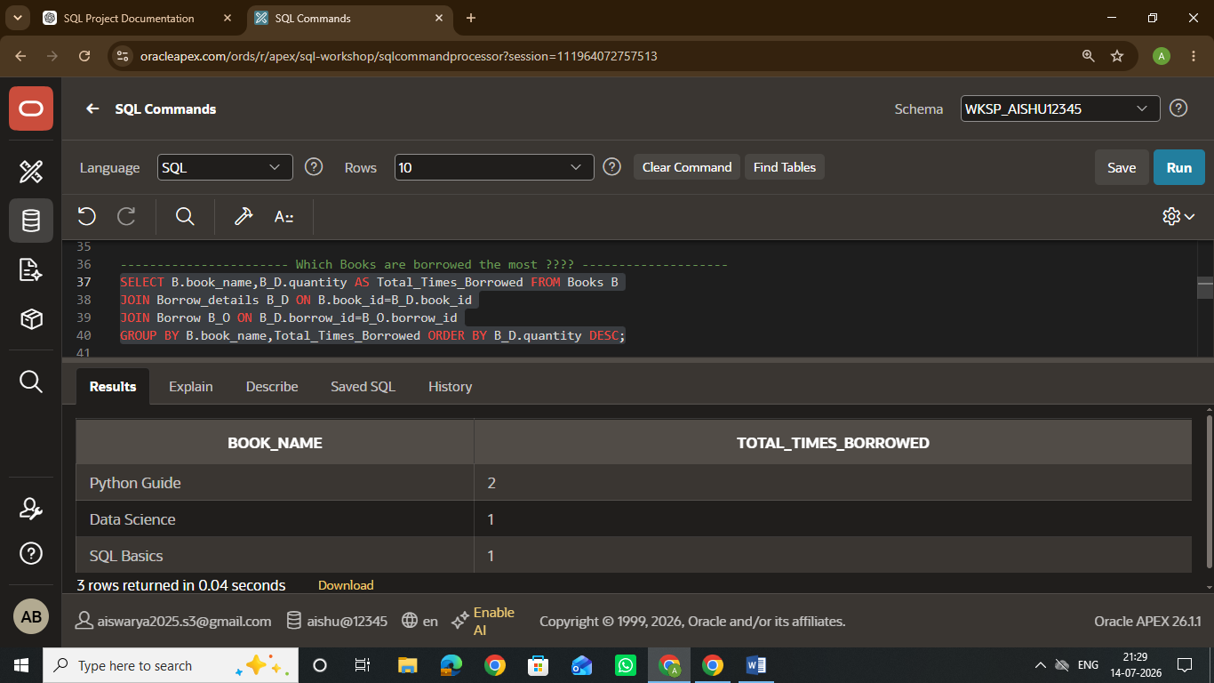
----------------------- Which members borrow the most books ?? --------------------
------------------------------------- Members Table -------------------------------
CREATE TABLE Members(
member_id VARCHAR(50),
member_name VARCHAR(50),
city VARCHAR(50),
email VARCHAR(50)
);
INSERT INTO Members(member_id,member_name,city,email) VALUES
('M101','John Smith','London','john@email.com'),
('M102','Emma Brown','Manchester','emma@email.com'),
('M103','David Lee','Birmingham','david@email.com');
---- SELECT *FROM Members;

SELECT M.member_name, NVL(SUM(B_D.quantity),0) AS Total_Times_Borrowed FROM Members M
LEFT JOIN Borrow B_O ON M.member_id = B_O.member_id
LEFT JOIN Borrow_Details B_D ON B_D.borrow_id = B_O.borrow_id
LEFT JOIN Books B ON B.book_id = B_D.book_id
GROUP BY M.member_name ORDER BY Total_Times_Borrowed DESC;
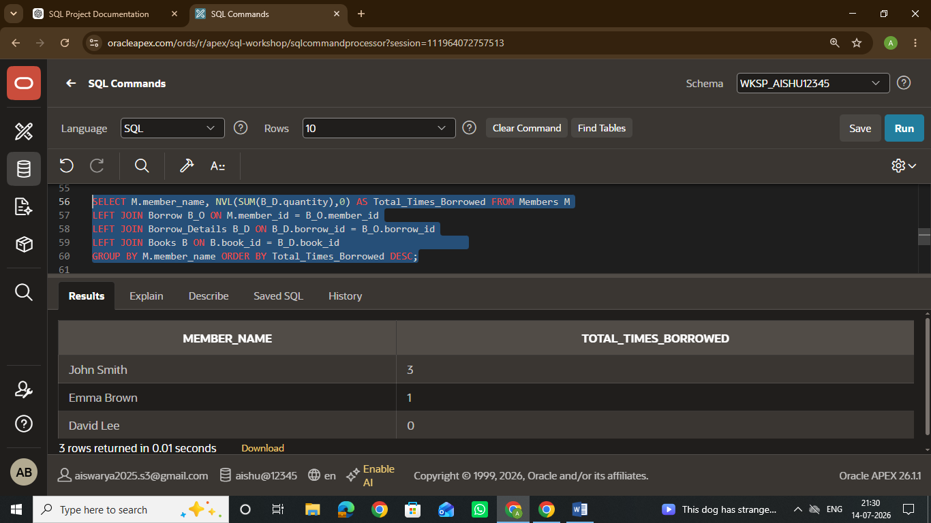

----------- DATE : 14-07-2026
----------------------- Which book category are most popular ?? --------------------
SELECT B.category,SUM(B_D.quantity) AS Most_popular_books_count FROM Books B
JOIN Borrow_Details B_D ON B.book_id=B_D.book_id
GROUP BY B.category ORDER BY Most_popular_books_count DESC;
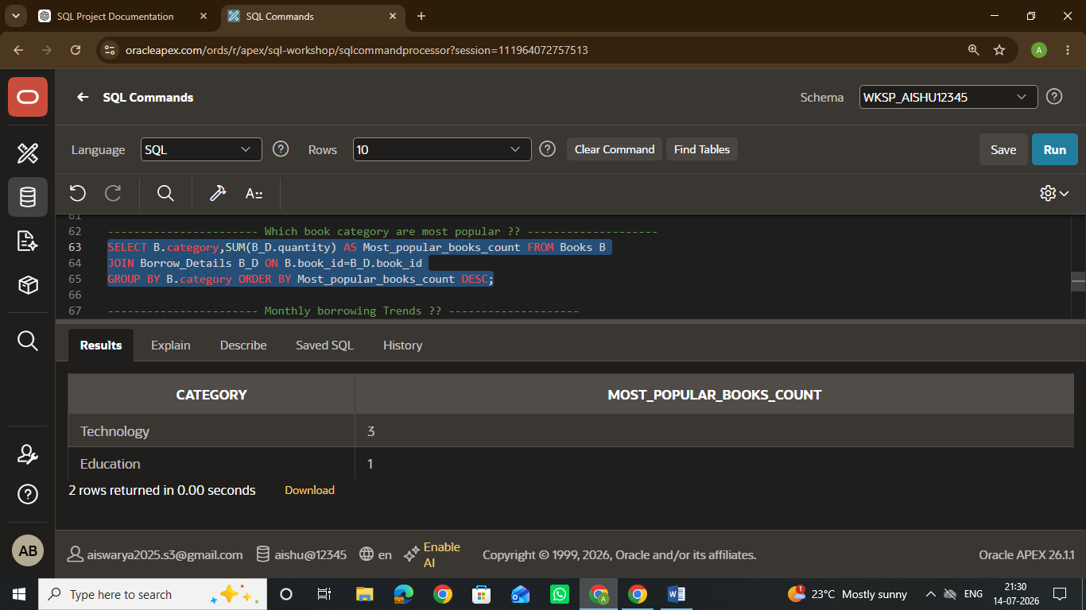
----------------------- Monthly borrowing Trends ?? --------------------
SELECT TO_CHAR(B_O.borrow_date,'Month') AS "Month", SUM(B_D.quantity) AS Total_Books_Borrowed_In_Month FROM Borrow_details B_D
JOIN Borrow B_O ON B_D.borrow_id=B_O.borrow_id
GROUP BY TO_CHAR(B_O.borrow_date,'Month'), TO_CHAR(B_O.borrow_date,'MM') ORDER BY TO_CHAR(B_O.borrow_date,'MM');
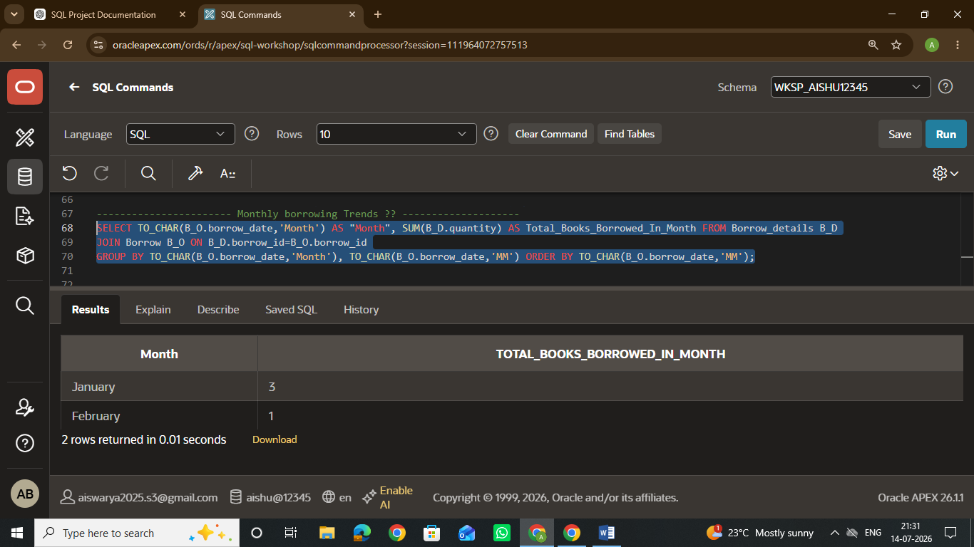

----------------------- Which members borrow the most books ?? --------------------
------------------------------------- Members Table -------------------------------
CREATE TABLE Members(
member_id VARCHAR(50),
member_name VARCHAR(50),
city VARCHAR(50),
email VARCHAR(50)
);
INSERT INTO Members(member_id,member_name,city,email) VALUES
('M101','John Smith','London','john@email.com'),
('M102','Emma Brown','Manchester','emma@email.com'),
('M103','David Lee','Birmingham','david@email.com');
---- SELECT *FROM Members;

SELECT M.member_name, NVL(SUM(B_D.quantity),0) AS Total_Times_Borrowed FROM Members M
LEFT JOIN Borrow B_O ON M.member_id = B_O.member_id
LEFT JOIN Borrow_Details B_D ON B_D.borrow_id = B_O.borrow_id
LEFT JOIN Books B ON B.book_id = B_D.book_id
GROUP BY M.member_name ORDER BY Total_Times_Borrowed DESC;

----------------------- Which book category are most popular ?? --------------------
SELECT B.category,SUM(B_D.quantity) AS Most_popular_books_count FROM Books B
JOIN Borrow_Details B_D ON B.book_id=B_D.book_id
GROUP BY B.category ORDER BY Most_popular_books_count DESC;

----------------------- Monthly borrowing Trends ?? --------------------
SELECT TO_CHAR(B_O.borrow_date,'Month') AS "Month", SUM(B_D.quantity) AS Total_Books_Borrowed_In_Month FROM Borrow_details B_D
JOIN Borrow B_O ON B_D.borrow_id=B_O.borrow_id
GROUP BY TO_CHAR(B_O.borrow_date,'Month'), TO_CHAR(B_O.borrow_date,'MM') ORDER BY TO_CHAR(B_O.borrow_date,'MM');
CREATE TABLE Librarians(
librarian_id VARCHAR(50),
Librarian_name VARCHAR(50),
Branch VARCHAR(50)
);
INSERT INTO Librarians(librarian_id,Librarian_name,Branch) VALUES
('L01','Alice','Central'),
('L02','Bob','North');

----------------------- Librarian Performance ?? --------------------
SELECT L.Librarian_name,SUM(B_D.quantity) AS Total_Books_Issued FROM Librarians L
JOIN Borrow B_O ON L.librarian_id=B_O.librarian_id
JOIN Borrow_Details B_D ON B_O.borrow_id=B_D.borrow_id
GROUP BY L.Librarian_name ORDER BY Total_Books_Issued DESC;
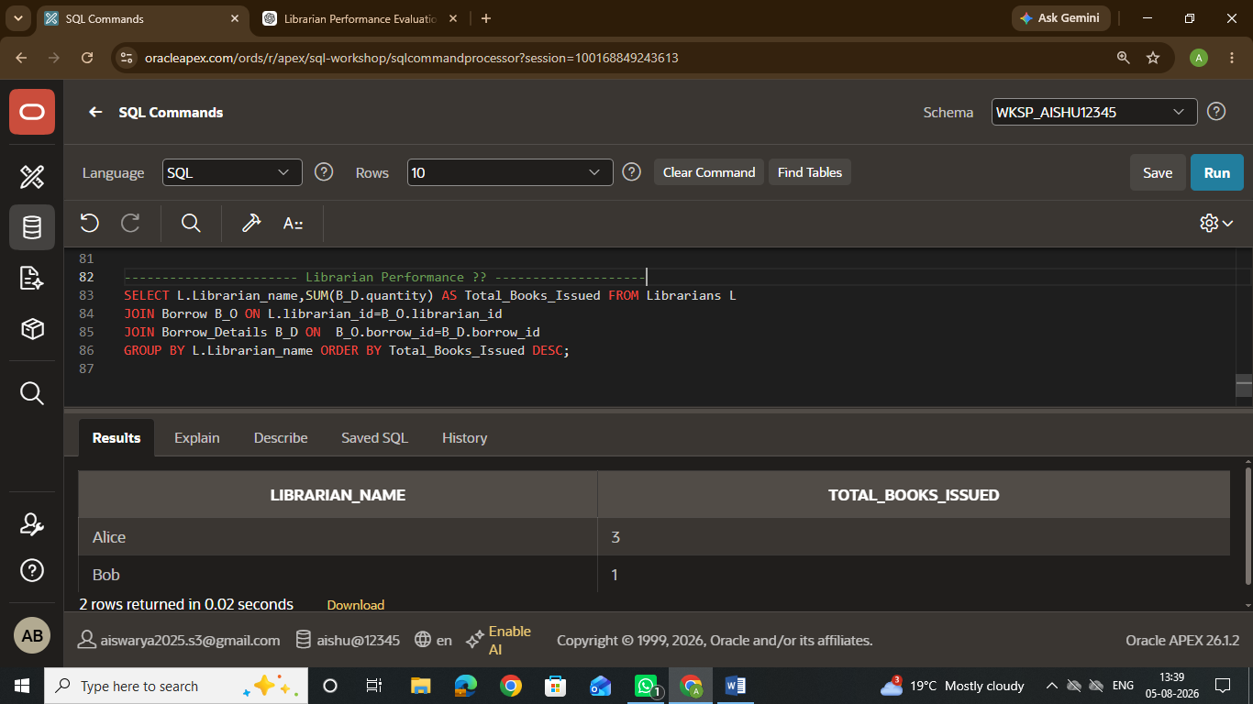

----------------------- Available VS Issued Books ?? --------------------
SELECT B.book_name, B.copies AS Total_Copies, B_D.quantity AS Issued_Copies, (B.copies - B_D.quantity ) AS Available_Copies FROM Books B
JOIN Borrow_Details B_D ON B.book_id=B_D.book_id
GROUP BY B.book_name,B.copies,B_D.quantity,(B.copies - B_D.quantity ) ORDER BY Available_Copies DESC;
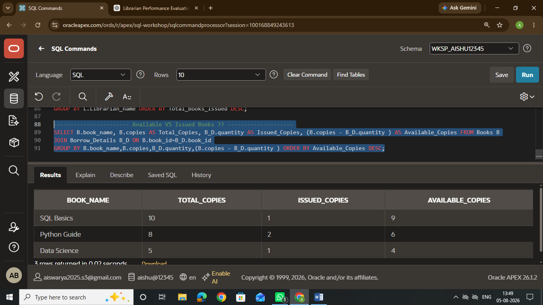
----------------------- Overdue Books ?? --------------------
SELECT B.book_name, B.book_id, B_O.borrow_date, B_D.return_date, 'Overdue' AS Status FROM Books B
JOIN Borrow_Details B_D ON B.book_id =B_D.book_id
JOIN Borrow B_O ON B_O.borrow_id = B_D.borrow_id
WHERE B_D.return_date IS NULL
GROUP BY B.book_name, B.book_id, B_O.borrow_date, B_D.return_date ;
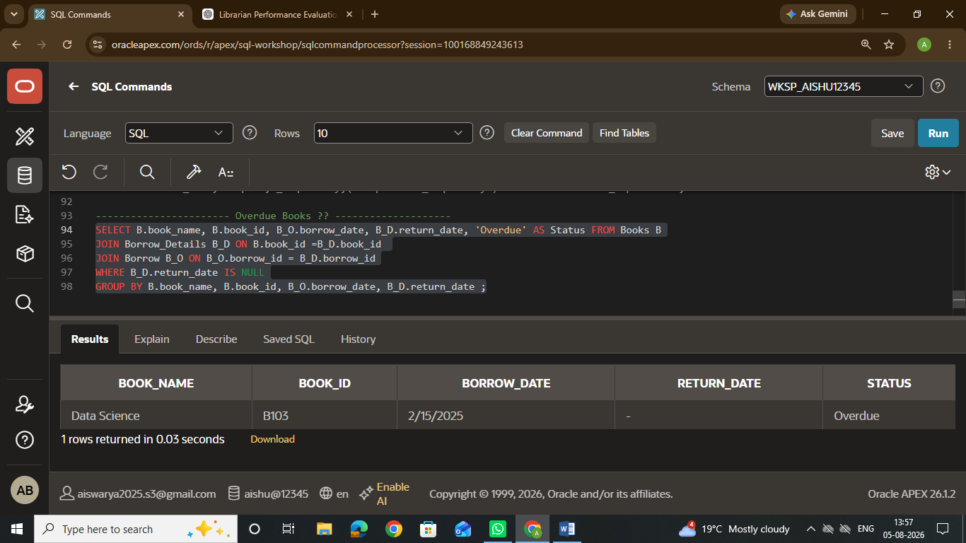
----------------------- Most Active Members ?? --------------------
SELECT M.member_name, NVL(SUM(B_D.quantity),0) AS Total_Books_Borrowed, RANK() OVER(ORDER BY NVL(SUM(B_D.quantity),0) DESC) AS Activity_Rank FROM Members M
LEFT JOIN Borrow B_O ON M.member_id=B_O.member_id
LEFT JOIN Borrow_Details B_D ON B_O.borrow_id=B_D.borrow_id
GROUP BY M.member_name ORDER BY Total_Books_Borrowed DESC;
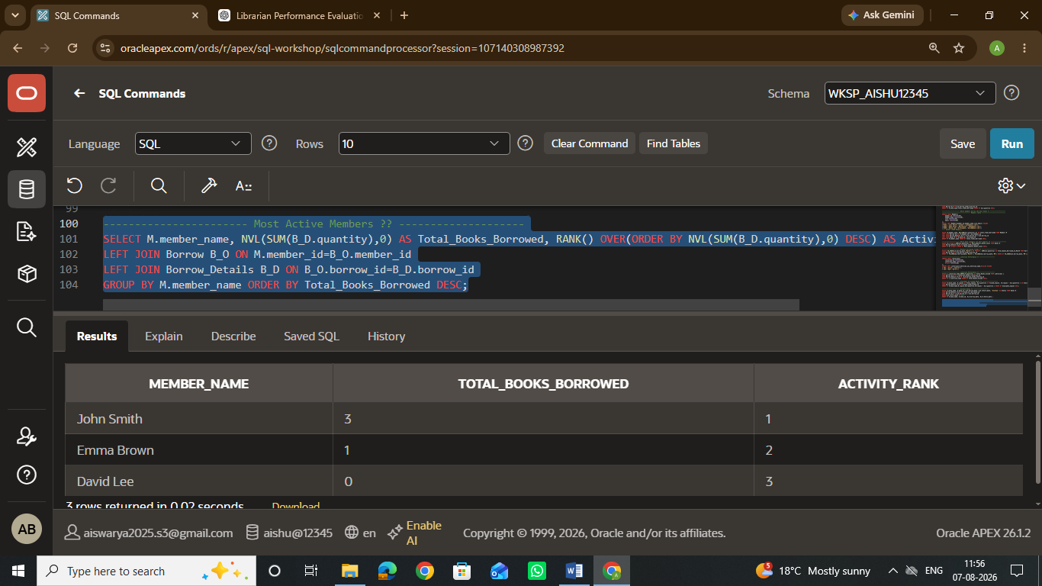
----------------------- Book Return Statistics ?? --------------------
SELECT book_name, Borrowed_quantity, Returned_quantity, Not_Returned,
CASE WHEN Borrowed_quantity = Returned_quantity
THEN 'Returned'
ELSE 'Not_Returned'
END AS Status FROM
(SELECT B.book_name, SUM(B_D.quantity) AS Borrowed_quantity,
SUM(
CASE
WHEN B_D.return_date IS NOT NULL
THEN B_D.quantity
ELSE 0
END ) AS Returned_quantity,
SUM(
CASE
WHEN B_D.return_date IS NULL
THEN B_D.quantity
ELSE 0
END ) AS Not_Returned,
FROM Books B
JOIN Borrow_Details B_D ON B.book_id=B_D.book_id
GROUP BY B.book_name) ORDER BY Borrowed_quantity ;
