centre for good governance

CGG Image Validation Application

**CGG Image Validation API application setup and usage**

**System Requirements:**

* Windows 64 bit
* Python > 3
* Cmake
* Visual Studio

**Downloads:**

|  |  |
| --- | --- |
| **Python** | <https://www.python.org/downloads/> |
| **CMake** | [cmake-3.26.3-windows-x86_64.msi](https://github.com/Kitware/CMake/releases/download/v3.26.3/cmake-3.26.3-windows-x86_64.msi) |
| **Visual Studio** | <https://visualstudio.microsoft.com/downloads/> |



* Open visual studio installer and select modify option as shown in below image.

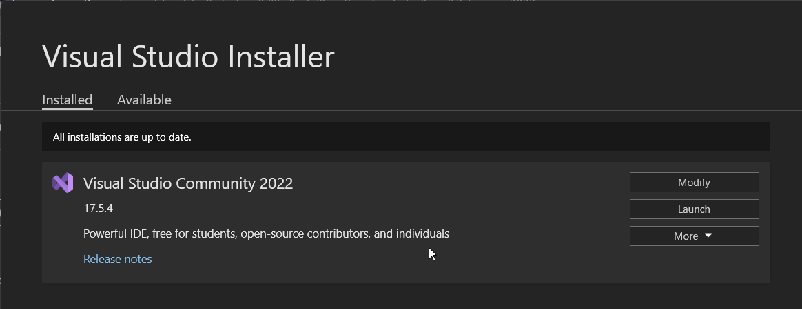

* Select option shown in below screenshot, and install

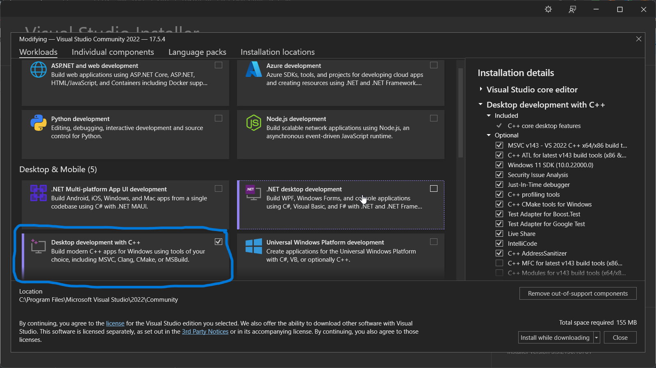

**Project Setup**

Once above setup is complete install below mentioned python packages using **pip** command line.

Example command: CMD> pip install <package-name>

**Python packages / libraries:**

* flask
* waitress
* requests
* face_recognition
* cmake
* opencv
* pillow
* numpy
* imutils
* scikit-image
* flask-swagger-ui

**Project Structure:**

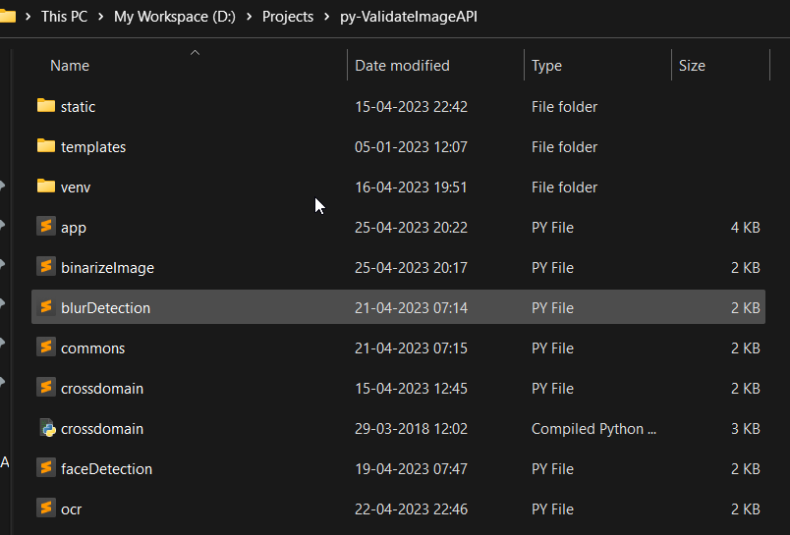

Open command prompt in the project folder and run the below command to start the application.

CMD> **python app.py**

If app start is successful, status becomes **Started.**

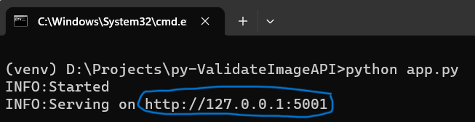

Navigate to the url <http://127.0.0.1:5001>

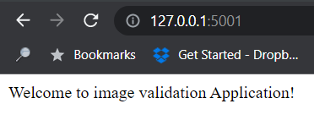

**API Details**

|  |  |
| --- | --- |
| **Api** | <http://127.0.0.1:5001/validateImage> |
| **Method** | POST |
| **Request Type** | application/json |
| **Response Type** | application/json |
| **Swagger** | <http://127.0.0.1:5001/swagger/> |
| **Log file location** | /<project directory>/static/logs/middleware.log |

**Request Params:**

|  |  |  |
| --- | --- | --- |
| **Param** | **Type** | **Value** |
| imageFilePath | String | “D:/detecting_blur_result_006.jpg" or “http://url.com/006.jpg” |
| id | String | "TS-2023454" |
| fileType | String | face/sign |
| appid | String | "TSPSC” |

**Response Params:**

|  |  |  |
| --- | --- | --- |
| **Param** | **Type** | **Value** |
| appid | String | TSPSC |
| createdatetime | String | 2023-04-25 20:24 |
| id | String | TS-2023454 |
| isblur | String | True / false |
| isvalidimage | String | True / false |
| status | String | OK / ERROR |
| type | String | Face / sign |
| uuid | String | 0370d2b7-e379-11ed-a2f9-005056c00008 |

**Request Body:**

{

"imageFilePath": "D:/Projects/py-ValidateImageAPI/static/images/006.jpg",

"id": "TS-2023454",

"fileType":"sign",

"appid": "TSPSC"

}

**Response:**

{

"appid": "TSPSC",

"createdatetime": "2023-04-25 20:24",

"id": "TS-2023454",

"isblur": "false",

"isvalidimage": "true",

"status": "OK",

"type": "sign",

"uid": "0370d2b7-e379-11ed-a2f9-005056c00008"

}

**Sample Postman Request Screenshot**

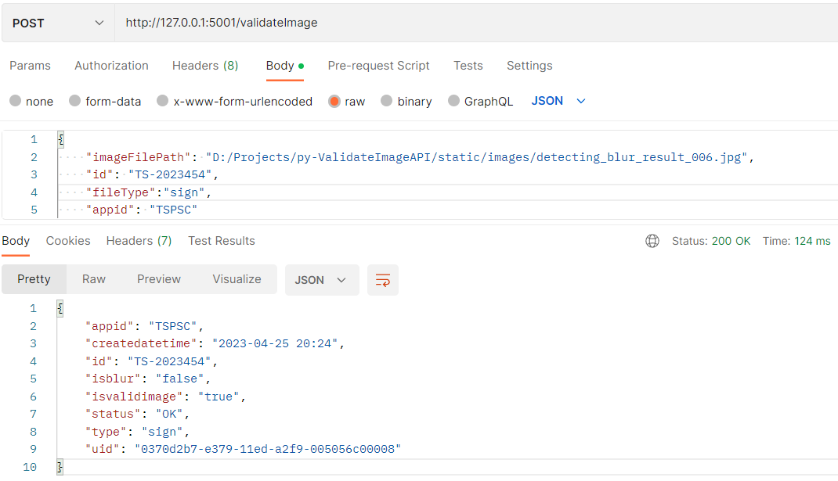

**Api Integration Examples**

**JAVA**

1. **okHttp library**

OkHttpClient client = new OkHttpClient().newBuilder().build();

MediaType mediaType = MediaType.parse("application/json");

RequestBody body = RequestBody.create(mediaType, "{\"imageFilePath\": \"D:/Projects/py-ValidateImageAPI/static/images/detecting_blur_result_006.jpg\", \"id\": \"TS-2023454\", \"fileType\":\"sign\", \"appid\": \"TSPSC\"}");

Request request = new Request.Builder() .url("http://127.0.0.1:5001/validateImage") .method("POST", body) .addHeader("Content-Type", "application/json") .build();

Response response = client.newCall(request).execute();

1. **Unirest Library**

Unirest.setTimeouts(0, 0);

HttpResponse<String> response = Unirest.post("http://127.0.0.1:5001/validateImage")

.header("Content-Type", "application/json").body("{ \"imageFilePath\": \"D:/Projects/py-ValidateImageAPI/static/images/detecting_blur_result_006.jpg\",\"id\": \"TS-2023454\", \"fileType\":\"sign\",\"appid\": \"TSPSC\"}").asString();

**Java Script**

var myHeaders **=** **new** Headers();

myHeaders.**append**("Content-Type", "application/json");

var raw **=** JSON.**stringify**({

"imageFilePath": "D:/Projects/py-ValidateImageAPI/static/images/detecting_blur_result_006.jpg",

"id": "TS-2023454",

"fileType": "sign",

"appid": "TSPSC"

});

var requestOptions **=** {

method: 'POST',

headers: myHeaders,

body: raw,

redirect: 'follow'

};

fetch("http://127.0.0.1:5001/validateImage", requestOptions)

.**then**(response **=>** response.text())

.**then**(result **=>** console.**log**(result))

.**catch**(error **=>** console.**log**('error', error));

**JQuery**

var settings **=** { "url": "http://127.0.0.1:5001/validateImage",

"method": "POST", "headers": {

"Content-Type": "application/json"

}, "data": JSON.**stringify**({

"imageFilePath": "D:/Projects/py-ValidateImageAPI/static/images/detecting_blur_result_006.jpg",

"id": "TS-2023454", "fileType": "sign",

"appid": "TSPSC"

}),

};

$.ajax(settings).done(**function** (response) {

console.**log**(response);

});

**Python**

import requests

import json

url = "http://127.0.0.1:5001/validateImage"

payload = json.dumps({ "imageFilePath": "D:/Projects/py-ValidateImageAPI/static/images/detecting_blur_result_006.jpg",

"id": "TS-2023454",

"fileType": "sign",

"appid": "TSPSC"

})

headers = {

'Content-Type': 'application/json'

}

response = requests.request("POST", url, headers=headers, data=payload)

print(response.text)