**Wireframe Documentation**

**Deloitte Case Study**

**Homepage**

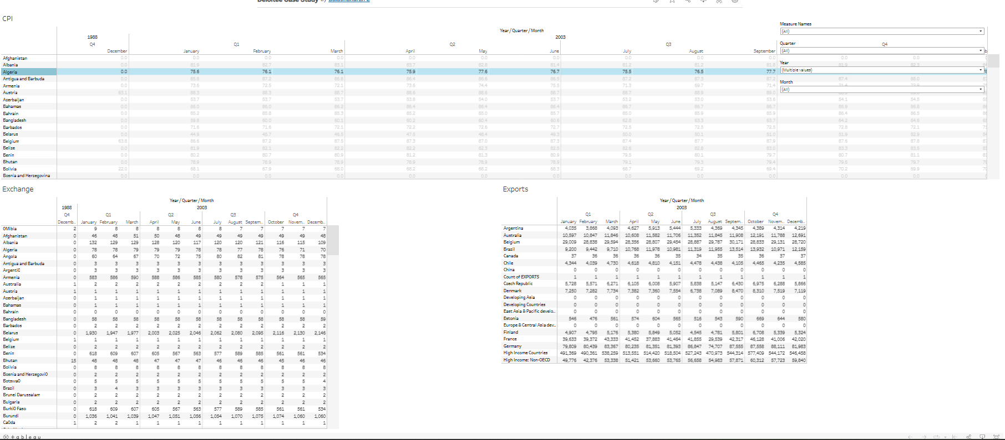

This is our dashboard design