PYTHON PROGRAMMING - ASSIGNMENT 1 (CO1-CO5)
PAYMENT CALCULATOR FOR A VILLAGE MILK CO-OPERATIVE
Name:- Balachandru.P
Register Number:- 1912260301C
Slot:- C
Code & Course:- CSA08 - Python Programming
Faculty:- Pokuri Swetha
GitHub Repository Link:- https://github.com/balachandru4562bala-blip/Python-slot-c.git
Scenario: the Ksheera Village Milk Producers' Co-operative pays about 300 farmers every ten days. The rate is Rs 30.00 per litre for milk with 3.5% fat and 8.5% SNF; every 0.1% of fat above or below 3.5% adds or subtracts Rs 0.40, and every 0.1% of SNF above or below 8.5% adds or subtracts Rs 0.30. This report designs, implements, tests and measures the calculator, then re-evaluates the design when the union installs an automatic analyser and announces seasonal rates with a volume bonus.
TASK 1 - UNDERSTAND THE PROBLEM AND IDENTIFY THE DATA (4 Marks, K4 Analyse)
1. Aim
To analyse the co-operative's payment problem and identify every value the program must store and compute, together with the rules each value must satisfy - before writing any code.
2. The data identified
Inputs (what the clerk records twice a day for each farmer) and outputs (what the program must produce):
Value | Kind | Type | Rule and justification
farmer_id | input | text (str) | Identifies who is paid. Never used in arithmetic, so it stays text even though it contains digits (F201).
day | input | whole number (int) | Position inside the ten-day period, 1 to 10. Fractions make no sense for a day number.
shift | input | text (str) | morning or evening; two collections per day. Text, because it is a label, not a quantity.
litres | input | fractional (Decimal) | Quantity of milk. Must be greater than 0; 8.5 litres is a normal entry, so an int cannot hold it.
fat | input | fractional (Decimal) | Fat percentage. Allowed 2.0 to 7.0 per the problem statement.
snf | input | fractional (Decimal) | SNF percentage. Allowed 7.0 to 10.0 (my stated assumption - see below).
rate | computed | money, 2 decimals | Rs 30.00 plus or minus the fat and SNF step values.
amount | computed | money, 2 decimals | litres x rate, rounded to the paisa.
ten_day_total | computed | money, 2 decimals | Sum of one farmer's accepted entries over the period.

3. Values that never change during a run (named constants)
Constant | Value | Why it is a constant
BASE_RATE | 30.00 | Rs per litre at the standard quality; fixed by the union's rate card.
STANDARD_FAT / STANDARD_SNF | 3.5 / 8.5 | The reference quality; all steps are measured from these.
FAT_STEP_VALUE / SNF_STEP_VALUE | 0.40 / 0.30 | Rs per 0.1% step; fixed until the union revises rates.
STEP_SIZE | 0.1 | Width of one quality step in percent.
MIN_FAT, MAX_FAT | 2.0, 7.0 | Acceptance limits for fat, given in the problem.
MIN_SNF, MAX_SNF | 7.0, 10.0 | Acceptance limits for SNF (assumption).
PAYMENT_PERIOD_DAYS | 10 | Farmers are paid every ten days.

4. Rules every correct payment must satisfy
(a) litres > 0 - a zero or negative delivery is a typing mistake, not milk. (b) 2.0 <= fat <= 7.0 and 7.0 <= snf <= 10.0 - outside these, the reading is rejected. (c) Steps are counted to the nearest whole 0.1% from the standard, in both directions. (d) Every amount is exact to the paisa - the bank statement must match to the last paisa. (e) A farmer's ten-day total is the sum of exactly his accepted entries, no one else's.
5. Assumptions I made
The problem fixes the fat range (2.0-7.0) but not the SNF range, so I assumed 7.0-10.0 - milk below 7% SNF is not realistic, and 10.0 gives headroom above the 8.5% standard. Half steps are rounded away from the standard for now; Task 12 revisits this when two-decimal readings make halves common. Invalid entries are rejected with a reason, never silently corrected - a corrected typo is a payment nobody can audit.
6. Alternative Concept and Complexity Analysis
If each farmer's entry were kept in three separate variables (litres1, fat1, snf1, litres2, ...), 300 farmers would need more than 900 named variables, and 150,000 farmers would need 450,000. Processing n entries takes O(n) time and O(n) space in both designs - the difference is the program itself: the separate-variable design needs O(n) lines of code, one line per variable, while the list-of-entries design is O(1) code (one loop) over O(n) data. The first design cannot even be typed at district-union scale; the second scales by changing the data file, not the program.
7. Conclusion
The problem needs six input values per entry, three computed money values, eleven named constants and five rules. Every later task builds on exactly this list.
TASK 2 - EXPLORE VALUES AND TYPES IN THE INTERPRETER (4 Marks, K4 Analyse)
1. Aim
To explore, in the interactive interpreter, the types the payment problem needs, the division operators, and the floating-point problem with money - and to complete TODO 1 of the given program.
2. Interactive session (evidence)
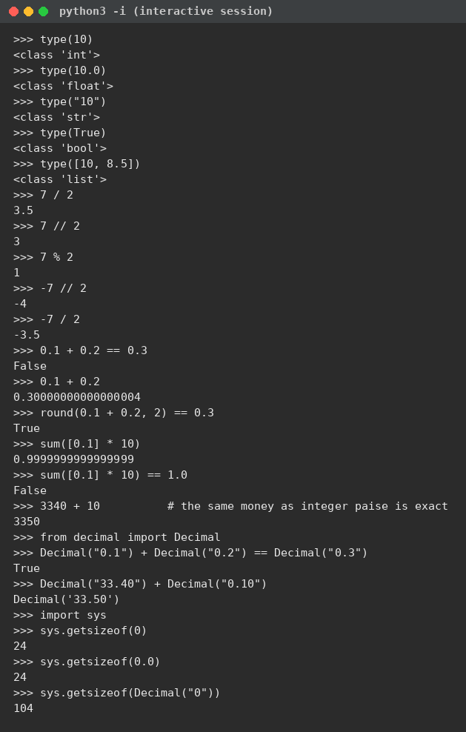
3. What the session shows
Types: 10 is int, 10.0 is float, "10" is str - the quotes decide the type, not the digits. True is bool, and [10, 8.5] is a list holding an int and a float. These are exactly the types Task 1 identified: text for IDs, whole numbers for days, fractional values for litres and percentages.
Division: 7 / 2 is 3.5 - true division always returns a float. 7 // 2 is 3 - floor division. 7 % 2 is 1 - the remainder. The surprise is -7 // 2 = -4, not -3: floor division rounds toward minus infinity, and the floor of -3.5 is -4. This matters directly for our rate rule: below-standard fat gives negative steps, and anyone who assumes // truncates toward zero will count one step too few.
Floating point: 0.1 + 0.2 == 0.3 is False because the sum is 0.30000000000000004 - 0.1, 0.2 and 0.3 have no exact representation in binary, so the computer stores the nearest value it can. round(0.1 + 0.2, 2) == 0.3 is True, and sum([0.1] * 10) is 0.9999999999999999, not 1.0. This is why money should not be added as float rupees. The alternatives, all shown in the session: integer paise (3340 + 10 = 3350, exact), round() after each step (a patch, not a cure), and the decimal module (Decimal("0.1") + Decimal("0.2") == Decimal("0.3") is True).
4. Complete the Code - TODO 1 (program and output)
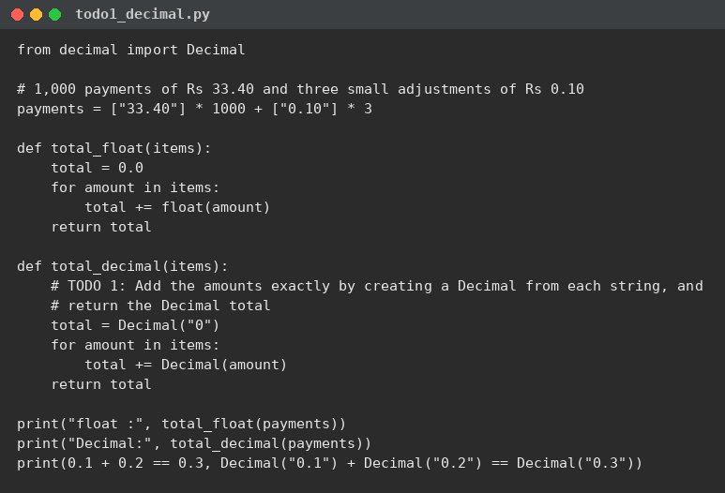
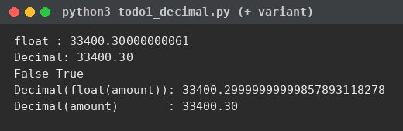
The output matches the expected output exactly: float : 33400.30000000061, Decimal: 33400.30, False True. The float total of the same 1,003 amounts is wrong in the eleventh digit; the Decimal total is exact.
The follow-up change - Decimal(float(amount)) instead of Decimal(amount) - gives 33400.29999999999857893118278 (second run above). Converting to float first burns the binary error into the value, and Decimal then preserves that wrong value perfectly. Decimal must be built from the string, never from a float.
5. Alternative Concept and Complexity Analysis
Integer paise: keep every amount as an int count of paise. Exact, one small object per value (sys.getsizeof measured 24 bytes), and the fastest arithmetic - but every value must be scaled by 100 on the way in and out, and one forgotten scaling is a silent hundredfold error. Float with round() after every addition: still float underneath (24 bytes), the rounding costs time, and the accumulated error can survive the rounding, as the TODO 1 output shows. Decimal: exact base-10 arithmetic, but 104 bytes per value and visibly slower (Task 10 measures about 2.7x at 150,000 payments). Time per addition is O(1) in all three, so n payments cost O(n) each; the real difference is exactness: only integer paise and Decimal give the exact bank total for n payments.
6. Conclusion
The interpreter session settled the money question before any design work: fractional money goes in as Decimal (from strings), and // on negative numbers floors - both facts the calculator relies on.
TASK 3 - CHOOSE VARIABLES AND NAME THE CONSTANTS (3 Marks, K3 Apply)
1. Aim
To define the rates and limits as named constants so that a rate revision is made in one place only.
2. Program
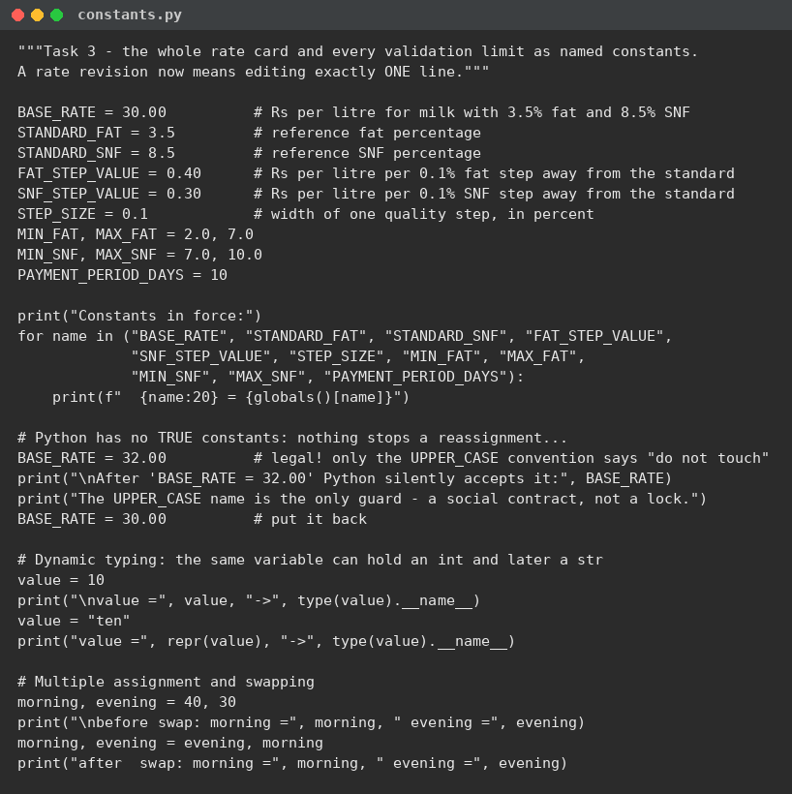
3. Output
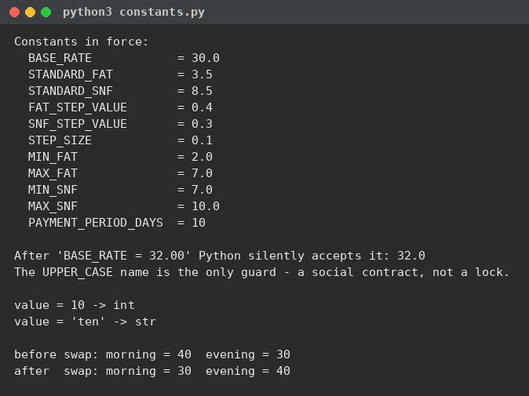
4. Discussion
Naming rules: constants in UPPER_CASE with underscores (BASE_RATE, FAT_STEP_VALUE), variables in lower_case (fat_steps, ten_day_total), and every name says what the value means - FAT_STEP_VALUE instead of x or v2. A reader should never have to ask what a name holds.
Python has no true constants. The run proves it: after BASE_RATE = 32.00 the interpreter silently accepts the new value. The UPPER_CASE name is a social contract, not a lock - it tells every reader "do not reassign this", and tools and reviewers enforce what the language does not.
Dynamic typing: the same variable can hold an int and later a str - value = 10 then value = "ten" runs without complaint, and type() follows the current value. Convenient for quick scripts, dangerous in a payment program: a variable that changes type mid-run usually hides a bug, so each of my names keeps exactly one type.
Multiple assignment and swapping: morning, evening = 40, 30 packs two values in one line, and morning, evening = evening, morning swaps them with no temporary variable - Python builds the tuple on the right first, then unpacks it.
5. Alternative Concept and Complexity Analysis
Magic numbers typed inside the expressions: a fat-step revision from 0.40 to 0.45 means finding and editing k places, and missing even one applies the revision only partly - precisely the bug the co-operative's volunteer calculator suffered. A dictionary RATE_CARD = {"base": 30.0, "fat": 0.40, "snf": 0.30} also keeps the values in one place with O(1) lookups, but a misspelt key fails only at run time with a KeyError, while a misspelt constant name fails immediately with a NameError; the dictionary also costs a little more memory per value. For a fixed rate card, named constants are the simplest safe form; the dictionary and JSON versions return in Tasks 11 and 12, where revisions arrive as data. Running time is unchanged - all three are O(1) reads.
6. Conclusion
One named home for every rate and limit turns a rate revision from a treasure hunt into a one-line edit - and the demo shows the convention is all we have, so it must be applied without exceptions.
TASK 4 - WRITE CORRECT EXPRESSIONS (4 Marks, K4 Analyse)
1. Aim
To write the expressions that compute the fat and SNF step counts, the rate per litre and the amount, and to demonstrate at least three expressions whose results surprise.
2. Program
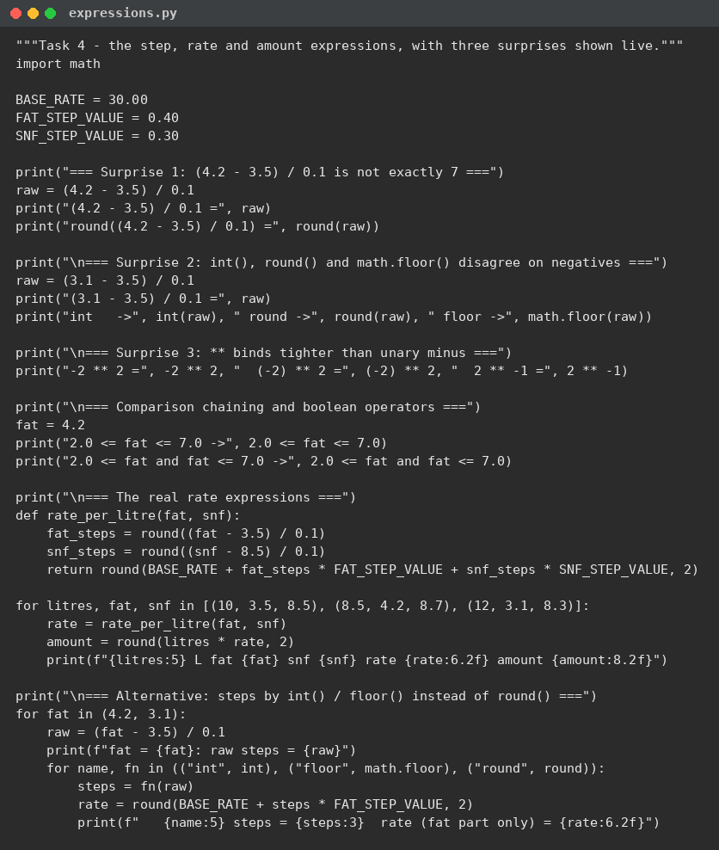
3. Output
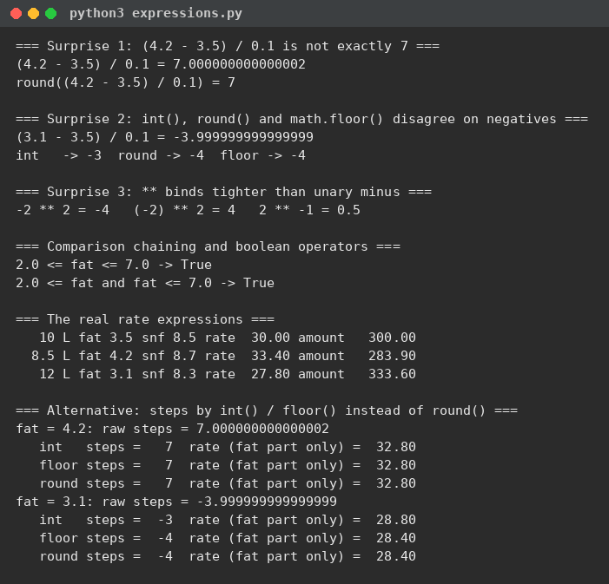
4. The three surprises, explained
Surprise 1: (4.2 - 3.5) / 0.1 prints 7.000000000000002, not 7. Neither 4.2 nor 0.1 is exact in binary, and the subtraction and division carry the error forward. round() pulls the count back to the intended whole step, because the float error (about 2 parts in 10^15) is vastly smaller than half a step. (The assignment sheet quotes 7.000000000000001 - same story, last digit depends on the print path.)
Surprise 2: on (3.1 - 3.5) / 0.1 = -3.999999999999999, int() answers -3 while round() and math.floor() answer -4. int() truncates toward zero, which on negative values moves the wrong way: it would count only 3 fat steps below the standard where 4 were measured - the farmer would be overpaid. For negative values, int() and floor() are not interchangeable.
Surprise 3: -2 ** 2 is -4, because ** binds tighter than the unary minus - the expression reads as -(2 ** 2). (-2) ** 2 is 4, and 2 ** -1 is 0.5. Exponentiation also groups right to left: 2 ** 3 ** 2 is 2 ** 9 = 512, not 64 ** ... - associativity matters as much as precedence.
Comparison chaining: 2.0 <= fat <= 7.0 reads exactly like the acceptance rule and means 2.0 <= fat and fat <= 7.0 - both confirmed True in the run for fat = 4.2.
The real expressions then behave: fat_steps = round((fat - 3.5) / 0.1), snf_steps = round((snf - 8.5) / 0.1), rate = BASE_RATE + fat_steps * 0.40 + snf_steps * 0.30, amount = round(litres * rate, 2) - giving 30.00/300.00, 33.40/283.90 and 27.80/333.60 for the three sample entries.
5. Alternative Concept and Complexity Analysis
Steps by int() or math.floor() instead of round(): the run shows fat = 4.2 gives 7 under all three (the raw value 7.000000000000002 truncates down to 7 anyway), while fat = 3.1 splits them - int() gives -3 (fat-only rate 28.80) against floor() and round() giving -4 (28.40). int() miscounts whenever the float error lands on the far side of a whole number, which happens on roughly half the below-standard readings; floor() matches round() for negatives but rounds 7.5 down to 7 on exact halves. Each of int(), floor() and round() is O(1) in time and space - the choice is about correctness of the step count, not cost.
6. Conclusion
The four expressions are one line each, and every line survived a live surprise: round() for step counts, parentheses where precedence bites, and chained comparisons for the limits.
TASK 5 - READ INPUT AND CONVERT TYPES (3 Marks, K3 Apply)
1. Aim
To design how the program reads the clerk's entries: conversion from text, rejection of invalid input, and neatly formatted output.
2. Program
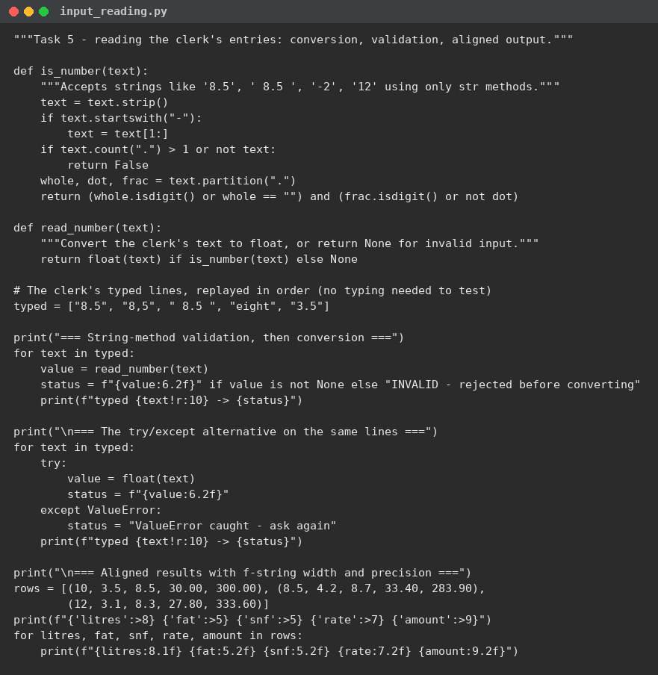
3. Output
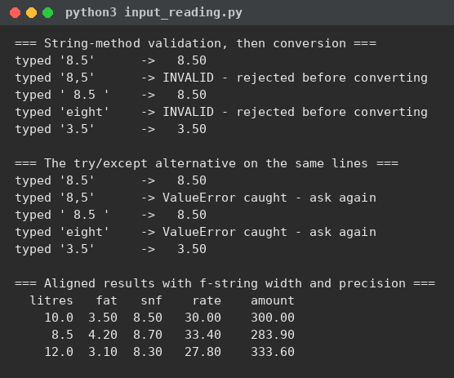
4. Discussion
input() always returns a string, because the keyboard delivers characters - "8.5" is three characters until float() turns it into a number. int() and float() raise ValueError when the text is not a number. When the clerk types "8,5" (a comma) or "eight", a bare float() would crash the program mid-collection; " 8.5 " with spaces is accepted once stripped. Checking the text before converting - strip(), then allowing one optional dot with digits on each side using partition() and isdigit() - lets the program reject bad lines with a clear message instead of a traceback. Finally, f-strings with width and precision ({amount:9.2f}) print aligned columns, which is what makes a payment slip readable.
5. Alternative Concept and Complexity Analysis
The try/except alternative - float(text) inside try, ValueError caught - produced identical accept/reject decisions on all five test lines in the run. try/except is shorter and is the usual Python style (ask forgiveness, not permission); it also accepts "1e3", which my string check rejects - and for milk entries that rejection is a feature: a clerk should never type scientific notation. Time per entry: the string check is one O(L) scan over L characters; try/except is one O(L) conversion attempt, with the exception cost added only on bad input - both O(L) per entry, so O(n.L) for a ten-day sheet. I kept the pre-check for clear clerk-facing messages; the calculator's CSV reader uses try/except as the second net.
6. Conclusion
Convert late, validate early, format always: the same five lines of test input now produce either a clean number or a clean rejection, and the slip prints in aligned columns.
TASK 6 - ORGANISE THE LOGIC INTO FUNCTIONS (4 Marks, K3 Apply)
1. Aim
To divide the calculation into well-named functions with parameters, return values and docstrings.
2. Program
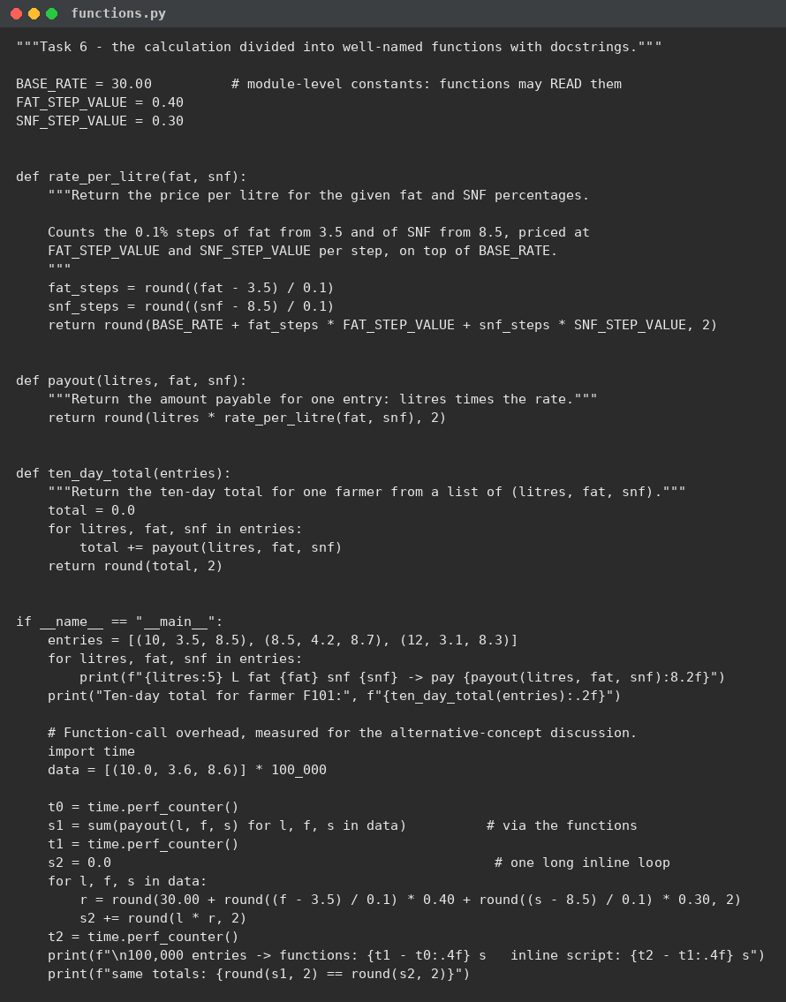
3. Output
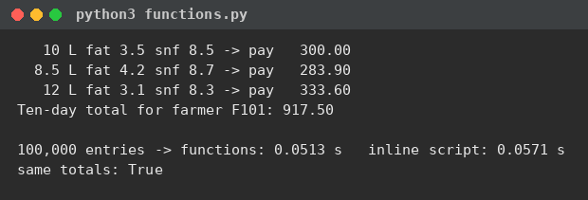
4. Discussion
Three functions carry the whole calculation. rate_per_litre(fat, snf) takes a quality reading and returns money; payout(litres, fat, snf) takes one entry and returns the amount; ten_day_total(entries) takes a farmer's list of entries and returns the period total. Parameters carry the entry in, the return value carries the result out - nothing else needs to be shared.
Returning a value versus printing it: a function that prints can only be watched; a function that returns can be tested, summed and reused. payout() returning 283.90 lets ten_day_total() add it and lets Task 9's asserts check it; had payout() printed, both would be impossible. Printing belongs to the outermost script only.
Scope: names created inside a function are local to that call - fat_steps in one call is invisible to the next. The rate constants are module-level (global): functions may read them freely, but they must not reassign them, which would need the global keyword and would hide a rate change inside a call - exactly the kind of partial revision the co-operative already suffered. Every function carries a docstring stating its inputs, its output and the rule it implements.
5. Alternative Concept and Complexity Analysis
One long script without functions repeats the rate formula at every use - k copies to fix when a rate changes. Lambdas (rate = lambda fat, snf: ...) are anonymous one-expression functions: same call machinery, but no name, no docstring, and unreadable once the body grows past one expression. The function-call overhead question is settled by measurement, not guessing: 100,000 entries took 0.0513 s through the functions against 0.0571 s inline - about half a microsecond per entry, within run-to-run noise. At roughly 600 entries a day, the centre could run for years before call overhead cost a single second. Both shapes are O(n) in time and O(1) in extra space; functions cost nothing measurable and buy testability.
6. Conclusion
Three small functions replaced a wall of repeated arithmetic, and the measured overhead - none that matters - removed the only argument against them.
TASK 7 - BUILD A MODULE (4 Marks, K4 Analyse)
1. Aim
To place the rate card and the calculation functions in a module, complete TODO 1 and TODO 2 of the given milkrate.py, run it directly, and then import it from a second script.
2. Program - milkrate.py with the TODOs completed
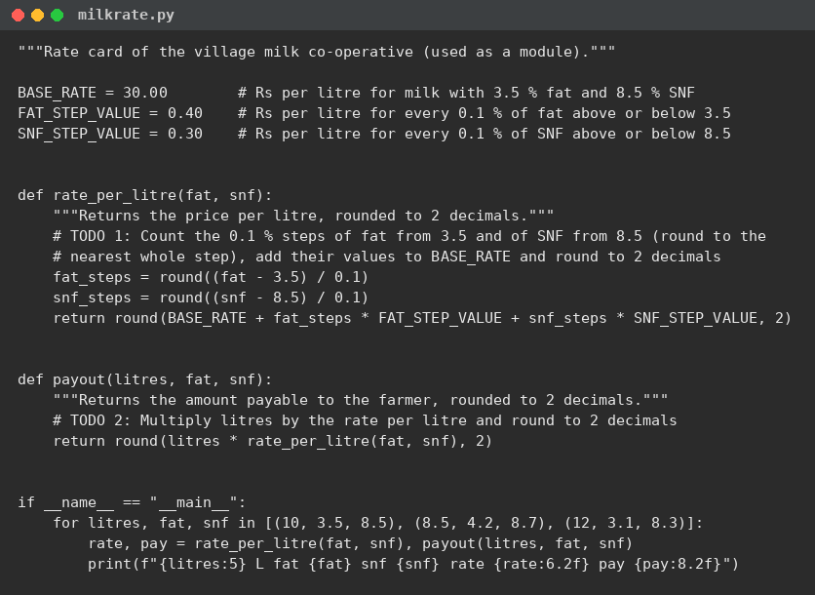
3. Output - run directly, and imported from a second script
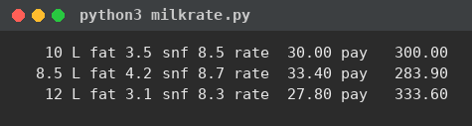
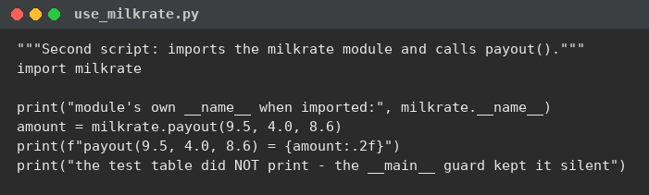
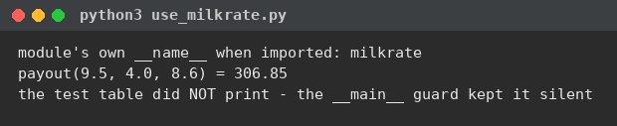
The direct run matches the expected output value for value: 30.00/300.00, 33.40/283.90, 27.80/333.60 (the assignment allows small spacing differences from the f-string widths).
4. Discussion
The three import forms: import milkrate brings in the whole module under one qualified name (milkrate.payout) - explicit about where each name lives. from milkrate import payout lifts one name into the script's own namespace - shorter to type, but two modules that both define payout would silently collide. import milkrate as mr only renames the handle. For one module they are equivalent; in a program with several modules, the qualified form is the safest.
if __name__ == "__main__" separates running as a program from being used as a library. When python3 milkrate.py runs, __name__ is "__main__" and the test table prints; when use_milkrate.py imports the module, __name__ is "milkrate" and the table stays silent - the second output proves it: the importer printed only its own two lines. Without the guard, every import would re-run the demo table on the importer's screen.
Standard modules such as math and decimal live on Python's installation path; Python searches the current folder first and then sys.path, which is why use_milkrate.py finds milkrate.py sitting beside it with no configuration.
5. Alternative Concept and Complexity Analysis
Copying the rate functions into every script that needs them: a rate revision then means editing k files and hoping none is missed - the co-operative's partial-revision bug by another route, and every copy is another chance for the copies to drift apart. Importing has a one-time cost: Python loads and compiles the module once and keeps it in sys.modules, so every later import in the same run is an O(1) dictionary lookup. Space is one copy of the code instead of k. The module wins on every axis except the two seconds it takes to type the import line.
6. Conclusion
milkrate.py is now the single source of the rate card: runnable on its own for a quick check, silent and reusable when imported.
TASK 8 - PLAN THE ALGORITHM BEFORE CODING (4 Marks, K3 Apply)
1. Aim
To plan the ten-day payment with pseudocode and a flowchart before writing Python, and to hand-trace the plan on three entries.
2. The steps of algorithmic problem solving
Understand the problem (Task 1: values, rules, assumptions), plan the solution (this pseudocode and flowchart), write the code (Tasks 6 to 9), and test it (Task 9's asserts, Task 10's measurements). Writing the pseudocode first forced the decisions - validate before computing, round steps to whole numbers, accumulate only accepted entries - while they were still cheap to change.
3. Pseudocode (required conventions: START/END, SET/INPUT/OUTPUT, IF...ENDIF, FOR...ENDFOR)
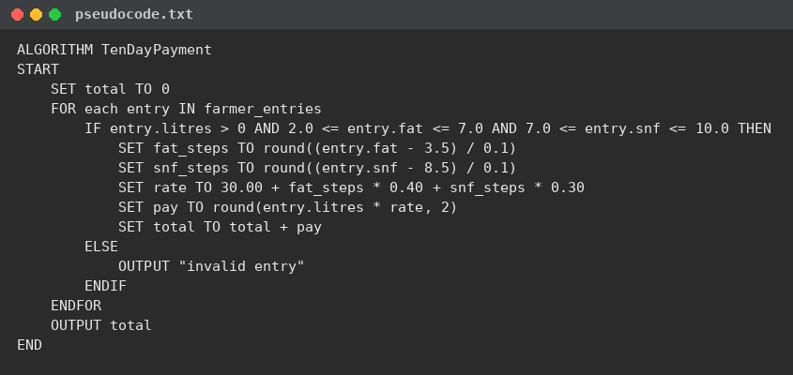
4. Flowchart
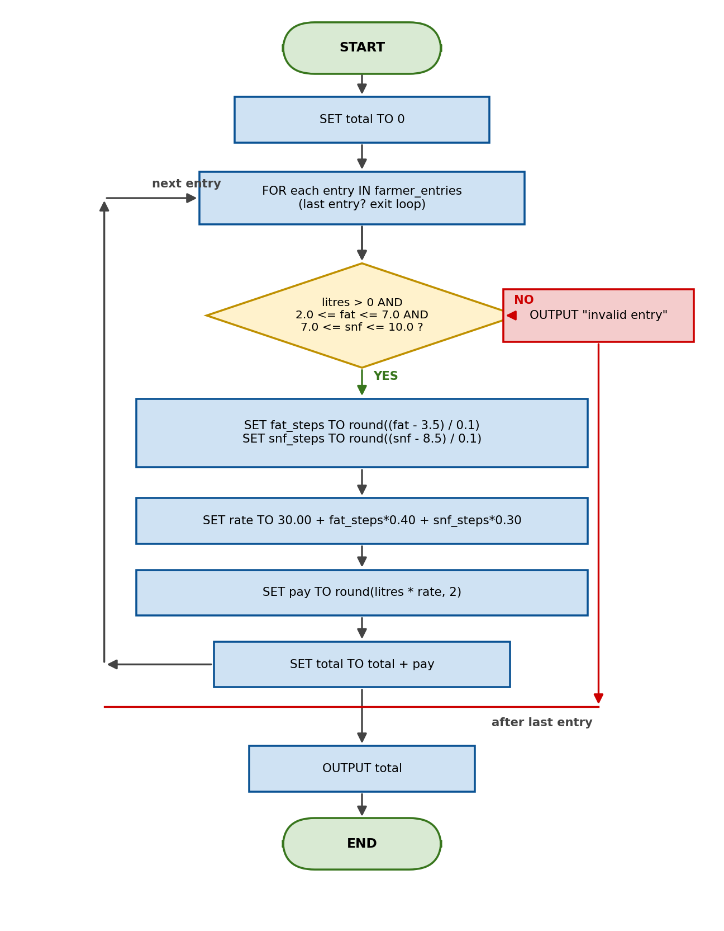
5. Hand trace of three entries (program in trace mode)
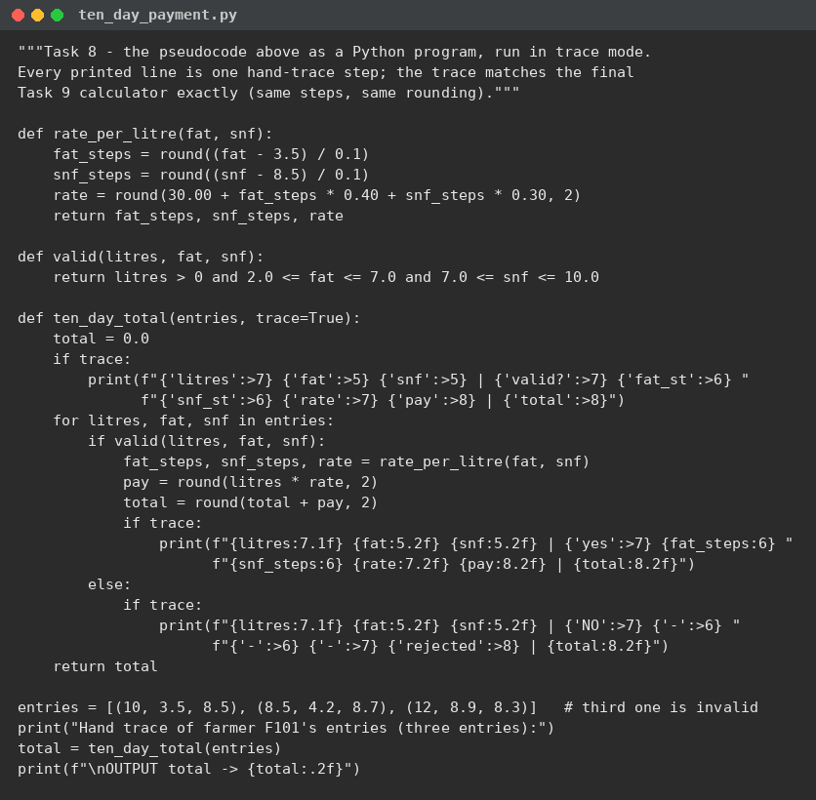
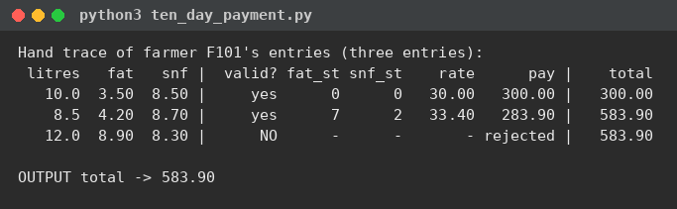
The trace walks farmer F101's three entries exactly as the pseudocode says: the first two are valid (0 and 0 steps -> 30.00 -> 300.00; then 7 and 2 steps -> 33.40 -> 283.90, total 583.90) and the third (fat 8.9, above the 7.0 limit) takes the ELSE branch - rejected, total untouched. The same total, 583.90, appears as F201's ten-day total in the Task 9 calculator output: plan and final program agree.
6. Alternative Concept and Complexity Analysis
Store every entry in a list and add at the end, versus keep a running total while reading: both walk the n entries once, so both are O(n) time; storing costs O(n) space, the running total O(1). Storing is still necessary whenever later questions need the entries themselves - reprinting a farmer's slips, auditing a disputed payment, or applying a rule that looks at the whole period. Task 12's bonus needs only the period's total litres, which a second O(1) counter covers - but a payment dispute needs the raw entries, so the calculator keeps the file and totals as it reads.
7. Conclusion
The pseudocode, the flowchart and the hand trace all say the same thing as the final program, and the trace's invalid entry proves the ELSE branch works before a real farmer's money depends on it.
TASK 9 - IMPLEMENT AND TEST THE CALCULATOR (4 Marks, K3 Apply)
1. Aim
To implement the complete calculator - Decimal money, one named rate card, validation before conversion, per-payment rounding, ten-day totals per farmer - and to test it across normal, boundary and invalid entries plus a hand-computed set.
2. Program
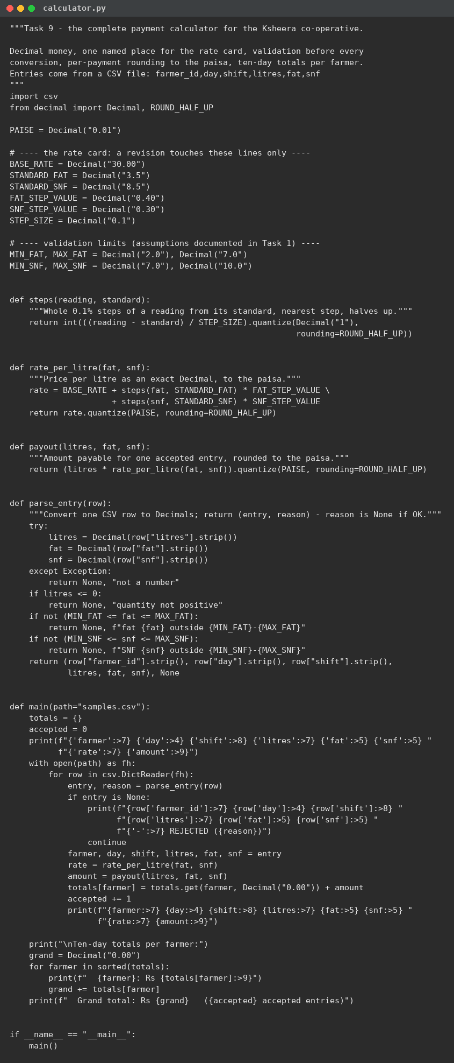
The sample data file (normal, boundary and deliberately invalid entries):
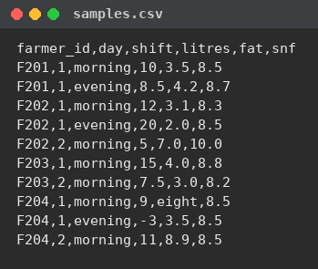
3. Output
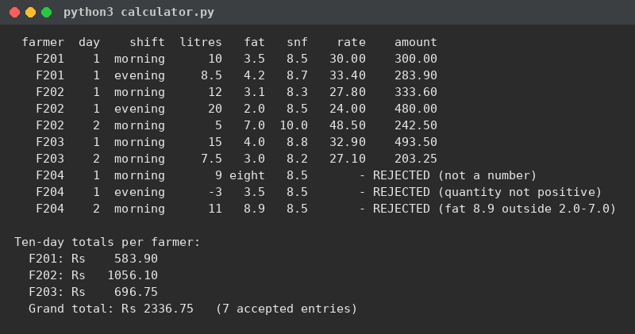
4. Test program and test table (assert-based)
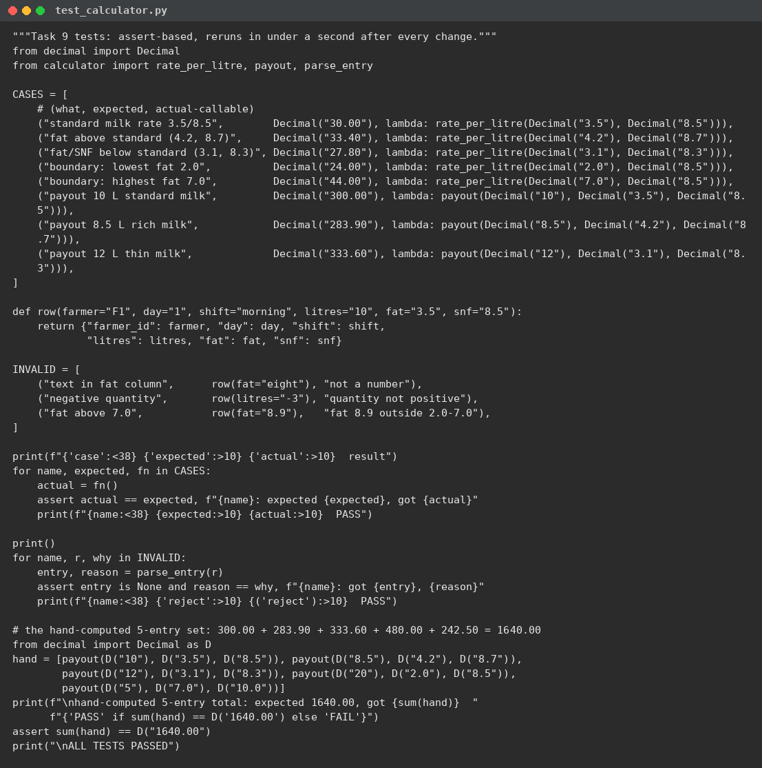
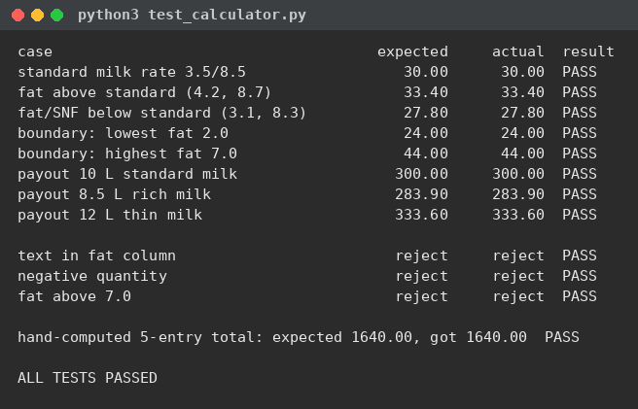
5. Analysis
Normal entries in each direction: fat and SNF above the standard (F203, 15 L at 4.0/8.8 -> 32.90 -> 493.50) and below (F202, 12 L at 3.1/8.3 -> 27.80 -> 333.60). Boundary entries: exactly 3.5/8.5 gives the base 30.00; the lowest allowed fat 2.0 gives 24.00; the highest allowed fat 7.0 gives 44.00 - all accepted, as the limits are inclusive. Invalid entries: text in the fat column, a negative quantity and fat 8.9 are all rejected with reasons, and none touches any total.
The hand-computed set of five: 10 L at 30.00 = 300.00, 8.5 L at 33.40 = 283.90, 12 L at 27.80 = 333.60, 20 L at 24.00 = 480.00, 5 L at 48.50 = 242.50; by hand the total is 1640.00, and the assert in the test program confirms the program agrees - expected and actual match for all 12 cases.
6. Alternative Concept and Complexity Analysis
Testing by typing inputs by hand each time: one careful pass over the 12 cases takes several minutes, cannot be trusted to be identical twice, and is quietly skipped when the deadline is near - so in practice each change is tested on one or two cases, not twelve. The assert function reruns all 12 in under a second after every change, which is what made the Task 12 rework safe. The cost of the test function is O(number of cases) to write once and O(1) effort per rerun; manual testing is O(cases) effort every single time. Manual typing keeps one use: feeling how the clerk-facing messages read.
7. Conclusion
The calculator accepts exactly the entries the rules allow, rejects the three invalid categories with reasons, and matches a hand-computed total to the paisa.
TASK 10 - COMPARE EXPECTATIONS WITH EXECUTION (4 Marks, K4 Analyse)
1. Aim
To measure, not guess: float versus Decimal totals and running time at 300, 6,000 and 150,000 payments, and per-payment rounding versus rounding only the total.
2. Program
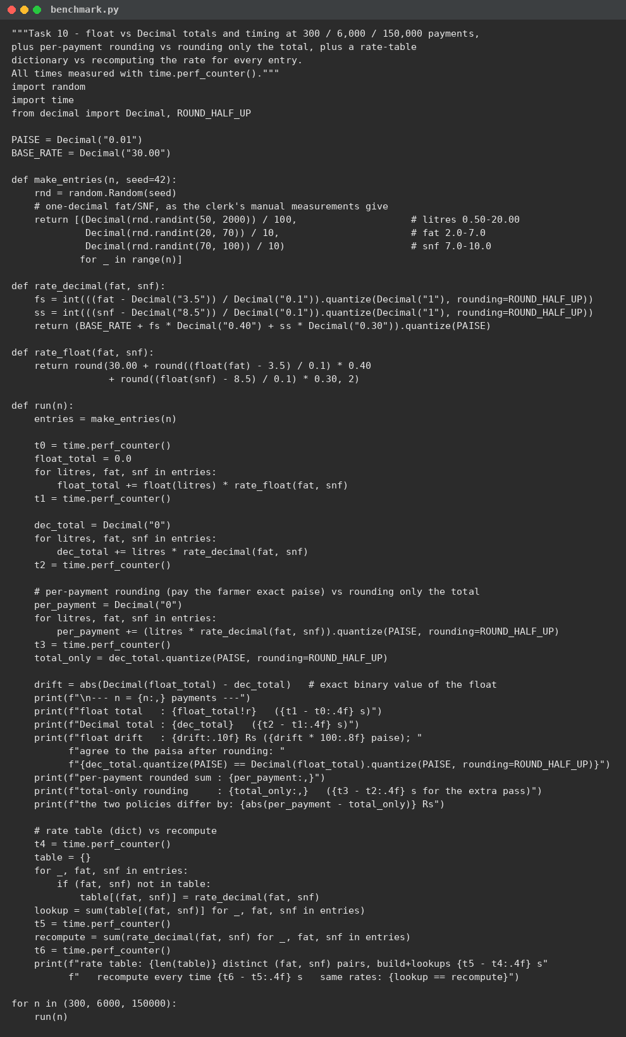
3. Output (time.perf_counter() measurements)
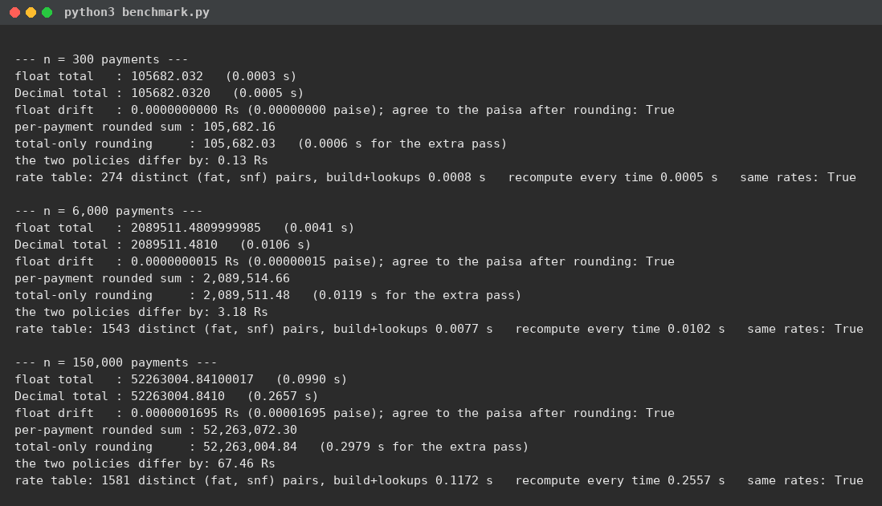
4. Expectation versus observation
Expectation: the float total would drift visibly away from the Decimal total. Observation: the drift was 0, 0.0000000015 and 0.00000017 rupees at 300, 6,000 and 150,000 payments - the two totals agree to the paisa after rounding at every size. The drift grows with n exactly as theory says (each float addition can add a sub-paisa error, and errors accumulate), but at this scale it stays a hundred-thousandth of a paisa. The dramatic float failure of Task 2 (33400.30000000061) does not reappear because rates and litre products carry at most four decimal places; the per-addition error is tiny beside them. So: the totals agree here, and Task 2 shows the shape of data where they would not.
Time: float was about 2.7x faster than Decimal at 150,000 payments (0.099 s against 0.266 s) - and both are instant in human terms. Correctness is free at this scale; there is no speed reason to keep float.
Rounding policy: per-payment rounding versus rounding only the total differ by 0.13, 3.18 and 67.46 rupees across the three sizes - orders of magnitude more than the float drift. The policy decision, not the numeric type, is what moves real money. Per-payment rounding gives the correct bank amount: every payment slip is issued in paise, so the bank statement is the sum of rounded payments, not the rounded sum of exact payments.
5. Alternative Concept and Complexity Analysis
A rate table - compute each (fat, snf) rate once and store it in a dictionary: with one-decimal readings at most 51 x 31 = 1,581 distinct pairs exist, and the run confirms exactly 1,581 were seen at 150,000 payments. Building the table plus 150,000 lookups took 0.117 s against 0.256 s for recomputing every rate - about 2.2x faster. Both are O(1) per entry (a dictionary lookup versus a fixed amount of arithmetic), so the win is a smaller constant, not a better Big-O; the extra space is O(k) for k distinct pairs, trivial here. Worth it at district-union scale, unnecessary at one centre.
6. Conclusion
Measurements replaced three expectations: float and Decimal agree to the paisa on this data, Decimal costs 2.7x time that nobody will ever notice, and the rounding policy - per payment - is the decision that actually keeps the co-operative's books matching the bank.
TASK 11 - RECOMMEND AND DEFEND THE FINAL DESIGN (4 Marks, K5 Evaluate)
1. Aim
To recommend the final design for the co-operative and defend it with the evidence gathered in Tasks 2 to 10.
2. The recommendation
Money as Decimal, built from strings, with per-payment ROUND_HALF_UP rounding to the paisa - Task 2 showed float money failing and Decimal exact; Task 10 showed the per-payment policy is the one that matches the bank. The rate card as named constants in one importable module - Tasks 3 and 7. Validation before conversion with clear rejection reasons - Task 5. Small functions with docstrings behind a __main__ guard - Tasks 6 and 7. An assert-based test script reran after every change - Task 9.
3. How a rate revision will be carried out
Edit the constants at the top of milkrate.py (or the JSON rate card, below), rerun test_calculator.py, commit. One file, one commit, no hunt through expressions - the partial revision that broke the volunteer's calculator is structurally impossible.
4. Limitations of the design
The CSV input still trusts an honest clerk - the program rejects bad numbers, not dishonest ones. There is no database: history lives in files, so backups are the co-operative's job. The half-step rounding rule is a policy choice the union must sign off (Task 12 makes it explicit). And it is a single-machine program - no synchronisation between collection centres.
5. Correctness at district-union scale
The measured 150,000-payment run - 500 times one centre's volume - finished in 0.27 s with exact Decimal totals, and the running-total design uses O(1) extra space. The design is comfortable at district-union scale; if entry volume ever made rate computation the bottleneck, Task 10's rate table halves that too.
6. Alternative Concept and Complexity Analysis
Reading the rate card from a small JSON file at start-up instead of writing it in the module: measured start-up cost 0.056 ms against 0.091 ms for the first module import - both negligible, and both O(size of card) to read and O(1) per lookup afterwards. The operational difference is the revision workflow: with JSON the union emails one small text file and no code changes hands; with module constants every revision edits and redistributes the program. The new failure mode is a missing or malformed file, which start-up validation must catch. For a union now revising rates seasonally (Task 12), the file wins operationally; for a rate card that changes once a year, the module constants win on simplicity.
7. Conclusion
Every piece of the recommendation traces to a measurement in this report - that is what makes it a recommendation rather than an opinion.
TASK 12 - RE-EVALUATE AND ADAPT THE DESIGN (8 Marks, K5 Evaluate)
A. Impact Analysis (2 marks)
Three requirements changed. (1) The automatic analyser sends two-decimal readings (4.25% fat, 8.63% SNF), which makes half steps real: 4.25 is exactly 7.5 steps from 3.5. The old float round() resolves halves by banker's rounding - round(7.5) is 8 but round(2.5) is 2 - an arbitrary, alternating rule no union ever agreed to. Worse, float error can push a half below itself: for fat 4.05 the raw step count is 5.499999999999998, so float round() counts 5 steps while exact decimal arithmetic counts 6 - a 40-paise-per-litre difference from one reading. (2) Seasonal rates change WHICH constants apply: from April to June the base is Rs 32.00 and the fat step Rs 0.45; the SNF step stays Rs 0.30 in both seasons. (3) The bonus is a period-level rule, not an entry-level rule: it needs the farmer's total litres over the ten days, and pays Rs 0.50 on ALL litres only when that total strictly exceeds 500. Affected: the steps() expression, the rate constants, and ten_day_total(). Unaffected: validation, CSV parsing, and the shape of payout() - the decomposition holds.
B. Evaluation of the Original Design (2 marks)
Verdict: RETAIN the structure, MODIFY the arithmetic. The module layout, the function shapes and the test suite carried over unchanged - that is the payoff of the Tasks 3, 6 and 7 decisions. Two things could not stay. First, float round() for step counting: worked examples with the new readings show it silently one step short on 4.05% fat (5 steps instead of 6) and arbitrarily alternating on exact halves (7.5 up but 2.5 down). Second, a single hard-coded rate card cannot express two seasons. Everything else - limits, parsing, per-payment rounding, the tests - survived contact with the new requirements.
C. Adaptation (2 marks) - the revised design, implemented
milkrate2.py keeps the original function shapes and changes only what the impact analysis named: a RATE_CARDS dictionary selected by a season parameter (season_for_month maps April-June to summer), steps() computed in Decimal with ROUND_HALF_UP so halves always count, and a separate bonus_amount() that applies Rs 0.50 per litre to all litres only when the period total strictly exceeds 500.
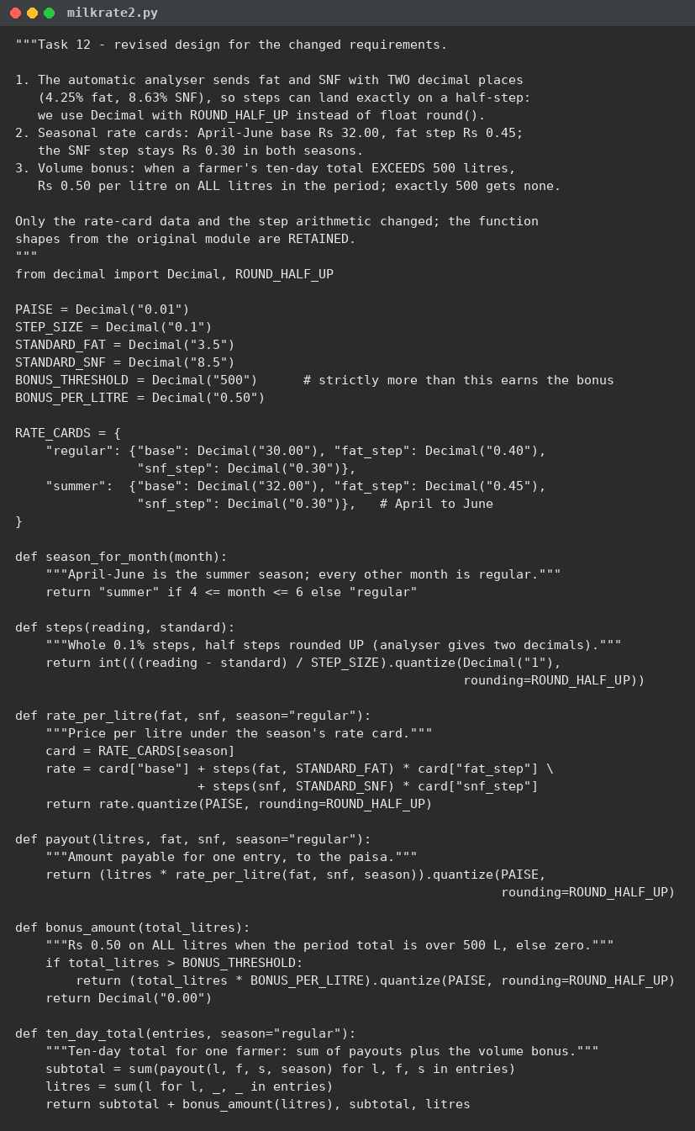
D. Evidence-Based Defence (2 marks)
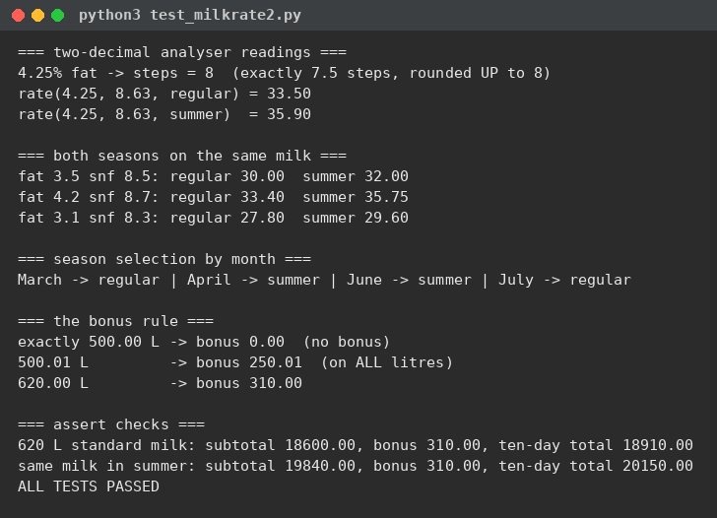
Both seasons on identical milk: 30.00/32.00, 33.40/35.75, 27.80/29.60 - the summer card raises every rate by exactly Rs 2.00 plus Rs 0.05 per fat step, as announced. The season boundary is correct: March regular, April and June summer, July regular. The bonus boundary is exact: 500.00 L earns nothing, 500.01 L earns Rs 250.01 on all litres, 620 L earns Rs 310.00. A full ten-day total works end to end in both seasons: 620 L of standard milk totals Rs 18,910.00 regular and Rs 20,150.00 summer. And the original Task 7 values (33.40 for 4.2/8.7) still pass unchanged - existing payments are not disturbed by the rework.
Trade-offs, honestly: the bonus is a cliff - a farmer at 500.00 L earns nothing while 500.01 L earns Rs 250.01. That is the rule as announced, but the union should know one sip of milk across the line is worth Rs 250; a tapered bonus would remove the cliff at the cost of a harder rule. Passing the season as a parameter keeps one code path for both seasons - a third season is one more dictionary entry - at the price of every call supplying it, which the season_for_month helper keeps simple. ROUND_HALF_UP replaces banker's rounding deliberately: it is the rule a clerk can verify with pen and paper.
E. Test program
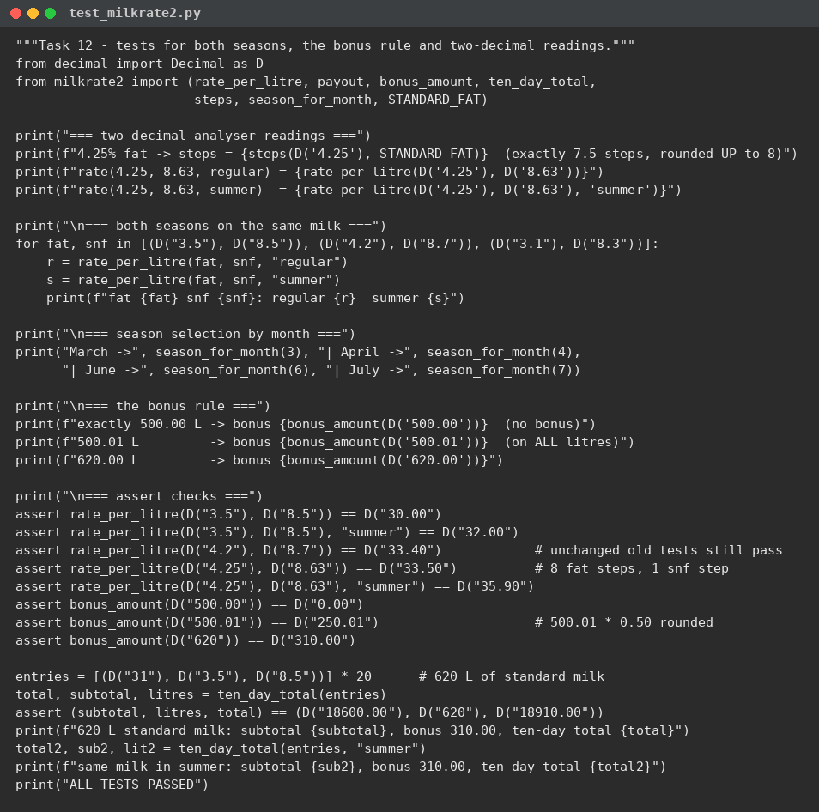
OVERALL CONCLUSION
Tasks 1 to 8 built the understanding, the expressions, the functions and the module; Task 9 proved the calculator against hand-computed totals; Task 10 replaced expectations with measurements - float drift is real but negligible on this data, the rounding policy is the decision that moves money, and a rate table halves the arithmetic cost at scale; Task 11 fixed the final design on that evidence; and Task 12 stress-tested it against the union's new requirements, where only the step arithmetic and the rate-card data had to move. The workflow - analyse, express, organise, verify, measure, recommend, re-evaluate - held end to end, and the Day-4 challenge needed modification, not redesign: the strongest evidence that the original decomposition was right.

