

**Service Contract**

**Service Agreement**

**This Service Agreement** ("Agreement") is made on [10/29/24] by and between:

Company name: **WSWebSolution**

Company Address: gulshan-e-iqbal karachi

Company Contact: admin@wswebsolution.com / 03313345084

**Client Name:** usama

Clint Contact: +92 315 8961803

### **1. Services Provided**

WSWebSolution agrees to provide the following services:

Web Development on wordpress

### **2. Payment Terms**

The Client agrees to pay WSWebSolution:

* **Total Payment:** 6,000
* **Payment Schedule:**
  + 0 upfront at the start of the project
  + 50% upon completion of certain milestones
  + 50% upon final delivery

### **3. Timeline**

* Project start date: 10/31/24
* Estimated completion date: 11/3/24

### **4. Revisions**

* The Client is entitled to 1 revisions during the project. Any additional revisions may incur additional costs.

### **5. Client Responsibilities**

The Client agrees to provide all necessary content, materials, and feedback in a timely manner to avoid delays.

### **6. Confidentiality**

Both parties agree to keep any sensitive information confidential.

### **7. Ownership of Work**

Once full payment has been received, WSWebSolution will transfer the ownership of the final deliverables to the Client.

### **8. Termination**

Either party may terminate this agreement if the other party breaches any of its obligations. Upon termination, the Client will pay WSWebSolution for any completed work.

### **9. Dispute Resolution**

In the event of a dispute, both parties agree to resolve it through negotiation or mediation before pursuing legal action.

### **10. Governing Law**

This Agreement shall be governed by and interpreted in accordance with the laws of Pakistan/Karachi.

**Signature Section**:

WSWebSolution Representative:

Name: Balach Zehri

CEO Signature: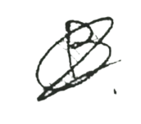

Date: 10/29/24

Clint Name: usama

Clint Signature: 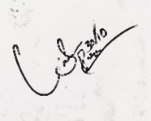

Date of Signature: 30/10/24