NORMALIZATION

Table of Contents
1. Data Redundancy
2. Types of Anomalies
3. What is Normalization?
4. Normalization Forms — Overview
5. First Normal Form (1NF)
6. Second Normal Form (2NF)
7. Third Normal Form (3NF)
8. Boyce-Codd Normal Form (BCNF)
9. Fourth Normal Form (4NF)
10. Fifth Normal Form (5NF)

1. Data Redundancy
• Data redundancy means having the same data stored at multiple places within a database.
• Data redundancy leads to anomalies (errors) in the database.
• It becomes very hard to maintain a database that has redundant data.
Example — Data Redundancy:
NAME | ROLL NO | SECTION
SAI | 21 | A
SAI | 21 | A
SHIVA | 22 | B

Notice that the row for "SAI, 21, A" is repeated — this duplication is an example of data redundancy.

2. Types of Anomalies
Data redundancy causes anomalies. The three types of anomalies are:
• Insertion Anomalies — difficulty inserting data due to missing/dependent information.
• Updation Anomalies — the need to update the same data in multiple places, risking inconsistency if missed.
• Deletion Anomalies — deleting a record unintentionally removes other, unrelated information stored in the same row.

3. What is Normalization?
Normalization is the process of organizing data in a database to reduce data redundancy and improve data integrity.
It involves dividing large tables into smaller ones and defining relationships between them to ensure data consistency.
The main goals of normalization are:
• Eliminate data redundancy (duplicate data).
• Ensure data dependencies are logical.
• Improve data integrity (missing values) and consistency (correctness).

4. Normalization Forms — Overview
Normalization is typically carried out through a series of normal forms (NF), each addressing specific issues:
• First Normal Form (1NF) — Eliminate repeating groups.
• Second Normal Form (2NF) — Eliminate partial dependency.
• Third Normal Form (3NF) — Eliminate transitive dependency.
• Boyce-Codd Normal Form (BCNF) — A stricter version of 3NF.
• Fourth Normal Form (4NF) — Handle multi-valued dependencies.
• Fifth Normal Form (5NF) — Handle join dependencies.

5. First Normal Form (1NF)
• A relation should be in 1NF if it contains only atomic values.
• It states that an attribute of a table cannot hold multiple values.
• 1NF does not allow multi-valued attributes.
Before applying 1NF (multi-valued attribute LANGUAGES_KNOWN):
ROLL NO | NAME | BRANCH | LANGUAGES_KNOWN
101 | SAI | CSE | TELUGU, ENGLISH
102 | SHIVA | AIML | ENGLISH, HINDI
103 | RAJU | DS | ENGLISH, HINDI

After applying 1NF (each value made atomic — one language per row):
ROLL NO | NAME | COURSE | LANGUAGES_KNOWN
101 | SAI | CSE | TELUGU
101 | SAI | CSE | ENGLISH
102 | SHIVA | AIML | ENGLISH
102 | SHIVA | AIML | HINDI
103 | RAJU | DS | ENGLISH
103 | RAJU | DS | HINDI

6. Second Normal Form (2NF)
• The table must already be in 1NF.
• There are no partial dependencies — i.e., no non-prime attribute depends on only part of a composite primary key.
• The primary key should not contain duplicate columns.
Table before applying 2NF (roll no repeats due to multiple languages, a partial dependency on part of the key):
ROLL NO [PK] | NAME | COURSE | LANGUAGES_KNOWN
101 | SAI | CSE | TELUGU
101 | SAI | CSE | ENGLISH
102 | SHIVA | AIML | ENGLISH
102 | SHIVA | AIML | HINDI
103 | RAJU | DS | ENGLISH
103 | RAJU | DS | HINDI

After applying 2NF — split into two related tables:
ROLL NO | NAME | BRANCH
101 | SAI | CSE
102 | SHIVA | AIML
103 | RAJU | DS

ROLL NO | LANGUAGES_KNOWN
101 | TELUGU
101 | ENGLISH
102 | ENGLISH
102 | HINDI
103 | ENGLISH
103 | HINDI

7. Third Normal Form (3NF)
• The table must already be in 2NF.
• There are no transitive dependencies — i.e., no non-prime attribute (N.P.A) depends on another non-prime attribute.
Table before applying 3NF (FEE depends on BRANCH, not directly on ROLL NO — a transitive dependency):
ROLL NO [PK] | NAME | BRANCH [N.P.A] | FEE [N.P.A]
101 | SAI | CSE | 60000
102 | SHIVA | AIML | 75000
103 | RAMESH | DS | 55000
104 | SURESH | ECE | 30000

After applying 3NF — split into two related tables:
ROLL NO [PK] | NAME [N.P.A] | BRANCH [N.P.A]
101 | SAI | CSE
102 | SHIVA | AIML
103 | SURESH | DS
104 | RAMESH | ECE

BRANCH [PK] | FEE [N.P.A]
CSE | 60000
AIML | 75000
DS | 55000
ECE | 35000

8. Boyce-Codd Normal Form (BCNF)
• The table must already be in 3NF.
• Every determinant must be a candidate key — i.e., no non-trivial functional dependency should exist where the determinant is not a superkey.
• In other words: if A depends on B, then B should be a super key.
Table before applying BCNF:
ROLL NO [PK] | NAME | BRANCH_ID | BRANCH NAME
101 | SAI | 121 | CSE
102 | SIVA | 122 | AIML
103 | RAMESH | 123 | DS
104 | SURESH | 121 | CSE

After applying BCNF — split into two related tables:
ROLL NO [PK] | NAME
101 | SAI
102 | SHIVA
103 | RAMESH
104 | SURESH

BRANCH_ID | BRANCH_NAME
121 | CSE
122 | AIML
123 | DS

9. Fourth Normal Form (4NF)
• The table must already be in BCNF.
• It has no multi-valued dependencies — i.e., attributes are independent of each other and depend only on the primary key.
Table before applying 4NF (COURSE and HOBBY are independent multi-valued facts about the same ROLL NO):
ROLL NO [PK] | COURSE [N.P.A] | HOBBY [N.P.A]
101 | CSE | DANCING
102 | AIML | SLEEPING
103 | DS | SINGING

After applying 4NF — split into two independent tables:
ROLL NO [PK] | COURSE [N.P.A]
101 | CSE
102 | AIML
103 | DS

ROLL NO [PK] | HOBBY [N.P.A]
101 | DANCING
102 | SLEEPING
103 | SINGING

10. Fifth Normal Form (5NF)
• The table must already be in 4NF.
• It does not consist of any join dependencies.
• 5NF is satisfied when tables present in the DBMS are broken down into multiple tables to ensure there is no redundancy when they are re-joined.
Table before applying 5NF:
SUBJECT | FACULTY | YEAR
C | SAI | 1
C | SHIVA | 1
JAVA | RAJU | 2
DBMS | RAMESH | 3

After applying 5NF — split into three tables to remove the join dependency:
SUBJECT | FACULTY
C | SAI
C | SHIVA
JAVA | RAJU
DBMS | RAMESH

FACULTY | YEAR
SAI | 1
SHIVA | 1
RAJU | 2
RAMESH | 3

SUBJECT | YEAR
C | 1
JAVA | 2
DBMS | 3

Normalization Practical — 1NF → 2NF → 3NF

Step 0: Unnormalized Table
First create a table containing multiple values in the same column
CREATE TABLE student_details (
student_id INT,
student_name VARCHAR(50),
courses VARCHAR(100),
trainers VARCHAR(100),
trainer_phones VARCHAR(100)
);

INSERT INTO student_details
VALUES
(101, 'Ravi', 'Java, Python', 'Kumar, Ramesh', '9876543210, 9876543211'),
(102, 'Priya', 'Python, SQL', 'Ramesh, Suresh', '9876543211, 9876543212'),
(103, 'Arun', 'Java, SQL', 'Kumar, Suresh', '9876543210, 9876543212');

SELECT * FROM student_details;

Output:
student_id | student_name | courses | trainers | trainer_phones
101 | Ravi | Java, Python | Kumar, Ramesh | 9876543210, 9876543211
102 | Priya | Python, SQL | Ramesh, Suresh | 9876543211, 9876543212
103 | Arun | Java, SQL | Kumar, Suresh | 9876543210, 9876543212

Problem
courses, trainers, and trainer_phones contain multiple values.
So this table is not in 1NF.

Step 1: Convert to 1NF

1NF Rule
Every column should contain a single/atomic value.
Create a new table:
CREATE TABLE student_course_1nf (
student_id INT,
student_name VARCHAR(50),
course VARCHAR(30),
trainer VARCHAR(50),
trainer_phone VARCHAR(15)
);

INSERT INTO student_course_1nf
VALUES
(101, 'Ravi', 'Java', 'Kumar', '9876543210'),
(101, 'Ravi', 'Python', 'Ramesh', '9876543211'),
(102, 'Priya', 'Python', 'Ramesh', '9876543211'),
(102, 'Priya', 'SQL', 'Suresh', '9876543212'),
(103, 'Arun', 'Java', 'Kumar', '9876543210'),
(103, 'Arun', 'SQL', 'Suresh', '9876543212');

SELECT * FROM student_course_1nf;

Output:
student_id | student_name | course | trainer | trainer_phone
101 | Ravi | Java | Kumar | 9876543210
101 | Ravi | Python | Ramesh | 9876543211
102 | Priya | Python | Ramesh | 9876543211
102 | Priya | SQL | Suresh | 9876543212
103 | Arun | Java | Kumar | 9876543210
103 | Arun | SQL | Suresh | 9876543212
Now every cell contains a single value.
✅ Table is in 1NF.

Step 2: Convert 1NF to 2NF
Now we identify the primary key.
A student can attend multiple courses.
ALTER TABLE student_course_1nf ADD PRIMARY KEY (student_id, course);

CREATE TABLE student_2nf (
student_id INT PRIMARY KEY,
student_name VARCHAR(50)
);

INSERT INTO student_2nf
VALUES
(101, 'Ravi'),
(102, 'Priya'),
(103, 'Arun');

CREATE TABLE enrollment_2nf (
student_id INT,
course VARCHAR(30),
trainer VARCHAR(50),
trainer_phone VARCHAR(15),
PRIMARY KEY (student_id, course),
FOREIGN KEY (student_id) REFERENCES student_2nf(student_id)
);

INSERT INTO enrollment_2nf
VALUES
(101, 'Java', 'Kumar', '9876543210'),
(101, 'Python', 'Ramesh', '9876543211'),
(102, 'Python', 'Ramesh', '9876543211'),
(102, 'SQL', 'Suresh', '9876543212'),
(103, 'Java', 'Kumar', '9876543210'),
(103, 'SQL', 'Suresh', '9876543212');

Now we have:

STUDENT
student_id | student_name
101 | Ravi
102 | Priya
103 | Arun

ENROLLMENT
student_id | course | trainer | trainer_phone
101 | Java | Kumar | 9876543210
101 | Python | Ramesh | 9876543211
102 | Python | Ramesh | 9876543211
102 | SQL | Suresh | 9876543212
103 | Java | Kumar | 9876543210
103 | SQL | Suresh | 9876543212
The student_name partial dependency has been removed.
✅ Tables are now in 2NF.

Step 3: Convert 2NF to 3NF
Now look at the enrollment_2nf table:

student_id
course
trainer
trainer_phone
We can identify another dependency:
trainer → trainer_phone
For example:
Kumar → 9876543210
Ramesh → 9876543211
Suresh → 9876543212
But:
student_id + course → trainer
trainer → trainer_phone
Therefore:
student_id + course → trainer → trainer_phone
This is a transitive dependency.
To achieve 3NF, we remove this dependency.

Create TRAINER table
CREATE TABLE trainer_3nf (
trainer_id INT PRIMARY KEY,
trainer_name VARCHAR(50),
trainer_phone VARCHAR(15)
);
Insert:
INSERT INTO trainer_3nf
VALUES
(1, 'Kumar', '9876543210'),
(2, 'Ramesh', '9876543211'),
(3, 'Suresh', '9876543212');


Create COURSE table
CREATE TABLE course_3nf (
course_id INT PRIMARY KEY,
course_name VARCHAR(30),
trainer_id INT,
FOREIGN KEY (trainer_id) REFERENCES trainer_3nf(trainer_id)
);
Insert:
INSERT INTO course_3nf
VALUES
(1, 'Java', 1),
(2, 'Python', 2),
(3, 'SQL', 3);


Create ENROLLMENT table
Now instead of storing trainer details here, we store IDs.
CREATE TABLE enrollment_3nf (
student_id INT,
course_id INT,
PRIMARY KEY (student_id, course_id),
FOREIGN KEY (student_id) REFERENCES student_2nf(student_id),
FOREIGN KEY (course_id) REFERENCES course_3nf(course_id)
);
Insert:
INSERT INTO enrollment_3nf
VALUES
(101, 1),
(101, 2),
(102, 2),
(102, 3),
(103, 1),
(103, 3);


Final 3NF Structure
Now we have four tables:

STUDENT
STUDENT
---------------------
student_id PK
student_name

COURSE
COURSE
---------------------
course_id PK
course_name
trainer_id FK

TRAINER
TRAINER
---------------------
trainer_id PK
trainer_name
trainer_phone

ENROLLMENT
ENROLLMENT
---------------------
student_id PK, FK
course_id PK, FK
The relationship is:
STUDENT
|
| student_id
|
ENROLLMENT
|
| course_id
|
COURSE
|
| trainer_id
|
TRAINER


ENTITY-RELATIONSHIP (ER) MODEL

Table of Contents
1. The Entity-Relationship (ER) Model
2. Entity
3. Attributes
4. Entity and Attributes — Combined Example
5. Relationships
6. One-to-One (1:1) Relationship
7. One-to-Many (1:M) Relationship
8. Many-to-Many (M:N) Relationship
9. Cardinality
10. Practice Question

1. The Entity-Relationship (ER) Model
The Entity-Relationship (ER) Model is a conceptual framework used to describe data relationships in a structured way.
Components of the ER Model:
• Entities
• Attributes
• Relationships
• Cardinality

2. Entity
An entity represents a real-world object or concept that has a unique existence.
Entities are classified into:
• Strong Entities — exist independently (e.g., Customer, Student, Book).
• Weak Entities — depend on other entities for existence (e.g., Order_Item depends on Order).
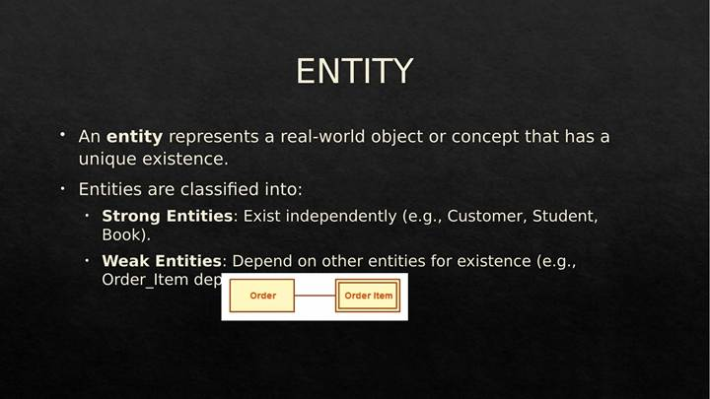
Diagram: Strong Entity vs. Weak Entity (Slide 3)

3. Attributes
Attributes describe properties or characteristics of an entity.
Types of Attributes:
• Simple (Atomic) Attributes — cannot be divided further (e.g., Name, Age).
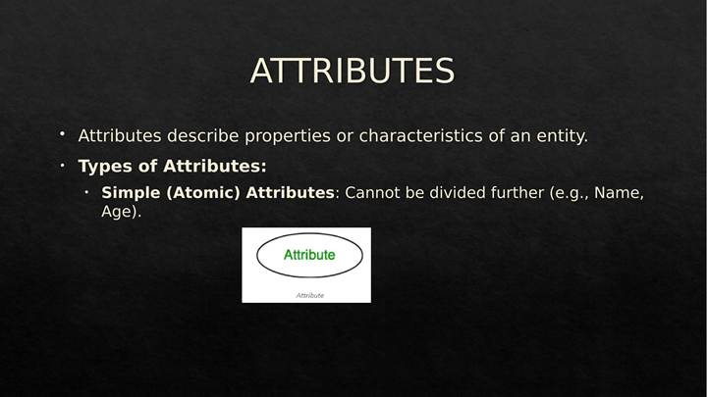
Diagram: Simple (Atomic) Attribute (Slide 4)
• Composite Attribute — can be broken down into sub-attributes (e.g., Address → Street, City, Zip).
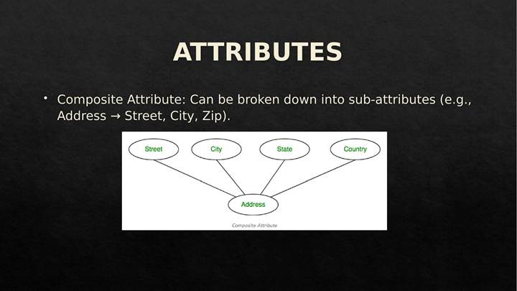
Diagram: Composite Attribute (Slide 5)
• Key Attribute — uniquely identifies an entity (Primary Key).
• Multivalued Attributes — can have multiple values (e.g., Phone Numbers).
• Derived Attributes — calculated from other attributes (e.g., Age from Date of Birth).
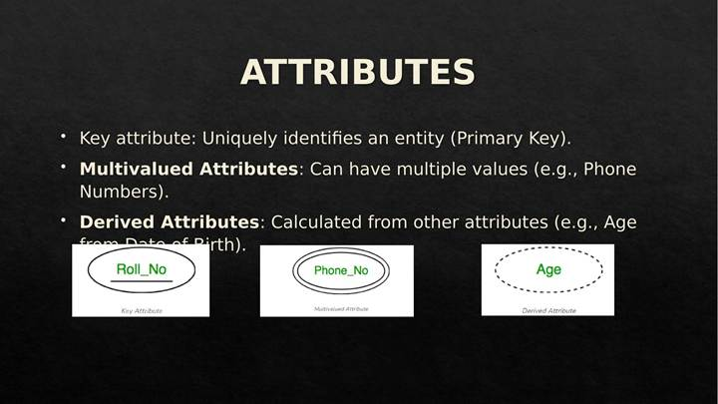
Diagram: Key, Multivalued, and Derived Attributes (Slide 6)

4. Entity and Attributes — Combined Example
The diagram below brings together an entity with its full set of attribute types in a single ER diagram.
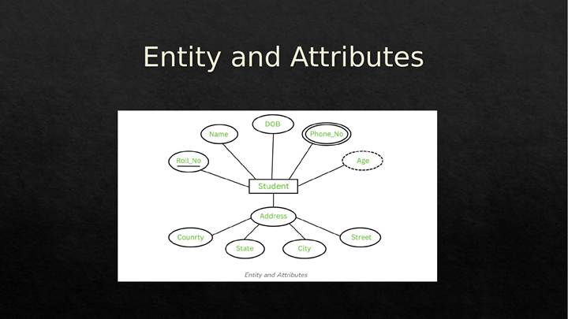
Diagram: Entity with Attributes (Slide 7)

5. Relationships
A relationship represents an association between two or more entities.
Types of Relationships:
• One-to-One (1:1)
• One-to-Many (1:M)
• Many-to-Many (M:N)

6. One-to-One (1:1) Relationship
One-to-One (1:1) → Each entity in A is related to one entity in B.
Example: COUNTRY – PRESIDENT.
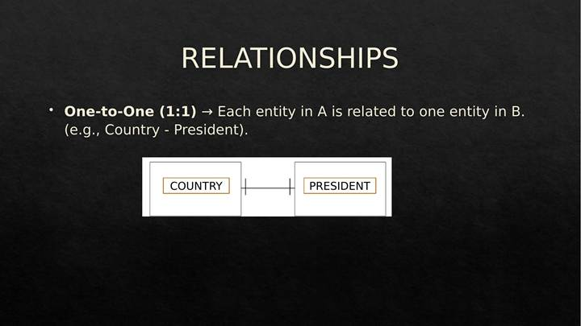
Diagram: One-to-One Relationship — Country and President (Slide 9)

7. One-to-Many (1:M) Relationship
One-to-Many (1:M) → One entity in A can relate to multiple entities in B.
Example: TEACHER – STUDENTS.
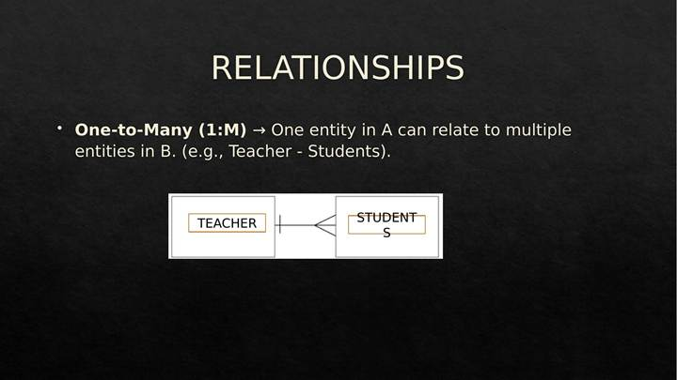
Diagram: One-to-Many Relationship — Teacher and Students (Slide 10)

8. Many-to-Many (M:N) Relationship
Many-to-Many (M:N) → Multiple entities in A relate to multiple entities in B.
Example: STUDENTS – COURSES.
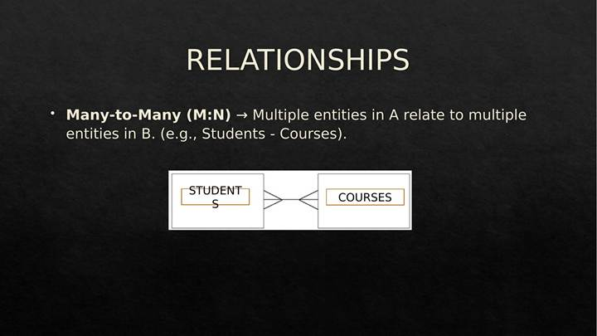
Diagram: Many-to-Many Relationship — Students and Courses (Slide 11)

9. Cardinality
Cardinality defines the number of instances of an entity involved in a relationship.
Types:
• 1:1 (One-to-One)
• 1:M (One-to-Many)
• M:N (Many-to-Many)

10. Practice Question
Generate an ER Diagram based on the scenario below:
• Patient details will be provided with values: ID [PK], Name, Age, and Visit Date.
• Test Reports will be provided with values: Name [PK], Date, and Result.
• A Patient will visit a Doctor, where Doctor has values: ID [PK], Name, and Specialization.

MySQL Learning Scenario: The "Kitab
Ghar" Bookstore
This document contains a complete MySQL learning scenario based on an Indian online bookstore context. It includes 6 tables, DDL/DML scripts, and 3 levels of practice questions.
