WEEK 1 TASK
Data Acquisition, Cleaning, and Preprocessing
Dataset: Laptop Price Dataset
File analyzed: laptopData.csv

Field | Details
Dataset size | 1303 rows × 12 columns
Final cleaned size | 1244 rows × 19 columns
Programming language | Python
Main libraries | Pandas, NumPy, Matplotlib
Task focus | Acquisition, exploration, cleaning, outlier analysis, preprocessing
Prepared as a detailed Week 1 data-quality report.

1. Executive Summary
This report documents the acquisition, exploration, cleaning, and preprocessing of a public laptop-price dataset. The supplied CSV contains laptop specifications such as company, laptop type, screen size, display resolution, CPU, RAM, storage, GPU, operating system, weight, and price. The objective was to convert the raw dataset into a consistent and analysis-ready form while preserving valid observations.
The raw file contains 1303 records and 12 columns. Thirty records contain missing values. These incomplete records were removed because the missingness affects the complete specification row and the dataset is sufficiently large to retain 1273 complete records. After that step, 29 exact duplicate rows were removed. One clearly erroneous weight value (0.0002 kg) was identified and replaced with the median valid weight (2.04 kg). The resulting working dataset contains 1244 records.

2. Dataset Acquisition and Source
The CSV used for this report is the laptopData.csv-style dataset containing 1,303 laptop records. The same dataset structure and record count are documented in publicly available analyses of the “Uncleaned Laptop Price Dataset” on Kaggle. A public reference identifies the dataset as “Uncleaned Laptop Price Dataset” and reports the same 1,303 × 12 structure.
Public reference: Kaggle dataset: Uncleaned Laptop Price Dataset (Ehtisham Sadiq).
Reference used for verification: https://www.kaggle.com/datasets/ehtishamsadiq/uncleaned-laptop-price-dataset

2.1 Data Collection Method
- The dataset was obtained as a CSV file and loaded locally using Pandas.
- The file was inspected before any transformation so that the original structure could be documented.
- All cleaning operations were performed through reproducible Python code rather than manual spreadsheet editing.
import pandas as pd
df = pd.read_csv("laptopData .csv")
print(df.shape)
print(df.head())
print(df.info())

3. Initial Data Exploration
Initial exploration is important because preprocessing decisions should be based on evidence from the raw data. The dataset contains 12 columns. Ten are stored as text/object values and two are numeric in the raw file. Several fields contain units or multiple attributes embedded in strings, which makes direct numerical analysis difficult.
print(df.head())
print(df.shape)
print(df.info())
print(df.describe(include="all"))

3.1 Dataset Structure
Column | Raw Type | Meaning
Company | Categorical | Laptop manufacturer
TypeName | Categorical | Laptop type
Inches | Text in raw data | Screen size
ScreenResolution | Categorical/text | Resolution and display features
Cpu | Categorical/text | Processor details
Ram | Text in raw data | RAM capacity with GB unit
Memory | Categorical/text | Storage configuration
Gpu | Categorical/text | Graphics processor
OpSys | Categorical | Operating system
Weight | Text in raw data | Weight with kg unit
Price | Numeric | Laptop price

3.2 Missing-Value Analysis
Column | Missing Values | Missing %
Unnamed: 0 | 30 | 2.30%
Company | 30 | 2.30%
TypeName | 30 | 2.30%
Inches | 30 | 2.30%
ScreenResolution | 30 | 2.30%
Cpu | 30 | 2.30%
Ram | 30 | 2.30%
Memory | 30 | 2.30%
Gpu | 30 | 2.30%
OpSys | 30 | 2.30%
Weight | 30 | 2.30%
Price | 30 | 2.30%
The missing-value pattern is row-wise: the 30 incomplete records contain missing values across the dataset fields. Because these rows do not provide complete laptop specifications, removing the incomplete records is preferable to inventing values for manufacturer, CPU, GPU, operating system, or price.
missing = df.isna().sum()
missing_percent = df.isna().mean() * 100
print(pd.concat([missing, missing_percent], axis=1))

3.3 Duplicate Analysis
The raw dataset contains 29 exact duplicate records. Exact duplicates do not add independent information and can bias frequency counts or statistical summaries, so they were removed after missing rows were handled.
duplicate_count = df.duplicated().sum()
df = df.drop_duplicates()
print("Duplicates removed:", duplicate_count)

4. Data Cleaning Procedures

4.1 Removing the Unnamed Index Column
The column named “Unnamed: 0” is an exported row index rather than a meaningful laptop attribute. It was removed to avoid treating an artificial identifier as an analytical feature.
df = df.drop(columns=["Unnamed: 0"])

4.2 Handling Missing Records
df = df.dropna()
This operation reduced the dataset from 1303 rows to 1273 complete rows. For this task, deletion was chosen over imputation because the missing rows do not contain enough information to reliably reconstruct complete laptop specifications.

4.3 Removing Duplicate Records

df = df.drop_duplicates()
After duplicate removal, the dataset contained 1244 records before feature extraction. This step prevents repeated records from receiving unintended additional weight in later analysis.

4.4 Correcting Data Types and Removing Units

Several columns contain numeric information embedded inside strings. RAM is represented like “8GB”, weight like “1.37kg”, and CPU clock speed is embedded in processor descriptions. These fields were converted into numeric features so that mathematical analysis and machine-learning algorithms can use them.
df["Inches"] = pd.to_numeric(df["Inches"], errors="coerce")
df["Ram_GB"] = df["Ram"].str.extract(r"(\d+(?:\.\d+)?)")[0].astype(float)
df["Weight_kg"] = df["Weight"].str.extract(
r"(\d+(?:\.\d+)?)"
)[0].astype(float)
df["CPU_GHz"] = df["Cpu"].str.extract(
r"(\d+(?:\.\d+)?)GHz"
)[0].astype(float)

4.5 Erroneous Entry Detection and Correction

After parsing the weight field, one record produced a weight of 0.0002 kg. This is not a plausible laptop weight and was treated as an erroneous entry rather than a legitimate outlier. The median valid weight (2.04 kg) was used as a conservative replacement because the objective was to preserve the record while avoiding an impossible value.
invalid_weight = df["Weight_kg"] < 0.5
median_weight = df.loc[~invalid_weight, "Weight_kg"].median()
df.loc[invalid_weight, "Weight_kg"] = median_weight

5. Outlier Detection and Treatment
Outliers were investigated using the Interquartile Range (IQR) rule. A value below Q1 − 1.5×IQR or above Q3 + 1.5×IQR is flagged for inspection. An IQR flag is not automatically an error: laptop prices, RAM capacities, and weights can legitimately vary substantially.
Q1 = df[column].quantile(0.25)
Q3 = df[column].quantile(0.75)
IQR = Q3 - Q1
lower = Q1 - 1.5 * IQR
upper = Q3 + 1.5 * IQR
outliers = df[(df[column] < lower) | (df[column] > upper)]
Variable | Q1 | Q3 | IQR | Lower Bound | Upper Bound | IQR Flags
Price | 32655.45 | 79813.44 | 47157.99 | -38081.55 | 150550.43 | 28
Inches | 14.00 | 15.60 | 1.60 | 11.60 | 18.00 | 43
Ram_GB | 4.00 | 8.00 | 4.00 | -2.00 | 14.00 | 215
Weight_kg | 1.50 | 2.33 | 0.83 | 0.25 | 3.58 | 54
CPU_GHz | 2.00 | 2.70 | 0.70 | 0.95 | 3.75 | 2
The IQR procedure flagged several high-RAM and high-price records. These were retained because values such as 16 GB, 32 GB, 64 GB RAM and premium laptop prices can be legitimate. The same principle applies to heavy laptop models. Therefore, the report distinguishes statistical outliers from erroneous data entries instead of deleting all observations beyond the IQR limits.
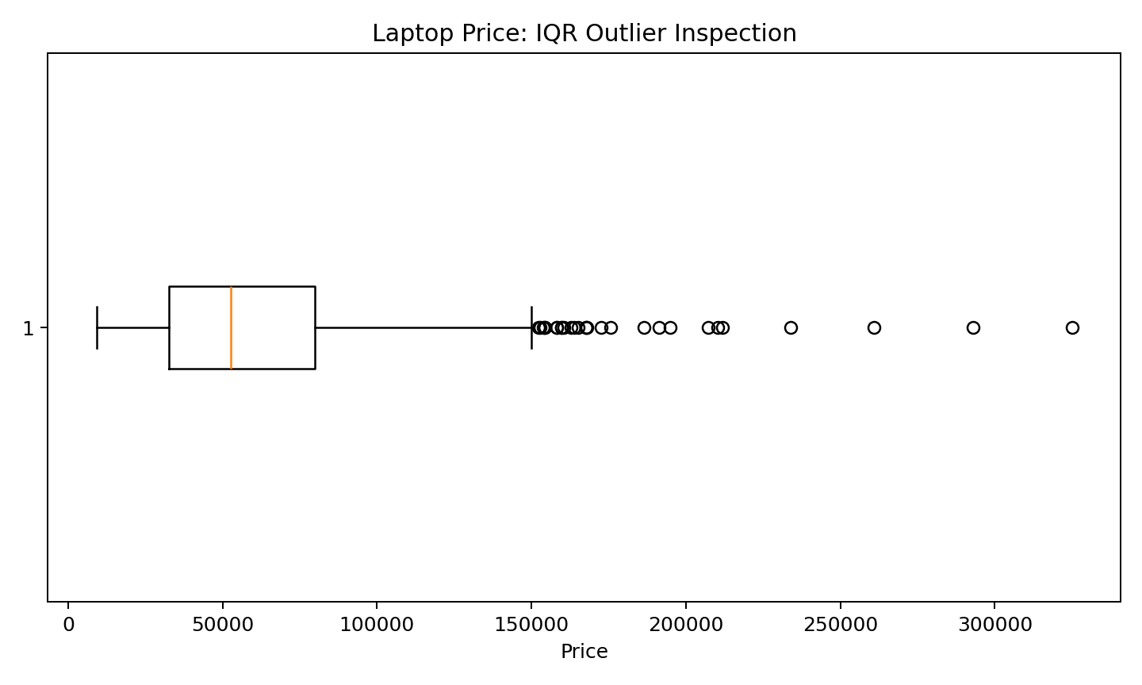
Figure 1. Boxplot used to inspect the distribution of laptop prices and potential IQR outliers.

6. Data Preprocessing and Feature Engineering

6.1 Screen Resolution Features
The ScreenResolution field contains both resolution dimensions and display properties such as IPS and touchscreen. Two numeric resolution features and two binary indicators were extracted.
resolution = df["ScreenResolution"].str.extract(r"(\d{3,5})x(\d{3,5})")
df["ScreenWidth_px"] = pd.to_numeric(resolution[0], errors="coerce")
df["ScreenHeight_px"] = pd.to_numeric(resolution[1], errors="coerce")
df["Touchscreen"] = df["ScreenResolution"].str.contains(
"Touchscreen", case=False, na=False
).astype(int)
df["IPS"] = df["ScreenResolution"].str.contains(
"IPS", case=False, na=False
).astype(int)

6.2 CPU and GPU Brand Extraction
df["CPU_Brand"] = df["Cpu"].str.split().str[0]
df["GPU_Brand"] = df["Gpu"].str.split().str[0]
Extracting brands creates simpler categorical variables for future analysis. More advanced work could further split CPU/GPU model, generation, clock speed, storage type, and storage capacity.

6.3 Categorical Encoding for Machine Learning
Categorical variables such as Company, TypeName, OpSys, CPU_Brand, and GPU_Brand cannot be supplied directly to most numerical machine-learning algorithms. One-hot encoding is an appropriate next-stage transformation.
categorical_cols = [
"Company", "TypeName", "OpSys", "CPU_Brand", "GPU_Brand"
]
encoded = pd.get_dummies(
df,
columns=categorical_cols,
drop_first=True
)

6.4 Numerical Scaling
If a later model is sensitive to feature magnitude, numerical variables such as RAM, screen size, weight, CPU speed, and price can be standardized. Scaling was not applied blindly in the cleaning stage because some tree-based models do not require it and price may be the prediction target.
from sklearn.preprocessing import StandardScaler
num_cols = ["Inches", "Ram_GB", "Weight_kg", "CPU_GHz"]
scaler = StandardScaler()
df[num_cols] = scaler.fit_transform(df[num_cols])

7. Before-and-After Quality Summary

Metric | Raw | After Basic Cleaning | Final Working Data
Rows | 1303 | 1273 | 1244
Columns | 12 | 11 | 19
Missing rows | 30 | 0 | 0
Exact duplicates | 29 | 29 | 0
Clearly erroneous weight values | 1 identified after parsing | 1 corrected | 0 remaining

7.1 Final Numeric Summary

Variable | Count | Mean | Std | Min | 25% | Median | 75% | Max
Price | 1244.0 | 60606.22 | 37424.64 | 9270.72 | 32655.45 | 52693.92 | 79813.44 | 324954.72
Inches | 1243.0 | 15.14 | 1.97 | 10.1 | 14.0 | 15.6 | 15.6 | 35.6
Ram_GB | 1244.0 | 8.53 | 5.59 | 1.0 | 4.0 | 8.0 | 8.0 | 64.0
Weight_kg | 1243.0 | 2.08 | 0.81 | 0.69 | 1.5 | 2.04 | 2.33 | 11.1
CPU_GHz | 1244.0 | 2.3 | 0.5 | 0.9 | 2.0 | 2.5 | 2.7 | 3.6

8. Visual Evidence and Exploratory Outputs
The following figures provide evidence that the dataset was inspected visually as well as numerically.
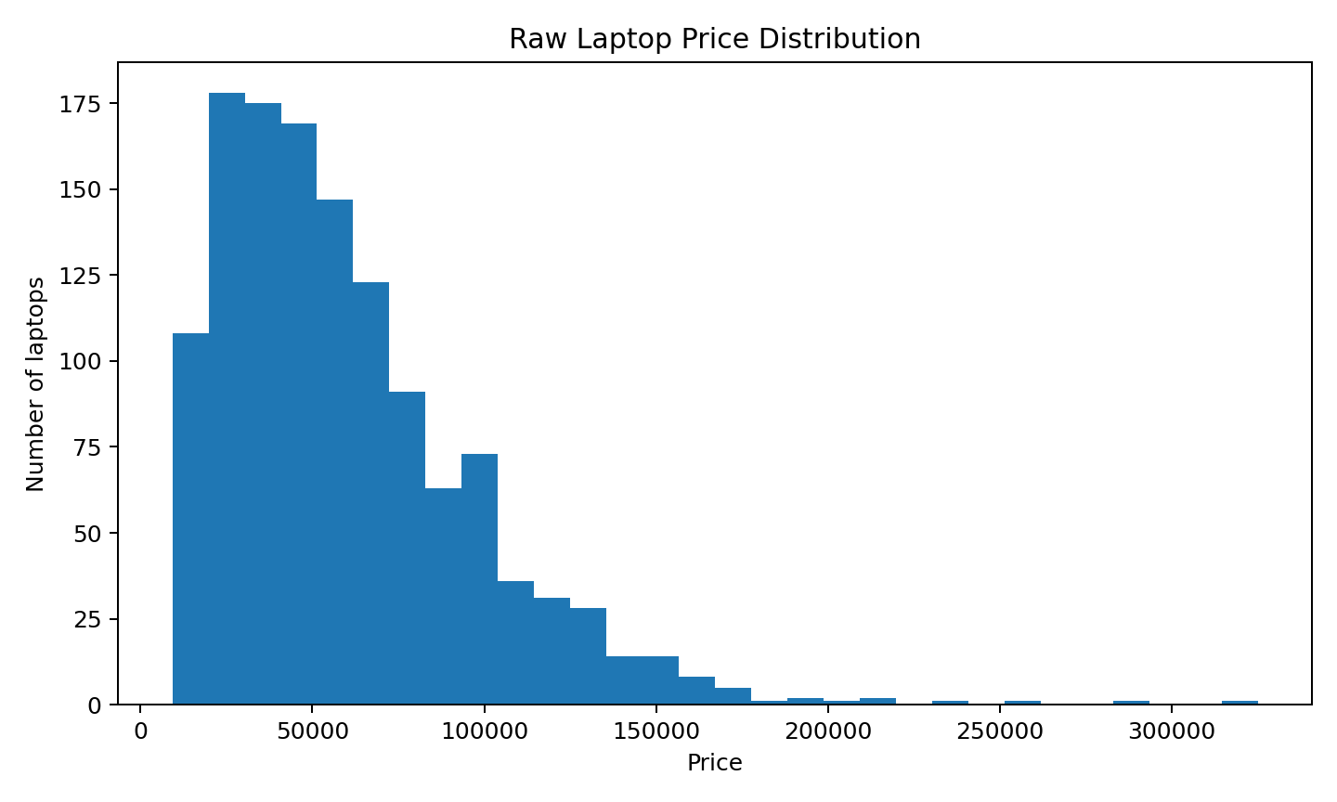
Figure 2. Raw price distribution.
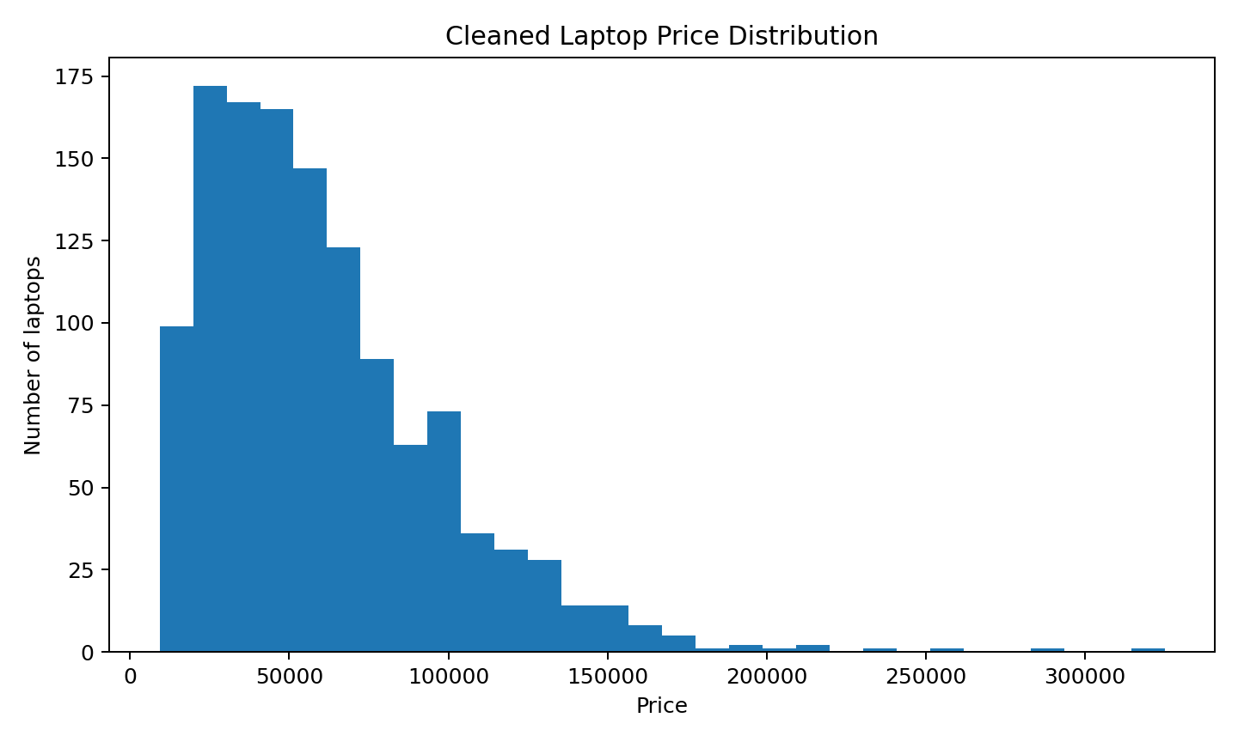
Figure 3. Cleaned price distribution.
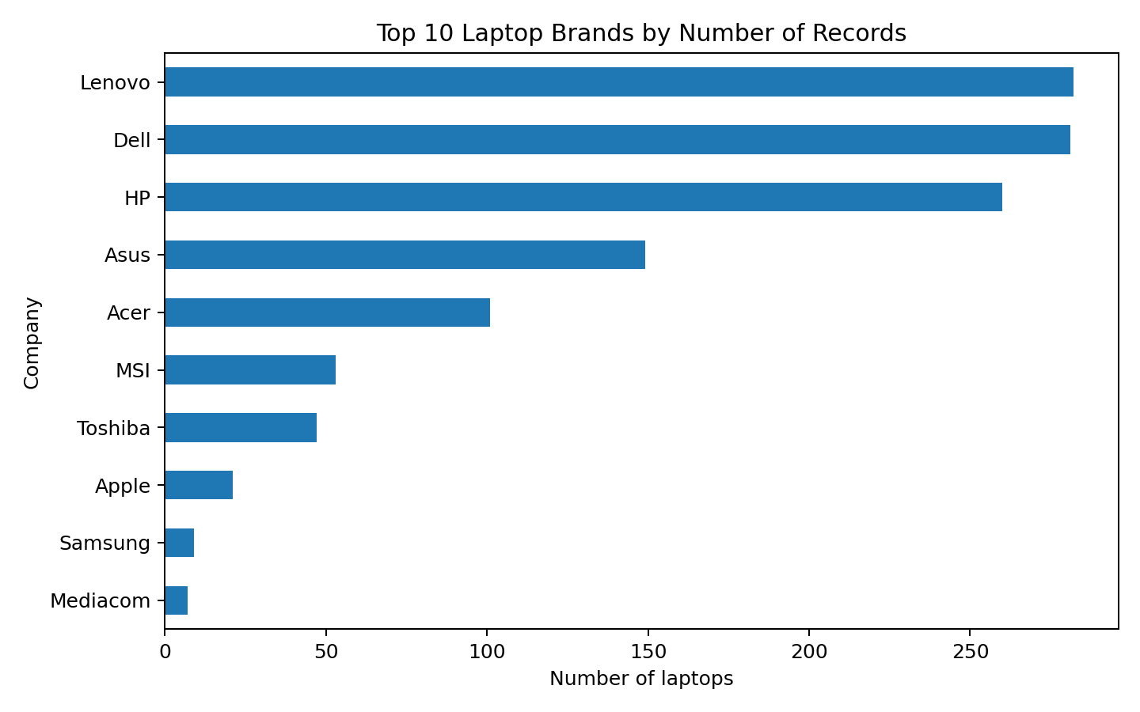
Figure 4. Ten most frequently represented laptop brands.
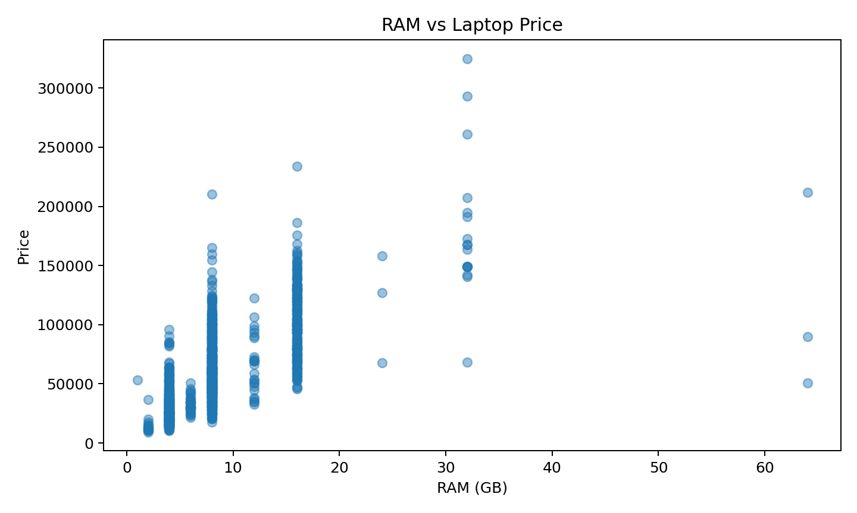
Figure 5. Relationship between RAM capacity and price.

9. Challenges Faced and Solutions

Challenge | Evidence | Solution
Missing records | 30 rows contained missing values | Removed incomplete rows because complete specifications could not be reconstructed reliably.
Duplicate records | 29 exact duplicates after missing-row removal | Removed exact duplicates using drop_duplicates().
Mixed data types | RAM, weight and screen size were stored as text | Extracted numeric values and converted them to numeric types.
Embedded features | Resolution, touchscreen and IPS information were combined in one field | Extracted resolution dimensions and binary feature indicators.
Erroneous value | 0.0002 kg was physically implausible | Replaced it with the median of valid weights.
Statistical outliers | IQR flagged high RAM, price and weight observations | Inspected them rather than deleting valid high-end laptops automatically.

10. Potential Impact of Preprocessing on Future Analysis
- Removing incomplete rows improves consistency but reduces the sample size. If missingness is systematic, deletion could introduce bias.
- Removing exact duplicates prevents repeated observations from artificially increasing brand frequencies and summary statistics.
- Converting RAM, weight, screen size, and CPU speed to numeric variables enables correlation, regression, visualization, and machine-learning operations.
- Retaining legitimate high-end laptops prevents the model from losing important information about the premium segment.
- Replacing the clearly impossible 0.0002 kg value prevents a single erroneous measurement from distorting weight-based analysis.
- Feature extraction from screen resolution creates more interpretable variables and makes display characteristics easier to analyze.
- One-hot encoding increases the number of columns but makes categorical information usable by numerical algorithms.

11. Complete Reproducible Cleaning Code
import pandas as pd
import numpy as np
# Load data
df = pd.read_csv("laptopData (1).csv")
# Remove exported index column
df = df.drop(columns=["Unnamed: 0"])
# Handle missing records
df = df.dropna()
# Remove exact duplicates
df = df.drop_duplicates()
# Convert numeric text fields
df["Inches"] = pd.to_numeric(df["Inches"], errors="coerce")
df["Ram_GB"] = df["Ram"].str.extract(r"(\d+(?:\.\d+)?)")[0].astype(float)
df["Weight_kg"] = df["Weight"].str.extract(r"(\d+(?:\.\d+)?)")[0].astype(float)
df["CPU_GHz"] = df["Cpu"].str.extract(r"(\d+(?:\.\d+)?)GHz")[0].astype(float)
# Correct clearly erroneous weight
invalid_weight = df["Weight_kg"] < 0.5
median_weight = df.loc[~invalid_weight, "Weight_kg"].median()
df.loc[invalid_weight, "Weight_kg"] = median_weight
# Extract screen resolution
resolution = df["ScreenResolution"].str.extract(r"(\d{3,5})x(\d{3,5})")
df["ScreenWidth_px"] = pd.to_numeric(resolution[0], errors="coerce")
df["ScreenHeight_px"] = pd.to_numeric(resolution[1], errors="coerce")
# Extract display features
df["Touchscreen"] = df["ScreenResolution"].str.contains(
"Touchscreen", case=False, na=False
).astype(int)
df["IPS"] = df["ScreenResolution"].str.contains(
"IPS", case=False, na=False
).astype(int)
# Extract CPU/GPU brands
df["CPU_Brand"] = df["Cpu"].str.split().str[0]
df["GPU_Brand"] = df["Gpu"].str.split().str[0]
# Save cleaned data
df.to_csv("laptop_cleaned_week1.csv", index=False)
print("Final shape:", df.shape)
print("Remaining missing values:")
print(df.isna().sum())

12. Conclusion

The Week 1 data-quality process transformed the supplied laptop dataset from 1303 raw records into 1244 cleaner, analysis-ready records. The process addressed missing values, exact duplicates, inconsistent numeric formats, an implausible weight entry, and embedded information within text fields. Outliers were treated carefully: statistical unusualness was not automatically equated with data error. This is especially important for laptop data because premium products naturally have higher prices and larger memory capacities.
The resulting dataset is suitable for further exploratory data analysis and can serve as the foundation for a future laptop-price prediction project. Additional preprocessing may be required depending on the selected machine-learning algorithm, especially categorical encoding, feature selection, and train/test splitting.

13. References

- Ehtisham Sadiq. Uncleaned Laptop Price Dataset, Kaggle. https://www.kaggle.com/datasets/ehtishamsadiq/uncleaned-laptop-price-dataset
- Pandas documentation: DataFrame data loading, missing-value handling and duplicate removal.
- NumPy documentation: Numerical operations in Python.
- Matplotlib documentation: Data visualization in Python.

Appendix A – Sample Raw Records

Unnamed: 0 | Company | TypeName | Inches | Screen Resolution | CPU | RAM | Memory | GPU | OpSys | Weight | Price
0.0 | Apple | Ultrabook | 13.3 | IPS Panel Retina Display 2560x1600 | Intel Core i5 2.3GHz | 8GB | 128GB SSD | Intel Iris Plus Graphics 640 | macOS | 1.37kg | 71378.6832
1.0 | Apple | Ultrabook | 13.3 | 1440x900 | Intel Core i5 1.8GHz | 8GB | 128GB Flash Storage | Intel HD Graphics 6000 | macOS | 1.34kg | 47895.5232
2.0 | HP | Notebook | 15.6 | Full HD 1920x1080 | Intel Core i5 7200U 2.5GHz | 8GB | 256GB SSD | Intel HD Graphics 620 | No OS | 1.86kg | 30636.0
3.0 | Apple | Ultrabook | 15.4 | IPS Panel Retina Display 2880x1800 | Intel Core i7 2.7GHz | 16GB | 512GB SSD | AMD Radeon Pro 455 | macOS | 1.83kg | 135195.336
4.0 | Apple | Ultrabook | 13.3 | IPS Panel Retina Display 2560x1600 | Intel Core i5 3.1GHz | 8GB | 256GB SSD | Intel Iris Plus Graphics 650 | macOS | 1.37kg | 96095.808
5.0 | Acer | Notebook | 15.6 | 1366x768 | AMD A9-Series 9420 3GHz | 4GB | 500GB HDD | AMD Radeon R5 | Windows 10 | 2.1kg | 21312.0
6.0 | Apple | Ultrabook | 15.4 | IPS Panel Retina Display 2880x1800 | Intel Core i7 2.2GHz | 16GB | 256GB Flash Storage | Intel Iris Pro Graphics | Mac OS X | 2.04kg | 114017.6016
7.0 | Apple | Ultrabook | 13.3 | 1440x900 | Intel Core i5 1.8GHz | 8GB | 256GB Flash Storage | Intel HD Graphics 6000 | macOS | 1.34kg | 61735.536

Appendix B – Sample Cleaned Records

Company | TypeName | Inches | Ram_GB | Weight_kg | CPU_GHz | Touchscreen | IPS | Price
Apple | Ultrabook | 13.3 | 8.0 | 1.37 | 2.3 | 0 | 1 | 71378.68
Apple | Ultrabook | 13.3 | 8.0 | 1.34 | 1.8 | 0 | 0 | 47895.52
HP | Notebook | 15.6 | 8.0 | 1.86 | 2.5 | 0 | 0 | 30636.0
Apple | Ultrabook | 15.4 | 16.0 | 1.83 | 2.7 | 0 | 1 | 135195.34
Apple | Ultrabook | 13.3 | 8.0 | 1.37 | 3.1 | 0 | 1 | 96095.81
Acer | Notebook | 15.6 | 4.0 | 2.1 | 3.0 | 0 | 0 | 21312.0
Apple | Ultrabook | 15.4 | 16.0 | 2.04 | 2.2 | 0 | 1 | 114017.6
Apple | Ultrabook | 13.3 | 8.0 | 1.34 | 1.8 | 0 | 0 | 61735.54

