WEEK 2 TASK
Exploratory Data Analysis and Visualization
Laptop Price Dataset
Continuation of Week 1 Data Acquisition, Cleaning and Preprocessing

1. Executive Summary
This report presents a detailed exploratory data analysis of the cleaned laptop dataset produced in Week 1. The analysis contains 1,244 records and <docx.text.paragraph.Paragraph object at 0x7f283b60c0e0> variables covering laptop manufacturer, type, display, processor, RAM, storage, graphics, operating system, weight and price. The purpose of this stage is to identify distributions, relationships, differences between groups and patterns that can guide future statistical or machine-learning work.
Laptop prices range from approximately 9,271 to 324,955. The mean price is 60,606, while the median is 52,694. The higher mean indicates that relatively expensive laptops influence the upper tail. The analysis also finds a positive RAM-price relationship (r = 0.68), whereas screen size has a weaker relationship with price (r = 0.04). Category and brand comparisons show additional differences.
To address the feedback from the previous submission, this report includes visual evidence for every major analysis section. Each figure has a title, labelled axes and a written interpretation. The discussion also explains why observed patterns may exist and avoids treating correlation as proof of causation.

2. Objective
- Summarize the cleaned dataset using descriptive statistics.
- Identify dominant brands, laptop types, operating systems and CPU brands.
- Explore relationships between specifications and laptop price.
- Compare price distributions across laptop categories and brands.
- Use correlation analysis to identify important numerical relationships.
- Interpret findings critically and document limitations.

3. Dataset and Source
The analysis uses the cleaned laptop dataset created during Week 1. The Week 1 report documents the public source as the Kaggle 'Uncleaned Laptop Price Dataset' by Ehtisham Sadiq. The present report uses the locally cleaned CSV so that Week 2 is directly reproducible from the Week 1 preprocessing output.
Dataset used: laptop_cleaned_week1.csv | Records: 1,244 | Variables: <docx.text.paragraph.Paragraph object at 0x7f283b60c0e0>

4. Tools and Libraries
Python was used with Pandas, NumPy, Matplotlib and Seaborn. Pandas handled data loading and aggregation; Matplotlib and Seaborn support statistical visualization.
import pandas as pd
import numpy as np
import matplotlib.pyplot as plt
import seaborn as sns
df = pd.read_csv("../data/cleaned/laptop_cleaned_week1.csv")

5. Initial Exploratory Analysis
print(df.shape)
print(df.head())
print(df.info())
print(df.describe())
print(df.isnull().sum())
The cleaned file contains 1,244 observations. Week 1 converted several text-based fields into analysis-ready numerical features, including RAM in GB, weight in kilograms, CPU clock speed, and screen dimensions. These engineered fields make statistical comparisons possible without changing the underlying laptop records.

6. Descriptive Statistics
Variable | Mean | Median | Std. Dev. | Minimum | Maximum
Price | 60,606.22 | 52,693.92 | 37,424.64 | 9,270.72 | 324,954.72
Inches | 15.14 | 15.60 | 1.97 | 10.10 | 35.60
Ram_GB | 8.53 | 8.00 | 5.59 | 1.00 | 64.00
Weight_kg | 2.08 | 2.04 | 0.81 | 0.69 | 11.10
CPU_GHz | 2.30 | 2.50 | 0.50 | 0.90 | 3.60
The descriptive statistics show substantial variation in laptop configurations. Price is particularly dispersed, so median and distribution-based summaries are important alongside the mean. The same principle applies to weight and CPU characteristics, where different laptop categories naturally occupy different ranges.

7. Univariate Analysis

7.1 Brand Distribution
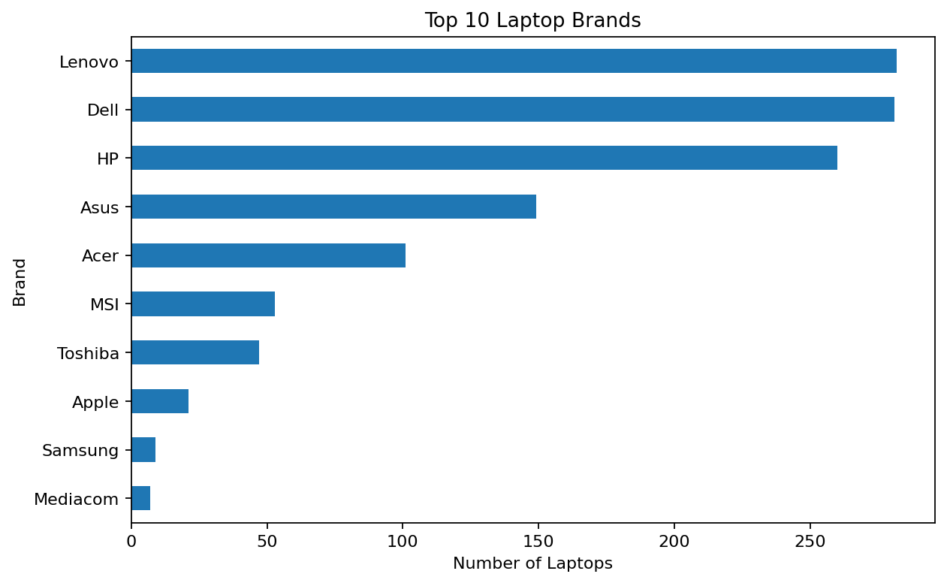
Figure 1. Top 10 laptop brands by number of records.
Lenovo is the most represented manufacturer with 282 records. The unequal counts mean this dataset should not be interpreted as a direct estimate of real-world market share. Instead, the chart describes the composition of the available sample.

7.2 Price Distribution
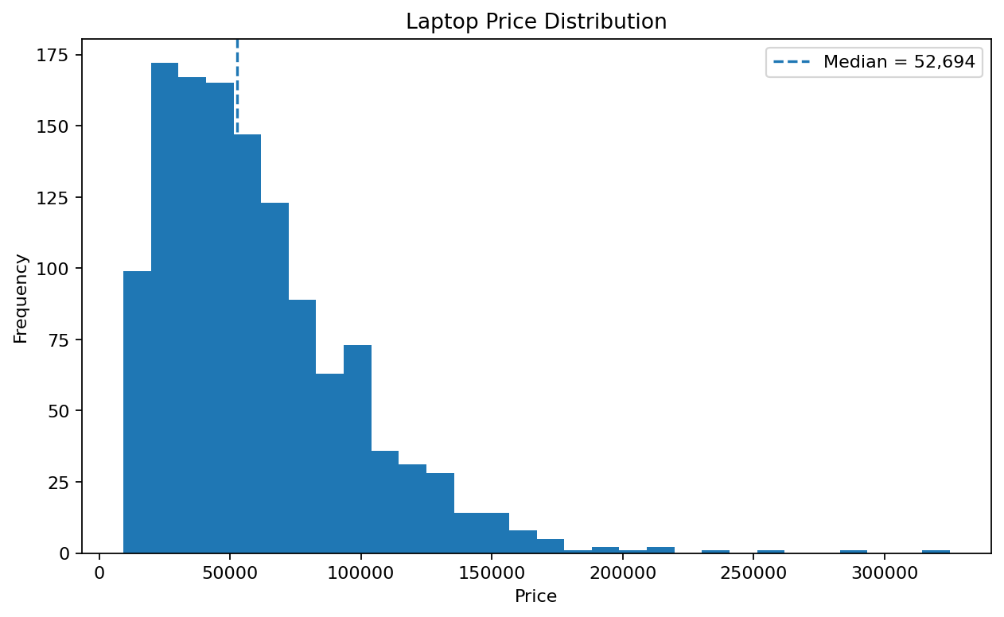
Figure 2. Laptop price distribution with the median indicated.
The distribution extends from 9,271 to 324,955. The median (52,694) is below the mean (60,606), indicating that high-priced observations pull the mean upward. Premium and workstation laptops are likely contributors to this upper tail. For future modelling, a log transformation of price could be investigated.

7.3 Laptop Type Distribution
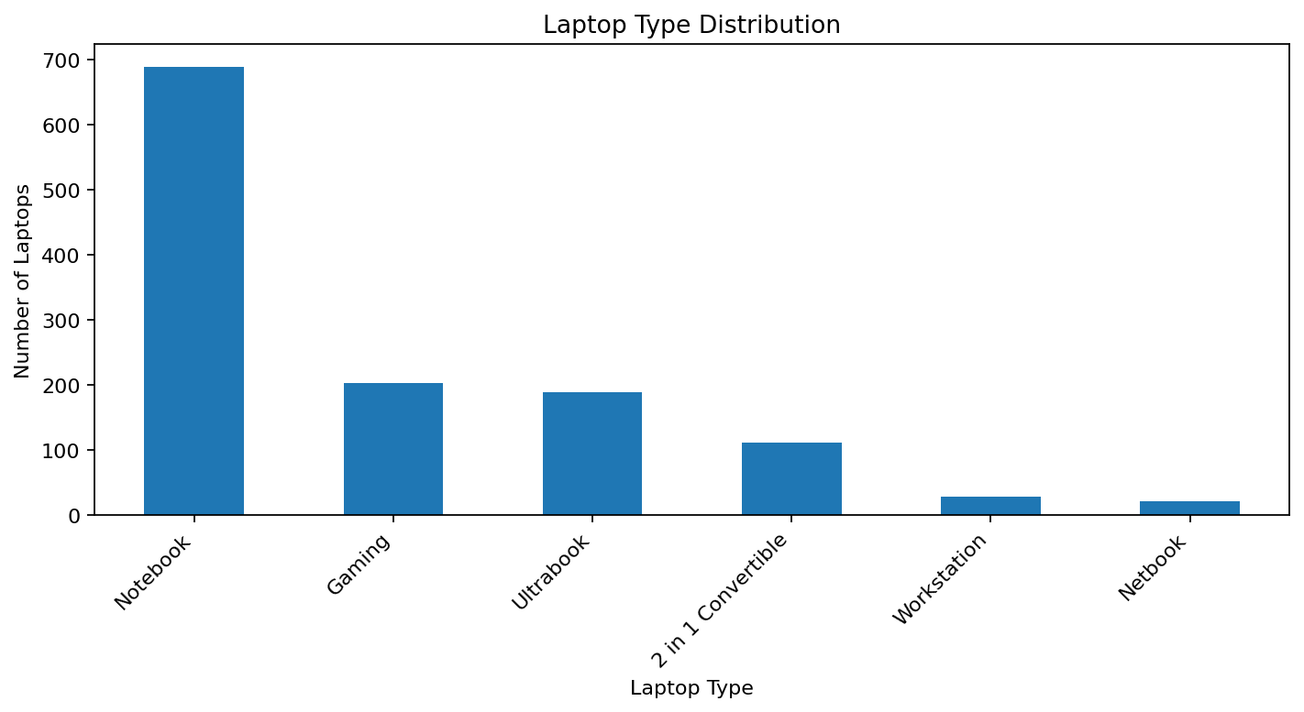
Figure 3. Distribution of laptop types.
Notebook is the dominant category with 689 records. The category imbalance matters because group comparisons based on very small categories may be less stable than comparisons within well-represented categories.

7.4 Operating System Distribution
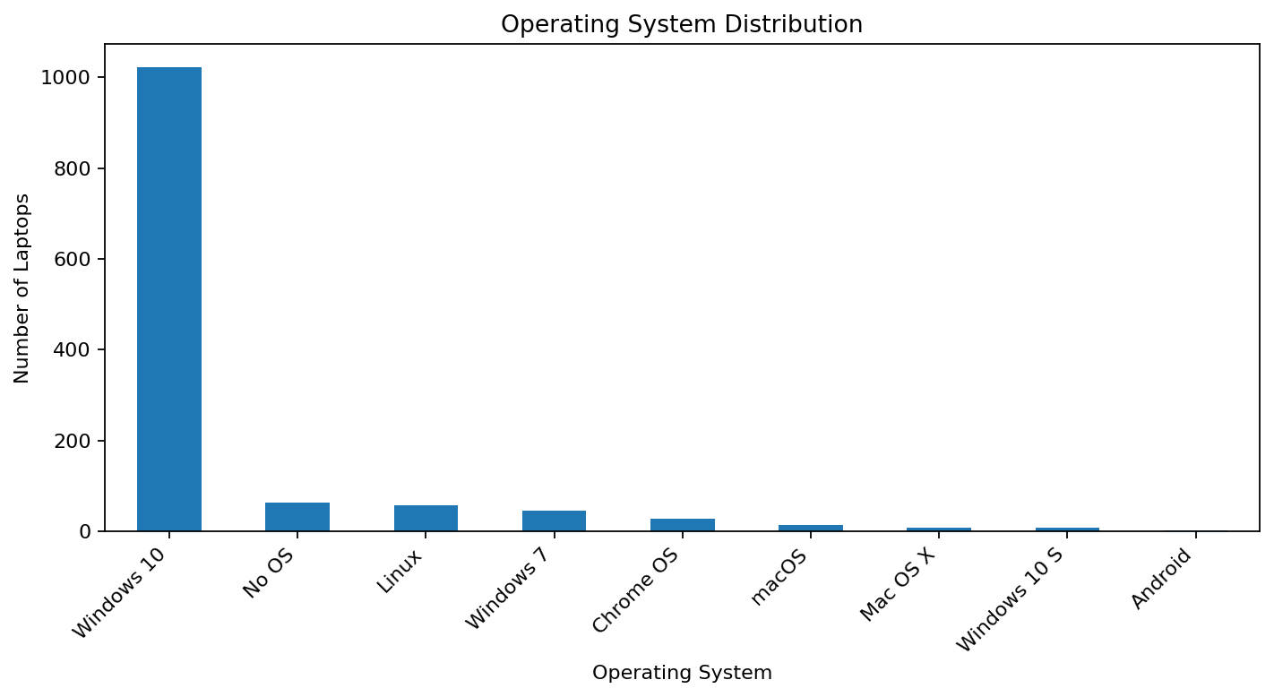
Figure 4. Operating system distribution.
Windows 10 is the most common operating system with 1,022 observations. The strong concentration of one OS means that rare OS categories should be interpreted cautiously.

8. Bivariate Analysis

8.1 RAM and Price
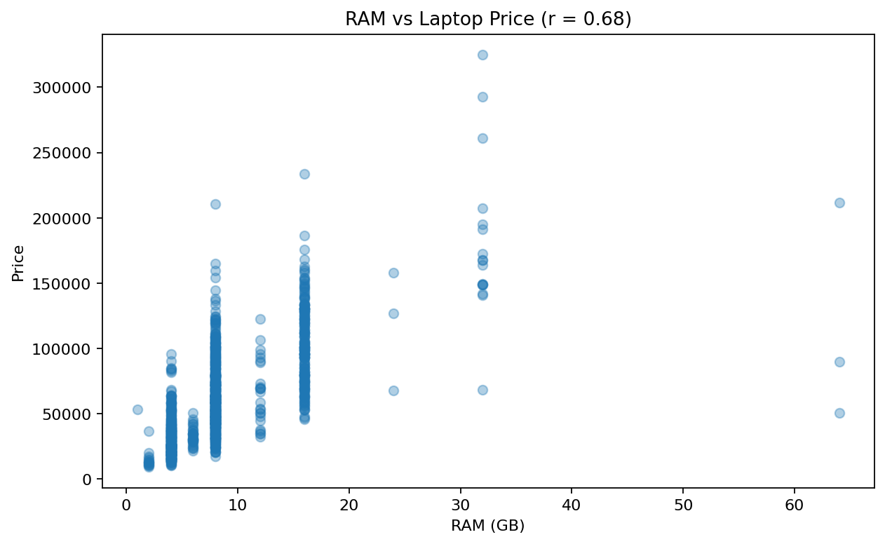
Figure 5. RAM versus laptop price (Pearson correlation = 0.68).
RAM has a positive correlation with price of 0.68. This means that higher-RAM configurations tend to be associated with higher prices. However, the broad vertical spread shows that RAM is not sufficient to explain price. CPU, GPU, storage, brand and laptop type can all contribute to the observed price.
df[["Ram_GB", "Price"]].corr()

8.2 Screen Size and Price
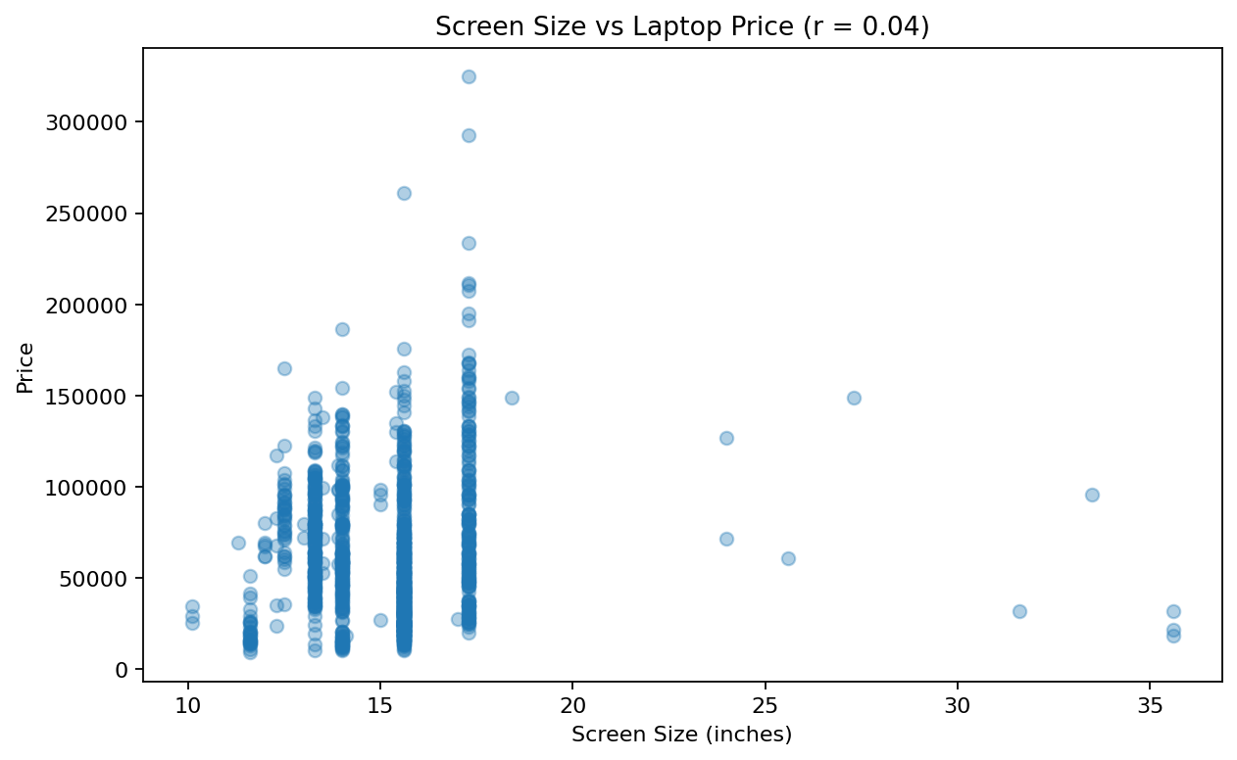
Figure 6. Screen size versus laptop price (Pearson correlation = 0.04).
Screen size has a correlation of 0.04 with price, which is weaker than the RAM relationship. This indicates that screen size alone provides limited information about price. A large screen can occur in both budget-oriented notebooks and premium machines.

8.3 Price by Laptop Type
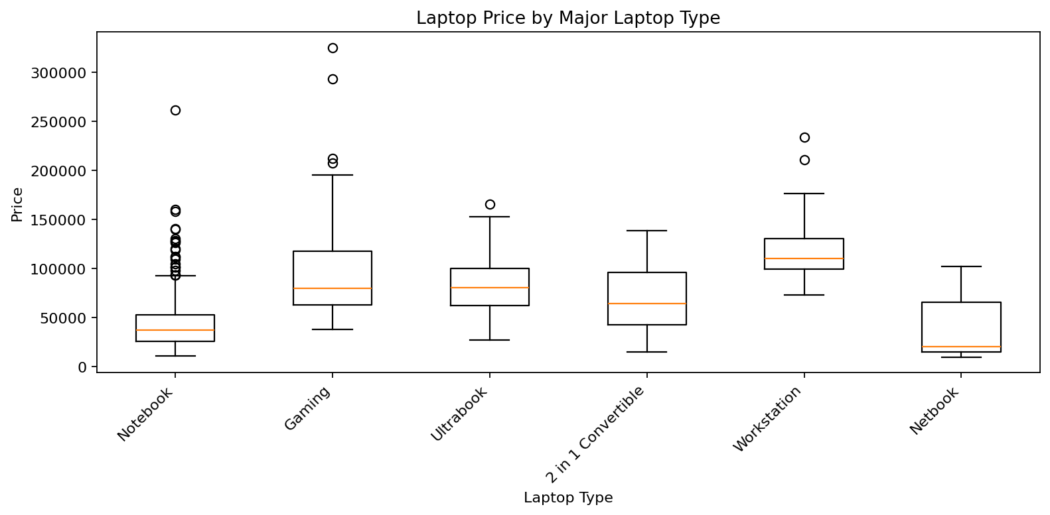
Figure 7. Price distributions for the major laptop types.
The box plot shows that price distributions vary substantially by laptop type. Gaming and workstation products can occupy higher price ranges because they are commonly configured with stronger processors, dedicated GPUs, higher RAM or specialized hardware. The within-category spread also demonstrates that category alone cannot explain all price variation.

8.4 Average Price by Brand
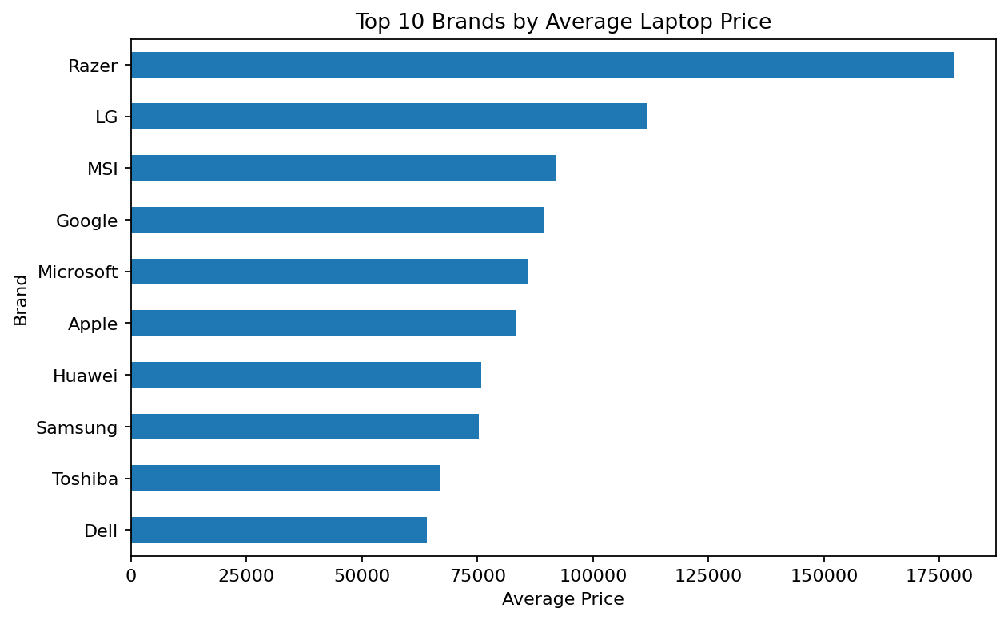
Figure 8. Top 10 brands by average laptop price.
Razer has the highest average price among the represented brands at approximately 178,282. This should not be interpreted as a universal brand-pricing effect. Average price depends heavily on the product mix represented in the dataset; a manufacturer with many premium products will naturally have a higher average.
avg_price_by_brand = (
df.groupby("Company")["Price"]
.mean()
.sort_values(ascending=False)
)
avg_price_by_brand.head(10)

9. Additional Feature Analysis

9.1 CPU Brand Distribution
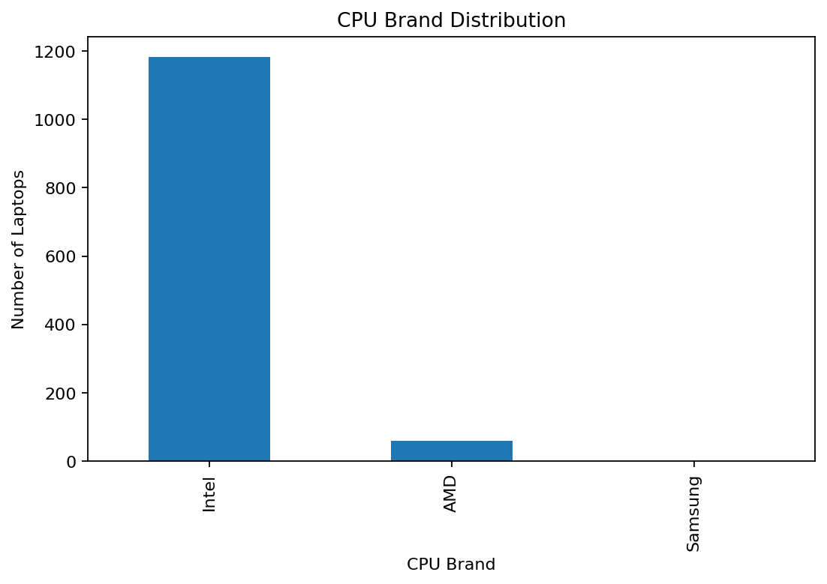
Figure 9. CPU brand distribution.
Intel is the dominant CPU brand in the dataset. The imbalance indicates that comparisons involving less common CPU brands may be affected by small sample sizes.

9.2 Correlation Analysis
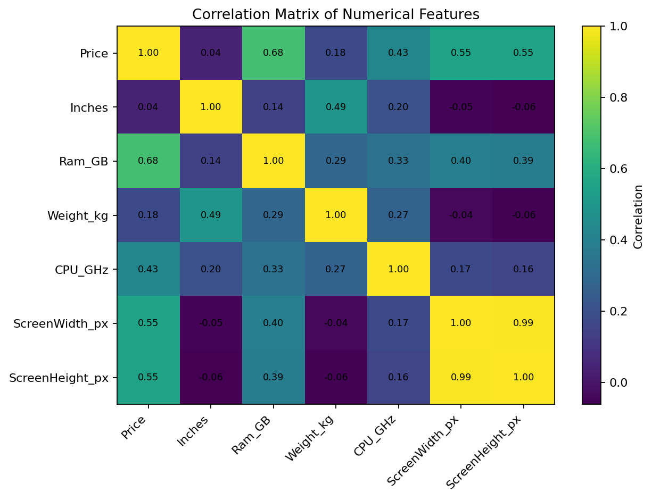
Figure 10. Correlation matrix of numerical laptop features.
The correlation matrix shows that RAM has a positive association with price (0.68), while screen size has a weaker relationship (0.04). Correlation is useful for identifying candidate relationships, but it does not prove causation and only measures linear association.
numeric_cols = [
"Price","Inches","Ram_GB","Weight_kg",
"CPU_GHz","ScreenWidth_px","ScreenHeight_px"
]
corr = df[numeric_cols].corr()
sns.heatmap(corr, annot=True, cmap="coolwarm", fmt=".2f")
plt.title("Correlation Matrix")
plt.show()

9.3 Touchscreen and Price
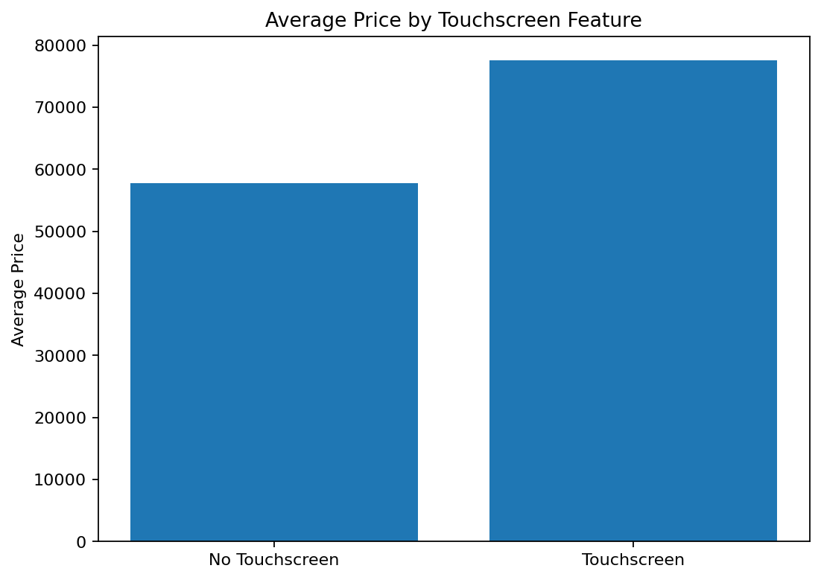
Figure 11. Average laptop price by touchscreen availability.
Touchscreen laptops have an average price of approximately 77,504, compared with 57,729 for non-touchscreen laptops. This difference may reflect the fact that touchscreen functionality is often combined with convertible designs and premium displays. It does not establish that the touchscreen feature itself causes the price difference.

9.4 IPS Display and Price
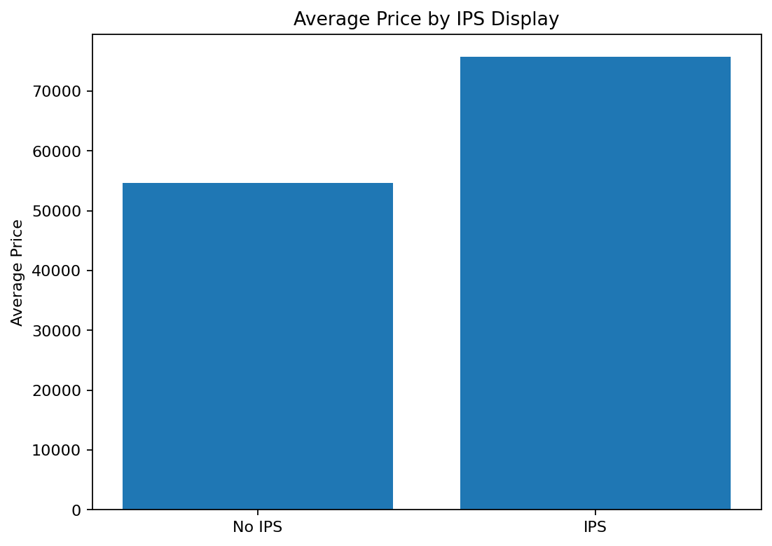
Figure 12. Average laptop price by IPS display availability.
IPS-equipped laptops have an average price of approximately 75,700, compared with 54,673 for laptops without the IPS flag. The difference may be associated with product positioning and display quality, but other specifications are likely contributing factors.

10. Data Transformations and Aggregations
The Week 2 analysis mainly uses grouping and aggregation rather than modifying the cleaned observations.
- value_counts() summarizes categorical distributions.
- groupby().mean() compares average price between brands and feature groups.
- groupby().agg() provides count, mean and median for laptop types.
- corr() quantifies linear relationships among numerical variables.
- Scatter plots, bar charts and box plots expose patterns that are difficult to see from tables alone.
df["Company"].value_counts()
df.groupby("Company")["Price"].mean().sort_values(ascending=False).head(10)
df.groupby("TypeName")["Price"].agg(
["count","mean","median"]
).sort_values("mean", ascending=False)

11. Key Findings
- The dataset contains 1,244 cleaned records and provides broad variation in laptop specifications.
- Price is right-skewed: the mean (60,606) is above the median (52,694).
- Lenovo is the most represented brand, so the dataset is not evenly distributed by manufacturer.
- Notebook is the most common laptop category.
- Windows 10 dominates the operating-system distribution.
- RAM shows a positive relationship with price (r = 0.68).
- Screen size has a weaker relationship with price (r = 0.04).
- Laptop type and product positioning create noticeable differences in price distributions.
- Brand average prices should be interpreted together with the product mix of each brand.
- Touchscreen and IPS features are associated with different average prices, but the effects cannot be isolated from other specifications.

12. Critical Discussion
The analysis demonstrates that laptop price is a multi-factor outcome. A single specification cannot adequately explain the observed variation. For example, two laptops with the same RAM may have very different prices because of CPU generation, GPU, storage, display resolution, brand and product category.
Dataset composition is another important limitation. Some categories are heavily represented while others contain relatively few observations. Therefore, frequency and average-price findings describe this dataset rather than the entire laptop market.
The difference between mean and median price also demonstrates why visual evidence matters. A numerical table can show the difference, but the histogram makes the upper-tail structure immediately visible. Similarly, scatter plots show that positive relationships can still contain substantial variation.
Correlation should be treated as an exploratory tool rather than a causal conclusion. A stronger next step would be multivariate regression or a machine-learning model that controls for several specifications simultaneously.

13. Challenges and Solutions
Challenge | Effect | Solution
Mixed categorical and numerical variables | Different analysis methods were required. | Used frequency counts for categories and statistical summaries for numerical features.
Price skewness | Mean can be influenced by premium laptops. | Reported both mean and median and used a histogram.
Unequal group sizes | Small groups can produce unstable averages. | Considered group counts when interpreting averages.
Many possible relationships | Too many plots can reduce clarity. | Selected plots that answer specific analytical questions.
Risk of causal interpretation | Correlation does not prove cause. | Used cautious interpretation and discussed confounding factors.

14. Response to Week 1 Feedback
The previous Week 1 submission received 59.2/100 with feedback stating that the report was comprehensive but lacked visual evidence and needed more substantive discussion. The present report directly addresses those points.
- Twelve figures are embedded directly into the DOC report.
- Every major figure has a title and labelled axes.
- Each visualization is followed by substantive interpretation rather than being presented without explanation.
- The discussion considers skewness, sample imbalance, product mix, confounding factors and the difference between association and causation.
- Code snippets are integrated with the narrative so the analytical process is reproducible.
- Numerical summaries and visual evidence are used together to support the conclusions.

15. Conclusion
The EDA shows that the laptop dataset contains substantial variation in price and specifications. RAM is positively associated with price, while screen size has a weaker association. Laptop type, brand and display features also show differences in price. The mean price of 60,606 being above the median of 52,694 highlights the influence of premium products.
Overall, the analysis confirms that laptop pricing is influenced by multiple interacting specifications. The embedded visualizations provide evidence for the observed patterns and create a strong foundation for future predictive modelling or deeper statistical analysis.

16. GitHub Submission Structure
- data/raw/laptopData (1).csv – original dataset
- data/cleaned/laptop_cleaned_week1.csv – Week 1 cleaned dataset
- notebooks/data_cleaning.ipynb – Week 1 notebook
- notebooks/week2_eda.ipynb – Week 2 EDA notebook
- report/Week2_EDA_and_Visualization_Laptop_Dataset.docx – final Week 2 report
- visuals/ – figures used in the report

17. Appendix – Core EDA Code
import pandas as pd
import numpy as np
import matplotlib.pyplot as plt
import seaborn as sns
df = pd.read_csv("../data/cleaned/laptop_cleaned_week1.csv")
print(df.shape)
print(df.describe())
# Category analysis
df["Company"].value_counts()
df["TypeName"].value_counts()
df["OpSys"].value_counts()
# Aggregation
df.groupby("Company")["Price"].mean().sort_values(ascending=False).head(10)
# Relationships
df[["Ram_GB","Price"]].corr()
df[["Inches","Price"]].corr()
# Correlation heatmap
numeric_cols = [
"Price","Inches","Ram_GB","Weight_kg",
"CPU_GHz","ScreenWidth_px","ScreenHeight_px"
]
sns.heatmap(df[numeric_cols].corr(), annot=True, cmap="coolwarm", fmt=".2f")
plt.title("Correlation Matrix")
plt.show()

