WEEK 3 REPORT
Unsupervised Learning and Clustering Analysis
Laptop Price Dataset

1. Executive Summary
This report applies K-Means clustering to the cleaned laptop dataset developed in Week 1 and explored in Week 2. The analysis uses 1242 complete laptop records and seven numerical features representing memory, display size, portability, processor speed, display resolution and price. Candidate values from K=2 to K=8 were evaluated using both inertia and silhouette score. The highest silhouette score among the tested values was obtained at K=2, so 2 clusters were selected for the final model.
The report is designed to respond to earlier feedback by ensuring that each section adds a distinct analytical insight. Preprocessing explains model reliability, validation justifies the cluster count, visualizations reveal structure, and cluster profiles provide a detailed interpretation of the groups.

2. Introduction
Unsupervised learning identifies patterns in data without requiring a predefined target variable. In this study, clustering is used to investigate whether laptops naturally form groups based on combinations of technical specifications, physical characteristics and price. This is useful because laptops are not defined by one characteristic alone: two products with similar RAM may differ substantially in portability, processor speed, display quality and market price.

3. Objective
The objectives are to prepare the cleaned laptop data for clustering, apply K-Means, determine a defensible number of clusters, visualize the resulting segments, analyze the characteristics of each cluster, and discuss potential business and research implications.

4. Dataset Description
The analysis continues the same public laptop dataset used in the previous weeks. Week 1 reduced the raw dataset to a cleaned dataset of 1,244 records by removing incomplete and duplicate observations and creating numerical features. The selected clustering variables are: Ram_GB, Inches, Weight_kg, CPU_GHz, ScreenWidth_px, ScreenHeight_px, Price.
These variables were chosen because together they represent different dimensions of a laptop. RAM and CPU speed represent computing capability; screen size and resolution represent display characteristics; weight represents portability; and price represents market value.

5. Data Preparation and Feature Scaling
K-Means relies on distance calculations. The selected variables have very different units and ranges: price is measured in large currency values, screen resolution uses pixel counts, and CPU speed uses GHz. Without scaling, variables with larger numerical ranges could dominate the distance calculation. StandardScaler transforms each feature to a comparable standardized scale.
from sklearn.preprocessing import StandardScaler
features = ["Ram_GB","Inches","Weight_kg","CPU_GHz",
"ScreenWidth_px","ScreenHeight_px","Price"]
X = df[features].apply(pd.to_numeric, errors="coerce").dropna()
scaler = StandardScaler()
X_scaled = scaler.fit_transform(X)

6. Clustering Methodology
K-Means was selected because the analysis is based on standardized numerical variables and the resulting centroid-based groups are straightforward to profile. The model assigns each observation to the nearest centroid and iteratively updates centroids to reduce within-cluster variation. A fixed random_state of 42 and n_init=20 were used for reproducibility and more stable initialization.
from sklearn.cluster import KMeans
model = KMeans(
n_clusters=K,
random_state=42,
n_init=20
)
labels = model.fit_predict(X_scaled)

7. Selecting the Number of Clusters
The number of clusters was not selected arbitrarily. Two complementary methods were used. The Elbow Method examines the decrease in within-cluster inertia as K increases. The silhouette score evaluates both cohesion within a cluster and separation from other clusters. Using both methods provides stronger evidence than relying only on a visual elbow.
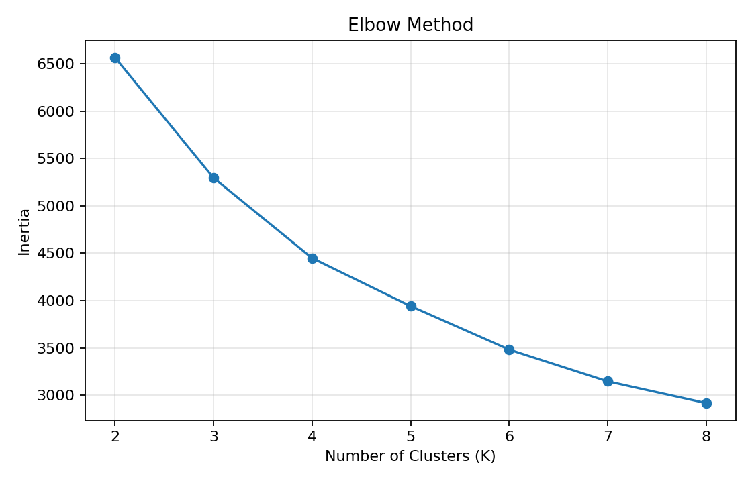
Figure 1. Elbow Method for candidate cluster counts.
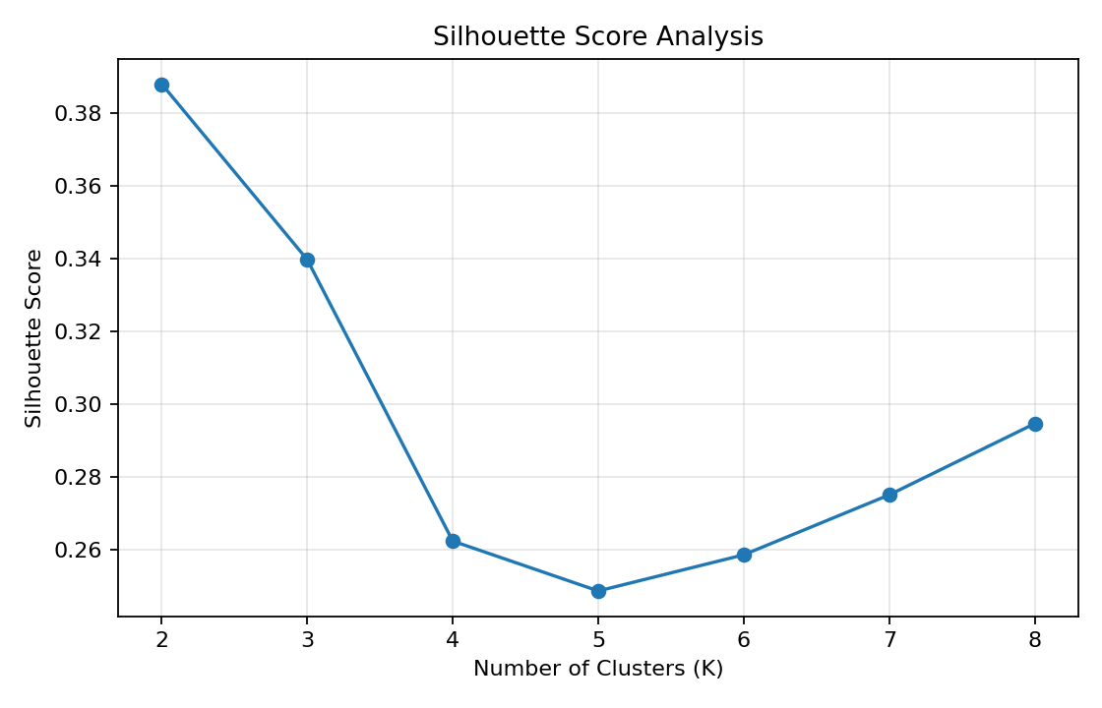
Figure 2. Silhouette scores for K values from 2 to 8.
The highest silhouette score among the tested values was 0.388 at K=2. Therefore, K=2 was selected as the final clustering solution. The elbow plot is used as supporting evidence because inertia always decreases as additional clusters are added.

8. Final Cluster Model
kmeans = KMeans(n_clusters=2, random_state=42, n_init=20)
clusters = kmeans.fit_predict(X_scaled)
df_clustered = X.copy()
df_clustered["Cluster"] = clusters
Cluster numbers are only identifiers; Cluster 0 is not automatically better or lower than Cluster 1. Meaning is assigned only after comparing the average feature profiles and sizes of the clusters.

9. Cluster Visualizations
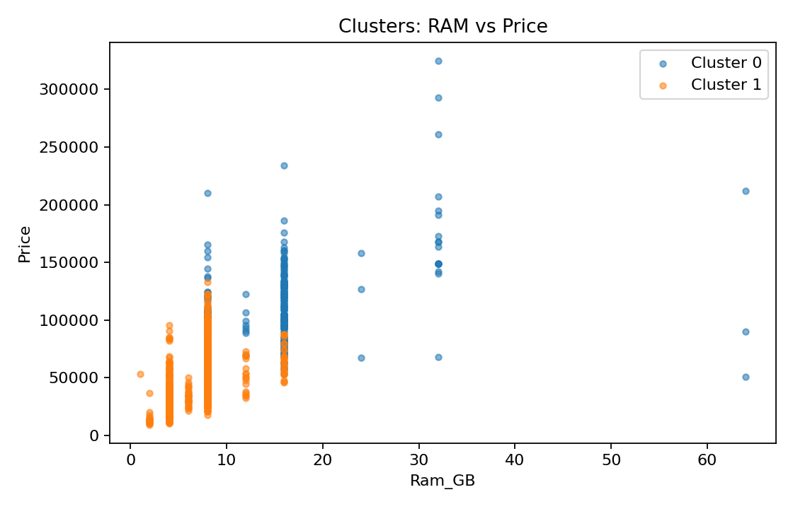
Figure 3. Laptop clusters projected using RAM and Price.
The RAM-versus-price view shows how memory capacity contributes to segmentation. Overlap between points is expected because the model uses all seven features while this figure displays only two dimensions.
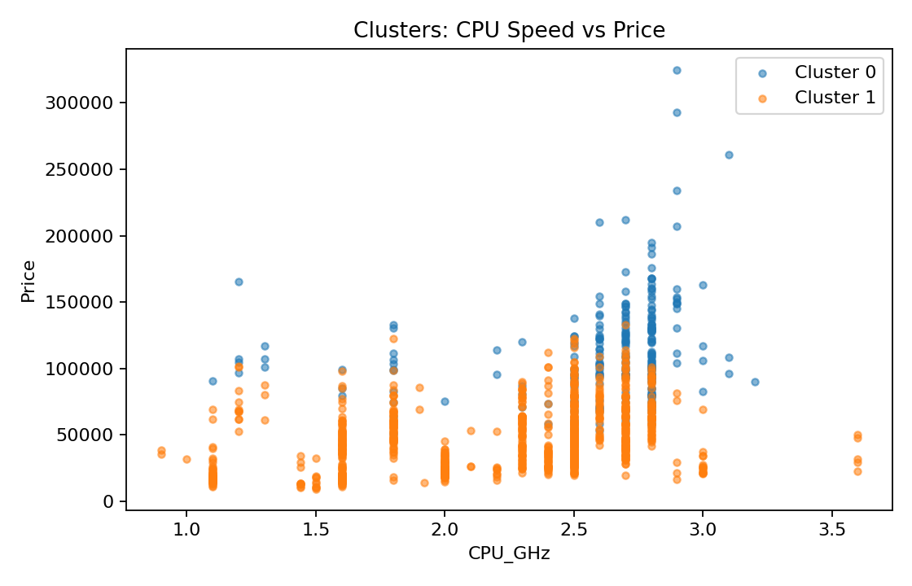
Figure 4. Laptop clusters projected using CPU speed and Price.
This projection provides a second performance-oriented view. Differences in price cannot be attributed to CPU speed alone because the clustering process also considers memory, weight, screen size and display resolution.
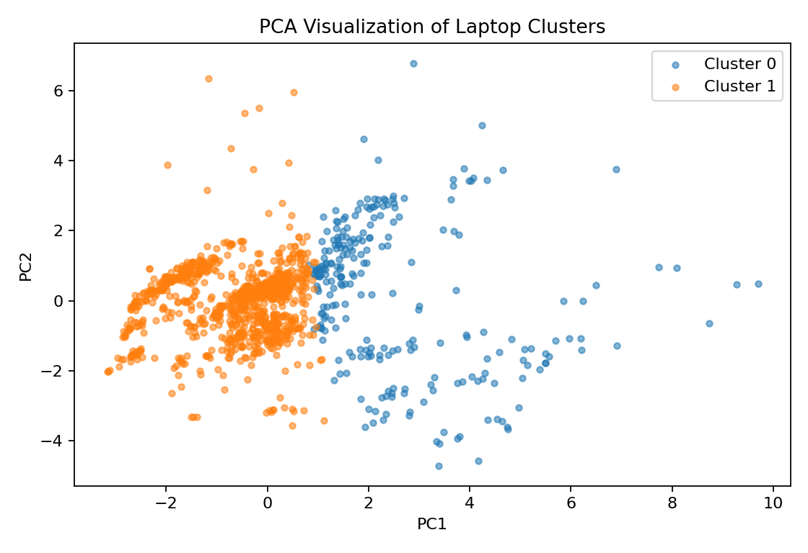
Figure 5. PCA projection of the multi-dimensional cluster structure.
The first two principal components explain approximately 67.7% of the total standardized variance. PCA is used only to visualize the multi-dimensional structure; the K-Means model itself uses all seven selected features.

10. Detailed Cluster Analysis
The following table summarizes the mean values of the selected features for each cluster. The interpretation of each segment is based on these actual values rather than assigning labels before analysis.
Cluster | Ram_GB | Inches | Weight_kg | CPU_GHz | ScreenWidth_px | ScreenHeight_px | Price
0 | 15.81 | 15.55 | 2.47 | 2.61 | 2,442.39 | 1,384.22 | 112,113.83
1 | 6.66 | 15.03 | 1.98 | 2.22 | 1,760.55 | 994.14 | 47,279.08
Cluster 0: contains 254 laptops (20.5% of the analyzed records). Compared with the overall dataset, its relatively stronger characteristics are Price, Ram_GB, while Inches, Weight_kg are comparatively lower. The mean price is 112,113.83, average RAM is 15.8 GB, average CPU speed is 2.61 GHz, and average weight is 2.47 kg.
Cluster 1: contains 988 laptops (79.5% of the analyzed records). Compared with the overall dataset, its relatively stronger characteristics are Inches, Weight_kg, while Price, Ram_GB are comparatively lower. The mean price is 47,279.08, average RAM is 6.7 GB, average CPU speed is 2.22 GHz, and average weight is 1.98 kg.
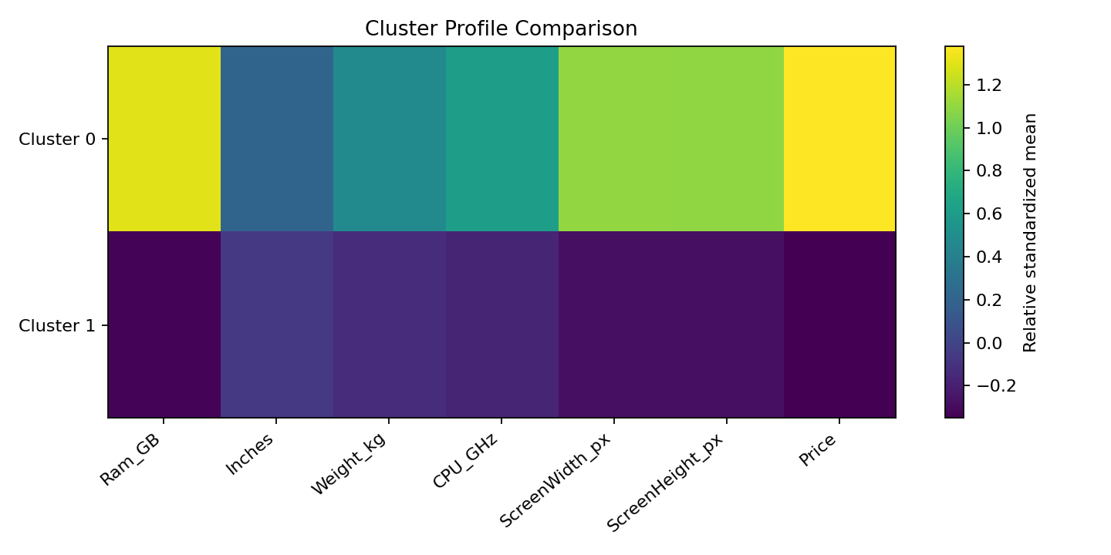
Figure 6. Standardized comparison of cluster profiles across all selected features.
The profile comparison makes it easier to distinguish groups that may appear similar in one individual chart. It highlights whether a segment is relatively performance-oriented, portability-oriented, display-oriented or higher/lower in market value.
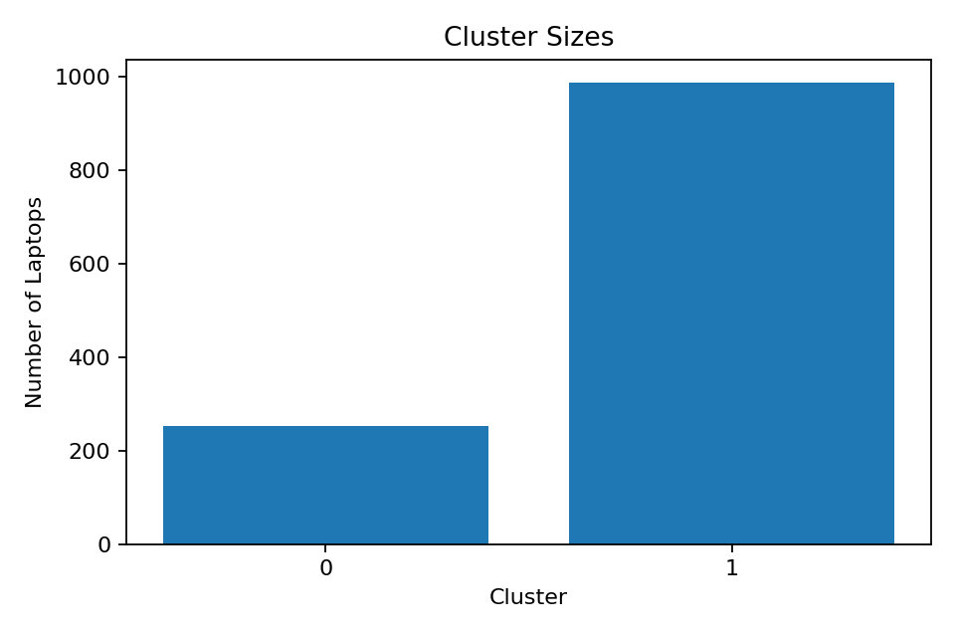
Figure 7. Number of laptop records in each cluster.
Cluster size is important when interpreting the results. A smaller cluster may represent a more specialized product profile, whereas a larger cluster may represent a common combination of specifications.

11. Potential Segment Interpretation
After examining the profile table, clusters can be described relative to one another rather than treated as fixed market labels. A group with below-average price and specifications may represent an entry-level profile. A group with balanced values may represent a general-purpose or mid-range profile. Clusters with above-average RAM, CPU speed, display resolution and price may indicate performance-oriented or premium profiles. These descriptions should remain data-driven and should be updated if the feature set changes.

12. Business and Research Implications
Inventory management: retailers can organize stock according to data-driven specification profiles and identify whether certain segments are over- or underrepresented.
Pricing analysis: laptops in the same technical cluster but with noticeably different prices can be examined further for brand, storage, GPU or design effects.
Product portfolio analysis: manufacturers can investigate whether their products are concentrated in one segment or distributed across several types of technical profiles.
Further research: cluster labels can be compared with Company, TypeName, CPU_Brand, GPU_Brand or operating system to investigate how categorical product characteristics align with the numerical segments.

13. Validation, Limitations and Challenges
The silhouette score provides quantitative evidence about the tested cluster solutions, but clustering does not prove that the identified groups are the only true laptop market categories. K-Means is sensitive to scaling, initialization, outliers and feature selection. Important characteristics such as storage capacity, GPU performance and brand were not directly included in this numerical model.
A PCA chart reduces seven dimensions to two, so visible overlap in the projection does not necessarily mean that observations are identical in the original feature space. Future work could compare the K-Means solution with hierarchical clustering or other clustering approaches.

14. Response to Previous Feedback
The previous feedback requested greater analytical depth and unique insights in each section. This report addresses that requirement by separating the purposes of the sections: feature selection explains what information enters the model; scaling explains why distance calculations are fair; cluster validation justifies the parameter choice; visualizations examine different projections; PCA addresses high-dimensional interpretation; cluster profiles quantify group characteristics; and business implications connect the findings to practical decisions. Figures are supported by written observations instead of being included without analysis.

15. Conclusion
This Week 3 activity successfully applies unsupervised learning to the cleaned laptop dataset. Seven numerical features were selected and standardized, candidate K values from 2 to 8 were evaluated, and K=2 was selected because it produced the highest silhouette score among the tested solutions. The resulting clusters demonstrate that laptops can be segmented according to combinations of memory, processor speed, portability, display characteristics and price. The analysis provides a reproducible foundation for product segmentation, inventory analysis and further machine-learning experimentation.

Appendix: Core Reproducible Code
# Load cleaned dataset
df = pd.read_csv("data/cleaned/laptop_cleaned_week1.csv")
# Prepare features
X = df[features].apply(pd.to_numeric, errors="coerce").dropna()
# Standardize
X_scaled = StandardScaler().fit_transform(X)
# Evaluate K
for k in range(2, 9):
model = KMeans(n_clusters=k, random_state=42, n_init=20)
labels = model.fit_predict(X_scaled)
print(k, model.inertia_, silhouette_score(X_scaled, labels))
# Final model
kmeans = KMeans(n_clusters=optimal_k, random_state=42, n_init=20)
clusters = kmeans.fit_predict(X_scaled)

