**Add New User**

POST

http://localhost:9090/api/addUser

{

"firstName": "bala",

"lastName": "ganesh",

"email": "bala.ganesh@abc.com"

}

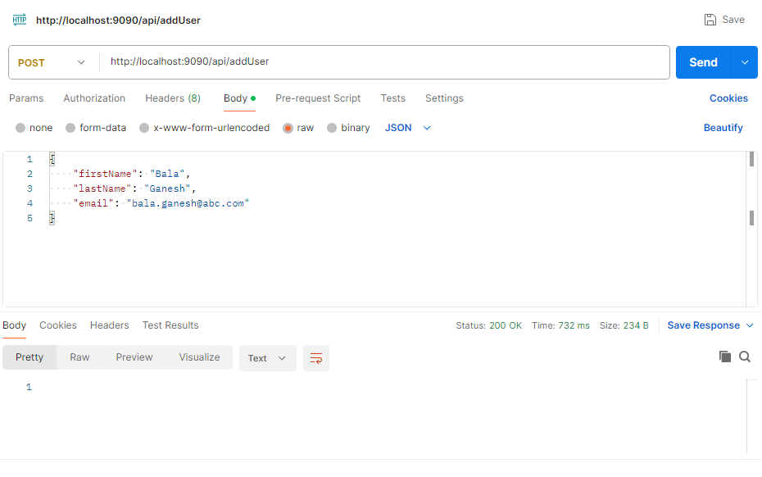

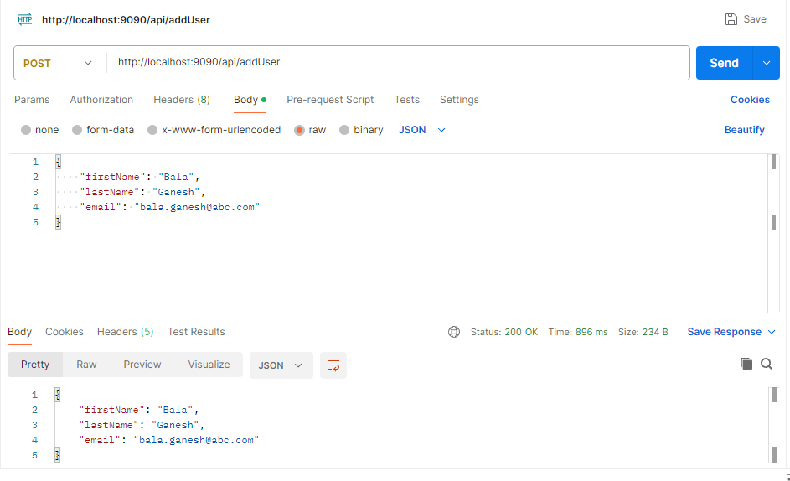

**Book Ticket**

POST

http://localhost:9090/api/bookTicket

{

"ticketFrom":"london",

"ticketTo":"Paris",

"userId": "1",

"secion": "Ä",

"seats": "1"

}

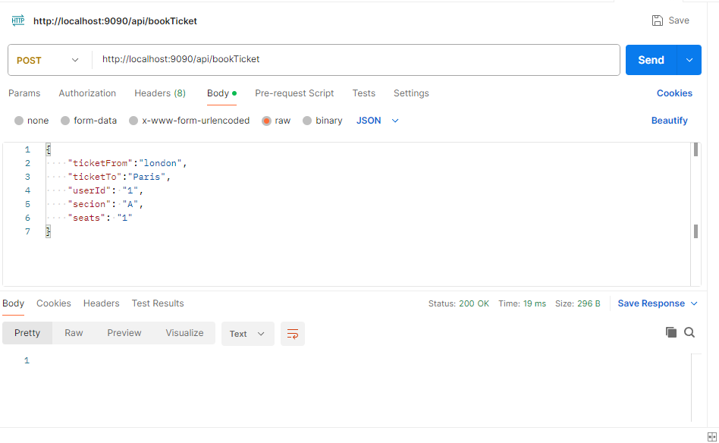

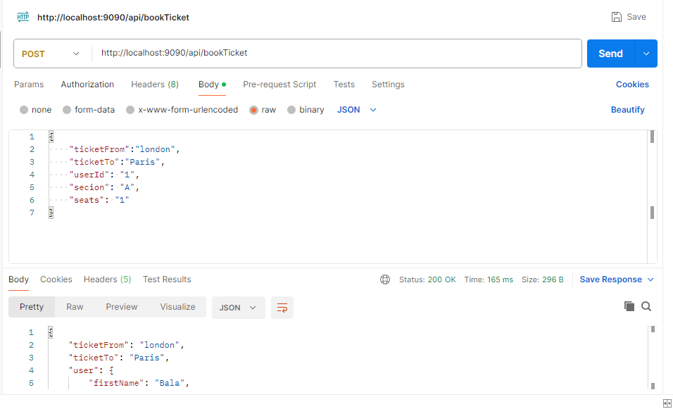

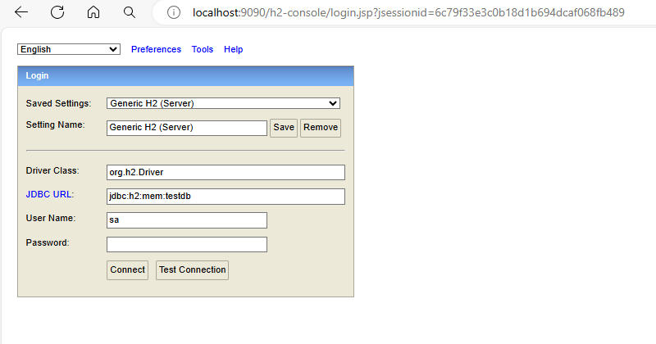

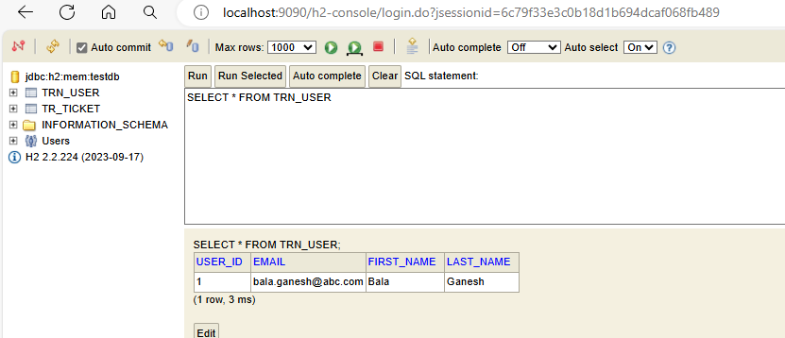

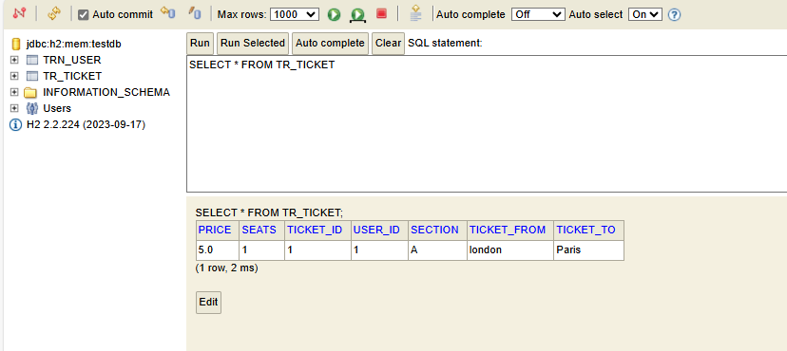

**Get Ticket Receipts by User ID**

GET

http://localhost:9090/api/getTicket?userId=1

QUERYPARAM

userId = 1

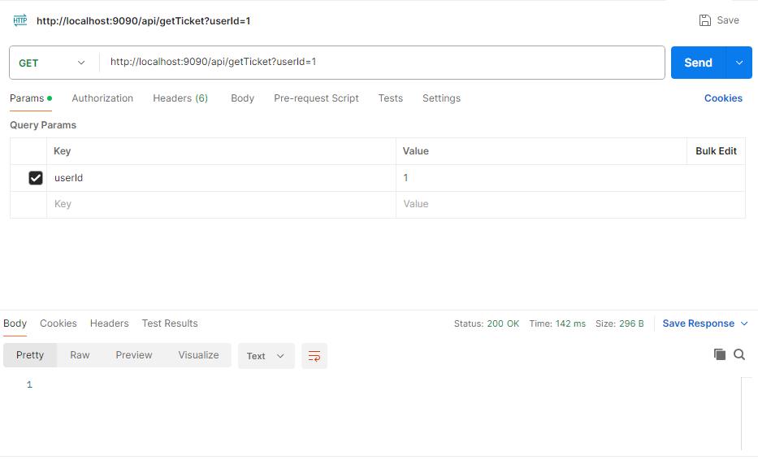

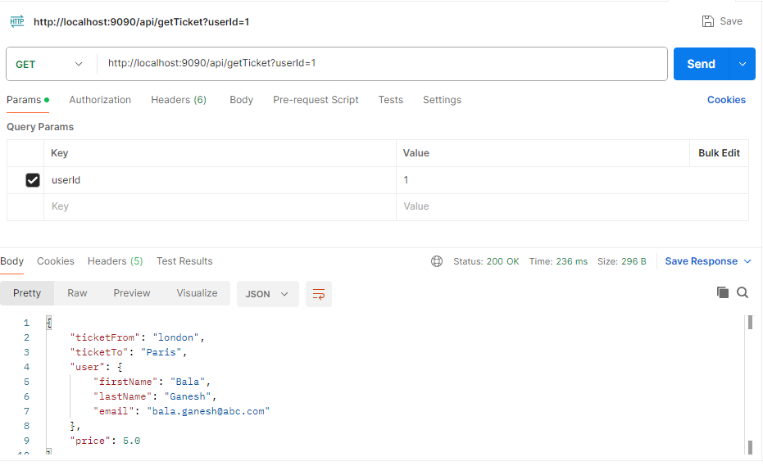

**Get Ticket by Section**

GET

<http://localhost:9090/api/getTicketBySection?section=A>

QUERYPARAM

section = A

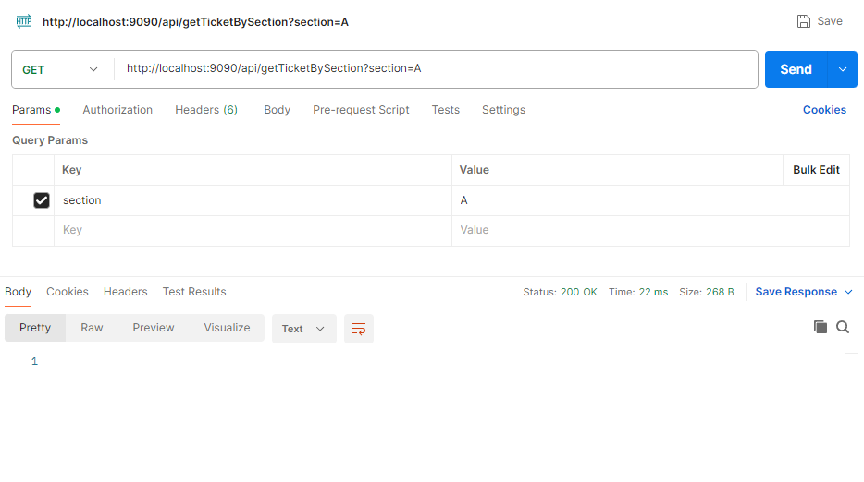

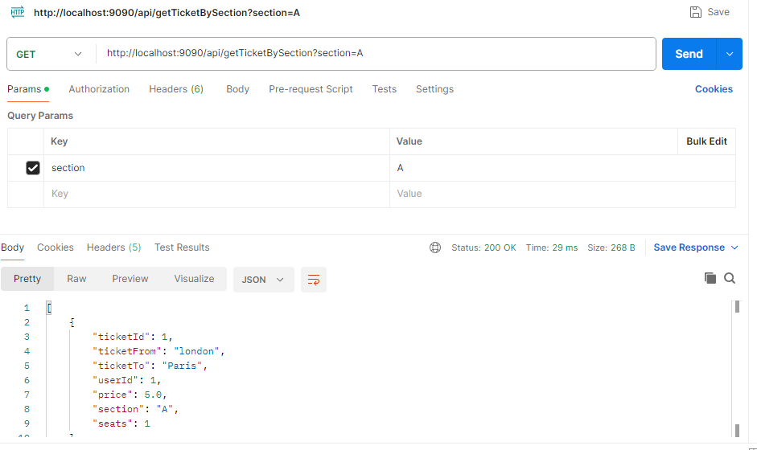

**Modify Ticket**

http://localhost:9090/api/modifyTicket?ticketId=2

QUERYPARAM

userId = 1

{

"ticketFrom":"london",

"ticketTo":"Paris",

"userId": "1",

"secion": "B",

"seats": "2"

}

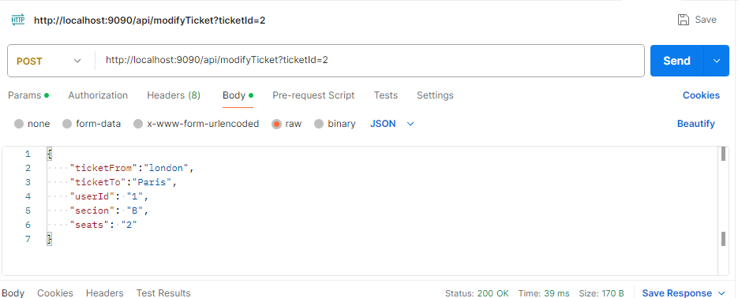

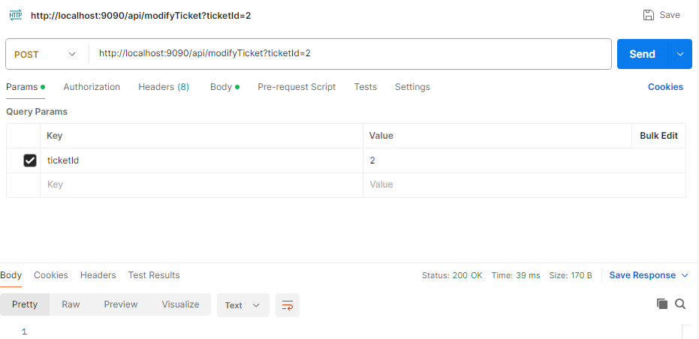

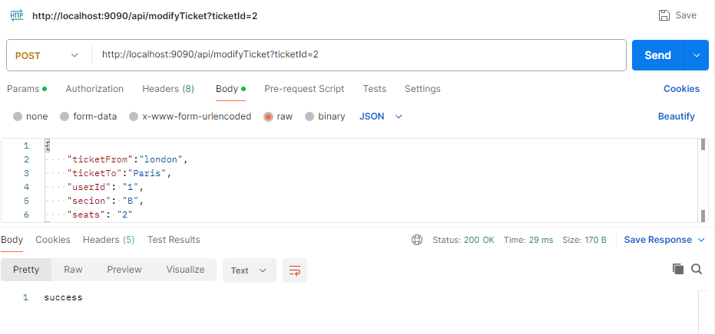

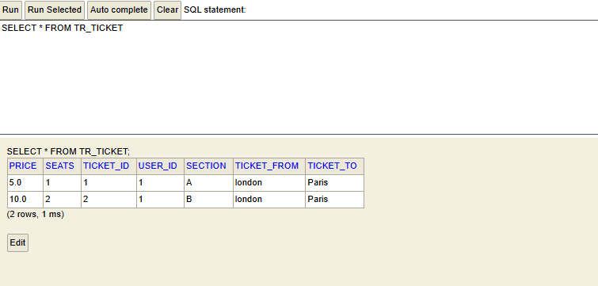

**Cancel Ticket By UserId**

http://localhost:9090/api/cancelTicketByUserId?userId=1

QUERYPARAM

userId = 2

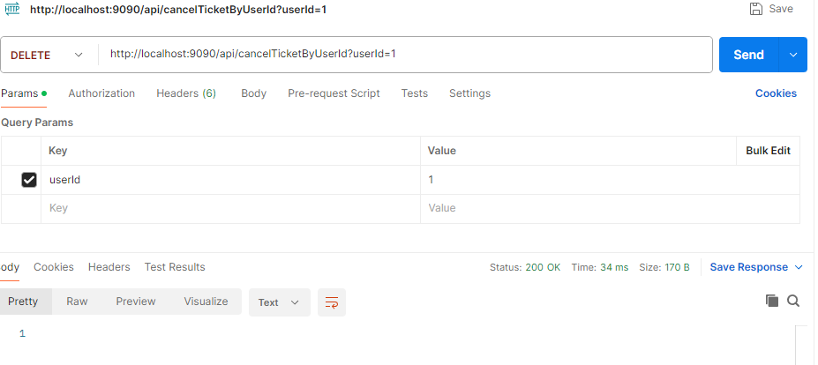

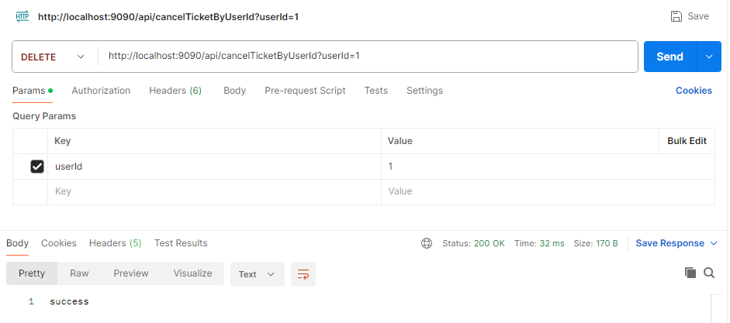

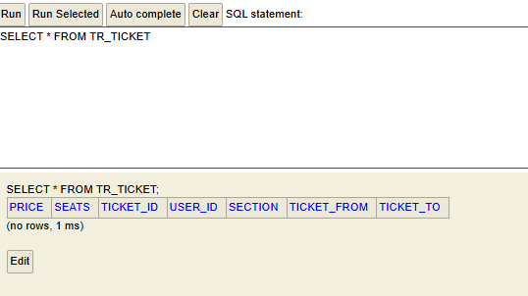

**Junit Test case**

